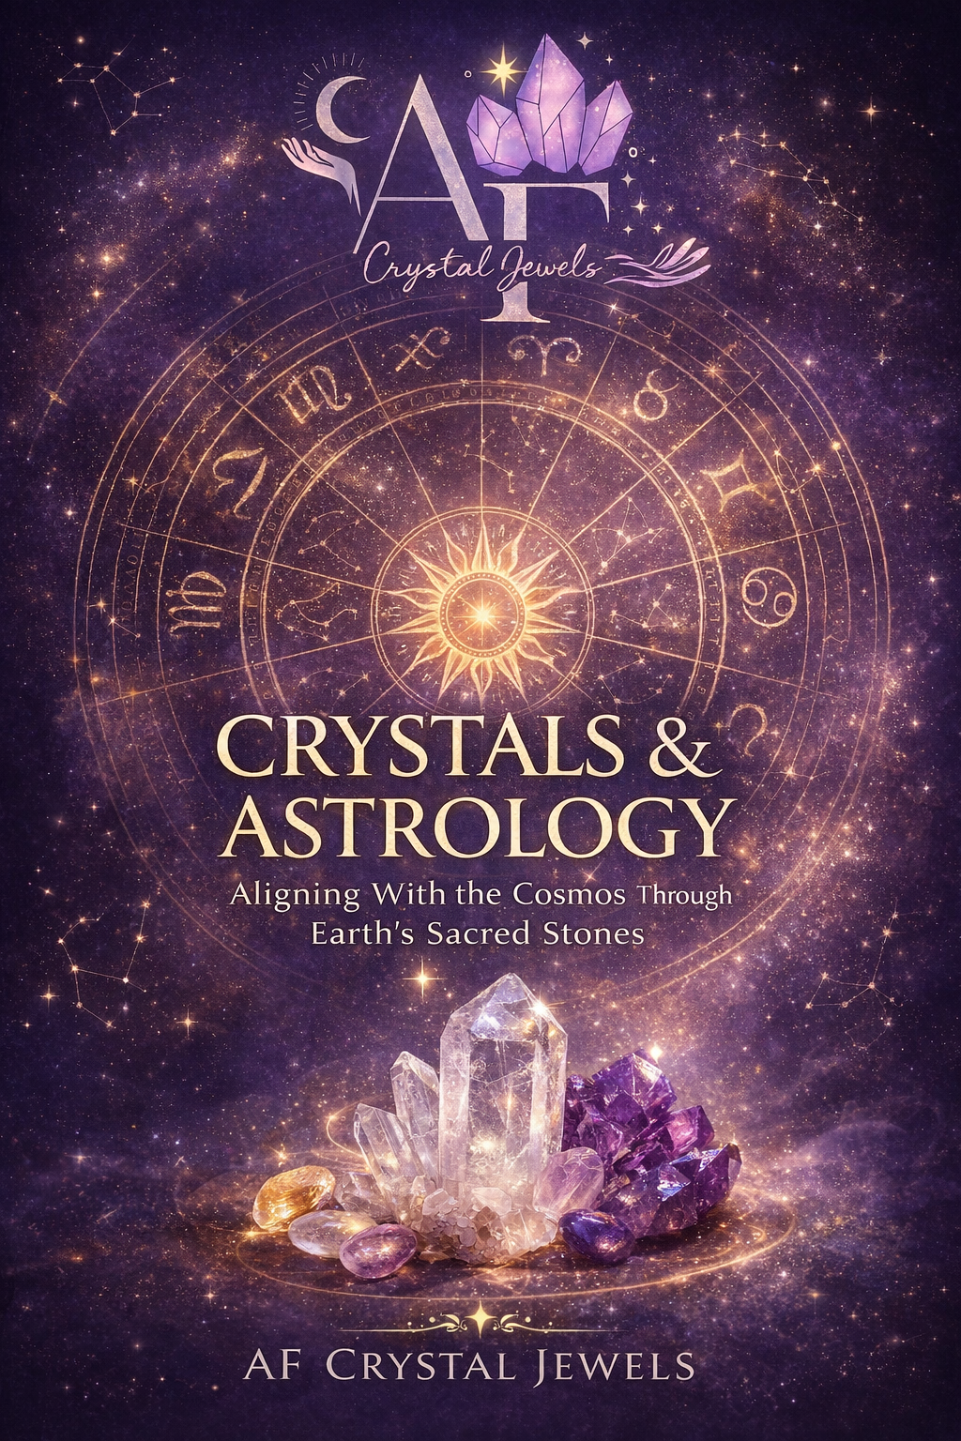
Crystals & Astrology
Aligning With the Cosmos Through Earth’s Sacred Stones

Copyright Page
© 2026 AF Crystal Jewels
All rights reserved. No part of this publication may be reproduced, distributed, or transmitted in any form without prior written permission, except for brief quotations in reviews.
This book is intended for spiritual and educational purposes only and is not a substitute for professional medical, psychological, or financial advice.

Table of Contents
Introduction: The Cosmic Language of Crystals
Astrology & Crystal Energy: How They Interact
Working With Your Birth Chart Using Crystals
Sun Signs & Crystal Alignments
Moon Signs & Emotional Crystal Support
Rising Signs & Aura Enhancement
Planetary Energies & Crystal Correspondences
Crystals for Retrogrades & Astrological Transits
Full Moon & New Moon Crystal Rituals
Seasonal Astrology & Crystal Work
Crystal Grids Based on Zodiac Energy
Creating Your Personal Astrological Crystal Kit
Daily Practices for Cosmic Alignment
Ethical Sourcing, Care & Programming
Final Reflections: Living in Harmony with the Stars

Chapter 1: Introduction – The Cosmic Language of Crystals
Astrology and crystals are ancient systems that speak the same energetic language. Astrology maps the movement of cosmic forces, while crystals anchor those forces into the physical realm. When used together, they form a bridge between the heavens and the Earth.
Crystals are formed over millions of years under immense pressure, making them natural holders of memory, frequency, and intention. Astrology, meanwhile, reflects the rhythmic intelligence of the universe. Aligning crystal work with astrological wisdom allows us to work with cosmic timing rather than against it.

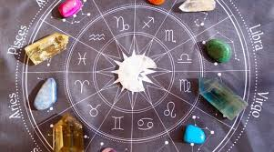

Chapter 2: Astrology & Crystal Energy – How They Interact
Each planet, zodiac sign, and astrological house vibrates at a specific frequency. Crystals resonate with these same frequencies due to their mineral composition and geometric structure.
When paired correctly:
Crystals amplify planetary energy
Astrology provides timing and intention
Rituals become more potent and focused
This synergy enhances manifestation, healing, and spiritual awareness.

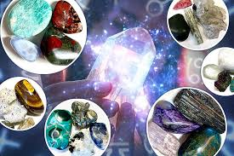

Chapter 3: Working With Your Birth Chart Using Crystals
Your birth chart is your energetic blueprint. It reveals your strengths, challenges, emotional patterns, and soul lessons.
Key placements to focus on:
Sun sign: Core identity and purpose
Moon sign: Emotional body and intuition
Rising sign: Aura, presence, and life path

By selecting crystals aligned with these placements, you create personalized energetic support rather than generic crystal use.

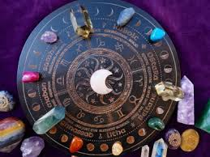

Chapter 4: Sun Signs & Crystal Alignments
Your Sun sign governs vitality, confidence, and self-expression.
Aries
Crystals: Carnelian, Red Jasper, Bloodstone
Focus: Motivation, courage, leadership

Taurus
Crystals: Rose Quartz, Emerald, Green Aventurine
Focus: Stability, abundance, self-worth

Gemini
Crystals: Blue Lace Agate, Citrine, Fluorite
Focus: Communication, clarity, adaptability
Cancer
Crystals: Moonstone, Selenite, Pearl
Focus: Emotional security, intuition, nurturing

Leo
Crystals: Sunstone, Tiger’s Eye, Pyrite
Focus: Confidence, creativity, visibility

Virgo
Crystals: Amazonite, Moss Agate, Peridot
Focus: Balance, healing, organization

Libra
Crystals: Lapis Lazuli, Opal, Rose Quartz
Focus: Harmony, relationships, beauty

Scorpio
Crystals: Obsidian, Malachite, Garnet
Focus: Transformation, protection, depth

Sagittarius
Crystals: Amethyst, Turquoise, Labradorite
Focus: Expansion, wisdom, spiritual growth

Capricorn
Crystals: Onyx, Smoky Quartz, Garnet
Focus: Discipline, grounding, success

Aquarius
Crystals: Aquamarine, Amethyst, Clear Quartz
Focus: Innovation, intuition, higher mind
Pisces
Crystals: Lepidolite, Fluorite, Aquamarine
Focus: Compassion, creativity, emotional flow

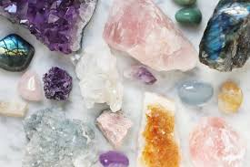

Chapter 5: Moon Signs & Emotional Crystal Support
Moon signs govern inner needs and subconscious patterns.

Best practices:
Sleep with Moon-aligned crystals near your bed
Use them during emotional processing or journaling
Pair with lunar rituals for deeper healing
Moonstone, Selenite, Lepidolite, and Rose Quartz are universal Moon allies.

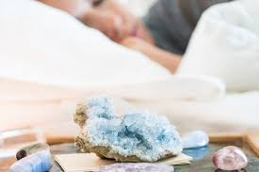

Chapter 6: Rising Signs & Aura Enhancement
Your Rising sign shapes how others perceive you and how your energy enters the world.
Crystals aligned with your Rising sign:
Strengthen your aura
Improve confidence and presence
Support life transitions
Wear these crystals as jewellery or keep them in your workspace.

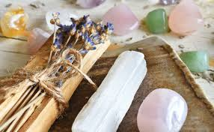

Chapter 7: Planetary Energies & Crystal Correspondences
Sun: Sunstone, Citrine
Moon: Moonstone, Pearl
Mercury: Fluorite, Blue Lace Agate
Venus: Rose Quartz, Emerald
Mars: Carnelian, Red Jasper
Jupiter: Amethyst, Lapis Lazuli
Saturn: Onyx, Smoky Quartz
Uranus: Labradorite, Moldavite
Neptune: Aquamarine, Lepidolite
Pluto: Obsidian, Malachite
Working with planetary crystals on corresponding days amplifies results.

Chapter 8: Crystals for Retrogrades & Astrological Transits
Retrogrades are periods of review, not punishment.
Recommended crystals:
Mercury Retrograde: Fluorite, Amazonite
Venus Retrograde: Rose Quartz, Rhodonite
Mars Retrograde: Hematite, Red Jasper
Use grounding crystals to stabilize energy and reduce overwhelm.

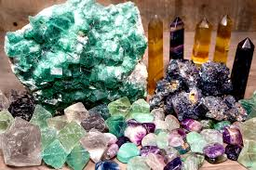

Chapter 9: Full Moon & New Moon Crystal Rituals
New Moon Ritual
Set intentions
Use Clear Quartz, Moonstone, Citrine
Write goals and place crystals over them
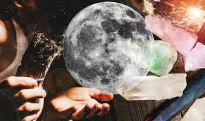
Full Moon Ritual
Release and cleanse
Use Selenite, Obsidian, Amethyst
Moonlight charging overnight

Chapter 10: Seasonal Astrology & Crystal Work
Spring: Green Aventurine, Moss Agate
Summer: Sunstone, Carnelian
Autumn: Tiger’s Eye, Jasper
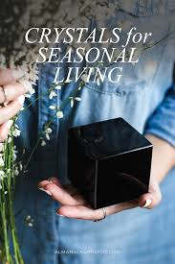
Winter: Smoky Quartz, Amethyst
Align crystal work with seasonal energy for balance.

Chapter 11: Crystal Grids Based on Zodiac Energy
Zodiac grids amplify specific sign qualities.
Examples:
Leo grid for confidence
Virgo grid for healing
Scorpio grid for transformation
Use sacred geometry such as circles, triangles, or the Flower of Life.

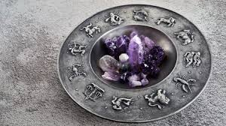

Chapter 12: Creating Your Personal Astrological Crystal Kit
Your kit should include:
One Sun sign crystal
One Moon sign crystal
One Rising sign crystal
One grounding stone
One amplifier (Clear Quartz)
This becomes your energetic toolkit for daily alignment.
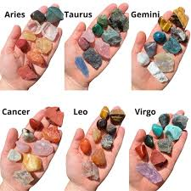

Chapter 13: Daily Practices for Cosmic Alignment
Morning intention with Sun crystal
Emotional check-in with Moon crystal
Evening grounding ritual
Consistency matters more than complexity.

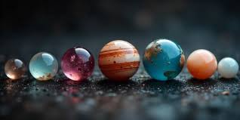

Chapter 14: Ethical Sourcing, Care & Programming
Choose ethically sourced crystals when possible.
Cleanse regularly using:
Smoke
Sound
Moonlight
Program crystals by setting clear, focused intentions.



Chapter 15: Final Reflections – Living in Harmony with the Stars
Crystals and astrology remind us that we are not separate from the universe—we are expressions of it. When you align your crystal practice with cosmic rhythms, life flows with greater clarity, balance, and purpose.
Let the stars guide your timing. Let the Earth support your journey.

