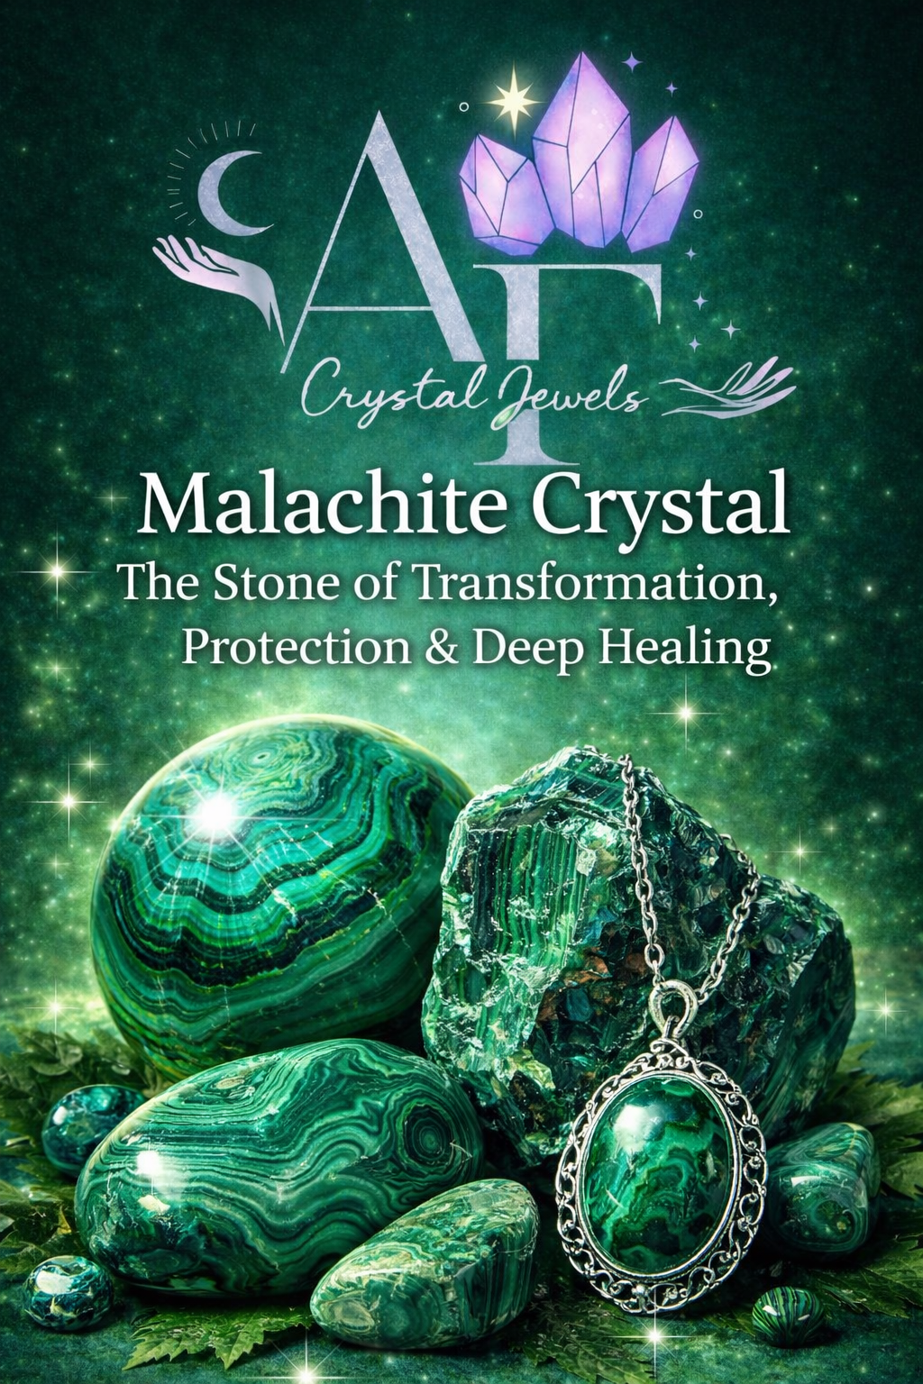
Malachite Crystal
The Stone of Transformation, Protection & Deep Healing

Copyright & Disclaimer
AF Crystal Jewels. All rights reserved.
This eBook is intended for educational and spiritual purposes only. Crystal healing practices are complementary and should not replace professional medical, psychological, or legal advice.

Table of Contents

Introduction to Malachite
The History & Lore of Malachite
Geological Formation & Physical Properties
Energetic & Metaphysical Properties
Emotional & Mental Healing with Malachite
Physical Healing Associations
Chakra Connections
Spiritual Growth & Transformation
Malachite for Protection & Energy Shielding
Using Malachite for Manifestation
Malachite in Meditation & Ritual Work
Crystal Pairings & Synergies
How to Cleanse, Charge & Care for Malachite
Who Should (and Should Not) Use Malachite
Malachite in Jewellery & Daily Wear
Working with Malachite Safely
Malachite Affirmations
Practical Exercises & Rituals
Frequently Asked Questions
Final Thoughts: Embracing Transformation

1. Introduction to Malachite
Malachite is one of the most powerful transformation stones in the crystal kingdom. Recognised by its rich green colour and distinctive swirling patterns, malachite acts as a catalyst for deep emotional healing, energetic protection, and profound personal change.
This stone does not work gently—it works honestly. Malachite brings suppressed emotions, limiting beliefs, and unresolved patterns to the surface so they can be acknowledged, released, and transformed.

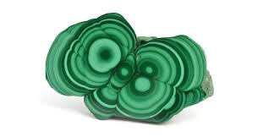

2. The History & Lore of Malachite
Malachite has been revered for over 4,000 years. Ancient Egyptians used it in amulets, pigments, and cosmetics, believing it protected against evil and guided souls safely into the afterlife. In ancient Greece and Rome, malachite was carved into talismans to guard against danger and misfortune.
Throughout history, malachite has been associated with:
- Protection during travel
- Transformation and rebirth
- Divine feminine energy
- Emotional truth and courage

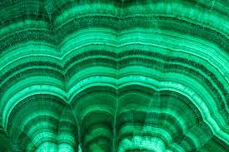

3. Geological Formation & Physical Properties
Mineral Class: Copper carbonate hydroxide
Colour: Light to deep green with banded patterns
Hardness: 3.5–4 on the Mohs scale
Primary Sources: Congo, Zambia, Russia, Australia
Malachite forms in copper-rich environments, which explains its strong connection to energy flow, circulation, and vitality.
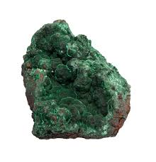

4. Energetic & Metaphysical Properties
Malachite is known as: The Stone of Transformation
The Mirror Stone (reflects inner truth)
A powerful energy amplifier
Key metaphysical traits:
- Absorbs negative energies and pollutants
- Encourages risk-taking and growth
- Breaks emotional dependency patterns
- Strengthens intuition and awareness
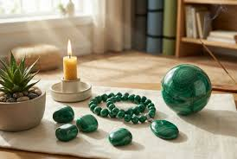

5. Emotional & Mental Healing with Malachite
Malachite is particularly effective for:
- Emotional trauma and past wounds
- Anxiety rooted in suppressed emotions
- Fear of change or growth
- Breaking cycles of self-sabotage
It encourages radical honesty with oneself, helping you identify where emotional stagnation is blocking progress.
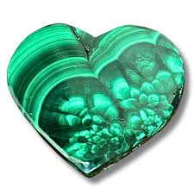

6. Physical Healing Associations
Traditional energetic associations include:
- Supporting detoxification
- Encouraging healthy circulation
- Assisting with menstrual discomfort
- Relieving tension held in the body
Malachite is strongly associated with drawing out energetic blockages from the physical body.

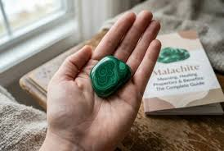

7. Chakra Connections

Malachite primarily activates:
Heart Chakra: Emotional healing, compassion, self-love. Mantra “My heart is healed, open, and filled with love.”
Solar Plexus Chakra: Personal power, confidence, boundaries. Mantra “I am confident, empowered, and in control of my life.”
Together, these chakras support empowered emotional expression and aligned action.

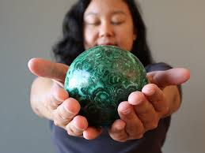

8. Spiritual Growth & Transformation
Spiritually, malachite acts as a teacher. It exposes illusion, strengthens discernment, and accelerates spiritual awakening. It is especially powerful during periods of:
Major life transitions
Spiritual initiations
Shadow work and inner healing
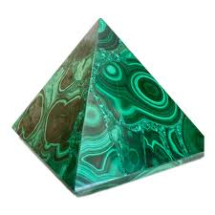

9. Malachite for Protection & Energy Shielding

Malachite creates a strong energetic barrier, absorbing:
Negative intentions
Environmental stress
Emotional manipulation
It is often placed near entrances, worn during travel, or used during energy work for psychic protection.

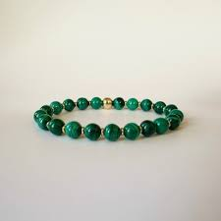

10. Using Malachite for Manifestation
Malachite supports manifestation by:
- Removing subconscious resistance
- Strengthening intention clarity
- Aligning action with purpose
It is especially effective for manifestations related to:
- Career advancement
- Financial empowerment
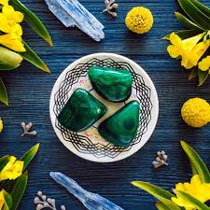
- Emotional independence

11. Malachite in Meditation & Ritual Work
Meditation with malachite may bring intense insights. Best practices include:
- Short, intentional sessions
- Grounding before and after
- Journaling insights immediately
Malachite works best when approached with respect and readiness for change.

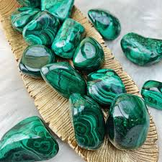

12. Crystal Pairings & Synergies
Powerful combinations include:
Malachite + Rose Quartz: Emotional healing with compassion
Malachite + Black Tourmaline: Deep protection and grounding
Malachite + Clear Quartz: Amplified transformation
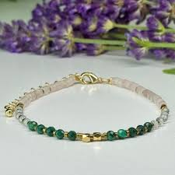
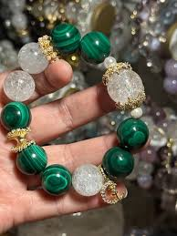

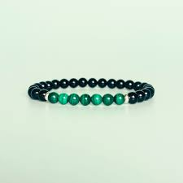

13. How to Cleanse, Charge & Care for Malachite
Never cleanse malachite with water.
Safe cleansing methods:
- Smoke cleansing
- Sound healing
- Moonlight (short exposure)
- Placing on selenite

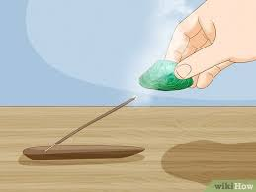

14. Who Should (and Should Not) Use Malachite
Malachite is ideal for those ready for change.
It may feel overwhelming for individuals who:
- Are emotionally fragile
- Resist introspection
- Prefer gentle energy
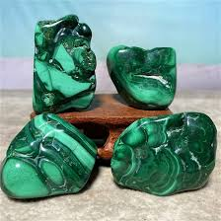
Always listen to your intuition.

15. Malachite in Jewellery & Daily Wear
Worn as jewellery, malachite:
- Provides constant energetic protection
- Encourages emotional balance
- Strengthens personal boundaries
Avoid wearing during sleep or for extended periods initially.
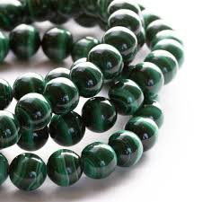

16. Working with Malachite Safely
Malachite contains copper and should never be:
- Ingested
- Used in elixirs
- Exposed to prolonged moisture
Polished stones are safe for handling when treated respectfully.

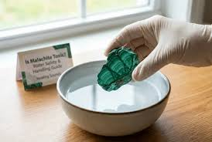

17. Malachite Affirmations
I embrace change with courage and clarity.
I release what no longer serves my growth.
I am protected, empowered, and aligned.
Transformation unfolds effortlessly within me.

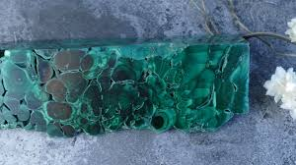

18. Practical Exercises & Rituals
Transformation Ritual:
- Hold malachite over your heart
- Identify one pattern you are ready to release
- Speak it aloud
- Visualise green light dissolving the pattern
- Close with gratitude
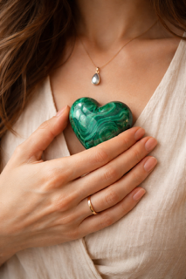

19. Frequently Asked Questions

Is malachite safe to use daily?
Yes, when used mindfully and in short durations.

Can malachite cause emotional intensity?
Yes. This is part of its transformative nature.

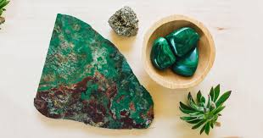

20. Final Thoughts: Embracing Transformation
Malachite is not a passive stone—it is a powerful ally for those ready to evolve. When worked with consciously, it offers protection, clarity, emotional liberation, and profound spiritual growth.
If you are ready to face truth, release the past, and step into empowered change, malachite will walk beside you—every step of the way.



