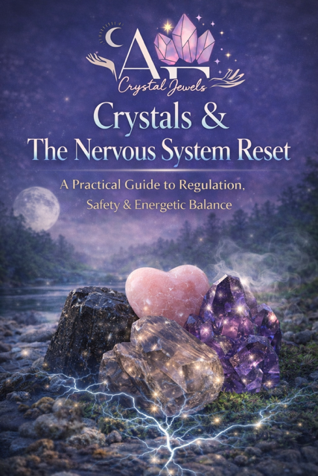
Crystals & The Nervous System Reset
A Practical Guide to Regulation, Safety & Energetic Balance

Table of Contents

- Understanding the Nervous System
- Stress, Trauma & Dysregulation
- The Energetic Role of Crystals in Regulation
- Grounding Stones for Safety & Stability
- Heart-Centred Crystals for Emotional Regulation
- Calming the Mind & Reducing Anxiety
- Releasing Stored Stress from the Body
- Higher-Frequency Stones for Recalibration
- Designing Your Personal Nervous System Reset Plan
- The 30-Day Nervous System Reset Protocol
- Integrating Breathwork & Somatic Techniques
- Advanced Practices for Long-Term Resilience
- Ethical Use & Clinical Considerations
- Final Integration

Chapter 1

Understanding the Nervous System
The nervous system is the body’s command centre. It regulates perception, emotion, movement, digestion, heart rate, and survival responses. When balanced, it allows fluid movement between alertness and relaxation. When dysregulated, it becomes locked in patterns of stress or shutdown.

The nervous system consists of:
Central Nervous System (CNS): Brain and spinal cord
Peripheral Nervous System (PNS): Nerves extending throughout the body
Within the peripheral system lies the Autonomic Nervous System (ANS), which governs automatic bodily functions.

The ANS includes:
Sympathetic branch: Mobilizes fight-or-flight
Parasympathetic branch: Activates rest-and-digest
Healthy regulation means the body can activate when necessary and return to calm afterward. Chronic stress disrupts this flexibility.



Chapter 2
Stress, Trauma & Dysregulation
When the nervous system perceives threat—whether physical or emotional—it initiates protective responses. Short-term stress is adaptive. Prolonged activation is not.
Common symptoms of dysregulation include:
- Anxiety and hypervigilance
- Insomnia
- Digestive disruption
- Emotional reactivity
- Dissociation
- Chronic fatigue
The body stores unresolved stress somatically. Regulation therefore requires both cognitive awareness and physiological recalibration.

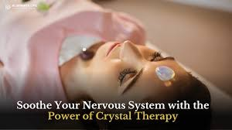

Chapter 3
The Energetic Role of Crystals in Regulation
Crystals are structured mineral forms created through intense geological processes. Their internal lattice structures are stable and consistent. This stability makes them effective tools for ritual anchoring and sensory grounding.
For example, Quartz possesses piezoelectric properties, meaning it can generate electrical charge under pressure. While crystal work is complementary—not clinical treatment—the symbolism of structural coherence and energetic consistency supports regulation practices.
- Crystals assist nervous system reset through:
- Tactile grounding (weight, texture, temperature)
- Repetition and ritual structure
- Focused intention
- Emotional anchoring
- Environmental cues of safety
Their function is not to override biology, but to support the body’s inherent capacity to regulate.
Chapter 4
Grounding Stones for Safety & Stability
Grounding stones support parasympathetic activation and physical awareness.

Black Tourmaline
Associated with energetic protection and boundary reinforcement.
Best used when experiencing overwhelm or hypervigilance.
Practice: Sit upright, place the stone near the base of the spine, and engage in slow diaphragmatic breathing for five minutes.

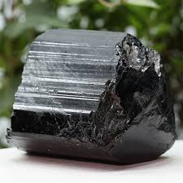

Hematite
Encourages embodied presence and somatic awareness.
Beneficial for dissociation or mental overactivity.
Practice: Hold in the palm and name five sensations in the body.
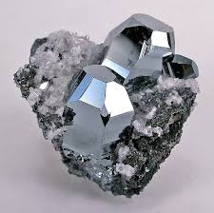

Smoky Quartz
Traditionally used for energetic transmutation and stress release.
Practice: Place near the feet during seated meditation to promote grounding.
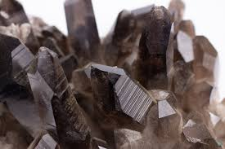

Chapter 5
Heart-Centred Crystals for Emotional Regulation
The heart plays a key role in emotional safety. When the body feels safe, vagal tone improves and regulation becomes easier.

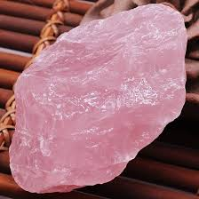
Rose Quartz
Associated with compassion and emotional softness.
Supports self-soothing and gentle emotional processing.
Practice: Place over the heart centre and repeat:
“I am safe to soften.”

Rhodonite
Encourages emotional integration and trauma-informed reflection.
Practice: Use during journaling sessions focused on emotional release.



Chapter 6
Calming the Mind & Reducing Anxiety
Cognitive overstimulation keeps the sympathetic system activated. Certain crystals are traditionally used to quiet mental chatter.

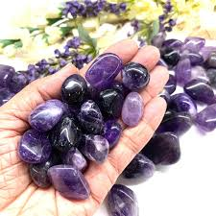
Amethyst
Supports relaxation and mental clarity.
Place near the pillow during sleep rituals or hold during meditation.

Lepidolite
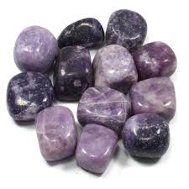
Contains trace lithium and is often associated with emotional balance.
Use during evening wind-down routines.

Chapter 7
Releasing Stored Stress from the Body
Stress is frequently stored in the musculature and connective tissue. Somatic awareness combined with crystal anchoring can assist release work.

Malachite
Often used during emotional release practices.
Practice: Pair with slow exhalation breathing while gently scanning the body for tension.

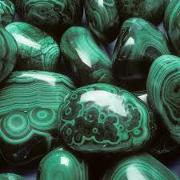

Chapter 8
Higher-Frequency Stones for Recalibration
Once grounding and stabilization are established, some individuals may incorporate higher-frequency stones for energetic expansion.

Phenakite
Traditionally associated with spiritual elevation and clarity.
Use only after stable grounding practices are consistent.

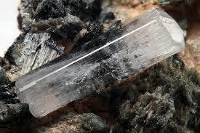

Chapter 9
Designing Your Personal Nervous System Reset Plan
Step 1: Identify your dominant state (anxious, numb, fatigued, reactive).
Step 2: Select one grounding stone.
Step 3: Add one emotional regulation stone after 7–14 days.
Step 4: Practice daily for consistency before layering additional stones.
Consistency regulates more effectively than intensity.

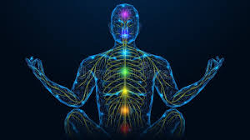

Chapter 10
The 30-Day Nervous System Reset Protocol
- Days 1–7:
Grounding practice daily (5–10 minutes).
- Days 8–14:
Add heart-centred stone and journaling.
- Days 15–21:
Introduce breathwork (4-second inhale, 6-second exhale).
- Days 22–30:
Optional higher-frequency integration if stable.

Daily Framework:
5 minutes breath regulation
5 minutes crystal holding practice
5 minutes journaling or reflection

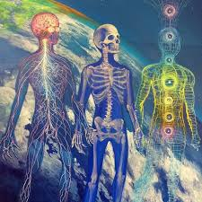

Chapter 11
Integrating Breathwork & Somatic Techniques
Crystals are most effective when paired with physiological regulation tools:
- Diaphragmatic breathing
- Bilateral tapping
- Gentle body scanning
- Temperature regulation (warmth for calm, cool for alertness)

These techniques strengthen vagal tone and restore resilience.



Chapter 12
- Advanced Practices for Long-Term Resilience
- Create a consistent evening wind-down ritual.
- Keep a grounding stone near entryways to symbolize energetic transition.
- Develop a sleep sanctuary with calming stones placed nearby.
- Use structured journaling with heart-centred stones for emotional processing.
Long-term regulation requires repetition, safety, and integration—not intensity.

Chapter 13
Ethical Use & Clinical Considerations
Crystal practices are complementary wellness tools. They do not replace:
- Medical treatment
- Psychotherapy
- Psychiatric support
- Trauma-informed care
Encourage readers to seek professional support when needed. Regulation is strengthened by multi-layered support systems.



Chapter 14
Final Integration
Nervous system reset is not about eliminating stress. It is about restoring flexibility.
Crystals function as:
- Anchors of safety
- Ritual stabilizers
- Sensory grounding tools
- Energetic reminders of coherence
With repetition and intentional practice, the body relearns safety.
Regulation becomes sustainable when approached with patience, structure, and self-compassion.



