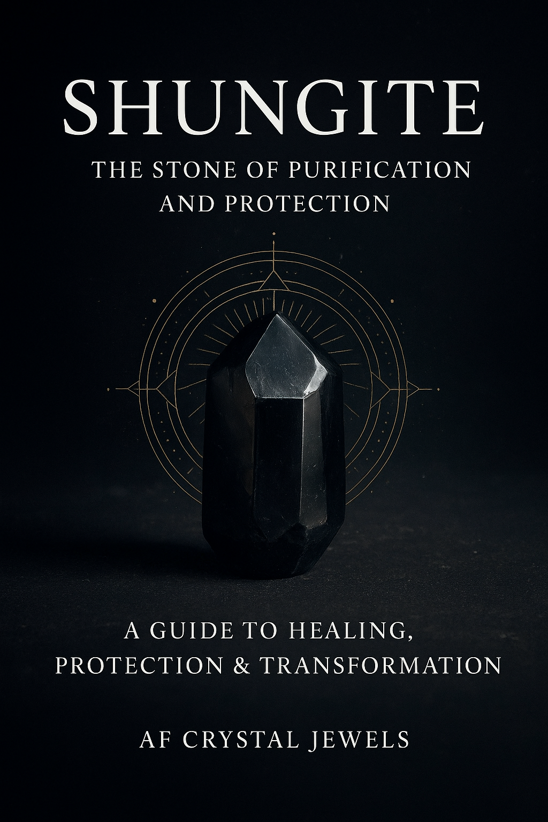

Introduction to Shungite

Among Earth’s most mysterious minerals lies Shungite, a rare black stone from Russia that has captivated healers, scientists, and crystal enthusiasts alike. Unlike most crystals, Shungite is composed almost entirely of carbon, the building block of life, and contains rare molecules called fullerenes — unique carbon structures with powerful antioxidant and shielding properties.

Revered as a stone of purification, protection, and transformation, Shungite offers both scientific intrigue and spiritual depth. From cleansing water to shielding against electromagnetic fields (EMFs), it bridges the worlds of science and mysticism. This eBook will guide you through its history, properties, healing uses, and practical applications so you can integrate Shungite into your daily life.

Origins & History

Shungite is found almost exclusively in the Karelia region of northwestern Russia, near Lake Onega. Scientists estimate it to be over 2 billion years old, formed when Earth was still young.

Historical Uses:

Russian folklore tells of Shungite being used for healing waters, where people would bathe in springs flowing through Shungite deposits.

Tsar Peter the Great established the first spa using Shungite-infused water in the early 1700s, calling it “living water.”

Shungite has long been associated with longevity, purification, and vitality.

Today, its popularity has surged worldwide as both a metaphysical protector and a scientifically fascinating mineral.

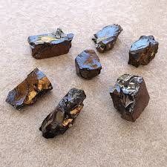

The Science of Shungite

Shungite is composed of 60–98% carbon, containing fullerenes — hollow carbon molecules discovered in the 1980s. Fullerenes are known for their antioxidant properties, making Shungite unique among minerals.

Fullerenes: Believed to neutralize free radicals, support cellular health, and absorb harmful radiation.

Electrical Conductivity: Shungite conducts electricity, enhancing its reputation as an energy shield.

EMF Absorption: Studies suggest Shungite may reduce the effects of electromagnetic radiation from phones, Wi-Fi, and other electronics.

This scientific foundation adds credibility to Shungite’s protective reputation in metaphysical traditions.

Types of Shungite

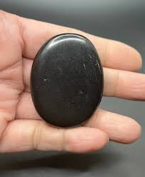Shungite is categorized into three main types based on carbon content:

Regular Shungite (30–50% carbon)

Matte black, common, widely available.

Used in carvings, pyramids, plates, and EMF-shielding items.

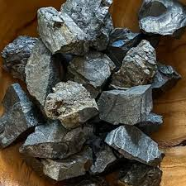

Petrovsky Shungite (50–70% carbon)

Shiny and smoother, rarer than regular Shungite.

Higher energy resonance, popular for personal use.

Elite/Noble Shungite (90–98% carbon)

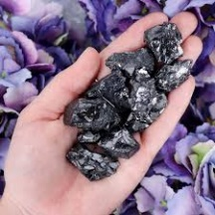Silvery-black, lustrous, extremely rare.

Contains the highest concentration of fullerenes.

Known as the most potent and pure form for spiritual and healing purposes.

Healing & Metaphysical Properties

Protection & Grounding

Shungite is renowned for its protective shield against unwanted energies and electromagnetic pollution. It grounds the body’s energy field and stabilizes emotions, making it invaluable in chaotic environments.

Chakra Connections

Root Chakra: Grounds and stabilizes.

Sacral Chakra: Clears emotional blockages.

Third Eye & Crown: Assists in mental clarity and higher awareness.

Emotional Healing

Reduces anxiety and stress.

Encourages emotional resilience.

Helps release toxic thought patterns.

Physical Healing

Supports detoxification and purification.

Believed to enhance vitality and immune defence.

Traditionally used to purify water for consumption.

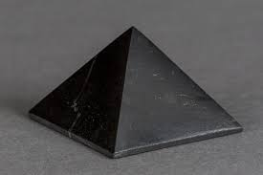

Spiritual Transformation

Assists in shadow work and self-discovery.

Shields the aura from psychic attack.

Connects to universal energies while keeping one rooted.

Practical Everyday Uses

Water Purification

Place Shungite stones in a glass pitcher of water.

Let sit for 6–12 hours before drinking.

Known to improve taste and remove impurities.

(Note: Only use raw, non-polished Shungite specifically sold for water purification.)

EMF Protection

Keep Shungite pyramids, spheres, or plates near electronics.

Wear Shungite jewellery (pendants or bracelets) to reduce exposure.

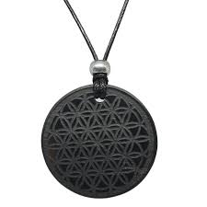

Meditation & Rituals

Hold Elite Shungite during meditation to deepen grounding.

Place near your root chakra to anchor your energy.

Jewellery & Home Décor

Shungite pendants, beads, and bracelets keep protective energy with you.

Shungite tiles and pyramids harmonize living spaces.

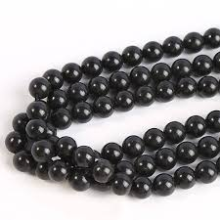

Caring for Your Shungite

Shungite requires gentle care:

Cleansing: Rinse with water and allow it to rest under moonlight.

Charging: Place in sunlight briefly (avoid long exposure to prevent cracks).

Maintenance: Polish with a soft cloth if tarnished.

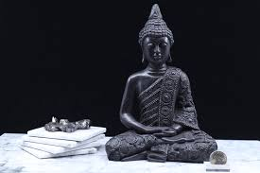

Affirmations for Shungite

Use affirmations while holding Shungite to strengthen its effects:

“I am grounded, safe, and shielded from negativity.”

“My body and mind are purified and renewed.”

“I am balanced, resilient, and connected to Earth’s energy.”

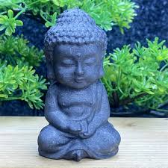

Shungite Crystal Grids & Combinations

Grid for Protection: Place Shungite at four corners of a room to create a protective shield.

Grid for Grounding: Combine with Hematite and Smoky Quartz.

Grid for Spiritual Growth: Pair with Amethyst and Selenite.

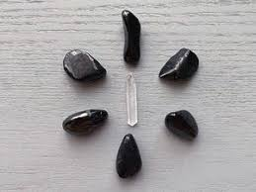

Myths, Legends & Misconceptions

Myth: Shungite is a meteorite.

Reality: It is a terrestrial mineral, though ancient and unique.

Myth: Shungite blocks all EMFs completely.

Reality: It reduces and absorbs some radiation, but not entirely.

Myth: Only Elite Shungite is powerful.

Reality: All forms carry strong protective energies, though Elite is the most concentrated.

Shungite in the Modern World

Shungite continues to intrigue both healers and scientists:

Used in water purification systems in Russia.

Studied for potential medical applications due to its antioxidant properties.

Popular worldwide as an energy protection tool in homes and workplaces.

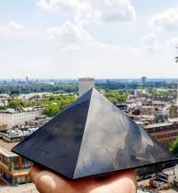

Conclusion: Living with Shungite

Shungite is not just another crystal — it is a guardian stone, a purifier, and a reminder of our connection to Earth’s ancient energies. Whether used for EMF protection, emotional balance, or spiritual growth, Shungite offers a unique blend of science and spirituality.

By welcoming Shungite into your daily practices, you invite grounding, protection, and transformation into your life — a powerful ally in navigating our modern, high-tech world.

