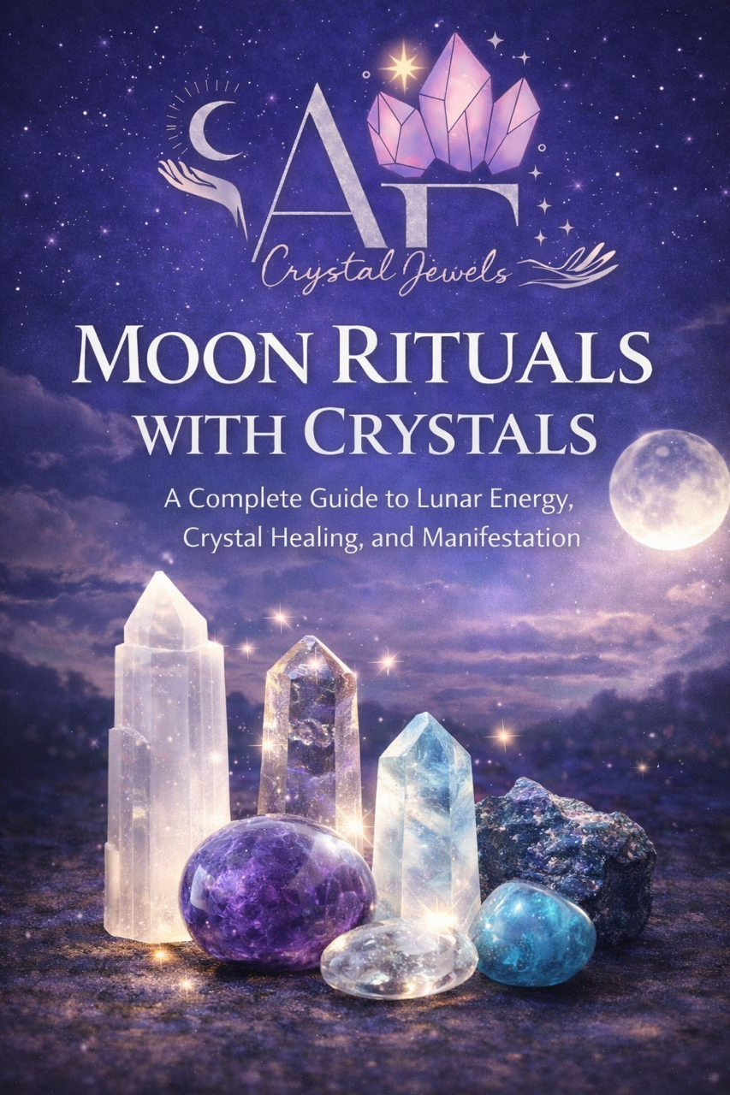
Moon Rituals with Crystals
A Complete Guide to Lunar Energy, Crystal Healing, and Manifestation

Introduction
For thousands of years, the Moon has been revered as a powerful spiritual force. Its luminous presence in the night sky influences the oceans, the tides, the cycles of nature, and even the subtle rhythms within our own bodies and emotions. In spiritual traditions across the world, the Moon represents intuition, transformation, feminine energy, and the cycles of life.
When combined with crystals—natural mineral formations that carry their own energetic vibrations—the Moon becomes an even more potent ally for healing, manifestation, and spiritual growth.
Crystals act as energetic amplifiers and conductors. They store intention, stabilize energy, and help align the mind, body, and spirit. When these stones are used in alignment with the lunar phases, their energy becomes synchronized with one of the most powerful natural cycles on Earth.

This book will guide you through:
- The spiritual meaning of lunar cycles
- The most powerful crystals for moon rituals
- Ritual practices for each moon phase
- Lunar crystal grids
- Moon charging and cleansing methods
- Manifestation rituals using crystal energy

Whether you are a beginner or experienced in spiritual practices, moon rituals with crystals can deepen your connection to nature and awaken profound inner transformation.

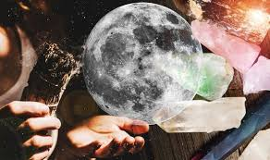

Chapter 1
Understanding Lunar Energy
The Moon moves through a continuous cycle that lasts approximately 29.5 days, known as the lunar cycle. Each phase carries a unique energetic quality that influences intention setting, emotional healing, manifestation, and spiritual reflection.
Working with these phases allows you to align your personal energy with the natural rhythm of the universe.

The Moon as an Energetic Mirror
Spiritually, the Moon reflects our inner world. While the Sun symbolizes outward action and vitality, the Moon governs:
- Intuition
- Emotional healing
- Psychic awareness
- Dreams and subconscious patterns
- Feminine energy
- Spiritual receptivity
When we consciously work with lunar cycles, we gain a powerful framework for personal transformation.

The Lunar Cycle Phases
The main lunar phases include:
- New Moon
- Waxing Crescent
- First Quarter
- Waxing Gibbous
- Full Moon
- Waning Gibbous
- Last Quarter
- Waning Crescent

Each phase represents a stage in the cycle of creation, growth, culmination, release, and renewal.
By combining crystals with these phases, we align our intentions with the Moon’s energetic flow.

Chapter 2
Why Crystals Amplify Moon Rituals
Crystals form deep within the Earth under pressure, heat, and geological transformation. Over thousands or millions of years, minerals crystallize into stable geometric structures that hold and transmit energy.
This crystalline structure allows stones to:
- Absorb energy
- Store intention
- Amplify spiritual focus
- Stabilize emotional vibrations
- Channel healing frequencies
When exposed to moonlight, crystals resonate with lunar frequencies, enhancing their metaphysical properties.
Crystals as Energy Anchors
During rituals, crystals help anchor your intention. They act as physical symbols of your spiritual goals.
For example:
- Amethyst enhances spiritual insight
- Rose Quartz supports emotional healing
- Clear Quartz amplifies manifestation
- Selenite connects with divine guidance
When placed under moonlight, crystals absorb lunar energy that can later be used during meditation, manifestation, or healing practices.

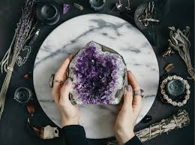

Chapter 3
Best Crystals for Moon Rituals
Certain crystals resonate particularly well with lunar energy.

Selenite
Selenite is one of the most powerful lunar stones. Named after the Greek moon goddess Selene, this crystal carries a pure, high vibration that promotes spiritual clarity and energetic cleansing.
Uses in moon rituals:
- Energy clearing
- Spiritual communication
- Intuition activation
- Crown chakra alignment

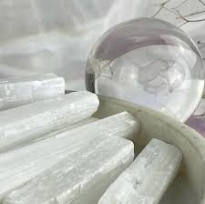

Moonstone
Moonstone is strongly connected to the divine feminine and lunar cycles. It enhances emotional balance and psychic awareness.
Uses include:
- Emotional healing
- Feminine empowerment
- Intuitive guidance
- Hormonal balance

Amethyst
Amethyst is a deeply spiritual crystal associated with higher consciousness.
Moon ritual benefits:
- Meditation support
- Psychic awareness
- Protection during spiritual work
- Dream enhancement

Clear Quartz
Known as the master healer, Clear Quartz amplifies all intentions and energy.
Moon ritual uses:
- Manifestation
- Energy amplification
- Charging other crystals
- Spiritual clarity

Labradorite
Labradorite enhances mystical awareness and transformation.
Benefits include:
- Psychic protection
- Awakening intuition
- Spiritual awakening
- Shadow work support
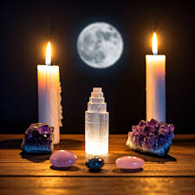

Chapter 4
Preparing for a Moon Ritual
Before performing a moon ritual, it is important to create a sacred environment.
Cleansing Your Space
Energetic cleansing prepares your environment for ritual work.
Methods include:
- Burning incense or sage
- Ringing bells or chimes
- Using sound bowls
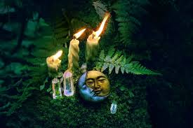
- Placing cleansing crystals like selenite

Setting Up a Moon Altar
A moon altar serves as the focal point for your ritual.
Your altar may include:
- Crystals
- Candles
- Moon imagery
- Flowers
- Sacred objects
- A journal for intentions
Place your altar near a window or outside where moonlight can reach your crystals.
Grounding Yourself
Before beginning the ritual:
- Sit quietly for several minutes.
- Take slow, deep breaths.
- Visualize roots extending from your body into the Earth.

Grounding stabilizes your energy and enhances the effectiveness of your intentions.

Chapter 5
New Moon Crystal Ritual
Setting Intentions

The New Moon represents new beginnings. It is the ideal time to plant energetic seeds for future manifestations.
Recommended Crystals
- Clear Quartz
- Moonstone
- Labradorite
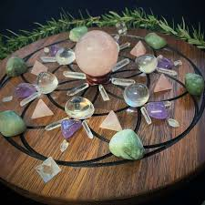
- Green Aventurine

New Moon Ritual Practice
- Light a white candle.
- Hold your chosen crystal in your hands.
- Close your eyes and focus on your intention.
- Write your intention in a journal.

Examples:
“I welcome abundance and opportunity.”
“My intuition guides me clearly.”
“I create peace and balance in my life.”
Place your crystal on your altar overnight to absorb New Moon energy.

Chapter 6

Waxing Moon Ritual
Growth and Momentum
The waxing moon symbolizes expansion, progress, and momentum.
During this phase, your intentions begin to grow.
Recommended Crystals
- Citrine
- Carnelian
- Pyrite
- Green Aventurine

Ritual for Growth
- Place crystals in a circle.
- Sit within the circle.
- Visualize your goals already achieved.

Repeat affirmations such as:
“I move confidently toward my goals.”
This phase strengthens motivation and confidence.

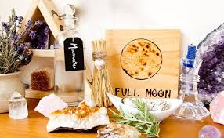

Chapter 7

Full Moon Crystal Ritual
Amplification and Release
The Full Moon is the most powerful point of the lunar cycle. Energy peaks, making this the ideal time for manifestation and emotional release.
Recommended Crystals
- Amethyst
- Selenite
- Clear Quartz
- Labradorite

Full Moon Ritual
Place your crystals outside or by a window.
Write down what you wish to release.
Safely burn the paper in a fireproof dish.
Visualize emotional burdens dissolving.
Finish by meditating with your crystals under moonlight.

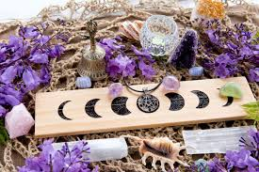

Chapter 8
Waning Moon Ritual
Letting Go and Healing
The waning moon supports cleansing, forgiveness, and inner healing.
Recommended Crystals
- Smoky Quartz
- Black Tourmaline
- Obsidian
- Lepidolite

Healing Ritual
Hold your crystal and repeat:
“I release what no longer serves me.”
Imagine negativity leaving your body and dissolving into the Earth.
This phase prepares you for the next cycle.

Chapter 9
Moon Charging Crystals
One of the simplest and most powerful practices is charging crystals under moonlight.
How to Charge Crystals
- Place crystals outside or on a windowsill.
- Leave them overnight during the Full Moon.
- Set an intention before placing them outside.
Moonlight gently cleanses and re-energizes crystals without overwhelming their energy.
Crystals That Love Moonlight
- Amethyst
- Moonstone
- Selenite
- Labradorite
- Clear Quartz
Avoid placing water-sensitive crystals outside if rain is expected.

Chapter 10
Lunar Crystal Grids
Crystal grids combine sacred geometry with crystal energy to amplify intentions.
Basic Moon Grid Layout
You will need:
- One central stone (Clear Quartz)
- Six surrounding crystals
- A sacred geometric pattern
Arrange the stones in a circular pattern symbolizing the lunar cycle. Activate the grid by tracing energy between the stones with a crystal point.

Grid Intentions
Common grid purposes include:
- Protection
- Abundance
- Emotional healing
- Intuition
Leave the grid active for one full lunar cycle.

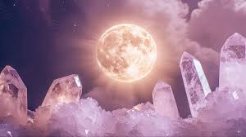

Chapter 11
Moon Meditation with Crystals
Moon meditation deepens your connection with lunar energy.
Simple Meditation Practice
- Sit under moonlight.
- Hold a crystal in your hands.
- Close your eyes and breathe slowly.
Imagine silver moonlight flowing into your crown chakra.
Feel the energy filling your body with calm and clarity.
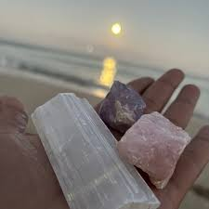
Meditate for 10–20 minutes.

Chapter 12
Creating a Monthly Moon Ritual Practice
Working with lunar cycles becomes most powerful when practiced consistently.
A simple monthly cycle may include:
- New Moon: Set intentions
- Waxing Moon: Take inspired action
- Full Moon: Release and celebrate
- Waning Moon: Reflect and heal
Over time, these rituals strengthen intuition and deepen spiritual awareness.

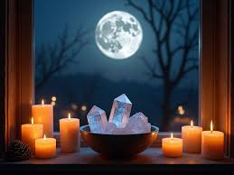

Conclusion
The Moon reminds us that life moves in cycles. Just as the Moon waxes and wanes, so do our emotions, ambitions, and spiritual journeys.
By combining moon rituals with crystals, we align ourselves with the rhythm of nature and the deeper currents of universal energy.
These practices invite us to slow down, reflect, release what no longer serves us, and consciously create the life we desire.
When you look up at the Moon, remember that you are witnessing the same celestial guide that has inspired humanity for millennia.
Let its light illuminate your path, your intentions, and your inner wisdom.

