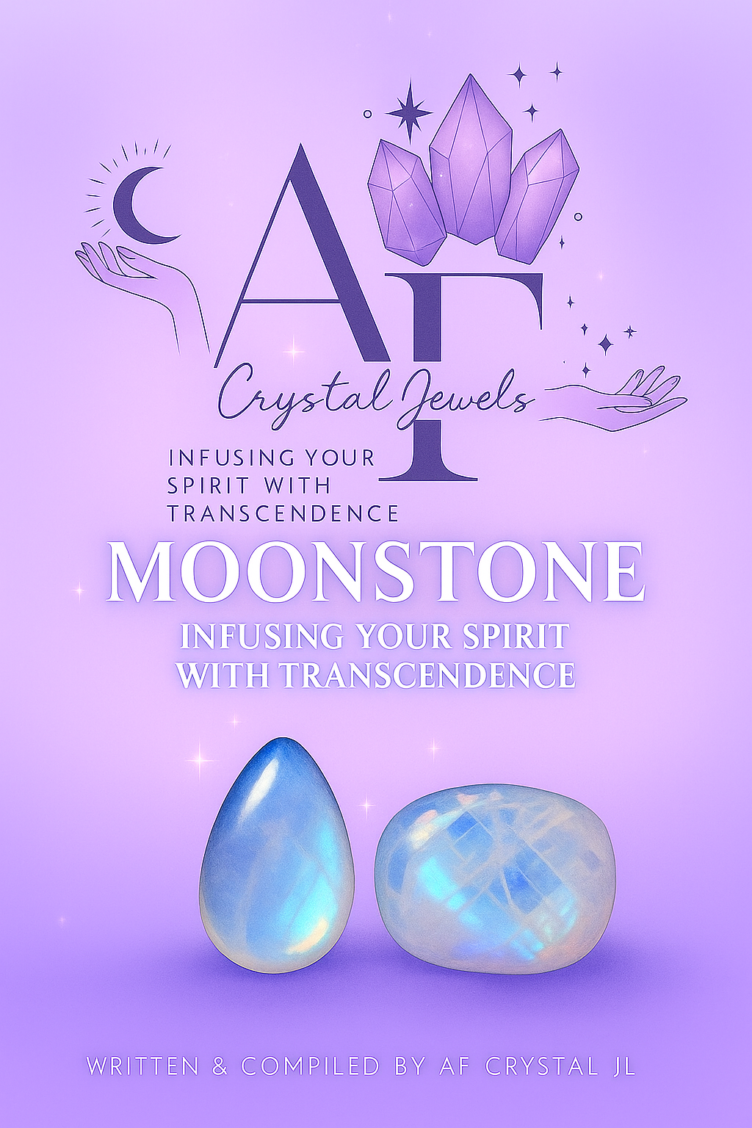
Moonstone: Infusing Your Spirit with Transcendence
Written & Compiled by AF Crystal Jewels

Table of Contents

- Introduction: The Light Within the Moon
- The Legend and History of Moonstone
- The Energetic Essence of Moonstone
- Types and Colours of Moonstone
- Healing Properties and Metaphysical Benefits
- Moonstone and the Chakras
- Working with Moonstone in Daily Practice
- Rituals and Moon Magic
- Crystal Pairings for Amplified Energy
- Caring for and Cleansing Your Moonstone
- Affirmations for Transcendence
- Final Reflections

1. Introduction: The Light Within the Moon
Moonstone embodies the divine feminine energy, reflecting the tranquil light of the moon and awakening intuition, empathy, and spiritual alignment. Its gentle luminescence guides one through emotional cycles and transitions, offering peace during transformation.
Moonstone is the stone of new beginnings, harmonizing the rhythms of life and reconnecting the spirit with the flow of divine timing. Its energy whispers, “Trust the process; you are guided.”

2. The Legend and History of Moonstone
Moonstone has captivated civilizations across millennia.
In ancient India, it was revered as a dream stone and a sacred symbol of divine wisdom.
Romans believed it formed from solidified moonlight, associating it with love and fortune.
In Eastern traditions, Moonstone was worn by travellers at night for protection and safe passage.
Legends say Moonstone’s glow waxes and wanes with the lunar cycle, mirroring our own spiritual ebb and flow.

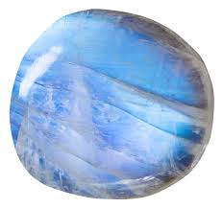

3. The Energetic Essence of Moonstone
Element: Water
Planetary Influence: Moon
Vibration: Calming, receptive, nurturing
Keywords: Intuition, emotional balance, divine feminine, new beginnings
Moonstone acts as a mirror to the soul—revealing hidden truths and nurturing emotional healing through self-reflection and acceptance.

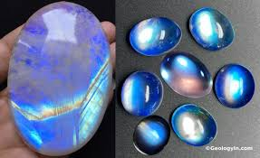

4. Types and Colours of Moonstone
Each variety carries its own energetic nuance:
Rainbow Moonstone: Enhances intuition, connects with higher realms, and shields from negativity.
White Moonstone: Promotes peace, clarity, and emotional healing.
Peach Moonstone: Supports the heart, encouraging self-love and compassion.
Gray Moonstone: Enhances psychic vision and ancestral connection.
Black Moonstone: Grounds lunar energy, aiding shadow work and emotional release.

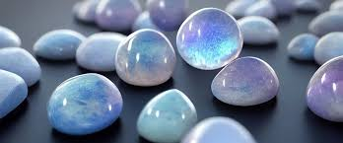

5. Healing Properties and Metaphysical Benefits
Emotional Healing:
Moonstone soothes emotional instability and stress. It fosters empathy, balances hormonal cycles, and encourages calm responses over reactive behaviour.
Spiritual Growth:
It heightens psychic awareness, dream recall, and intuition. It also strengthens connection to lunar cycles and divine guidance.
Physical Benefits:
Traditionally associated with reproductive health, Moonstone helps regulate menstrual cycles, fertility, and hormonal balance. It also supports restful sleep and hormonal harmony.
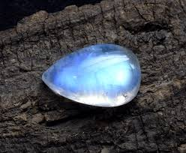

6. Moonstone and the Chakras

Chakra | Connection | Effect
Crown Chakra | Spiritual connection | Enhances intuition and divine communication
Third Eye Chakra | Inner vision | Strengthens psychic gifts and clarity
Heart Chakra | Emotional healing | Encourages empathy and unconditional love
Sacral Chakra | Creativity & fertility | Balances feminine energy and sensual expression

7. Working with Moonstone in Daily Practice

✨ Wear It: As a pendant or ring to maintain emotional calm and intuition throughout the day.
🕯 Meditate With It: Place on your third eye or heart chakra to heighten inner awareness.
💧 Moonlight Charging: Set under the full moon to recharge its energy and align with lunar cycles.
📔 Journaling: Use during new moons to set intentions or during full moons for emotional release.
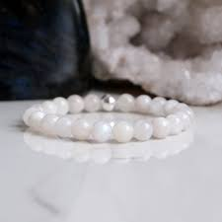

8. Rituals and Moon Magic
Full Moon Ritual for Clarity
Cleanse your Moonstone under running water.
Light a white candle and hold the stone over your heart.
Speak your intentions clearly: “I open my heart to divine guidance and release all that no longer serves me.”
Meditate under the moonlight for 10 minutes.
New Moon Manifestation Ritual
Write down your desires.
Place your Moonstone atop the list overnight.
Visualize the moonlight infusing your intentions with power.

9. Crystal Pairings for Amplified Energy
Labradorite: Enhances intuition and psychic protection.
Rose Quartz: Strengthens emotional healing and self-love.
Selenite: Purifies the aura and heightens divine connection.
Amethyst: Supports spiritual insight and tranquillity.

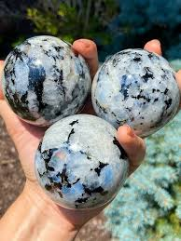

10. Caring for and Cleansing Your Moonstone
Moonstone is gentle and should be handled with care.
Avoid: Harsh sunlight or saltwater.
Best Cleansing: Moonlight, sound bowls, or selenite plates.
Recharging: Place under the light of the full moon or near flowing water.
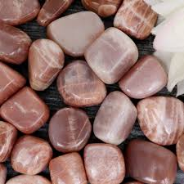

11. Affirmations for Transcendence
Repeat daily to align with Moonstone’s energy:
I trust the divine timing of my life.
I honour the cycles of change within and around me.
My intuition guides me toward peace and clarity.
I am in flow with the rhythms of the universe.
The light of the moon reflects my inner radiance.

12. Final Reflections
Moonstone teaches us to embrace the flow of life, to see beauty in cycles, and to trust our intuitive compass. As we surrender to its silvery glow, we open ourselves to transformation, rebirth, and transcendence.
Like the moon, you are ever-changing—yet always whole. 🌙

