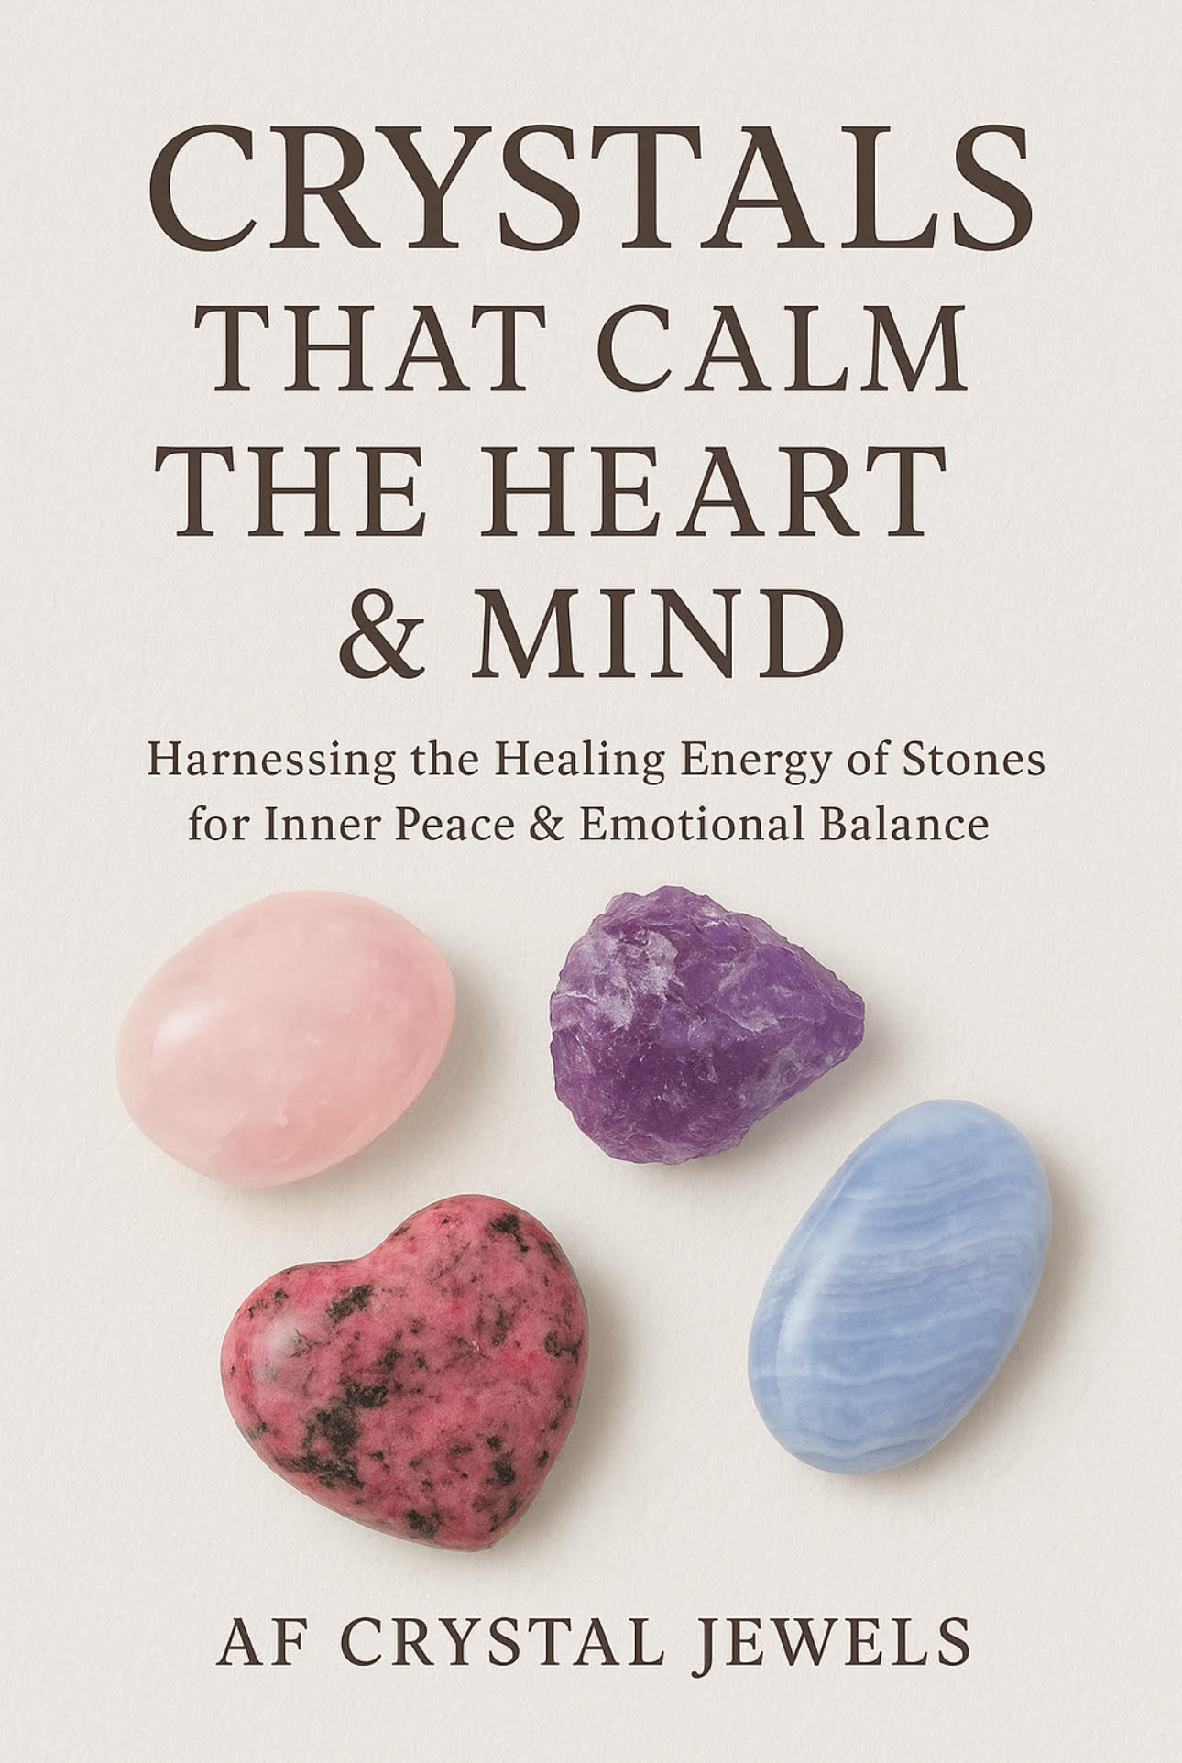

Table of Contents

Introduction: The Healing Power of Crystals

How Crystals Work with Heart & Mind Energies

Choosing & Cleansing Your Crystals

Crystals for Calming the Heart:

Rose Quartz

Rhodonite

Kunzite

Pink Amethyst

Crystals for Soothing the Mind:

Amethyst

Lepidolite

Blue Lace Agate

Sodalite

Crystals for Inner Peace & Emotional Release:

Amazonite

Chrysocolla

Moonstone

Crystal Combinations for Deep Calm

Rituals & Practices for Peace with Crystals

Daily Affirmations with Calming Stones

Conclusion: Embracing a Life of Serenity

Chapter 1: Introduction – The Healing Power of Crystals

Life can often feel overwhelming, with stress, anxiety, and emotional turbulence weighing heavily on the heart and mind. For centuries, crystals have been revered as allies for peace and balance. Their gentle yet powerful vibrations align with our energy field, dissolving tension and inviting serenity.

This book is dedicated to crystals that soothe emotional storms, quiet racing thoughts, and help you reconnect with the stillness within.

Chapter 2: How Crystals Work with Heart & Mind Energies

Crystals interact with the body’s energy centres (chakras). For calming the heart and mind, the most important chakras are:

Heart Chakra (Anahata): Governs love, compassion, and emotional healing.

Throat Chakra (Vishuddha): Helps with expression and releasing bottled-up emotions.

Third Eye (Ajna) & Crown Chakra (Sahasrara): Govern clarity, peace of mind, and spiritual connection.

When these chakras are balanced with crystal energy, we experience emotional relief, reduced stress, and mental clarity.

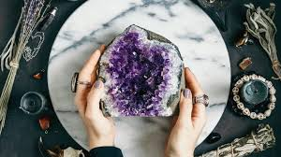

Chapter 3: Choosing & Cleansing Your Crystals

Choosing: Let intuition guide you. Hold a stone—if it feels warm, soothing, or draws you in, it may be meant for you.

Cleansing: Essential for keeping your crystals energetically pure. Methods include:

Smudging with sage or palo santo

Moonlight charging

Salt baths (for non-water-sensitive stones)

Sound healing with singing bowls

Chapter 4: Crystals for Calming the Heart

Rose Quartz – The Stone of Unconditional Love

Gentle pink hues radiate comfort and emotional healing.

Eases heartbreak, loneliness, and anxiety in relationships.

Promotes self-love and compassion.

Affirmation: “My heart is calm, open, and filled with love.”

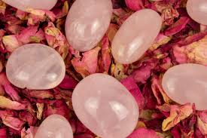

Rhodonite – The Emotional Balancer

Grounds emotional turmoil and promotes forgiveness.

Helps release resentment and encourages understanding.

Affirmation: “I forgive, I release, I embrace peace.”

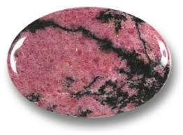

Kunzite – The Stone of Divine Love

Calms nervous energy and uplifts the spirit.

Ideal for overthinking and emotional overstimulation.

Affirmation: “I allow calmness and joy to flow through me.”

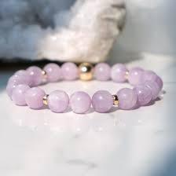

Pink Amethyst – The Gentle Soother

Provides tranquillity and spiritual comfort.

Wonderful for healing emotional wounds and reducing anxiety.

Affirmation: “I rest in the gentle embrace of peace.”

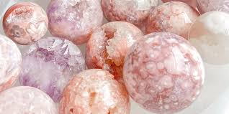

Chapter 5: Crystals for Soothing the Mind

Amethyst – The Stone of Tranquillity

Reduces stress and insomnia.

Brings clarity and spiritual calmness.

Affirmation: “My mind is clear, calm, and at ease.”

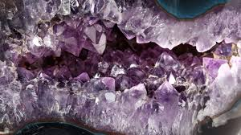

Lepidolite – The Stress Reliever

Contains lithium, often used to ease anxiety.

Helps regulate mood swings and promotes restful sleep.

Affirmation: “I release worry and embrace serenity.”

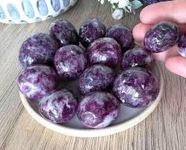

Blue Lace Agate – The Stone of Communication Peace

Calms nervous thoughts and racing speech.

Encourages gentle self-expression.

Affirmation: “I speak and think with peace and clarity.”

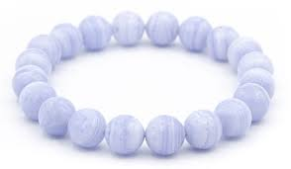

Sodalite – The Mind Harmonizer

Reduces mental confusion and overthinking.

Encourages rational thought balanced with intuition.

Affirmation: “My thoughts are balanced and harmonious.”

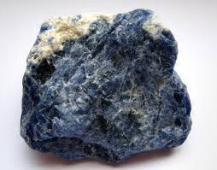

Chapter 6: Crystals for Inner Peace & Emotional Release

Amazonite – The Soother of the Soul

Dissolves stress and emotional blockages.

Helps release fear and worry.

Affirmation: “I am calm, balanced, and free.”

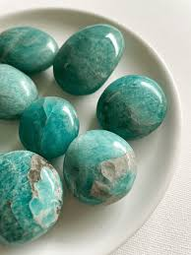

Chrysocolla – The Goddess Stone

Nurtures emotional healing, especially after grief or trauma.

Soothes heartbreak and restores emotional strength.

Affirmation: “I am supported, healed, and at peace.”

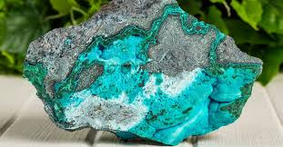

Moonstone – The Stone of Inner Calm

Connects with the divine feminine and emotional cycles.

Reduces emotional reactivity and enhances intuition.

Affirmation: “I flow with life’s rhythms in peace.”

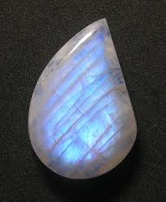

Chapter 7: Crystal Combinations for Deep Calm

Rose Quartz + Amethyst: Comforts the heart and clears the mind.

Lepidolite + Blue Lace Agate: Ideal for stress relief and peaceful communication.

Kunzite + Moonstone: Nurtures emotional stability and inner peace.

Amazonite + Sodalite: Helps release fear and overthinking.

Chapter 8: Rituals & Practices for Peace with Crystals

Meditation with Crystals: Hold a stone over your heart or third eye during deep breathing.

Crystal Bath Ritual: Add Amethyst, Rose Quartz, or Lepidolite near your bath (non-water-sensitive stones only).

Sleep Aid Ritual: Place Amethyst or Lepidolite under your pillow for restful sleep.

Affirmation Practice: Hold your chosen crystal while repeating affirmations daily.

Wearable Calm: Keep a crystal pendant or bracelet for constant support.

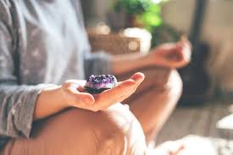

Chapter 9: Daily Affirmations with Calming Stones

“I release all tension and welcome serenity.” (Amethyst)

“I am safe, loved, and at peace.” (Rose Quartz)

“My heart and mind are balanced.” (Sodalite)

“I flow through life with calm ease.” (Moonstone)

“I forgive, release, and restore peace within.” (Rhodonite)

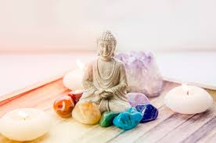

Chapter 10: Conclusion – Embracing a Life of Serenity

Crystals are more than beautiful treasures of the Earth; they are companions on our journey toward peace. By working with calming stones, we give ourselves permission to slow down, release emotional burdens, and reconnect with our inner stillness.

Carry them, meditate with them, or simply keep them close—their gentle vibrations will continuously remind you of the serenity already within.

