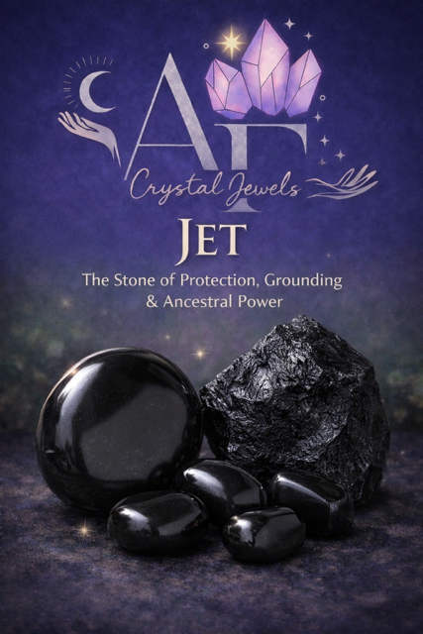
JET
The Stone of Protection, Grounding & Ancestral Power

Copyright & Disclaimer
© AF Crystal Jewels. All rights reserved. No part of this publication may be reproduced, distributed, or transmitted in any form without prior written permission, except for brief quotations for review purposes.
This book is for educational and spiritual purposes only. Crystal healing is a complementary practice and should not replace professional medical, psychological, or legal advice.

Table of Contents
Introduction to Jet
What Is Jet? (Geology & Formation)
The History & Ancient Use of Jet
Cultural & Spiritual Significance
Energetic Properties of Jet
Jet and Emotional Healing
Jet for Protection & Psychic Shielding
Jet and Grief, Loss & Ancestral Healing
Chakra Associations
Jet in Spiritual Practice
How to Use Jet Daily
Jet in Rituals & Spell work
Jet Jewellery & Wearing Guidelines
Cleansing, Charging & Care
Identifying Real Jet vs Imitations
Who Should Work With Jet
Jet Pairings & Crystal Combinations
Meditations with Jet
Affirmations for Jet
Final Reflections

1. Introduction to Jet
Jet is a powerful, ancient stone formed from fossilised wood, carrying the deep wisdom of the Earth and the ancestral realms. Known primarily for its protective, grounding, and grief-soothing qualities, Jet has been used for thousands of years as a talisman against negativity, psychic attack, and emotional overwhelm.
Unlike most crystals, Jet is organic in origin, giving it a unique energetic signature—soft yet profoundly absorbing. It does not amplify energy like quartz; instead, it draws in, neutralises, and stabilises.

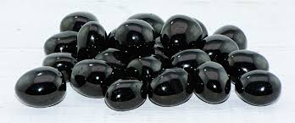

2. What Is Jet? (Geology & Formation)
Jet is a type of lignite, a precursor to coal, formed when ancient trees were buried under sediment and exposed to intense pressure over millions of years.
Key characteristics:
- Colour: Deep black to brown-black
- Texture: Lightweight, warm to the touch
- Composition: Fossilised wood (carbon-rich)
- Hardness: 2.5–4 on the Mohs scale
Jet is technically a mineraloid, not a true mineral, due to its organic origin.

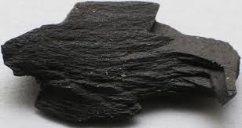

3. The History & Ancient Use of Jet
Jet has been revered since prehistoric times.
Neolithic Europe: Used for amulets and carvings
Ancient Rome: Believed to ward off evil spirits and illness
Victorian England: Widely used in mourning jewellery
Celtic traditions: Associated with protection and the spirit world
Whitby Jet, from England, remains the most famous and historically prized source.

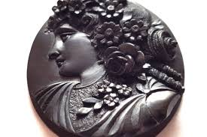

4. Cultural & Spiritual Significance
Jet has long been associated with:
- Death and rebirth
- Ancestral wisdom
- Spiritual protection
- Psychic boundaries
Rather than symbolising darkness in a negative sense, Jet represents the sacred void—the womb of transformation and deep inner strength.

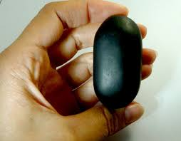

5. Energetic Properties of Jet
Jet’s energy is:
- Absorptive rather than amplifying
- Grounding and stabilising
- Protective and insulating

It is especially valued for:
- Absorbing negative energy
- Neutralising emotional shock
- Creating energetic boundaries

Jet acts like an energetic sponge—drawing in what no longer serves and anchoring the wearer back into the body.
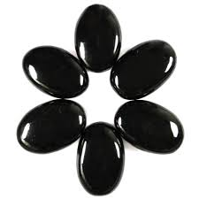

6. Jet and Emotional Healing
Jet is one of the most effective stones for:
- Grief and bereavement
- Emotional trauma
- Chronic stress and anxiety
- Emotional exhaustion

It provides containment, allowing emotions to be processed gently rather than overwhelming the nervous system.

7. Jet for Protection & Psychic Shielding
Jet is a traditional stone of psychic defence.
It helps to:
- Block energetic intrusion
- Absorb hostile intentions
- Reduce empathic overload
- Strengthen personal boundaries

This makes Jet ideal for:
- Healers
- Therapists
- Empaths
- Highly sensitive individuals
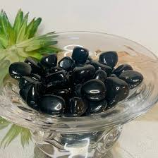

8. Jet and Grief, Loss & Ancestral Healing
Historically used in mourning, Jet supports:
- Processing loss
- Honouring ancestors
- Releasing inherited emotional patterns

Jet is especially powerful in ancestral or lineage work, helping to surface and dissolve deeply rooted emotional imprints.

9. Chakra Associations
Jet is primarily associated with:
Root Chakra – grounding, safety, survival
Earth Star Chakra – ancestral connection and karmic release
It anchors spiritual energy into the physical body, preventing dissociation or spiritual burnout.
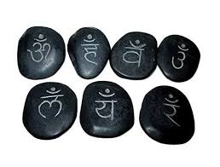

10. Jet in Spiritual Practice
Jet is best used when stability is needed.
It supports:
- Shadow work
- Trauma-informed spiritual practice
- Protection during divination
- Safe exploration of past-life or ancestral themes

Jet is not about ascension, it is about embodiment.


11. How to Use Jet Daily
Practical uses include:
- Carrying a tumbled stone for grounding
- Wearing Jet jewellery during emotionally demanding days
- Keeping Jet near the bed for emotional safety
- Holding during difficult conversations or transitions

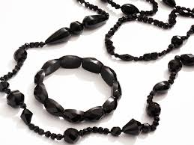

12. Jet in Rituals & Spell Work
Jet is commonly used in rituals focused on:
- Protection
- Banishing negativity
- Grief release
- Cutting energetic cords
Because of its absorptive nature, Jet should always be cleansed after ritual work.

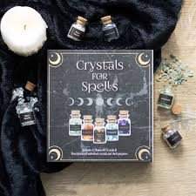

13. Jet Jewellery & Wearing Guidelines
Jet is traditionally worn as:
- Necklaces (heart-level protection)
- Bracelets (energetic boundary)
- Rings (intentional grounding)

Due to its softness, Jet jewellery should be handled with care and removed during physical activity.
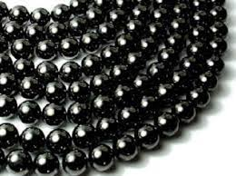

14. Cleansing, Charging & Care
Recommended cleansing methods:
- Smoke (sage, palo santo, incense)
- Sound (singing bowls, bells)
- Earth placement (short periods only)

Avoid:
- Water soaking
- Salt burial
- Prolonged sunlight

Jet does not require frequent charging; rest and intention are sufficient.

15. Identifying Real Jet vs Imitations
Authentic Jet:
- Feels warm to the touch
- Is lightweight
- Can be gently scratched with a copper coin

Common imitations include black glass and plastic-based substitutes.

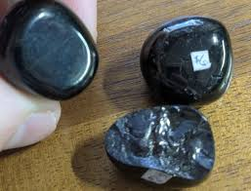

16. Who Should Work With Jet
Jet is ideal for:
- Empaths and sensitives
- Those processing grief or trauma
- People doing ancestral or shadow work
- Anyone needing emotional containment
It may feel heavy for those seeking high-vibration or expansive energy.

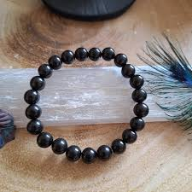

17. Jet Pairings & Crystal Combinations
Effective pairings include:
- Jet + Black Tourmaline (deep protection)
- Jet + Smoky Quartz (grounded release)
- Jet + Obsidian (shadow integration)
- Jet + Moonstone (emotional balance during grief)

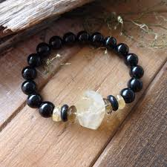

18. Meditations with Jet
Grounding Meditation:
Hold Jet at the root chakra. Visualise excess emotional energy draining into the Earth, leaving you calm, supported, and present.

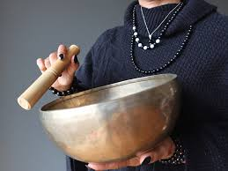

19. Affirmations for Jet
I am grounded, protected, and safe.
I release what no longer serves me.
I honour my past while standing firmly in the present.
My energy is my own.

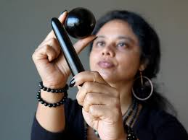

20. Final Reflections
Jet is not a flashy stone, but it is a profoundly necessary one. It teaches resilience, containment, and emotional sovereignty. In times of grief, overwhelm, or energetic vulnerability, Jet offers quiet strength and unwavering support.
It reminds us that true power is not always loud, sometimes it is steady, dark, and deeply rooted.

