**Goddesses & Crystals**

**Divine Feminine Energy for Healing and Empowerment**

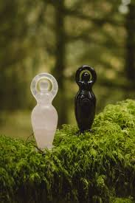

**By AF Crystal Jewels**

Table of Contents

1. Introduction
2. Working with Goddess Energy
3. How Crystals Amplify Divine Feminine Energy
4. Ritual Guide: Calling in the Goddess
5. 15 Goddesses and Their Crystal Allies
6. Crystal-Goddess Pairing Rituals
7. Daily Devotional Practices
8. Crystal Grids for Goddess Work
9. Creating Your Own Goddess Altar
10. Conclusion

Chapter 1: Introduction

Throughout history, the Divine Feminine has manifested in many forms—through ancient goddesses, sacred rituals, nature worship, and feminine archetypes. Whether you seek love, healing, courage, abundance, or spiritual connection, goddesses serve as guides and protectors. When paired with crystals, their power becomes magnified, offering a tangible way to connect with the unseen.

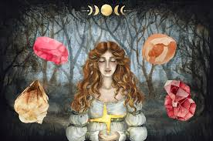

Chapter 2: Working with Goddess Energy

Each goddess carries a unique vibration and archetype—Maiden, Mother, Warrior, Queen, or Crone. Working with goddess energy can help you embody specific qualities, clear energetic blocks, and step into your power. You don’t need to belong to a particular religion to work with goddesses. All you need is intention and respect.

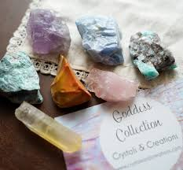

Chapter 3: How Crystals Amplify Divine Feminine Energy

Crystals are earth’s memory holders and energetic tools. When paired with goddess work, they help:

Anchor intention

Raise your vibration

Deepen meditation and visualization

Provide energetic support during transformation

Each goddess is linked to crystals that resonate with her frequency. Choosing the right combination can enhance your spiritual journey.

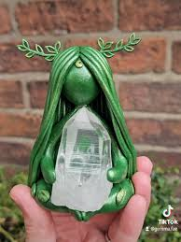

Chapter 4: Ritual Guide — Calling in the Goddess

What You’ll Need:

A candle (white, gold, or a colour matching the goddess)

A corresponding crystal

An offering (flowers, incense, herbs)

A quiet space

Steps:

Cleanse your space and your crystal.

Light the candle and set your intention.

Hold the crystal in your hand and say:

“I call upon the energy of [Goddess Name], divine presence of [virtue]. May your wisdom and love guide me.”

Sit in meditation, journal, or perform a devotional act.

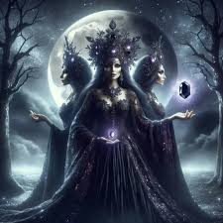

Chapter 5: 15 Goddesses and Their Crystal Allies

1. Aphrodite – Goddess of Love

Crystal: Rose Quartz

Attributes: Beauty, sensuality, attraction, self-love

Affirmation: “I am radiant and worthy of deep, soulful love.”

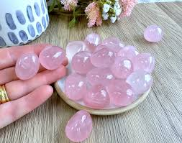

2. Athena – Goddess of Wisdom & Strategy

Crystal: Lapis Lazuli

Attributes: Intellect, justice, courage

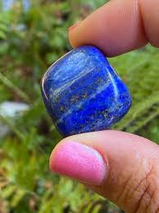Affirmation: “I act with clarity and insight.”

3. Isis – Egyptian Goddess of Magic & Motherhood

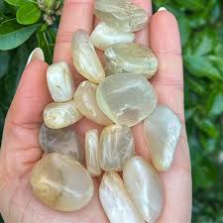Crystal: Moonstone

Attributes: Divine feminine, fertility, healing

Affirmation: “I trust in the mystery of the sacred.”

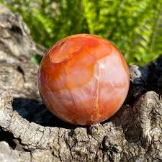4. Freya – Norse Goddess of Passion & War

Crystal: Carnelian

Attributes: Confidence, sexuality, strength

Affirmation: “I embrace my wild power with love.”

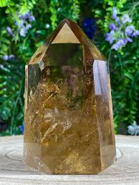

5. Lakshmi – Hindu Goddess of Abundance

Crystal: Citrine

Attributes: Prosperity, beauty, grace

Affirmation: “I welcome wealth and blessings into my life.”

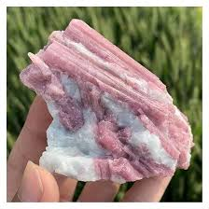6. Kuan Yin – Goddess of Compassion

Crystal: Pink Tourmaline

Attributes: Mercy, forgiveness, divine love

Affirmation: “Compassion flows from me freely.”

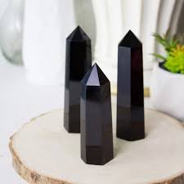7. Hecate – Goddess of the Crossroads & Magic

Crystal: Black Obsidian

Attributes: Shadow work, protection, transformation

Affirmation: “I trust my path and my inner power.”

8. Brigid – Celtic Goddess of Healing & Creativity

Crystal: Sunstone

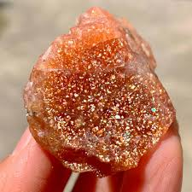Attributes: Poetry, rebirth, inspiration

Affirmation: “I am a divine channel of healing light.”

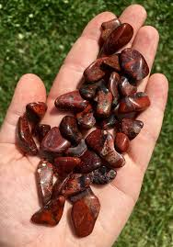9. Durga – Warrior Goddess of Strength

Crystal: Red Jasper

Attributes: Protection, determination, courage

Affirmation: “I rise with unstoppable power.”

10. Gaia – Earth Mother

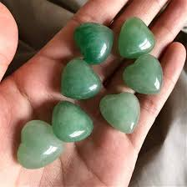Crystal: Green Aventurine

Attributes: Nature, nurturing, grounding

Affirmation: “I am one with the rhythms of the Earth.”

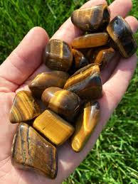11. Sekhmet – Lioness Goddess of Fire & Healing

Crystal: Tiger’s Eye

Attributes: Destruction of negativity, transformation

Affirmation: “I burn away fear and rise anew.”

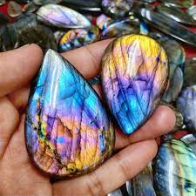

12. Artemis – Goddess of the Moon & Wilderness

Crystal: Labradorite

Attributes: Intuition, independence, protection

Affirmation: “I walk the path of freedom and truth.”

13. Persephone – Queen of the Underworld

Crystal: Garnet

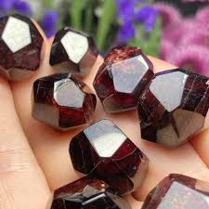Attributes: Rebirth, inner strength, duality

Affirmation: “From darkness I emerge empowered.”

14. Inanna – Sumerian Goddess of Rebirth

Crystal: Smoky Quartz

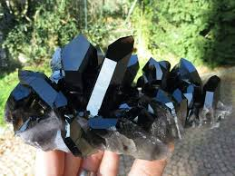Attributes: Shadow integration, sovereignty

Affirmation: “I rise from the depths with power and grace.”

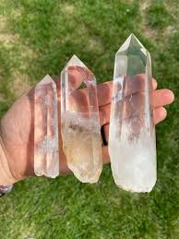15. Saraswati – Goddess of Knowledge & the Arts

Crystal: Clear Quartz

Attributes: Wisdom, music, eloquence

Affirmation: “I express my truth with divine clarity.”

Chapter 6: Crystal-Goddess Pairing Rituals

Moon Bath with Isis & Moonstone

Float Moonstone in your bath, light a silver candle, and recite affirmations about inner nurturing.

New Moon Wealth Ritual with Lakshmi & Citrine

Place Citrine on your altar with coins and basil. Speak intentions for wealth and visualize golden light.

Shadow Work with Hecate & Obsidian

Meditate with Obsidian at night, ask Hecate to reveal your hidden blocks, and journal what arises.

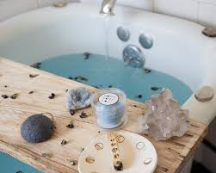

Chapter 7: Daily Devotional Practices

Morning Affirmations with a selected goddess and crystal

Wearing a goddess-aligned crystal as jewellery

Lighting a candle and offering flowers during sunrise

Keeping a goddess card or symbol on your altar or desk



Chapter 8: Crystal Grids for Goddess Work

Love Grid (Aphrodite): Rose Quartz, Rhodonite, Clear Quartz

Wisdom Grid (Athena): Lapis Lazuli, Fluorite, Sodalite

Protection Grid (Durga): Red Jasper, Obsidian, Hematite

Abundance Grid (Lakshmi): Citrine, Green Aventurine, Pyrite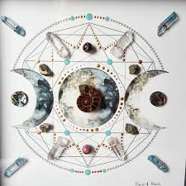.

Layout: Flower of Life or triangle shape around the central stone.

Chapter 9: Creating Your Own Goddess Altar

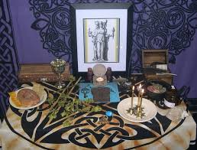Include:

A statue or image of the goddess

Crystals that align with her energy

Candles in corresponding colours

Offerings like herbs, feathers, or symbolic items

A written intention or prayer

Chapter 10: Conclusion

Goddesses and crystals together form a powerful bridge to your inner divinity. They help you access timeless wisdom, heal emotional wounds, and step into your fullest self. Whether you are in a season of creation, shedding, or renewal, trust that the goddess and her crystal allies are always by your side.

