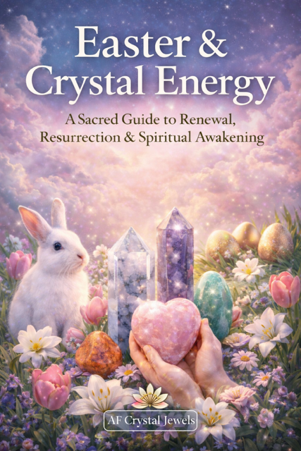
Easter & Crystal Energy
A Sacred Guide to Renewal, Resurrection & Spiritual Awakening

🌿 Introduction: The Sacred Energy of Easter
Easter, rooted in the celebration of resurrection and renewal, is far more than a seasonal holiday. Spiritually, it represents rebirth, transformation, and the awakening of divine light within.
Aligned with spring’s energy, Easter mirrors nature’s cycle—death dissolves into life, darkness into light, and stillness into growth. This is a powerful energetic gateway for:
- Letting go of old patterns
- Awakening spiritual gifts
- Manifesting new beginnings
- Reconnecting with divine purpose

Crystals, as Earth’s natural energy holders, amplify this transformation. When paired with Easter’s frequency, they become tools for deep healing, intention-setting, and spiritual rebirth.

🌸 Chapter 1: The Spiritual Meaning of Easter
Easter’s essence is resurrection consciousness—the ability to rise from limitation into expansion.
Key Spiritual Themes:
Rebirth: Shedding old identities
Renewal: Emotional and energetic cleansing
Light Activation: Awakening higher awareness
Faith & Trust: Surrendering to divine timing
From a metaphysical perspective, Easter aligns strongly with:
The Heart Chakra (Anahata) – compassion and love
The Solar Plexus Chakra – personal power and rebirth
The Crown Chakra – divine connection

💎 Chapter 2: Crystals for Easter Energy
Below are powerful crystals aligned with Easter’s vibration:

✨ Clear Quartz – The Master Amplifier
Enhances clarity and spiritual awakening
Amplifies intentions during rituals
Clears stagnant energy
Affirmation:
“I am clear, aligned, and open to divine renewal.”

🌿 Green Aventurine – Growth & Renewal
Symbolises spring and new beginnings
Supports emotional healing
Attracts abundance and opportunity
Affirmation:
“I welcome growth, prosperity, and fresh energy into my life.”

💗 Rose Quartz – Love & Compassion
Opens the heart chakra
Encourages forgiveness and self-love
Heals emotional wounds
Affirmation:
“I embody love, compassion, and gentle healing.”

🔥 Carnelian – Rebirth & Motivation
Ignites passion and courage
Supports transformation and action
Activates life force energy
Affirmation:
“I rise with strength, purpose, and renewed energy.”

🌙 Amethyst – Spiritual Awakening
Deepens intuition and connection to higher realms
Supports meditation and inner peace
Assists in releasing old patterns
Affirmation:
“I trust my intuition and embrace spiritual evolution.”

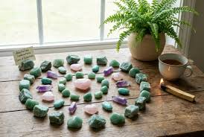

🕊️ Chapter 3: Easter Crystal Rituals

🌅 Ritual 1: Sunrise Renewal Ceremony
Purpose: Align with rebirth energy at dawn
You will need:
Clear Quartz
Green Aventurine
A candle
Steps:
Wake before sunrise
Hold your crystals and set an intention
As the sun rises, visualise light filling your body
Speak your intention aloud

🌸 Ritual 2: Letting Go & Rebirth Release
Purpose: Release old energy
You will need:
Amethyst
Paper & pen
Steps:
Write down what you are releasing
Hold Amethyst and reflect
Burn or tear the paper
Say: “I release and renew.”
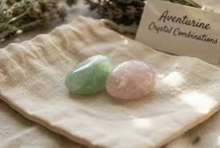

💗 Ritual 3: Heart Healing Easter Meditation
Purpose: Open the heart chakra
You will need:
Rose Quartz
Steps:
Place Rose Quartz over your heart
Breathe deeply
Visualise pink light expanding
Repeat loving affirmations

🐣 Chapter 4: The Symbolism of Easter & Crystal Pairings
🥚 Eggs – Creation & Potential
Crystal Pairing: Clear Quartz
Represents infinite possibility and manifestation
🐇 Rabbits – Fertility & Abundance
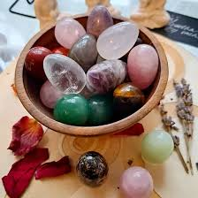
Crystal Pairing: Green Aventurine
Symbolises growth and expansion
🌸 Flowers – Renewal & Beauty
Crystal Pairing: Rose Quartz
Encourages emotional blossoming
🕯️ Light – Resurrection & Awakening
Crystal Pairing: Amethyst
Enhances spiritual illumination

🌼 Chapter 5: Creating an Easter Crystal Grid
A crystal grid amplifies intention through sacred geometry.

✨ Easter Renewal Grid Layout:

Centre Stone: Clear Quartz
Surrounding Stones:
Rose Quartz (love)
Green Aventurine (growth)
Carnelian (action)
Amethyst (spirit)

Activation Steps:
Cleanse your crystals
Set your intention
Arrange in a circular or flower pattern
Activate by connecting each stone energetically

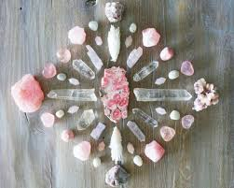

🌿 Chapter 6: Manifestation During Easter Energy
Easter is one of the most powerful times for manifestation due to its alignment with:

Seasonal rebirth
Increased solar energy
Collective spiritual focus

Manifestation Practice:
Write your desires as already achieved
Use Clear Quartz to amplify
Meditate daily for 7 days
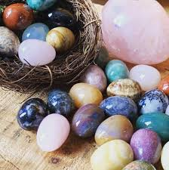

🌙 Chapter 7: Daily Easter Crystal Practices (7-Day Guide)
Day 1: Cleanse (Amethyst)
Day 2: Set Intentions (Clear Quartz)
Day 3: Open Heart (Rose Quartz)
Day 4: Take Action (Carnelian)
Day 5: Invite Abundance (Green Aventurine)
Day 6: Reflect & Align (Amethyst)
Day 7: Celebrate Renewal (All crystals)

✨ Chapter 8: Easter, Energy & the Soul
Spiritually, Easter reminds us:
You are always evolving
Darkness is temporary
Transformation is sacred
Your soul is designed to rise
Crystals act as companions on this journey, grounding you while elevating your energy.

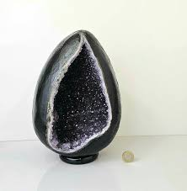

🌸 Conclusion: Your Personal Resurrection
Easter is not just a date, it is a state of being.
Each moment offers you the opportunity to:
Begin again
Heal deeper
Rise higher
With crystals as your allies, you can consciously step into your most empowered, aligned, and awakened self.

💫 Final Affirmation
“I embrace transformation, embody light, and rise into my highest self with love, clarity, and purpose.”

