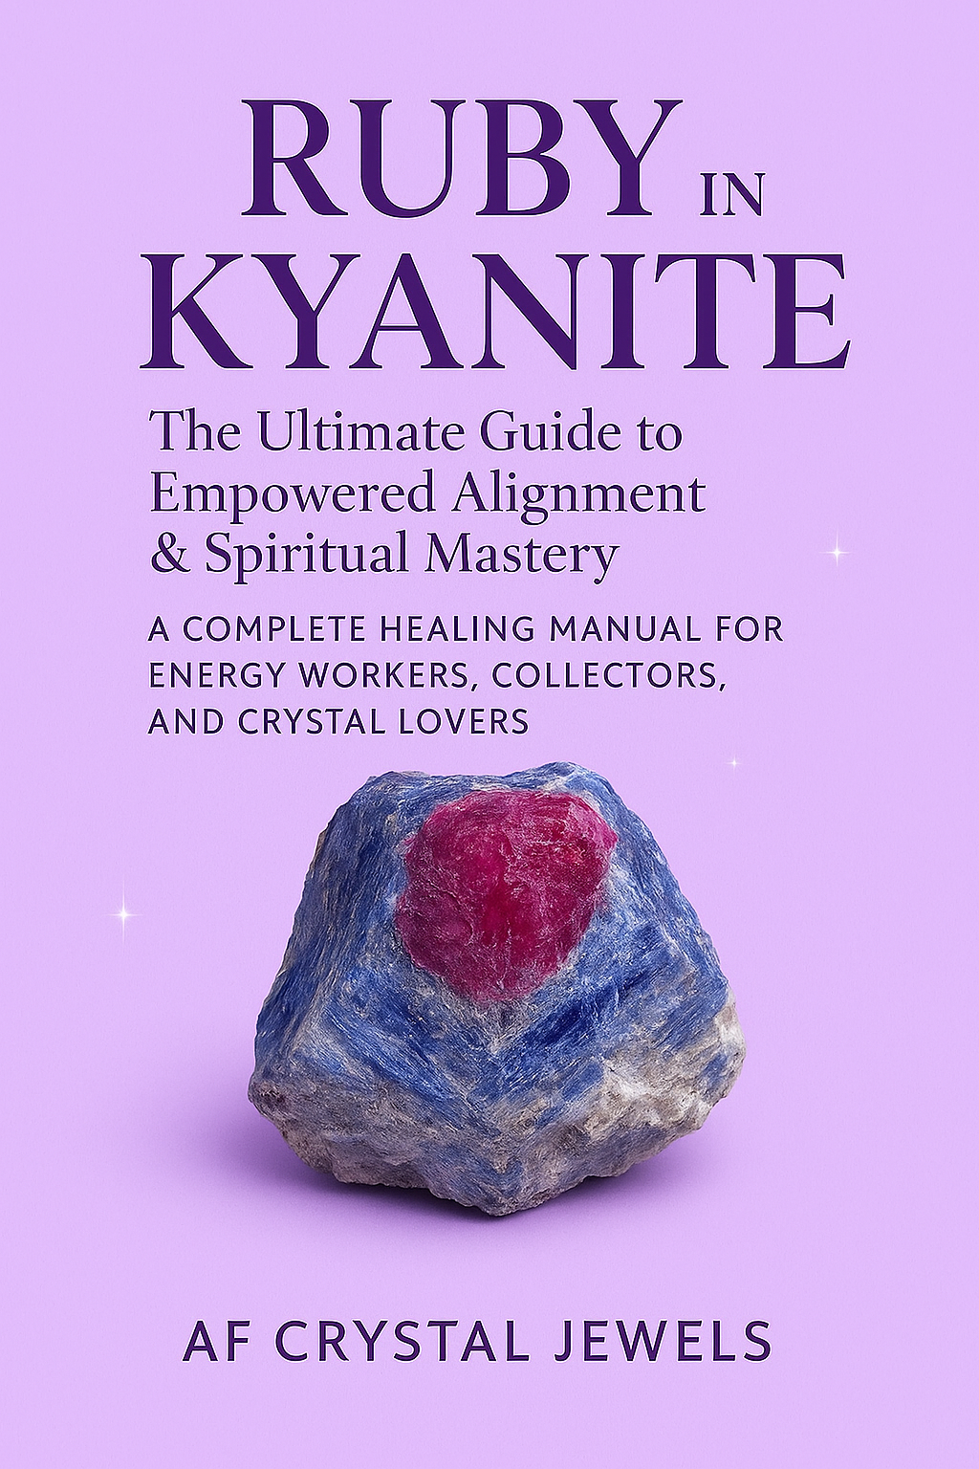
Ruby in Kyanite: The Ultimate Guide to Empowered Alignment & Spiritual Mastery
A Complete Healing Manual for Energy Workers, Collectors, and Crystal Lovers

Table of Contents

- Introduction
- What Is Ruby in Kyanite?
- The Geological Story
- Energetic Signature & Core Properties
- Ruby in Kyanite vs Ruby, Kyanite & Other Synergy Stones
- Spiritual Properties
- Emotional & Mental Healing Benefits
- Physical Healing Properties
- Chakra Correspondence & Energy Work Techniques
- How Ruby in Kyanite Supports Manifestation
- Meditations, Rituals & Grids
- Crystal Pairings & Combinations
- Daily Practices for Spiritual Growth
- Cleansing, Charging & Care
- How to Identify Genuine Ruby in Kyanite
- Home, Office & Bedroom Placement
- Affirmations for Ruby in Kyanite
- Conclusion

1. Introduction
Ruby in Kyanite is a powerhouse synergy stone—uniting the fierce, passionate energy of Ruby with the grounded, high-frequency alignment of Kyanite. It bridges confidence with clarity, strength with intuition, and ambition with higher wisdom. Whether you’re a healer, spiritual practitioner, or collector, this stone offers a transformative blend of fire and calm that reshapes how you approach your daily life, your spiritual path, and your soul’s purpose.
This eBook gives you a deep, professional level understanding of the stone’s metaphysics, healing modalities, and practical applications.
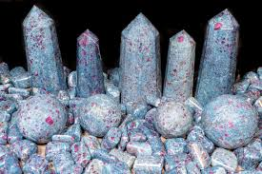

2. What Is Ruby in Kyanite?
Ruby in Kyanite is a naturally occurring combination mineral where deep red ruby crystals form within a matrix of blue kyanite. The stone is typically found in shades of:
Burgundy-to-crimson Ruby
Electric blue, indigo, or teal Kyanite
White or grey quartz inclusions
Black graphite veins (occasionally)
The contrast of fire-red over cool blue symbolizes balance, courage, divine order, and aligned power.

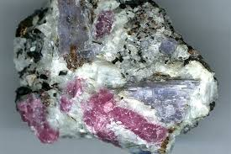

3. The Geological Story
Ruby (Corundum) forms under intense heat and pressure, while Kyanite crystallizes within metamorphic rocks at high pressure but comparatively low temperature. This unique dual-environment formation makes the pairing rare.
Key localities include:
India (primary source)
Nepal
Brazil
Madagascar
The stone’s complex formation reflects its energy: two polar forces harmonizing into one balanced, purposeful vibration.

4. Energetic Signature & Core Properties
Ruby in Kyanite blends:
Ruby Energy
Passion
Courage
Vitality
Manifestation
Self-worth
Kyanite Energy
Alignment
Clear communication
Spiritual attunement
Emotional stability
Higher guidance
Synergy Effect
The two minerals do not blend energetically; they run side-by-side, amplifying one another without interference. This creates:
Grounded passion
Aligned ambition
Intuitive leadership
Peaceful confidence
Protection with purpose
It is one of the few stones that naturally self-cleanses and stabilizes energy.

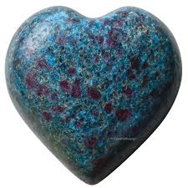

5. Ruby in Kyanite vs Other Stones
Versus Ruby Alone
Ruby gives fiery intensity—Ruby in Kyanite moderates this fire with stability, clarity & balance.
Versus Kyanite Alone
Kyanite clears blockages—Ruby adds drive, courage & manifestation power.
Versus Ruby Zoisite
Ruby Zoisite is softer and heart focused. Ruby in Kyanite is stronger, more grounding & more transformational.
Versus Auralite 23
Auralite is high-frequency and ethereal. Ruby in Kyanite is practical, action-oriented & empowering.

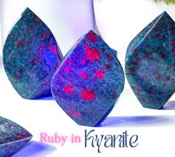

6. Spiritual Properties
Ruby in Kyanite is ideal for practitioners seeking:
Psychic protection
Aura strengthening
Multi-chakra alignment
Awakening life purpose
Activating intuition with confidence
Past-life recall
Soul-level energy clearing
Kyanite opens pathways to higher guidance while Ruby strengthens the will to follow that guidance.
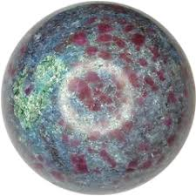

7. Emotional & Mental Healing Benefits
Ruby in Kyanite supports:
Emotional resilience
Self-confidence
Mental clarity
Boundary-setting
Reduction of anxiety
Release of guilt, shame, or self-doubt
Strength during stressful transitions
It helps you stop overthinking by grounding the mind while fuelling inspired action.

8. Physical Healing Properties
Traditionally associated with:
Circulation & blood support (Ruby)
Nervous system balance (Kyanite)
Hormonal harmony
Chronic fatigue relief
Strengthening motivation and vitality
Restoring depleted energy
This stone is not a substitute for medical care but complements holistic wellness.
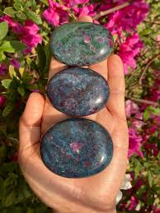

9. Chakra Correspondence & Energy Work Techniques
Ruby in Kyanite simultaneously works with:
Root Chakra – stability, courage
Sacral Chakra – passion, creativity
Heart Chakra – emotional strength
Throat Chakra – communication
Third Eye – intuition, insight

How It Aligns the System
Because Kyanite aligns all chakras without holding negative energy, and Ruby powers the lower centres, the result is a full-system energetic reset.

10. How Ruby in Kyanite Supports Manifestation
This stone teaches strategic manifestation—bringing goals into reality through:
Insight + action
Courage + planning
Intuition + discipline

It is highly effective for:
Career advancement
Entrepreneurial projects
Moving into soul-purpose work
Starting new paths
Building confidence
Breaking procrastination cycles

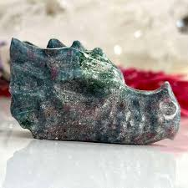

11. Meditations, Rituals & Grids
Meditation for Courage & Clarity
Hold the stone over your heart.
Breathe deeply.
Visualize blue light aligning the mind.
Visualize red flame empowering your spirit.
Feel merging into grounded determination.

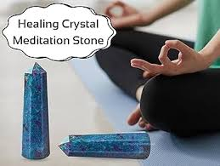

Protection Ritual
Place Ruby in Kyanite near your front door or on your altar to strengthen energetic boundaries and repel low-vibration influences.

Manifestation Grid
Combine:
Ruby in Kyanite (centre)
Pyrite (drive)
Clear Quartz (amplification)
Citrine (confidence)
Black Tourmaline (grounding)
This grid activates action-taking and consistent movement toward goals.

12. Crystal Pairings & Combinations

For Manifestation
Ruby in Kyanite + Pyrite
Ruby in Kyanite + Citrine

For Protection
Ruby in Kyanite + Black Tourmaline
Ruby in Kyanite + Obsidian

For Psychic Work
Ruby in Kyanite + Amethyst
Ruby in Kyanite + Labradorite

For Grounded Confidence
Ruby in Kyanite + Tiger’s Eye

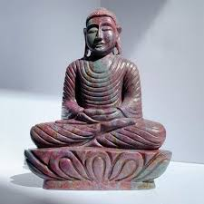

13. Daily Practices for Spiritual Growth
Carry a small stone for alignment throughout the day
Place it on your desk to encourage clarity and discipline
Use it during journaling sessions to reveal deeper truths
Hold it during decision-making
Sleep with it near the pillow for intuitive dreams

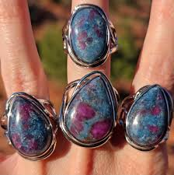

14. Cleansing, Charging & Care
Ruby in Kyanite is generally self-cleansing due to the Kyanite component, but light cleansing enhances its effectiveness.
Suitable Methods
Moonlight
Sound cleansing
Smoke cleansing
Selenite plate
Reiki energy
Avoid
Prolonged water exposure (kyanite can cleave)
Harsh sunlight (may fade)

15. How to Identify Genuine Ruby in Kyanite
Look for:
Natural ruby crystals with uneven edges
Distinct blue or indigo kyanite layers
Visible striations
Natural marbling or matrix, not painted surfaces
A cool, heavy feel
Avoid overly uniform or artificially bright pieces.
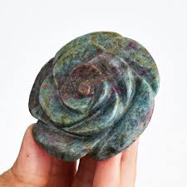

16. Home, Office & Bedroom Placement
Office
Promotes focus, productivity, and confident decision-making.
Bedroom
Supports restful sleep, intuitive messages, and emotional healing.
Front Entrance
Creates a strong energetic boundary for your home.
Altar or Meditation Area
Enhances spiritual alignment and ritual power.

17. Affirmations for Ruby in Kyanite
Use these during meditation or journaling:
“My confidence is grounded, clear, and aligned.”
“I act with purpose and intuition.”
“My energy is protected and empowered.”
“I am divinely supported as I step into my highest path.”
“I move forward with courage and clarity.”
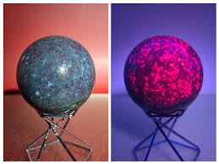

18. Conclusion
Ruby in Kyanite is a dynamic crystal that bridges strength with serenity, intuition with action, and passion with purpose. It guides you into aligned power—helping you become grounded, confident, spiritually attuned, and energetically protected.
Whether you use it for personal healing, manifestation, or spiritual development, this stone acts as a reliable companion on the journey to your highest potential.



