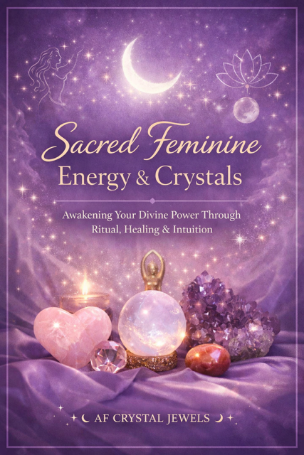
Sacred Feminine Energy & Crystals
Awakening Your Divine Power Through Ritual, Healing & Intuition

Table of Contents
Introduction: The Return to the Sacred Feminine
Understanding Feminine Energy
The Wounded vs Awakened Feminine
Crystals & Feminine Energy: How They Work Together
Core Crystals for Feminine Healing
Womb Healing & Creative Energy
Self-Love & Emotional Healing
Divine Feminine Archetypes & Crystal Pairings
Moon Cycles & Crystal Rituals
Sensuality, Magnetism & Feminine Power
Protection, Boundaries & Energetic Sovereignty
Daily Sacred Feminine Rituals
Creating Your Feminine Altar
Integration & Embodiment Practices
Closing: Becoming the Embodiment of Your Power

Chapter 1: The Return to the Sacred Feminine

There is a quiet awakening happening.
Women are remembering.
Not learning, remembering.
The Sacred Feminine is not something you need to become. It is something you return to. Beneath conditioning, expectations, and survival patterns lies your natural state: intuitive, magnetic, soft yet powerful, deeply connected.
Crystals act as energetic allies in this return. They stabilise, amplify, and mirror the frequencies already within you.
This book is your guide back to yourself.

Chapter 2: Understanding Feminine Energy

Feminine energy is not about gender—it is about essence.
It is:
- Flow over force
- Intuition over logic
- Being over doing
- Magnetism over chasing

When balanced, feminine energy feels:
- Calm, grounded, and open
- Emotionally expressive but not overwhelmed
- Receptive yet powerful

When blocked, it shows as:
- Over giving
- Burnout
- Emotional suppression
- Disconnection from intuition
- Crystals help regulate these imbalances by restoring energetic harmony.

Chapter 3: The Wounded vs Awakened Feminine

Wounded Feminine Patterns:
- Seeking validation externally
- Fear of vulnerability
- Overworking and control
- Suppressed emotions

Awakened Feminine Traits:
- Self-trust
- Emotional intelligence
- Magnetic presence
- Deep inner peace
Your healing journey is not about “fixing” yourself, it is about releasing what is not truly you.

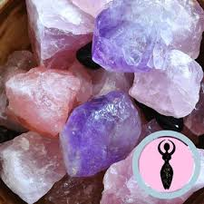

Chapter 4: Crystals & Feminine Energy
Crystals hold stable vibrational frequencies.
When you interact with them intentionally, they:
- Regulate emotional states
- Strengthen intuition
- Support energetic healing
- Anchor spiritual practices

Feminine energy responds deeply to:
- Touch
- Ritual
- Repetition
- Intention
This is why crystal rituals are so powerful.

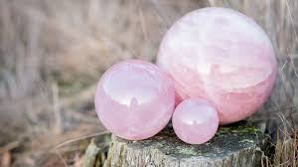
Chapter 5: Core Crystals for Feminine Healing

Rose Quartz
Unconditional love, emotional healing, softness

Moonstone
Intuition, cycles, feminine wisdom

Rhodonite
Heart healing, releasing past wounds
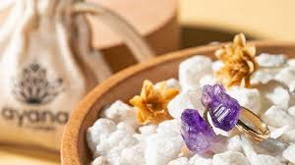
Carnelian
Womb energy, creativity, sensuality

Amethyst
Spiritual connection, emotional balance

Pink Opal
Gentle healing, emotional release

Practice:
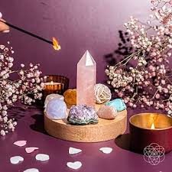
Hold one crystal daily and ask:
“What do I need to feel today?”
Listen.

Chapter 6: Womb Healing & Creative Energy

Your womb is not just physical, it is energetic.

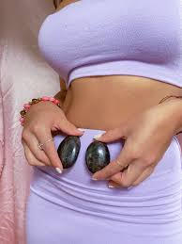
It stores:
- Creativity
- Emotional memory
- Feminine power

When blocked, you may feel:
- Disconnected
- Uninspired
- Emotionally heavy

Crystals for Womb Healing:
- Carnelian
- Moonstone
- Garnet

Simple Womb Ritual:
- Lie down comfortably
- Place crystal below the navel
- Breathe deeply
- Visualise warm, glowing light
Affirmation:
“I am safe to create, feel, and express.”
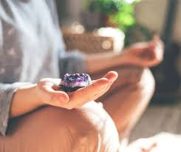

Chapter 7: Self-Love & Emotional Healing

Self-love is the foundation of feminine energy.
Without it, everything becomes external seeking.
Crystals for Self-Love:
- Rose Quartz
- Pink Opal
- Rhodochrosite

Mirror Ritual:
- Hold your crystal
- Look into your eyes
Say:
“I choose myself fully.”
This may feel uncomfortable, that means it’s working.

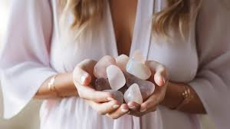

Chapter 8: Divine Feminine Archetypes & Crystal Pairings

The Goddess (Power & Leadership)
- Citrine
- Sunstone

The Lover (Sensuality & Desire)
- Rose Quartz
- Garnet

The Mystic (Intuition & Spirituality)
- Amethyst
- Labradorite

The Mother (Nurturing & Compassion)
- Moonstone
- Rhodonite

Work with the archetype you feel called to, or the one you resist most.

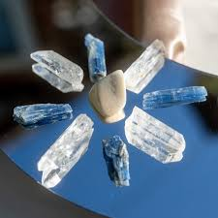

Chapter 9: Moon Cycles & Crystal Rituals

The moon mirrors feminine cycles.
New Moon (Manifestation)
Set intentions
Use: Moonstone, Clear Quartz

Full Moon (Release)
Let go of emotional weight
Use: Amethyst, Black Obsidian
Ritual Example:

Light a candle
Hold your crystal
Speak your intention aloud
Consistency is more powerful than perfection
Chapter 10: Sensuality, Magnetism & Feminine Power

Magnetism is not something you chase—it is something you allow.
Sensuality is presence in your body.
Crystals for Magnetism:
- Carnelian
- Garnet
- Sunstone
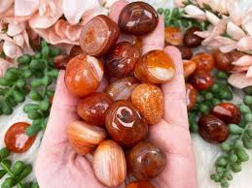
Practice:
Move your body slowly
Focus on sensation
Hold your crystal
Affirmation:
“I am magnetic without effort.”

Chapter 11: Protection & Boundaries

A strong feminine is not unprotected, it is sovereign.
Crystals for Protection:
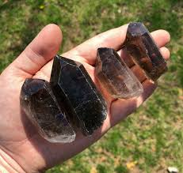
- Black Tourmaline
- Obsidian
- Smoky Quartz

Boundary Ritual:
Hold your crystal
Visualise a protective field
Say:
“I honour my energy. I choose what I allow.”

Chapter 12: Daily Sacred Feminine Rituals

Keep it simple and consistent.
Morning:
- Hold a crystal
- Set intention

Midday:
- Pause and breathe
- Reconnect with your body

Evening:
- Reflect
- Release emotions
Ritual is how you embody, not just understand.

Chapter 13: Creating Your Feminine Altar

Your altar is your energetic anchor.
Include:

- Crystals
- Candles
- Personal items
- Natural elements

This space should feel:
- Safe
- Soft
- Powerful
- Return to it daily.

Chapter 14: Integration & Embodiment

Knowledge is not transformation, embodiment is.
Ask yourself:
- Am I practicing or just reading?
- Am I feeling or avoiding?
- Choose one ritual and commit to it daily.
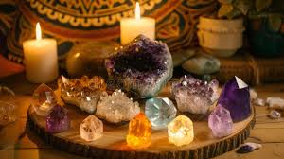
That is where change happens.

Chapter 15: Closing — Becoming the Embodiment

You are not becoming someone new.
You are shedding everything that is not aligned.
The Sacred Feminine is:
- In your intuition
- In your softness
- In your power
- In your truth
- Crystals are your tools. But you are the energy.

Affirmation Pages (Printable Section)
How to Use These Pages
Print and place on your altar or bedside
Read aloud daily (morning or evening)
Pair with your chosen crystal
Repeat each affirmation slowly, with intention

Self-Love & Worthiness Affirmations

Crystal Pairing: Rose Quartz / Pink Opal
Affirmations:
I am worthy of love exactly as I am
I choose myself fully and unapologetically
I release the need for external validation
I honour my emotions without judgment
I am safe to be seen, heard, and valued

Womb Healing & Creative Energy Affirmations

Crystal Pairing: Carnelian / Moonstone
Affirmations:
My body is a sacred vessel of creation
I trust my creative flow
I release stored pain and welcome healing
I am connected to my feminine power
I allow myself to feel deeply and freely

Feminine Magnetism & Confidence Affirmations

Crystal Pairing: Sunstone / Garnet
Affirmations:
I am naturally magnetic and radiant
I attract aligned energy effortlessly
I embody confidence with ease
My presence is powerful and felt
I trust myself completely
Protection & Boundaries Affirmations

Crystal Pairing: Black Tourmaline / Obsidian
Affirmations:
I am energetically protected at all times
I honour my boundaries with strength and clarity
I release what is not aligned with me
My energy is sacred and respected
I stand fully in my power

Intuition & Spiritual Connection Affirmations

Crystal Pairing: Amethyst / Moonstone
Affirmations:
I trust my intuition deeply
I am guided and supported
My inner voice is clear and strong
I am connected to higher wisdom
I honour my spiritual path

Printable Journal & Workbook Sections

Daily Sacred Feminine Check-In

(Print multiple copies)

Today’s Date: ___________

How do I feel emotionally?

What does my body need today?

What am I releasing?

What am I calling in?

Crystal I am working with:

Affirmation for today:

Weekly Reflection Page

This week, I felt most aligned when:

Challenges I experienced:

What triggered me and why:

How I supported myself:

What I am proud of:

Energy I am stepping into next week:

Moon Ritual Planner

New Moon Intentions

What am I calling into my life?

How do I want to feel?

Crystals I will use:

Full Moon Release

What am I ready to let go of?

What no longer serves me?

What lesson have I learned?

Crystal Ritual Planner

Ritual Name: ______________________

Intention:

Crystals Used:

Steps:

How I felt during the ritual:

Results / Insights:

Self-Love Mirror Work Page

What I see in myself today:

What I am learning to accept:

What I love about myself:

Affirmation:

