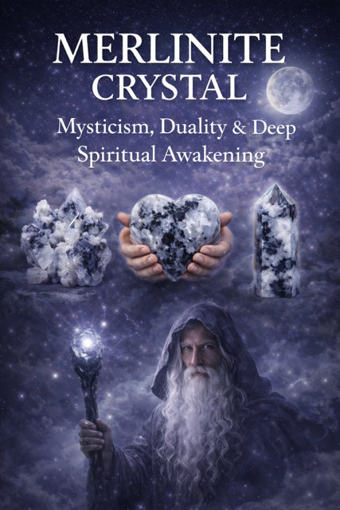
MERLINITE CRYSTAL
Mysticism, Duality & Deep Spiritual Awakening

Table of Contents
Introduction to Merlinite
Origins & Geological Formation
The Meaning & Symbolism of Merlinite
Spiritual & Metaphysical Properties
Emotional & Mental Healing Benefits
Physical Healing Associations
Merlinite & the Chakras
Merlinite in Shadow Work & Duality
Merlinite for Intuition & Psychic Development
Rituals & Daily Practices
Meditation with Merlinite
Manifestation & Energy Work
Merlinite in Love & Relationships
Protection & Energy Shielding
Combining Merlinite with Other Crystals
Cleansing, Charging & Care
How to Choose Your Merlinite
FAQs
Final Thoughts & Affirmations

Chapter 1: Introduction to Merlinite

Merlinite, also known as Dendritic Opal, is a captivating crystal of duality, magic, and spiritual evolution. Its striking black-and-white patterns symbolize the balance between light and shadow—making it a powerful stone for those on a journey of self-discovery.
Often associated with the legendary wizard Merlin, this crystal is believed to bridge the physical and spiritual realms, opening gateways to deeper awareness and hidden knowledge.



Chapter 2: Origins & Geological Formation

Merlinite is a variety of opal that contains dendritic inclusions, typically manganese or iron, creating tree-like or ink-blot patterns within the stone.
Found in: USA, Brazil, India, Madagascar
Composition: Silicon dioxide (Opal)
Appearance: Milky white base with black branching patterns
Each piece is unique, symbolizing the individuality of each spiritual journey.



Chapter 3: Meaning & Symbolism

Merlinite embodies:
Duality (light & dark, masculine & feminine)
Transformation
Spiritual alchemy
Hidden knowledge
It teaches that both light and shadow are essential for growth, encouraging deep acceptance and integration.
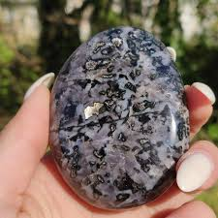

Chapter 4: Spiritual & Metaphysical Properties

Merlinite is known for:
Enhancing intuition and psychic awareness
Connecting to higher realms and spirit guides
Assisting in past life recall
Deepening meditation and spiritual insight
It acts as a bridge between dimensions, making it ideal for spiritual practitioners.

Chapter 5: Emotional & Mental Healing

This crystal supports:
Emotional balance
Releasing suppressed trauma
Accepting shadow aspects of self
Clarity during confusion
Merlinite gently pushes you to face what you’ve avoided—not to harm, but to heal.

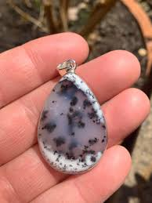

Chapter 6: Physical Healing Associations

While not a substitute for medical care, Merlinite is associated with:
- Nervous system balance
- Detoxification
- Energy alignment
- Stress reduction
Its calming yet activating energy supports overall well-being.

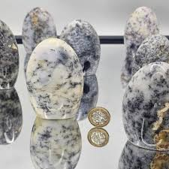

Chapter 7: Merlinite & the Chakras

Merlinite works primarily with:
Third Eye Chakra – intuition, vision
Crown Chakra – spiritual connection
Root Chakra – grounding shadow work
It aligns higher consciousness with grounded awareness.

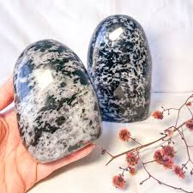

Chapter 8: Shadow Work & Duality

Merlinite is one of the most powerful stones for shadow work.
It helps you:
Acknowledge hidden emotions
Heal inner wounds
Accept both your light and dark sides
This is where true transformation begins.
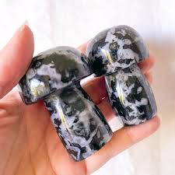

Chapter 9: Intuition & Psychic Development

Merlinite enhances:
- Clairvoyance
- Dream recall
- Spiritual downloads
- Energy sensitivity

It’s ideal for:
- Tarot readers
- Healers
- Spiritual entrepreneurs

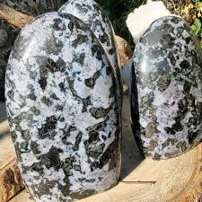

Chapter 10: Rituals & Daily Practices

Simple Daily Ritual:
Hold Merlinite in your hand
Close your eyes
Ask: “What truth am I ready to see today?”
Sit in stillness for 5–10 minutes

Chapter 11: Meditation with Merlinite

Use Merlinite to:
- Enter deep meditative states
- Access subconscious insights
- Connect with spiritual guides

Place it on your third eye for maximum effect.

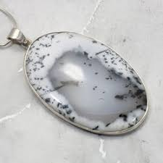

Chapter 12: Manifestation & Energy Work

Merlinite is not a typical “fast manifestation” stone—it works on alignment first.
It helps you:
- Remove subconscious blocks
- Align desires with truth
- Manifest from authenticity

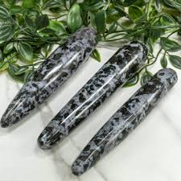

Chapter 13: Love & Relationships

Merlinite promotes:
- Honest communication
- Emotional awareness
- Healing relationship patterns
It reveals truths—whether comfortable or not.
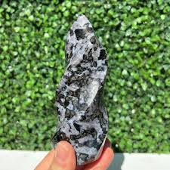

Chapter 14: Protection & Energy Shielding

While not a traditional protection stone, Merlinite:
- Shields against self-deception
- Protects your energy through awareness
- Grounds spiritual experiences

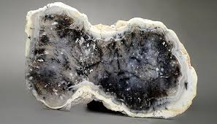

Chapter 15: Crystal Combinations

Pair Merlinite with:
- Black Tourmaline – grounding & protection
- Amethyst – spiritual clarity
- Clear Quartz – amplification
- Labradorite – magic & intuition
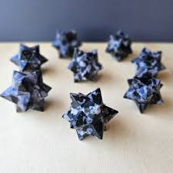

Chapter 16: Cleansing & Charging

Cleanse with:
Moonlight
Smoke (sage or palo santo)
Sound (singing bowls)
Avoid prolonged water exposure.

Chapter 17: Choosing Your Merlinite

Trust your intuition.
Look for:
Patterns that resonate with you
A piece that “calls” to you
Energy you feel drawn toward

Chapter 18: FAQs

Is Merlinite rare?
Moderately rare, especially high-contrast pieces.

Can beginners use it?
Yes—but be prepared for deep inner work.

Is it safe to sleep with?
It may cause vivid dreams—use with intention.

Chapter 19: Final Thoughts & Affirmations

Merlinite is not just a crystal—it is a mirror of your soul.
It asks you to embrace all that you are, without fear.

Daily Affirmations

“I embrace both my light and shadow.”
“I am open to truth and transformation.”
“I trust my intuition and inner wisdom.”
“I am aligned with my highest self.”



