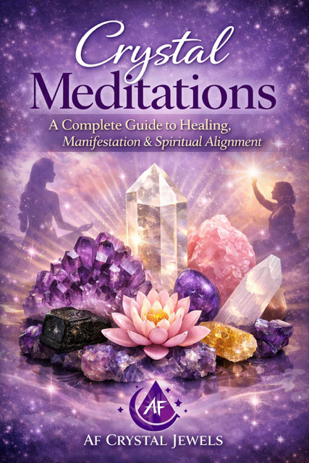
Crystal Meditations: A Complete Guide to Healing, Manifestation & Spiritual Alignment

Table of Contents

Introduction to Crystal Meditation
The Science & Energy Behind Crystals
Preparing for Crystal Meditation
Choosing the Right Crystals
Cleansing & Charging Your Crystals
Creating a Sacred Meditation Space
Foundational Meditation Techniques
Chakra-Based Crystal Meditations
Guided Meditations with Crystals
Crystal Meditation for Manifestation
Emotional Healing with Crystal Meditation
Protection & Grounding Practices
Advanced Crystal Meditation Techniques
Daily Crystal Meditation Rituals
Combining Crystals for Amplified Results
Troubleshooting Your Practice
Creating Your Personal Crystal Meditation Practice
Final Thoughts & Spiritual Integration

Chapter 1: Introduction to Crystal Meditation
Crystal meditation is the intentional practice of using crystals as energetic tools to deepen awareness, balance emotions, and align the mind, body, and spirit.
Each crystal carries a unique vibrational frequency. When combined with meditation, these frequencies interact with your own energy field, helping to:

- Calm the mind
- Release emotional blockages
- Enhance intuition
- Support manifestation
- Promote spiritual growth

This practice is accessible to beginners yet powerful enough for advanced spiritual work.


Chapter 2: The Science & Energy Behind Crystals

Crystals are formed through natural geological processes over thousands or millions of years. Their internal atomic structure creates stable vibrational patterns.
From an energetic perspective:
- Everything in the universe vibrates at a frequency
- Crystals maintain consistent energetic signatures
- Your body and emotions also emit frequencies
Crystal meditation works through resonance—helping your energy align with the crystal’s stable vibration.

Chapter 3: Preparing for Crystal Meditation

Preparation is essential for a powerful meditation session.

Steps to Prepare:
Choose a quiet, comfortable space
Set a clear intention
Turn off distractions
Sit or lie in a relaxed position
Have your chosen crystals nearby

Optional Enhancements:
Candles
Incense or essential oils
Soft music or silence

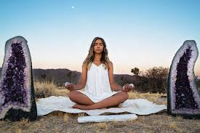

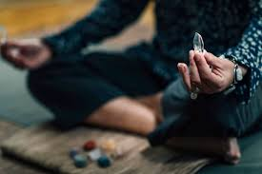

Chapter 4: Choosing the Right Crystals

Different crystals support different intentions.
Popular Choices:
Amethyst
Spiritual growth, intuition, calmness

Rose Quartz
Love, compassion, emotional healing

Clear Quartz
Amplification, clarity, manifestation

Black Tourmaline
Protection, grounding

Citrine
Abundance, confidence, success

Selenite
Cleansing, higher consciousness

Choose intuitively, your energy is often drawn to what you need most.

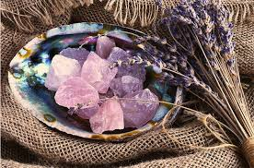

Chapter 5: Cleansing & Charging Your Crystals

Crystals absorb and store energy, so regular cleansing is essential.

Cleansing Methods:
Moonlight (full moon preferred)
Smoke cleansing (sage, palo santo)
Sound (bells, singing bowls)
Running water (only for water-safe crystals)
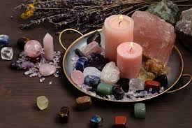

Charging Methods:
Sunlight (short exposure)
Intentional visualization
Placing on selenite

Chapter 6: Creating a Sacred Meditation Space
Your environment influences your energy.

Key Elements:
Clean, uncluttered area
Comfortable seating
Soft lighting
Personal spiritual objects

Create a space that feels safe, calming, and energetically supportive.

Chapter 7: Foundational Meditation Techniques

Before using crystals, establish a strong meditation foundation.

Basic Breath Awareness:
Inhale slowly through the nose
Exhale gently through the mouth
Focus only on your breath

Body Scan:
Bring awareness to each part of your body
Release tension consciously

Stillness Practice:
Observe thoughts without attachment



Chapter 8: Chakra-Based Crystal Meditations

Each chakra corresponds to specific crystals.
Root Chakra (Grounding)
- Black Tourmaline, Hematite
Sacral Chakra (Creativity)
- Carnelian, Orange Calcite
Solar Plexus (Confidence)
- Citrine, Tiger’s Eye
Heart Chakra (Love)
- Rose Quartz, Green Aventurine
Throat Chakra (Communication)
- Blue Lace Agate, Aquamarine
Third Eye (Intuition)
- Amethyst, Lapis Lazuli
Crown Chakra (Spiritual Connection)
- Clear Quartz, Selenite

Place crystals on the body or hold them during meditation.

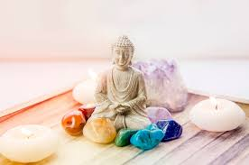

Chapter 9: Guided Crystal Meditation

Simple Guided Practice:
- Hold your crystal in your hand
- Close your eyes
- Take deep breaths
- Visualize light flowing from the crystal into your body
- Allow the energy to expand and balance you
Stay in this state for 10–20 minutes.

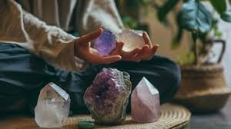

Chapter 10: Crystal Meditation for Manifestation

Crystals can amplify intention-setting.
Steps:
- Choose a crystal (e.g., Citrine or Clear Quartz)
- Set a clear intention
- Visualize your desired outcome
- Feel the emotion as if it already exists

Consistency strengthens results.

Chapter 11: Emotional Healing with Crystal Meditation

Crystals can support emotional release.
Practice:
- Use Rose Quartz or Amethyst
- Focus on the emotion you want to release
- Breathe into the feeling
- Visualize it dissolving into light

Allow yourself to feel without resistance.

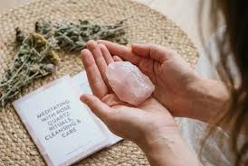

Chapter 12: Protection & Grounding Practices

Grounding stabilizes your energy.
Techniques:
- Hold Black Tourmaline
- Visualize roots extending from your body into the earth
- Feel supported and secure

This is especially important after deep meditation.

Chapter 13: Advanced Crystal Meditation Techniques

Crystal Grids
Arrange crystals in geometric patterns to amplify energy.

Third Eye Activation
Place Amethyst on your forehead and focus inward.

Energy Channeling
Visualize energy moving through your body like a current.
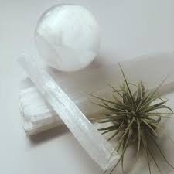

Chapter 14: Daily Crystal Meditation Rituals

Consistency builds transformation.
Daily Routine Example:
Morning: 5–10 minute intention meditation
Evening: Emotional release or grounding session

Even short practices are powerful when done regularly.

Chapter 15: Combining Crystals

Certain combinations enhance results:

- Rose Quartz + Amethyst → Emotional healing + spiritual growth
- Citrine + Clear Quartz → Manifestation amplification
- Black Tourmaline + Selenite → Protection + cleansing

Trust your intuition when combining stones.

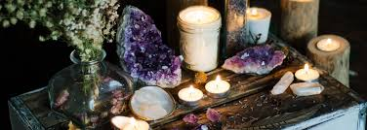

Chapter 16: Troubleshooting Your Practice

Common Challenges:
- “I can’t focus”
→ Shorten sessions and focus on breath
- “I don’t feel anything”
→ Sensitivity develops over time
- “My mind is too busy”
→ This is normal—observe without judgment

Chapter 17: Creating Your Personal Practice

Your practice should reflect your lifestyle and goals.
Ask Yourself:
- What do I want to heal or attract?
- How much time can I commit daily?
- Which crystals resonate most with me?
Build a routine that feels natural and sustainable.

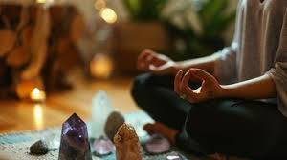

Chapter 18: Final Thoughts & Spiritual Integration
Crystal meditation is not just a practice, it becomes a way of living.
Over time, you may notice:
- Greater emotional balance
- Increased intuition
- Stronger manifestation ability
- A deeper connection to yourself
Trust the process. Your journey with crystals is uniquely yours.

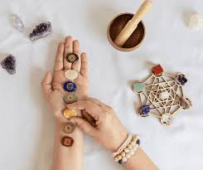

Bonus: Daily Affirmations
“I am aligned with my highest self.”
“I release all that no longer serves me.”
“I am open to abundance and love.”
“My energy is balanced and protected.”

Your energy is your greatest asset. Crystals simply help you remember your power.



Crystal Meditations: Guided Practices for Deep Healing & Manifestation

Guided Meditation 1: Deep Relaxation with Amethyst
Purpose: Calm the mind, reduce stress, enhance spiritual awareness
Crystal: Amethyst
Begin by finding a comfortable seated or lying position.
Hold your amethyst crystal gently in your hand or place it on your forehead.
Close your eyes.
Take a slow, deep breath in through your nose…
And exhale gently through your mouth.
Again… inhale deeply…
And exhale, allowing your body to soften.
Now bring your awareness to your body.
Release tension from your shoulders…
Your jaw…
Your chest…
Your stomach…
Your legs…
With each breath, feel yourself sinking deeper into relaxation.
Now, imagine a soft violet light radiating from your amethyst crystal.
This light begins to flow into your mind… calming your thoughts…
Slowing everything down…
Feel the energy gently washing away stress, anxiety, and tension.
Allow this violet light to expand…
Moving through your entire body…
You are safe.
You are calm.
You are at peace.
Remain here for several moments, simply breathing and receiving.
When you are ready, gently bring your awareness back to your body…
Wiggle your fingers and toes…
And slowly open your eyes.

Guided Meditation 2: Heart Healing with Rose Quartz
Purpose: Emotional healing, self-love, compassion
Crystal: Rose Quartz
Sit comfortably and place your rose quartz over your heart.
Close your eyes.
Take a deep breath in…
And exhale slowly.
Bring your awareness to your heart space.
Notice any emotions present—without judgment.
Now imagine a soft pink light glowing from your rose quartz.
With each breath, this light expands… filling your chest with warmth and love.
This light begins to dissolve emotional pain…
Old wounds…
Lingering sadness…
You are safe to release.
Silently repeat:
“I allow myself to heal.”
“I am worthy of love.”
“I forgive and release.”
Feel your heart becoming lighter… softer… more open.
Let this loving energy flow through your entire being.
Stay in this space as long as you need.
When ready, gently return… carrying this sense of love with you.

Guided Meditation 3: Manifestation Power with Citrine & Clear Quartz
Purpose: Abundance, success, intention amplification
Crystals: Citrine + Clear Quartz
Hold a Citrine in one hand and clear quartz in the other.
Close your eyes and take slow, deep breaths.
Bring your awareness to your intention.
What do you desire to manifest?
See it clearly in your mind.
Now imagine a golden light radiating from the Citrine…
And a bright white light amplifying it from the clear quartz.
These energies merge, forming a powerful field around you.
Step into this reality.
See yourself already living your desire.
Feel the emotions, joy, excitement, gratitude.
This is already yours.
Silently affirm:
“I attract abundance effortlessly.”
“I am aligned with success.”
“My desires are manifesting now.”
Hold this vision strongly.
Allow the energy to anchor into your body.
When ready, release the visualization and trust the process.

Guided Meditation 4: Grounding & Protection with Black Tourmaline
Purpose: Protection, grounding, energy stability
Crystal: Black Tourmaline
Sit comfortably with your feet flat on the ground.
Hold your black tourmaline.
Close your eyes.
Take a deep breath in…
And exhale slowly.
Now imagine roots growing from the soles of your feet…
These roots extend deep into the earth…
Anchoring you… supporting you…
You are grounded.
You are stable.
You are protected.
Now visualize a protective shield forming around your body.
A strong, dark energy field, absorbing negativity and shielding you from harm.
Nothing unwanted can enter your space.
Repeat silently:
“I am safe.”
“I am grounded.”
“I am protected.”
Feel the strength of this energy surrounding you.
Stay here for a few moments.
When ready, gently return, bringing this grounded energy with you.

Guided Meditation 5: Third Eye Activation with Amethyst & Lapis Lazuli
Purpose: Intuition, clarity, spiritual insight
Crystals: Amethyst + Lapis Lazuli
Lie down comfortably.
Place the crystals gently on your forehead.
Close your eyes and breathe deeply.
Bring your awareness to the space between your eyebrows.
Now visualize a deep indigo light glowing in this area.
This light begins to expand… opening your inner vision…
You may begin to see colours, shapes, or images.
Allow them to come naturally.
Do not force, simply observe.
Your intuition is awakening.
Silently repeat:
“I trust my inner wisdom.”
“I see clearly.”
“I am connected to higher guidance.”
Remain in this space of awareness.
When ready, slowly bring your attention back to your body.

Guided Meditation 6: Full Body Energy Alignment with Clear Quartz
Purpose: Energy balance, alignment, clarity
Crystal: Clear Quartz
Hold your clear quartz or place it on your body.
Close your eyes.
Take slow, steady breaths.
Now imagine a beam of white light entering through the top of your head.
This light flows down through your entire body…
Aligning… balancing… restoring…
It moves through your mind… your throat… your heart… your stomach… your legs…
Every cell is being cleansed and recharged.
You are in perfect alignment.
Your energy is clear and flowing.
Repeat silently:
“My energy is balanced.”
“I am aligned.”
“I am whole.”
Stay in this state of harmony.
When ready, gently return.

How to Use These Meditations
Practice daily or intuitively
Use them as scripts for recordings or audio products
Pair them with your crystal products for added value
Include them in courses or subscription boxes

Integration Tip
After each meditation, journal:
What you felt
What you saw
Any insights received
This deepens your connection and accelerates your growth.

