**Trinity of Transformation: The Healing Power of Malachite, Chrysocolla & Azurite**

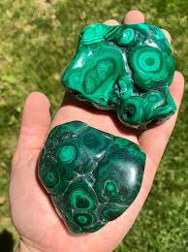



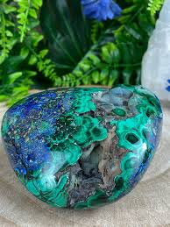

By AF Crystal Jewels

Roxy Slabber

Table of Contents:

1. Introduction
2. The Sacred Bond of Copper-Based Crystals
3. Malachite: The Stone of Transformation
4. Chrysocolla: The Stone of Divine Communication
5. Azurite: The Stone of Inner Vision
6. The Energetic Synergy: How They Work Together
7. Chakra Healing with Malachite, Chrysocolla & Azurite
8. Daily Rituals and Practices
9. Crystal Grids for Healing and Manifestation
10. Affirmations for Each Stone
11. How to Cleanse, Charge & Store These Crystals
12. Meditations and Visualizations
13. Using the Trinity in Jewellery and Everyday Life
14. Conclusion: Embodying the Power of the Trinity

Chapter 1: Introduction

In the heart of the Earth’s mineral kingdom lies a trio of exceptional crystals: malachite, chrysocolla, and azurite. Each one is unique, yet together they form a sacred alliance of energy, colour, and vibration. Bound by their copper-rich compositions and vivid blue-green hues, they are often found in close proximity within the Earth, creating powerful natural blends. This eBook explores their individual healing powers and their synergistic potential when used together for emotional, spiritual, and energetic transformation.

Chapter 2: The Sacred Bond of Copper-Based Crystals

Copper is a highly conductive element, both physically and metaphysically. Crystals like malachite, chrysocolla, and azurite all contain copper, making them energetically potent. This shared trait enhances their abilities to conduct energy, amplify intentions, and open blocked energy centres. Their naturally complementary colour ranges—green, blue, and indigo—align with the heart, throat, and third eye chakras, supporting healing across emotional expression, love, and spiritual insight.

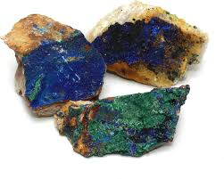

Chapter 3: Malachite – The Stone of Transformation

Malachite is a striking green crystal with swirling patterns that resemble the movement of water. Known as a powerful stone of transformation, malachite helps to clear negative energies and old traumas. It is a stone of the heart and solar plexus chakras, helping to release suppressed emotions and enhance personal power.

**Healing Properties:**

Absorbs negative energy

Encourages deep emotional healing

Protects against psychic attacks

Supports transformation and rebirth

**Spiritual Associations:**

Planet: Venus

Element: Earth

Chakra: Heart, Solar Plexus



Chapter 4: Chrysocolla – The Stone of Divine Communication

Chrysocolla is a soft yet powerful stone in vibrant hues of blue and green. It is deeply connected to the throat chakra and feminine energy, promoting authentic communication, emotional balance, and inner calm.

**Healing Properties:**

Encourages self-expression

Relieves emotional tension

Enhances feminine wisdom

Balances mood swings

**Spiritual Associations:**

Planet: Venus and Mercury

Element: Water

Chakra: Throat, Heart

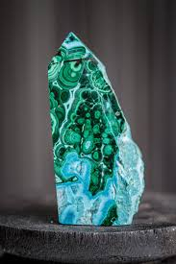

Chapter 5: Azurite – The Stone of Inner Vision

Azurite is a deep indigo-blue crystal that stimulates the third eye chakra. It enhances intuition, psychic ability, and insight. Often used by shamans and healers, azurite facilitates deep inner work, dream recall, and spiritual development.

**Healing Properties:**

Activates the third eye

Enhances inner vision and clarity

Supports astral travel and spiritual exploration

Aids in dissolving fear and anxiety

**Spiritual Associations:**

Planet: Jupiter

Element: Wind

Chakra: Third Eye

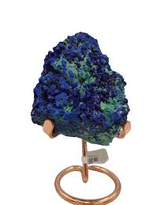

Chapter 6: The Energetic Synergy

When used together, malachite, chrysocolla, and azurite form a powerful triad. This combination addresses the heart, throat, and third eye chakras simultaneously, encouraging healing through emotional release, honest communication, and heightened spiritual awareness.

**Combined Benefits:**

Deep emotional detox

Intuitive self-expression

Energetic balance and alignment

Facilitates personal and spiritual evolution

Chapter 7: Chakra Healing

Heart Chakra (Malachite, Chrysocolla): Promotes forgiveness, compassion, and emotional healing.

Throat Chakra (Chrysocolla): Clears communication blocks and encourages truth-telling.

Third Eye Chakra (Azurite): Stimulates intuition and inner knowing.

**Chakra Ritual Tip: Lay each stone on its corresponding chakra during meditation for aligned healing.**

Chapter 8: Daily Rituals and Practices

Morning: Hold malachite over the heart while setting intentions for emotional strength.

Midday: Wear a chrysocolla pendant to promote calm communication.

Evening: Meditate with azurite to unlock insight from the day and dream state.

Chapter 9: Crystal Grids

Transformation Grid:

Centre: Malachite

North: Chrysocolla

South: Azurite

Add quartz points to amplify energy.

Place the grid under your bed or near your workspace for sustained transformation energy.

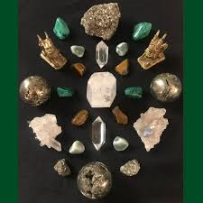

Chapter 10: Affirmations

Malachite: “I release the old and welcome transformation.”

Chrysocolla: “I speak my truth with grace and compassion.”

Azurite: “I trust my inner vision and follow divine guidance.”

Chapter 11: Cleansing & Charging

Cleansing Tips:

Do not use water for these stones due to copper content.

Use smoke, sound, or selenite.

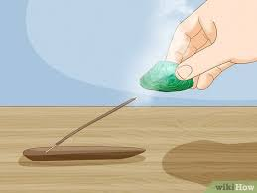Charging Methods:

Full moon light

Earth burying (overnight)

Intentional meditation

Chapter 12: Guided Meditation

Visualize yourself entering a luminous cave where malachite, chrysocolla, and azurite crystals line the walls. As you walk deeper, feel each stone activating a different part of your energy body. Malachite dissolves pain, chrysocolla soothes your voice, and azurite opens your inner sight.

Chapter 13: Jewellery & Everyday Use

**Necklaces:** Encourage communication and healing

**Bracelets:** Keep the trio close to your pulse points

**Tumbled stones:** Carry in a pouch for energy balance throughout the day



Chapter 14: Conclusion

Malachite, chrysocolla, and azurite each offer profound healing on their own—but their true magic lies in their union. Together, they create a sacred bridge between the heart, voice, and spirit. As you work with this trinity, you’ll find yourself releasing the past, speaking your truth, and awakening your deepest wisdom.

