**Crystals & Angels: A Divine Guide to Healing, Protection & Spiritual Connection**

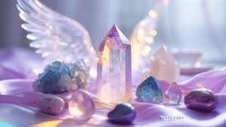

**By AF Crystal Jewels**

**Roxy Slabber**

**Table of Contents**

1. **Introduction: The Light of Crystals and Angels**
2. **Understanding Angelic Realms**
3. **How Crystals Connect Us to Angels**
4. **Angelic Colours and Crystal Frequencies**
5. **Top 15 Crystals for Angelic Connection**
6. **How to Work with Crystals and Angels**
7. **Creating a Sacred Angel Altar**
8. **Daily Practices and Rituals**
9. **Angelic Crystal Grids**
10. **Invoking Archangels with Crystals**
11. **Healing with Crystals & Angel Energy**
12. **Messages from the Angelic Realm**
13. **Affirmations for Divine Connection**
14. **Final Thoughts: Living in the Light**

Chapter 1: Introduction — The Light of Crystals and Angels

Throughout history, humans have sought connection with divine realms for healing, wisdom, and guidance. Crystals and angels serve as luminous bridges between our earthly lives and higher dimensions. While crystals are tangible carriers of Earth’s sacred energy, angels are celestial messengers who support, protect, and uplift. This book offers a guide to working with both — bringing harmony to your spirit, clarity to your mind, and sacred light to your daily life.

Chapter 2: Understanding Angelic Realms

Angels are non-denominational spiritual beings found across many faiths and cultures. They exist in high vibrational realms and are always available to assist us. The most commonly known categories include:

Guardian Angels – Personal protectors and guides

Archangels – Powerful beings overseeing large aspects of life

Healing Angels – Specialists in emotional, physical, and spiritual healing

Messenger Angels – Deliver divine guidance, signs, and synchronicities

Each angelic being resonates with a frequency that can be accessed more deeply through the use of specific crystals.

Chapter 3: How Crystals Connect Us to Angels

Crystals carry stable, high-frequency vibrations that amplify intentions, open portals to higher realms, and align us with the angelic frequency. By meditating, praying, or setting sacred space with specific crystals, we attune ourselves to angelic messages and healing. Crystals can:

Heighten spiritual awareness

Facilitate clearer communication with guides

Offer energetic protection

Anchor light codes and divine guidance



Chapter 4: Angelic Colours and Crystal Frequencies

Angels often appear in colour rays — and these colours correspond with crystal vibrations. For example:

White Light / Clear Quartz – Pure divine light, clarity

Pink Light / Rose Quartz – Love, compassion (Archangel Chamuel)

Blue Light / Celestite, Angelite – Communication, calm (Archangel Michael)

Green Light / Green Aventurine – Healing and abundance (Archangel Raphael)

Purple Light / Amethyst – Spiritual wisdom and psychic insight (Archangel Zadkiel)

Gold Light / Citrine – Divine purpose, joy (Archangel Uriel)

By combining these colours with intention, you align with the divine frequency of angelic beings.

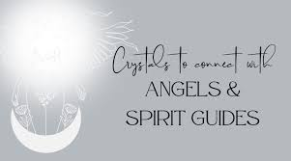Chapter 5: Top 15 Crystals for Angelic Connection

Angelite – Enhances telepathic connection with angels

Celestite – Facilitates divine communication and dreamwork

Selenite – Cleanses and opens channels to angelic realms

Amethyst – Heightens intuition, spiritual protection

Clear Quartz – Amplifies intention, calls in angelic light

Rose Quartz – Opens the heart to divine love

Lepidolite – Eases emotional distress, supports angelic healing

Danburite – High-vibration stone for direct contact with angels

Seraphinite – Named after the Seraphim, brings healing and connection

Blue Lace Agate – Gentle communication with angels

Chrysoprase – Invites joy, emotional balance, angelic comfort

Kunzite – Deepens heart-based connection with divine energies

Azeztulite – Elevates consciousness, facilitates angelic downloads

Apophyllite – Assists in angelic presence during meditation

Moonstone – Invokes angelic feminine energies and intuition

Chapter 6: How to Work with Crystals and Angels

Here are foundational steps to integrate crystal and angel energy:

Cleanse your crystals (smoke, selenite, moonlight)

Program with intention – Hold your crystal and ask to connect with divine guides

Call in your angels – Invite your guardian angel or specific Archangels by name

Sit in quiet meditation or prayer with your chosen crystal

Listen, feel, receive – Stay open to signs, visions, or intuitive nudges

Journal messages or insights that come through



Chapter 7: Creating a Sacred Angel Altar

Build a dedicated space to honour the angelic realm and support your practice. Include:

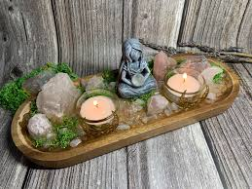A white cloth (symbolizing purity)

Crystals associated with angelic energy

Angel figurines or artwork

Candles (white, pink, or blue)

A journal or prayer book

Flowers, feathers, or sacred symbols

Visit your altar daily for peace, guidance, and realignment.

Chapter 8: Daily Practices and Rituals

Morning Invocation:

“I call upon my guardian angels and highest guides. Walk with me today. Help me see, feel, and act from divine light.”

Crystal Meditation (5–10 min):

Hold Celestite or Selenite and breathe deeply. Imagine light pouring through your crown as angelic presence surrounds you.

Evening Gratitude:

“Thank you, divine angels, for your love, protection, and guidance. I receive your messages with a grateful heart.”

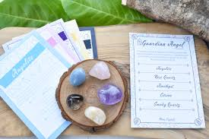

Chapter 9: Angelic Crystal Grids

Create intentional crystal grids to call in protection, love, or divine support. Use:

Centre Stone: Angelite or Celestite

Supporting Stones: Clear Quartz points, Rose Quartz, Selenite

Shape: Use a Flower of Life or Mandala base

Intention: “I welcome divine assistance in all forms. Angels of light, guide and protect me always.”

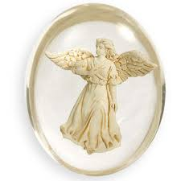

Chapter 10: Invoking Archangels with Crystals

Archangel Michael (Protection)

Crystal: Lapis Lazuli or Angelite

Invocation: “Archangel Michael, surround me with your shield of blue light. Protect me from all harm.”

Archangel Raphael (Healing)

Crystal: Green Aventurine or Emerald

Invocation: “Archangel Raphael, pour your healing light over my body and soul.”

Archangel Uriel (Wisdom)

Crystal: Citrine or Amber

Invocation: “Archangel Uriel, illuminate my mind with divine wisdom and purpose.”

Archangel Chamuel (Love)

Crystal: Rose Quartz or Rhodonite

Invocation: “Archangel Chamuel, fill my heart with unconditional love and compassion.”

Archangel Zadkiel (Forgiveness & Transmutation)

Crystal: Amethyst

Invocation: “Archangel Zadkiel, help me release the past and transform pain into peace.”

Chapter 11: Healing with Crystals & Angel Energy

You can use crystals and angelic energy to assist with emotional, spiritual, and physical healing.

Place crystals on the body during meditation

Visualize angel wings or divine light entering the affected area

Ask the angels to assist you in healing what no longer serves you

Affirm: “I am safe, held, and healed by divine presence.”

Chapter 12: Messages from the Angelic Realm

Angels speak to us through:

Synchronicities (numbers, symbols)

Feathers, sparkles of light

Sudden peace or knowing

Dreams and meditative visions

Intuitive thoughts or whispers

Crystals help strengthen these channels and validate the messages you receive.



Chapter 13: Affirmations for Divine Connection

“I am surrounded by divine light and love.”

“My angels guide me in every moment.”

“I trust the wisdom of the angelic realm.”

“I am open to receiving healing from above.”

“With every breath, I connect to higher guidance.”

Chapter 14: Final Thoughts — Living in the Light

Your journey with crystals and angels is a sacred one. With consistent intention, your connection to divine helpers will deepen, your heart will expand, and your life will transform. Allow this bond to be your compass through uncertainty, your light in darkness, and your reminder that you are never alone.

