**Azurite: The Stone of Inner Vision and Transformation**

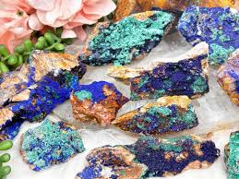

A Complete Guide to Healing, Growth, and Spiritual Awakening with Azurite

By AF Crystal Jewels

Roxy Slabber

**Table of Contents:**

1. Introduction: Meeting Azurite
2. History and Legends of Azurite
3. The Science Behind the Beauty
4. Azurite’s Metaphysical Properties
5. Emotional and Spiritual Healing with Azurite
6. Azurite and the Chakras
7. Using Azurite in Meditation and Intuition Practices
8. Azurite in Rituals and Daily Life
9. How to Care for and Cleanse Azurite
10. Combining Azurite with Other Crystals
11. Affirmations and Intentions with Azurite
12. Conclusion: Living with the Wisdom of Azurite

**Azurite: The Stone of Inner Vision and Transformation**

A Complete Guide to Healing, Growth, and Spiritual Awakening with Azurite

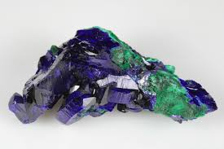

**Introduction: Meeting Azurite**

Azurite is one of the most captivating and profound crystals in the mineral kingdom. Known as the “Stone of Heaven,” it has been cherished by civilizations throughout history for its deep, celestial blue hues and powerful metaphysical qualities.

This guide will reveal how Azurite can open your mind, heal emotional wounds, awaken intuition, and align you with your highest path.

**Chapter 1: History and Legends of Azurite**

Throughout history, Azurite has been revered for its deep spiritual significance.

* Ancient Egypt: Used in sacred ceremonies and ground into pigments for powerful rituals.
* Greece and Rome: Believed to enhance psychic powers and connect with divine knowledge.
* Native American cultures: Used Azurite to communicate with spirit guides and interpret dreams.  
  Its powerful vibration has been honoured by mystics, shamans, and seers for thousands of years.

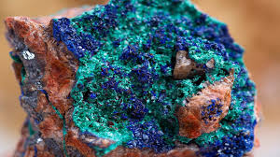

**Chapter 2: The Science Behind the Beauty**

Azurite is a copper carbonate mineral with the chemical formula Cu₃(CO₃)₂(OH)₂.

* Colour: Deep blue, often vibrant and intense.
* Formation: Grows in copper-rich regions, often alongside malachite.
* Hardness: 3.5–4 on the Mohs scale, making it a relatively delicate mineral.  
  Its shimmering, midnight-blue colour is due to its copper content, connecting it to both Earth and Sky energies.

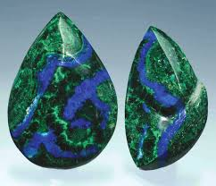

**Chapter 3: Azurite’s Metaphysical Properties**

Azurite carries a high-frequency energy that impacts the Third Eye and Crown Chakras.

Key properties include:

* Enhancing psychic visions and intuition
* Clearing mental fog and confusion
* Strengthening inner wisdom
* Supporting deep emotional healing
* Awakening the spiritual self to higher dimension

**Chapter 4: Emotional and Spiritual Healing with Azurite**

Azurite acts as an emotional cleanser, bringing deep-seated fears, traumas, and patterns into consciousness for healing.

It helps:

* Release limiting beliefs
* Heal anxiety, guilt, and sadness
* Promote clarity and emotional resilience
* Enhance self-trust and authenticity

Healing Practice:

Hold Azurite over your heart or third eye. Visualize its indigo light dissolving old pain and creating space for peace.

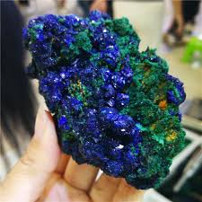

**Chapter 5: Azurite and the Chakras**

Primary Connection:

* Third Eye Chakra (Ajna): Enhances intuition, spiritual awareness, and mental clarity.
* Crown Chakra (Sahasrara): Connects to higher consciousness and divine guidance.

Signs You Need Azurite:

* Feeling stuck in decisions
* Lack of spiritual connection
* Overactive or chaotic mind

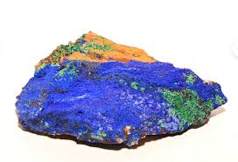

**Chapter 6: Using Azurite in Meditation and Intuition Practices**

Simple Azurite Meditation:

1. Hold an Azurite stone to your forehead.
2. Close your eyes and breathe deeply.
3. Visualize a vivid indigo light swirling through your mind.
4. Allow visions, messages, or feelings to arise naturally.

Tip: Journaling after an Azurite meditation often reveals hidden insights.



**Chapter 7: Azurite in Rituals and Daily Life**

* Morning: Hold Azurite during visualization or intention-setting.
* Workplace: Keep Azurite nearby to boost focus and creativity.
* Dreamwork: Place under your pillow to encourage prophetic dreams.
* Energy Grids: Combine with clear quartz and amethyst for a powerful intuitive grid.

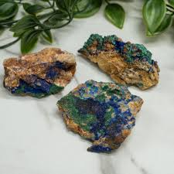

**Chapter 8: How to Care for and Cleanse Azurite**

Azurite is sensitive to water, heat, and sunlight.

To cleanse:

* Use sound (like singing bowls)
* Gently smudge with sage or palo santo
* Place on a selenite slab overnight  
  Avoid soaking Azurite in water, as it can damage the mineral structure.

**Chapter 9: Combining Azurite with Other Crystals**

Powerful combinations include:

* Malachite + Azurite: Deep emotional and spiritual transformation
* Lapis Lazuli + Azurite: Supreme wisdom and mental clarity
* Amethyst + Azurite: Heightened spiritual protection and intuition

Pairing Azurite thoughtfully amplifies its energies.

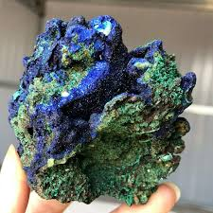

**Chapter 10: Affirmations and Intentions with Azurite**

Use these affirmations while holding your Azurite:

* “I see clearly with the eyes of my soul.”
* “I release fear and embrace my inner knowing.”
* “Divine wisdom flows through me effortlessly.”
* “I trust the visions and messages I receive.”

Repeating affirmations while meditating with Azurite strengthens your connection to your higher self.

**Conclusion: Living with the Wisdom of Azurite**

Azurite is more than a beautiful crystal — it is a teacher, a healer, and a bridge to your true self.

By integrating Azurite into your practices, you open doors to deeper understanding, profound healing, and expansive spiritual growth.

Let Azurite be a guiding light on your journey inward and beyond.

