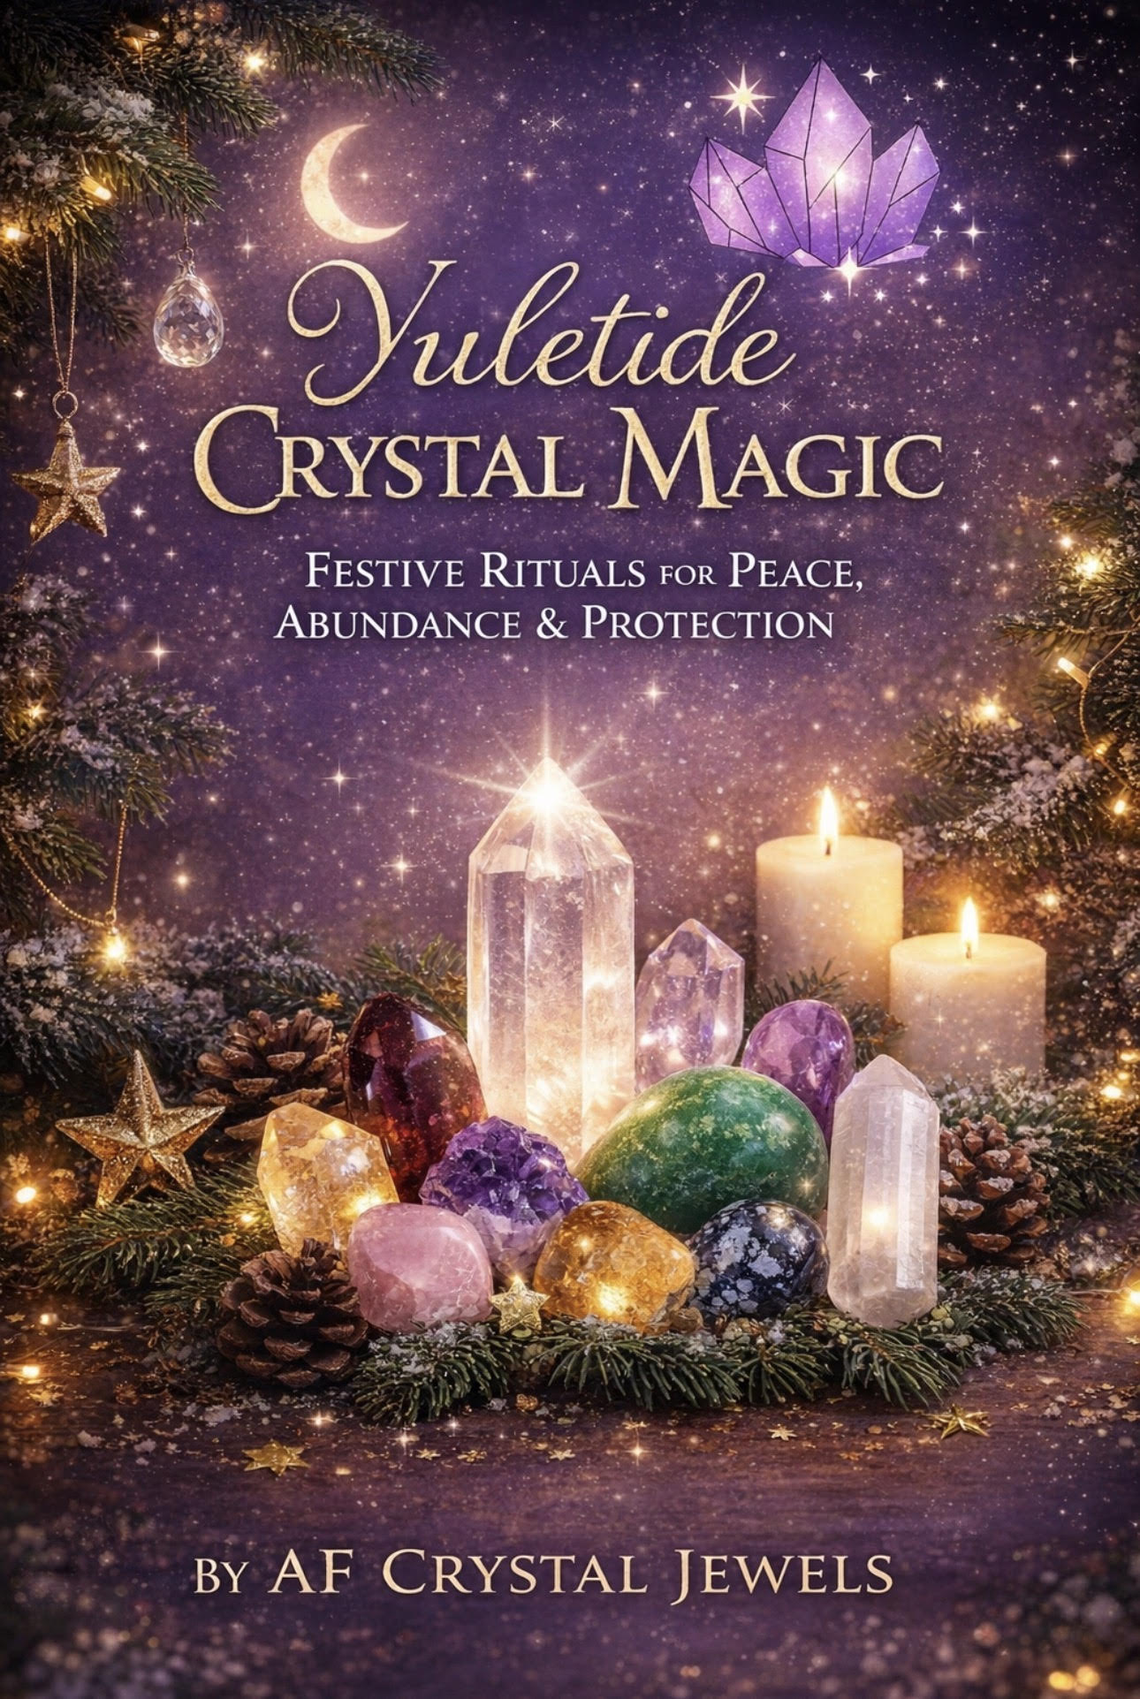
Yuletide Crystal Magic
Festive Rituals for Peace, Abundance & Protection
By AF Crystal Jewels

Christmas is more than a season.
It is a sacred pause.
A moment where light is honoured, homes are warmed, hearts soften, and intentions quietly take root for the year ahead.
This eBook is your invitation to slow down and work with the gentle yet powerful energies of crystals during the most magical time of the year. Blending Christmas symbolism, ancient Yule wisdom, and crystal healing, these practices are designed to bring peace, protection, love, and abundance into your home and life.

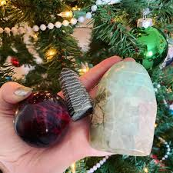

Chapter 1: The Sacred Energy of Christmas & Yule
Long before Christmas lights illuminated our homes, the Winter Solstice—also known as Yule—was celebrated as the rebirth of the sun. The darkest night of the year marked a turning point, where light began to return.
Christmas carries this same spiritual essence:
Hope after darkness
Renewal after rest
Love during stillness
Crystals hold memory, frequency, and intention. During winter, their energy feels deeper, quieter, and more introspective—perfect for reflection, healing, and intention-setting.
This season invites you to:
Release the year gently
Protect your energy during busy moments
Call in abundance and peace
Prepare your spirit for the year ahead

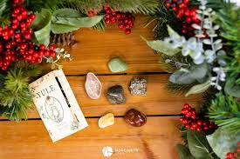

Chapter 2: The Christmas Crystal Collection
These crystals are especially aligned with the festive season. You may work with one or many—trust what you are drawn to.
Clear Quartz – The Light Bearer
Energy: Clarity, amplification, divine light
Clear Quartz reflects the essence of Christmas light. It magnifies intentions and brings mental clarity.
How to Use:
Place near candles, fairy lights, or on your altar.
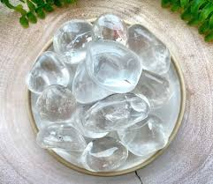
Affirmation:
I welcome light, clarity, and divine guidance

Garnet – The Heart of Winter
Energy: Protection, vitality, grounding
Garnet carries warmth and strength during cold, quiet months.
How to Use:
Carry during busy festive days for stability.
Affirmation:
I am protected, grounded, and strong.
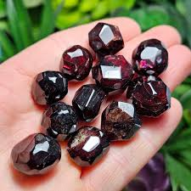

Green Aventurine – Abundance & Blessings
Energy: Prosperity, opportunity, optimism
How to Use:
Place near gifts, your wallet, or under the Christmas tree.
Affirmation:
Abundance flows easily into my life.

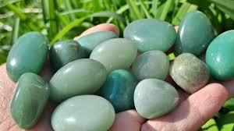

Red Jasper – Sacred Stability
Energy: Grounding, endurance, calm
How to Use:
Keep nearby during family gatherings or travel.
Affirmation:
I am calm, centred, and supported.
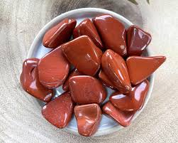

Amethyst – Peace of the Season
Energy: Calm, emotional balance, spiritual connection
How to Use:
Place in bedrooms or meditation spaces.
Affirmation:
Peace surrounds me and fills my heart.
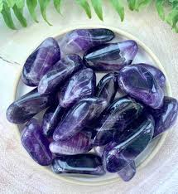

Rose Quartz – Christmas Love
Energy: Love, compassion, harmony
How to Use:
Place in shared spaces to encourage warmth and connection.
Affirmation:
Love flows freely through my home.

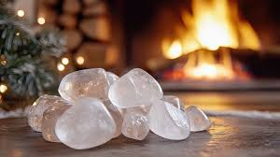

Citrine – Festive Joy
Energy: Joy, gratitude, generosity
How to Use:
Place where you gather or celebrate.
Affirmation:
I welcome joy, gratitude, and abundance.

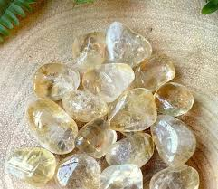

Snowflake Obsidian – Gentle Release
Energy: Reflection, emotional healing
How to Use:
Work with during journaling or quiet evenings.
Affirmation:
I release what no longer serves me.
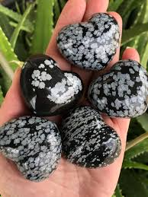

Labradorite – Winter Magic
Energy: Intuition, spiritual protection
How to Use:
Meditate with during solstice or moon nights.
Affirmation:
I trust the magic within me.
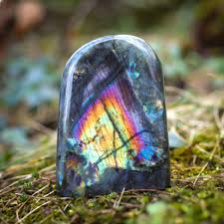

Selenite – Angelic Light
Energy: Cleansing, divine connection
How to Use:
Use to cleanse other crystals or your space.
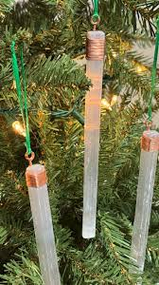
Affirmation:
I am surrounded by divine light and protection.

Chapter 3: Festive Crystal Rituals
Christmas Eve Peace Ritual
Purpose: Calm the mind and heart

You’ll Need:
Amethyst, candle, quiet space
Steps:
Light the candle.
Hold the Amethyst at your heart.
Breathe slowly for 3 minutes.
Say: “Peace enters my heart and home.”
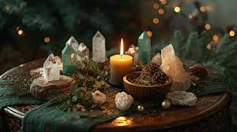

Yule Abundance Ritual
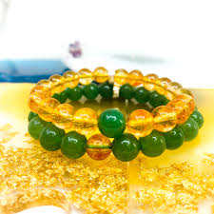
Purpose: Call in prosperity for the year ahead

You’ll Need:
Green Aventurine, Citrine
Steps:
Place crystals together.
Visualise abundance flowing toward you.
Speak your intention clearly.

Home Protection Ritual
Purpose: Energetic protection

You’ll Need:
Garnet, Selenite
Steps:
Walk through your home holding Selenite.
Place Garnet near the entrance.
Affirm: “My home is safe and protected.”

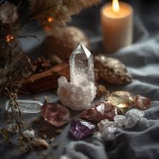

New Year Crystal Intention Ceremony
Purpose: Fresh beginnings
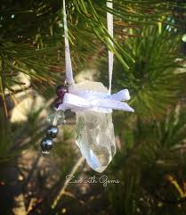
You’ll Need:
Clear Quartz, journal
Steps:
Write your intentions.
Place Quartz on the page overnight.
Begin the year aligned and focused.

Chapter 4: Crystal Decor & Gifting
Hang small Clear Quartz or Citrine on your Christmas tree
Create a crystal bowl as a festive centrepiece
Add crystals to wreaths or table décor

Gifting with Intention
Before gifting a crystal:
Hold it gently
Set a loving intention
Wrap with care
A crystal gift carries meaning long after Christmas ends.

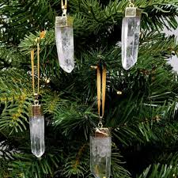

Chapter 5: 12 Days of Crystal Magic
Each day, choose one crystal and one intention:

Day 1: Gratitude (Citrine)
Day 2: Peace (Amethyst)
Day 3: Love (Rose Quartz)
Day 4: Protection (Garnet)
Day 5: Clarity (Clear Quartz)
Day 6: Joy (Citrine)
Day 7: Rest (Snowflake Obsidian)
Day 8: Abundance (Green Aventurine)
Day 9: Intuition (Labradorite)
Day 10: Healing (Amethyst)
Day 11: Reflection (Red Jasper)
Day 12: Renewal (Clear Quartz)

Carrying the Light Forward
Christmas teaches us that even in darkness, light returns.
Let your crystals remind you of this truth throughout the year. May the peace you cultivate now carry forward into every season.
Thank you for allowing AF Crystal Jewels to be part of your sacred journey.

