Kunzite: The Crystal of Divine Love and Emotional Healing

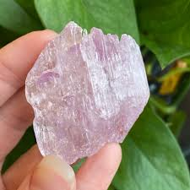

A Complete Guide to Spiritual, Emotional, and Energetic Transformation

By AF Crystal Jewels

Roxy Slabber

Table of Contents

* Introduction to Kunzite
* History and Discovery
* Physical Properties
* Metaphysical Properties
* Emotional and Spiritual Healing
* Kunzite and the Heart Chakra
* How to Use Kunzite in Daily Life
* Rituals and Affirmations
* Kunzite Pairings and Crystal Combinations
* Cleansing and Charging Kunzite
* Choosing and Caring for Your Kunzite
* Conclusion
* Bonus: Daily Affirmation Calendar

Chapter 1: Introduction to Kunzite

Kunzite is a high-vibrational crystal beloved for its delicate pink to violet hues and its powerful emotional healing properties. Known as the “Stone of Divine Love,” it opens the heart, calms the mind, and nurtures the soul. Kunzite is especially supportive for empaths, healers, and those seeking to release emotional trauma and reconnect with unconditional love.

Chapter 2: History and Discovery

Kunzite was discovered in 1902 in California by gemmologist George Frederick Kunz, after whom it was named. While it remains relatively new compared to ancient stones like quartz or jade, Kunzite has rapidly gained a reputation as one of the most spiritually potent gemstones. Its popularity has grown not only in metaphysical circles but also in fine jewellery due to its stunning colour and gentle energy.

Chapter 3: Physical Properties

Chemical Composition: Lithium aluminium silicate (Spodumene family)

Colour: Pink, lilac, violet (due to manganese content)

Hardness: 6.5 – 7 on the Mohs scale

Transparency: Transparent to translucent

Origin Locations: Afghanistan, Brazil, Madagascar, USA, Myanmar

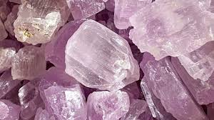

Chapter 4: Metaphysical Properties

Kunzite is a master healer of the emotional body and an amplifier of higher consciousness. It supports:

Heart healing & forgiveness

Divine feminine connection

Protection from energetic overwhelm

Expanded intuition

Emotional clarity and spiritual grounding

It resonates deeply with the Heart Chakra, Higher Heart, and sometimes the Third Eye, depending on its shade.

Chapter 5: Emotional and Spiritual Healing

Kunzite gently dissolves emotional walls and invites inner peace. It is ideal for:

Healing childhood wounds

Overcoming heartbreak or grief

Strengthening self-love and compassion

Balancing mood swings and emotional distress

Soothing anxiety and nervous energy

Kunzite is especially effective for sensitive souls—offering protection from emotional toxicity while amplifying inner resilience.

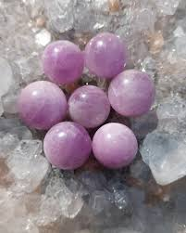

Chapter 6: Kunzite and the Heart Chakra

The heart chakra (Anahata) governs love, empathy, trust, and emotional balance. Kunzite:

Opens and clears blockages in the heart

Promotes forgiveness and emotional flow

Encourages romantic and platonic love

Connects you to universal divine love

Helps integrate spiritual compassion into daily actions

Affirmation:

“I am open to giving and receiving unconditional love.”

Chapter 7: How to Use Kunzite in Daily Life

Here are powerful ways to work with Kunzite:

Jewellery: Wear as a pendant or ring to stay emotionally balanced throughout the day.

Meditation: Hold Kunzite to the heart or third eye during meditation to elevate your frequency.

Sleep: Place under your pillow for emotional comfort and vivid dreams.

Elixirs: Infuse Kunzite energy into water using the indirect method (avoid direct contact with water).

Carry it: Keep a small piece in your pocket to ease social anxiety and overwhelm.

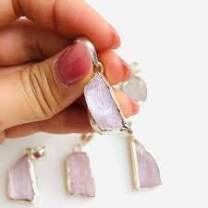

Chapter 8: Rituals and Affirmations

Heart Healing Ritual

What You’ll Need:

Kunzite crystal

A white candle

Rose or lavender essential oil

Steps:

Light the candle and anoint your heart space with a drop of essential oil.

Sit with Kunzite over your heart.

Breathe deeply and repeat:

“I release all that no longer serves my heart. I welcome healing, peace, and divine love.”

Sit in stillness for 10–15 minutes.

Daily Affirmations

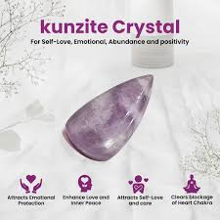“My heart is open, safe, and free.”

“I am guided by divine love and inner peace.”

“I forgive myself and others with grace.”

Chapter 9: Kunzite Pairings and Crystal Combinations

Pair Kunzite with the following crystals to amplify specific energies:

|  |  |
| --- | --- |
| Crystal | Purpose |
| Moonstone | Supporting feminine energy & cycles |
| Rose Quartz | Deepening unconditional love |
| Amethyst | Enhancing spiritual insight |
| Lepidolite | Anxiety relief and emotional calm |
| Black Tourmaline | Grounding and emotional protection |

Chapter 10: Cleansing and Charging Kunzite

Kunzite is a delicate crystal and must be cleansed gently.

Cleansing Methods:

Selenite slab or bowl, Sound (tuning fork or singing bowl), Moonlight (best during the Full Moon)

Avoid:

Direct sunlight (can fade colour)

Water (may damage surface or structure)

Charging:

Place near a rose quartz or amethyst cluster

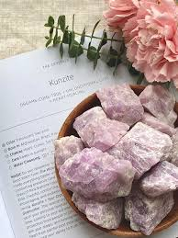Set intentions during the New Moon

Chapter 11: Choosing and Caring for Your Kunzite

When choosing a Kunzite crystal:

Trust your intuition. The one that draws your eye is likely aligned with your energy.

Choose by colour—paler shades for gentleness, deeper shades for emotional transformation.

Caring tips:

Store away from other hard crystals

Keep it out of long sun exposure

Recharge it with gentle energies regularly

Chapter 12: Conclusion

Kunzite is a heart-centred stone for those ready to love deeper, feel stronger, and live in alignment with their higher self. Whether you’re drawn to its beauty, its frequency, or its emotional support, Kunzite has the potential to be a lifelong ally in your spiritual journey.

Chapter 13: Bonus – 7-Day Affirmation Calendar

|  |  |
| --- | --- |
| Day | Affirmation |
|  |  |
| Day 1 | I am love. I radiate love. I attract love. |
| Day 2 | My heart is healing with every breath I take. |
| Day 3 | I deserve gentle, nurturing energy in all areas of my life. |
| Day 4 | I trust my emotions and honour their messages. |
| Day 5 | I am safe, supported, and seen. |
| Day 6 | Love flows through me like light. |
| Day 7 | I embrace emotional freedom and soul clarity. |

