Apophyllite: The Light-Bringer Crystal

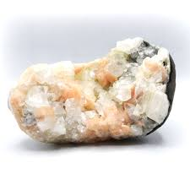

A Guide to Healing, Clarity & Spiritual Awakening

By AF Crystal Jewels

Table of Contents

1. Introduction
2. What is Apophyllite?
3. Origins and Varieties
4. Metaphysical Properties
5. Apophyllite and the Chakras
6. Healing Benefits
7. How to Use Apophyllite
8. Rituals with Apophyllite
9. Pairing Apophyllite with Other Crystals
10. Cleansing and Charging Apophyllite
11. Apophyllite in the Home & Sacred Spaces
12. Apophyllite Affirmations
13. Final Thoughts

Chapter 1: Introduction

In the realm of healing crystals, few stones carry the ethereal brilliance and spiritual depth of Apophyllite. Often described as a crystal of light, truth, and divine connection, Apophyllite is beloved by energy healers, lightworkers, and crystal lovers around the world.

This guide will walk you through Apophyllite’s magical properties, healing uses, spiritual connections, and practical ways to work with this radiant gem. Whether you’re just starting your crystal journey or deepening your practice, this book will illuminate the path Apophyllite offers.

Chapter 2: What is Apophyllite?

Apophyllite is a translucent to transparent mineral from the phyllosilicate family, often found in volcanic rock. It commonly forms in natural pyramid shapes or square clusters, sparkling with a pearlescent glow.

Its name is derived from the Greek word “apophylliso,” meaning “it flakes off,” referencing its tendency to flake when heated. Despite its fragility, Apophyllite is spiritually powerful and highly sought after for its calming and high-vibrational energy.

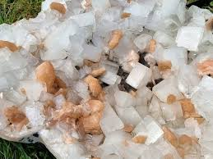

Chapter 3: Origins and Varieties

Apophyllite is most commonly found in:

India (the largest exporter, particularly from Maharashtra)

Brazil

Canada

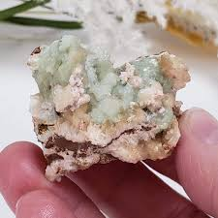Iceland

United States

Varieties:

Clear Apophyllite – Enhances spiritual insight and clarity.

Green Apophyllite – A rare form that deepens heart-centred healing and connects to nature.

Stilbite with Apophyllite – Often forms together, blending intuitive and heart energy.

Each variety carries unique energetic frequencies, though all share the qualities of purity, peace, and connection to higher realms.

Chapter 4: Metaphysical Properties

Apophyllite is known as a conduit between the physical and spiritual worlds. Its metaphysical attributes include:

Enhancing intuition and psychic abilities

Promoting clarity of thought and emotion

Acting as a powerful meditation aid

Creating a strong connection to angelic realms and spirit guides

Clearing negative thought patterns and emotional blockages

Helping access the Akashic Records or past life memories

Its high vibration helps to amplify the energy of other crystals and raise the frequency of a room or person.

Chapter 5: Apophyllite and the Chakras

|  |  |
| --- | --- |
| Chakra | Effect of Apophyllit |
| Third Eye (Ajna) | Enhances spiritual vision, intuition, and clarity |
| Crown (Sahasrara) | Promotes divine connection, enlightenment, and purity |
| Heart (Anahata) (especially with Green Apophyllite) | Encourages emotional healing and compassion |

Apophyllite’s energy flows upward, activating the higher chakras while gently balancing the heart.

Chapter 6: Healing Benefits

Emotional Healing:

Calms anxiety and panic attacks

Clears mental fog and emotional confusion

Supports inner peace during grief or transition

Physical Healing (Energetically):

Aids respiratory healing and asthma (used traditionally in India)

Relieves eye strain and tension headaches

Supports reiki and energy healing treatments

Note: Crystal healing is complementary and not a substitute for medical treatment.

Chapter 7: How to Use Apophyllite

Meditation: Hold a piece or place it on your third eye or crown chakra.

Energy Healing: Use during Reiki or crystal layouts.

Journaling Aid: Keep Apophyllite nearby to inspire honest reflection.

Under the Pillow: Promotes vivid dreams and divine guidance.

Workspaces: Reduces stress, mental overload, and clears EMF energy.

Apophyllite works best when used with intention and a quiet, open heart.

Chapter 8: Rituals with Apophyllite

Morning Light Ritual

Sit in natural sunlight with Apophyllite in your palm.

Inhale deeply and say:

“I awaken to the truth of who I am. I am clarity. I am light.”

Full Moon Charging & Reflection

Place Apophyllite under the moonlight.

Journal: What truths are being illuminated in your life right now?

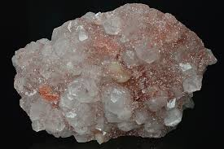

Divine Guidance Ritual

Create a sacred space with a candle and Apophyllite.

Ask your higher self or spirit guides a question.

Sit in meditation and receive insights.

Chapter 9: Pairing Apophyllite with Other Crystals

|  |  |
| --- | --- |
| Crystal | Synergy |
| Selenite | Amplifies purity and angelic connection |
| Amethyst | Deepens intuition and spiritual protection |
| Clear Quartz | Boosts Apophyllites clarity and energy output |
| Celestite | Invokes peace and celestial communication |
| Green Apophyllite + Rose Quartz | Powerful for heart healing and emotional release |

These pairings create high-frequency energy ideal for meditation, healing, or ritual work.

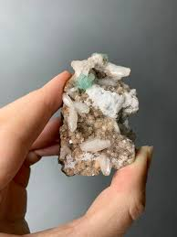

Chapter 10: Cleansing and Charging Apophyllite

Cleansing Methods:

Moonlight

Selenite plate

Sound (singing bowls, chimes)

Smoke (sage, palo santo)

Avoid water cleansing, as Apophyllite can be delicate and may flake.

Charging Methods:

Sunlight (briefly, avoid fading)

Meditation with intention

Visualization of white or golden light infusing the stone

Chapter 11: Apophyllite in the Home & Sacred Spaces

Apophyllite is ideal for:

Meditation rooms

Healing spaces

Bedrooms (promotes peaceful sleep)

Altar or sacred space décor

Living rooms or communal areas (clears energy and tension)

Its light-reflective surfaces help maintain a vibration of truth, tranquillity, and harmony in any space.

Chapter 12: Apophyllite Affirmations

Use these affirmations with your crystal daily:

“I am connected to divine truth and light.”

“My energy is clear, calm, and open.”

“I trust my intuition and receive divine guidance.”

“I radiate clarity, peace, and love.”

“I release fear and embrace spiritual truth.”

Repeat affirmations while holding your crystal or gazing into its natural prism-like surfaces.

Chapter 13: Final Thoughts

Apophyllite is not just a beautiful crystal—it’s a spiritual ally, a mirror of inner clarity, and a beacon of light in challenging times. Whether you’re meditating with it, placing it in your sacred space, or simply admiring its glow, Apophyllite invites you to return to your truth and embrace your inner light.

Let this radiant stone support you on your journey toward healing, awakening, and divine connection.

