The Power of Pink: A Complete Guide to Pink Amethyst & Pink Agate Crystals”

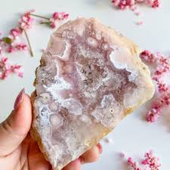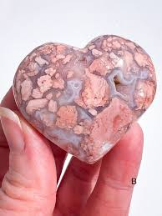

The Power of Pink

A Complete Guide to Pink Amethyst & Pink Agate Crystals

By AF Crystal Jewels

Table of Contents

1. Introduction to Pink Crystals
2. What is Pink Amethyst?
3. Healing Properties of Pink Amethyst
4. Spiritual Significance of Pink Amethyst
5. Uses of Pink Amethyst in Daily Life
6. What is Pink Agate?
7. Healing Properties of Pink Agate
8. Spiritual Significance of Pink Agate
9. Uses of Pink Agate in Daily Life
10. Pink Amethyst vs. Pink Agate: Key Differences
11. How to Cleanse, Charge & Store Pink Crystals
12. Rituals & Meditations Using Pink Amethyst
13. Rituals & Meditations Using Pink Agate
14. Crystal Pairings & Grids with Pink Amethyst
15. Crystal Pairings & Grids with Pink Agate
16. Affirmations for Love, Self-Worth & Inner Peace
17. Final Thoughts: Embracing the Power of Pink

**1. Introduction to Pink Crystals**

Pink crystals embody the energy of the heart, self-love, emotional healing, and peace. While rose quartz often takes centre stage, pink amethyst and pink agate offer rare, refined, and powerful alternatives that blend beauty with transformative energy.

**2. What is Pink Amethyst?**

Pink amethyst is a rare variety of amethyst discovered mainly in Patagonia, Argentina. Its pink hue is a result of hematite inclusions. Unlike the deep violet amethyst, it offers a softer, more heart-centred vibration.

**3. Healing Properties of Pink Amethyst**

* Emotional Healing: Soothes grief, sadness, and anxiety.
* Calming Energy: Reduces overthinking and worry.
* Self-Worth: Encourages healthy boundaries and inner confidence.
* Spiritual Detox: Clears energetic blocks gently but effectively.

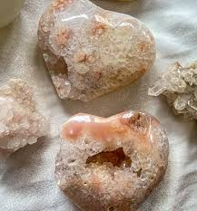

**4. Spiritual Significance of Pink Amethyst**

This crystal bridges the heart and crown chakras, uniting compassion with spiritual insight. It fosters divine feminine energy, angelic connection, and inner peace.

**5. Uses of Pink Amethyst in Daily Life**

* Place in bedrooms to enhance restful sleep.
* Wear as jewellery for gentle emotional support.
* Meditate with it to open the heart and higher self.
* Use during breathwork to deepen emotional release.

**6. What is Pink Agate?**

Pink agate is a variety of banded chalcedony, typically dyed or found naturally with beautiful layers in shades of pink. It is stabilizing, grounding, and deeply nurturing.

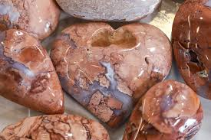

**7. Healing Properties of Pink Agate**

* Stabilization: Grounds and anchors your energy.
* Nurturing Love: Promotes maternal, protective love.
* Emotional Rebalancing: Calms rage, resentment, or emotional trauma.
* Inner Child Healing: Connects to early wounds with compassion.

**8. Spiritual Significance of Pink Agate**

Pink agate is associated with the root and heart chakras. It strengthens the emotional body and enhances one’s sense of safety in love and relationships.

**9. Uses of Pink Agate in Daily Life**

* Carry as a pocket stone for emotional grounding.
* Place in the home for a calm, safe environment.
* Include in rituals to heal inner child wounds.
* Use in massage or facial tools to release tension.

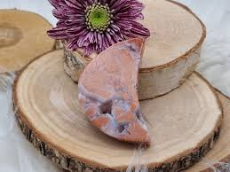

**10. Pink Amethyst vs. Pink Agate: Key Differences**

|  |  |  |
| --- | --- | --- |
| **Feature** | **Pink Amethyst** | **Pink Agate** |
| Crystal System | Trigonal (Quartz family) | Hexagonal (Chalcedony/Quartz) |
| Vibration | High (spiritual + emotional) | Medium (grounding + emotional) |
| Energy Focus | Heart-Crown alignment | Root-Heart balance |
| Primary Benefit | Spiritual and emotional insight | Grounded emotional stability |
| Appearance | Soft pink, often druzy or raw forms | Layered pink bands, often polished |

**11. How to Cleanse, Charge & Store Pink Crystals**

* Cleansing: Use smoke, sound, or moonlight. Avoid water for druzy specimens.
* Charging: Full moon, selenite plate, or sunlight (briefly).
* Storing: Wrap in soft cloth, away from harsh light and metals.

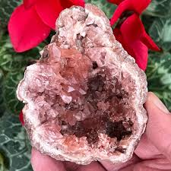

**12. Rituals & Meditations Using Pink Amethyst**

Self-Worth Heart Meditation:

Hold pink amethyst to your heart, breathe deeply, and repeat:

“I am worthy of love, peace, and divine connection.”

Grief Release Ritual:

Place pink amethyst on your chest while lying down. Visualize pink light dissolving sadness.

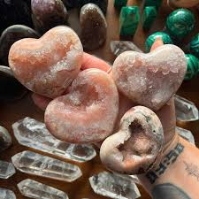

**13. Rituals & Meditations Using Pink Agate**

Inner Child Healing Ritual:

Hold pink agate while journaling to your younger self. Invite compassion and forgiveness.

Stability Grounding Practice:

Sit with pink agate in each hand. Imagine roots growing from your feet into the earth.

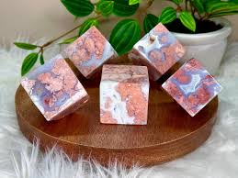

**14. Crystal Pairings & Grids with Pink Amethyst**

* With Lepidolite: For anxiety and deep calm
* With Selenite: To amplify spiritual guidance
* With Rose Quartz: For divine love and emotional healing  
  Create a grid with pink amethyst at the centre, forming a heart shape with rose quartz around it.

**15. Crystal Pairings & Grids with Pink Agate**

* With Black Tourmaline: For protection and grounding
* With Moonstone: For emotional nurturing and cycles
* With Carnelian: For gentle confidence  
  Try a flower-like grid with pink agate at the centre and moonstone petals.

**16. Affirmations for Love, Self-Worth & Inner Peace**

* “I am safe to feel deeply and heal fully.”
* “Love flows to me and through me.”
* “I honour my heart, my spirit, and my truth.”
* “I stand strong in compassion and grace.”
* “I am grounded in peace, wrapped in love.”

**17. Final Thoughts: Embracing the Power of Pink**

Pink amethyst and pink agate are more than beautiful crystals—they are allies in your emotional, spiritual, and energetic healing. Whether you’re navigating heartbreak, seeking self-love, or looking to feel grounded in your spiritual path, these pink stones will walk beside you.

Let them remind you that softness is strength, and the heart holds the greatest power of all.

