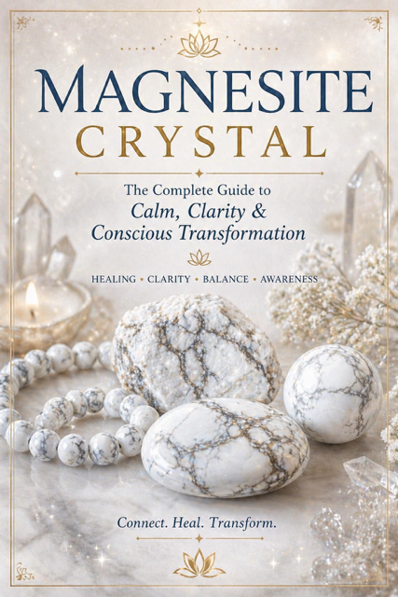
Magnesite Crystal: The Complete Guide to Calm, Clarity & Conscious Transformation

Table of Contents

- Introduction to Magnesite
- History & Origins
- Geological Formation & Properties
- Types & Varieties of Magnesite
- Metaphysical & Healing Properties
- Emotional & Mental Benefits
- Physical Healing Associations
- Magnesite & the Chakras
- Magnesite in Meditation & Spiritual Work
- How to Use Magnesite Daily
- Magnesite Rituals & Practices
- Crystal Pairings & Synergies
- Cleansing, Charging & Care
- Identifying Real vs Fake Magnesite
- FAQs About Magnesite
- Final Thoughts & Affirmations

1. Introduction to Magnesite
Magnesite is a powerful, yet often underrated crystal known for its deeply calming and mind-expanding properties. With its soft, milky white appearance, often veined with grey or brown, it carries a gentle but transformative energy that works on both emotional balance and higher consciousness.

This crystal is particularly valued for promoting peace, self-awareness, and clarity of thought, making it an essential tool for those navigating stress, overthinking, or spiritual awakening.

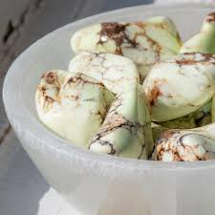

2. History & Origins
Magnesite has been used historically for both industrial and metaphysical purposes. While it is widely known as a source of magnesium, ancient cultures also recognised its calming influence on the mind and body.
It is found in regions such as:
- Austria
- Brazil
- China
- USA
- South Africa
Its name derives from its high magnesium content, linking it energetically to grounding and physical balance.

3. Geological Formation & Properties
Magnesite is a magnesium carbonate mineral formed through the alteration of magnesium-rich rocks.
Key Properties:
Colour: White, cream, grey, sometimes dyed turquoise
Hardness: 3.5–5 (Mohs scale)
Composition: Magnesium carbonate (MgCO₃)
Structure: Porous and often matte
Due to its porous nature, magnesite is sometimes dyed to resemble turquoise—something to be aware of when purchasing.
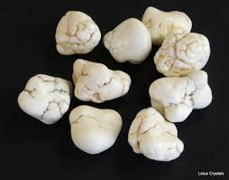

4. Types & Varieties of Magnesite
While naturally white, magnesite can appear in different forms:
- Raw Magnesite – Stronger, grounding energy
- Polished Magnesite – Softer, more soothing vibration
- Dyed Magnesite – Often blue; primarily decorative
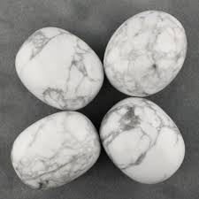
- Howlite vs Magnesite – Frequently confused due to similar appearance
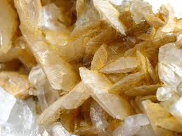

5. Metaphysical & Healing Properties
Magnesite is often referred to as a stone of deep peace and awareness.
Core Energies:
- Calming and soothing
- Enhances self-reflection
- Supports emotional release
- Expands higher consciousness
- Strengthens intuition
It encourages you to slow down, observe your thoughts, and release patterns that no longer serve you.

6. Emotional & Mental Benefits
Magnesite is particularly effective for emotional regulation and mental clarity.
Supports:
- Anxiety and overwhelm
- Overthinking and racing thoughts
- Emotional triggers and reactions
- Patience and tolerance
It teaches emotional responsibility—helping you respond rather than react.

7. Physical Healing Associations
While not a replacement for medical care, magnesite is traditionally associated with:
- Muscle relaxation
- Nervous system support
- Magnesium-related balance
- Improved sleep quality
Its calming frequency is often used in energy healing to reduce tension in the body.

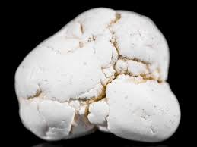

8. Magnesite & the Chakras
Magnesite primarily resonates with:
- Crown Chakra – Enhances spiritual awareness
- Third Eye Chakra – Supports insight and intuition
- Heart Chakra – Encourages compassion and emotional healing
It creates a bridge between the heart and higher consciousness.

9. Magnesite in Meditation & Spiritual Work
Magnesite is an exceptional meditation stone.
Benefits during meditation:
- Deepens stillness
- Enhances visualisation
- Opens intuitive channels
- Promotes spiritual downloads
Practice Tip:
Hold magnesite in your hand or place it on your third eye to quiet the mind and enter deeper states of awareness.

10. How to Use Magnesite Daily
Incorporating magnesite into your routine can create lasting calm.
Simple uses:
- Carry it to reduce stress throughout the day
- Place under your pillow for better sleep
- Keep on your desk to stay mentally clear
- Wear as jewellery for continuous support
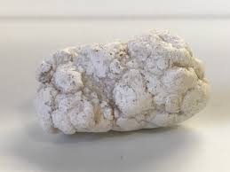
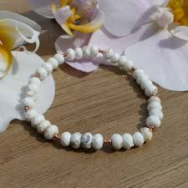

11. Magnesite Rituals & Practices
Calm Mind Ritual
- Sit quietly with magnesite
- Focus on your breath
- Visualise stress dissolving
- Emotional Release Ritual
- Hold the stone over your heart
- Speak what you need to release
- Imagine the energy leaving your body
- Sleep Enhancement Ritual

Place magnesite beside your bed
Set an intention for restful sleep

12. Crystal Pairings & Synergies
Magnesite works beautifully with:
- Amethyst – Deep spiritual calm
- Rose Quartz – Emotional healing
- Lepidolite – Anxiety relief
- Clear Quartz – Amplification of clarity
- Selenite – Higher consciousness activation

13. Cleansing, Charging & Care
Due to its porous nature, magnesite requires gentle care.
Avoid:
- Water soaking
- Harsh chemicals

Best cleansing methods:
- Smoke cleansing (sage, palo santo)
- Sound (singing bowls)
- Moonlight charging

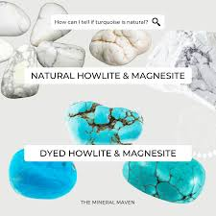
14. Identifying Real vs Fake Magnesite
Because it is often dyed, authenticity matters.
Real Magnesite:
- Soft white colour
- Natural veining
- Matte or slightly chalky texture
Dyed Magnesite:
- Bright blue or unnatural colours
- Often sold as “turquoise”

15. Frequently Asked Questions
Is magnesite good for anxiety?
Yes, it is one of the most effective calming stones.

Can I sleep with magnesite?
Absolutely, it promotes deep, restful sleep.

Is it safe to wear daily?
Yes, but handle gently due to its softness.
16. Final Thoughts & Affirmations
Magnesite is a quiet yet powerful ally for those seeking peace, clarity, and emotional balance. It doesn’t overwhelm, it gently guides you back to yourself.

Affirmations for Magnesite
I am calm, centred, and at peace.
My mind is clear and focused.
I release all tension and embrace stillness.
I trust my inner wisdom.
Peace flows through me effortlessly.

