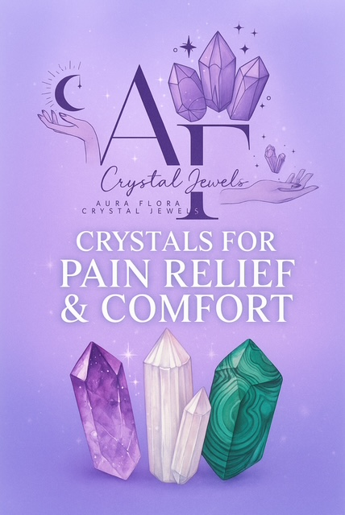
Table of Contents

Introduction – The Healing Power of Crystals
Understanding Pain from an Energetic Perspective
How Crystals Alleviate Pain and Discomfort
Top 10 Crystals for Pain Relief
- Amethyst
- Lepidolite
- Hematite
- Black Tourmaline
- Malachite
- Selenite
- Blue Lace Agate
- Smoky Quartz
- Chrysocolla
- Amber

Crystal Pairings for Specific Ailments
How to Use Crystals for Pain Relief
Daily Rituals for Healing & Comfort
Cleansing and Charging Your Crystals
Affirmations for Pain-Free Living
Final Thoughts – Reclaiming Your Energy Through Healing Stones

Chapter 1: Introduction – The Healing Power of Crystals
Pain is more than a physical sensation — it is a message from the body and soul that something needs attention, release, or balance.
Crystals, with their stable vibrational frequencies, act as allies in the journey to healing by helping to realign the body’s energetic fields.
Each crystal carries unique mineral compositions and vibrational patterns that influence the body’s electromagnetic field, easing discomfort, soothing emotions, and promoting natural restoration.
In this guide, we will explore the most powerful stones known to relieve physical, emotional, and energetic pain — helping you restore peace, comfort, and vitality.

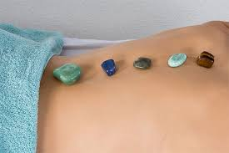

Chapter 2: Understanding Pain from an Energetic Perspective
From an energetic point of view, pain occurs when energy flow becomes blocked or stagnant.
Whether the cause is physical injury, emotional trauma, or spiritual imbalance, unexpressed energy often lodges itself in the body’s energetic meridians or chakras.
When you hold or wear crystals, their energy can help dissolve these blockages, allowing your life force — or prana — to flow freely again. This restores harmony not just to your body, but to your emotional and spiritual layers as well.
Common energetic causes of pain:
Emotional suppression (heart or throat chakra imbalance)
Stress or overthinking (third eye or crown imbalance)
Physical strain or grounding issues (root or sacral imbalance)

Chapter 3: How Crystals Alleviate Pain and Discomfort
Crystals work on multiple levels:
Energetically – They absorb and transmute stagnant or painful vibrations.
Emotionally – They calm the nervous system and ease tension.
Physically – Some stones resonate with the body’s mineral structure, promoting balance and detoxification.
Spiritually – They help release karmic or emotional pain linked to deeper patterns.

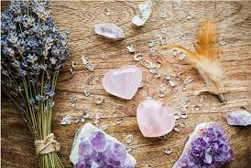

Chapter 4: Top 10 Crystals for Pain Relief

1. Amethyst – The Soothing Healer
Colour: Purple to lavender
Chakra: Crown & Third Eye
Healing Properties: Eases tension headaches, reduces inflammation, and promotes relaxation.
How to Use: Place on the forehead for migraines or under your pillow for nightly relief.
Affirmation: “I release all pain and allow peace to flow through me.”

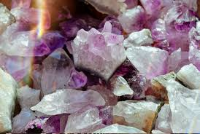

2. Lepidolite – The Calming Stone
Colour: Lilac, pinkish-purple
Chakra: Heart, Third Eye, Crown
Healing Properties: Contains natural lithium; relieves anxiety-related pain and muscle tension.
How to Use: Hold during deep breathing or place on sore muscles during meditation.
Affirmation: “Calmness and comfort fill every cell of my being.”

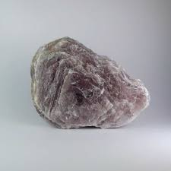

3. Hematite – The Grounding Protector
Colour: Metallic grey-black
Chakra: Root
Healing Properties: Excellent for joint pain, back pain, and grounding energy after trauma.
How to Use: Wear as a bracelet or place near the lower back.
Affirmation: “My body feels strong, balanced, and supported.”
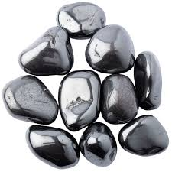

4. Black Tourmaline – The Energy Shield
Colour: Black
Chakra: Root
Healing Properties: Absorbs electromagnetic and emotional pain; stabilizes nerves.
How to Use: Keep near electronics or wear daily for protection.
Affirmation: “I am shielded from pain and filled with pure healing light.”

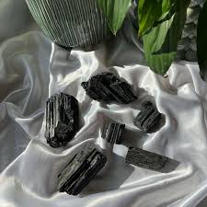

5. Malachite – The Stone of Transformation
Colour: Deep green with swirls
Chakra: Heart & Solar Plexus
Healing Properties: Known for drawing out inflammation, joint pain, and emotional distress.
How to Use: Place over painful areas (use polished stones; not raw).
Affirmation: “Healing energy flows freely through every part of me.”

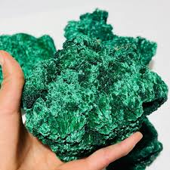

6. Selenite – The Liquid Light Crystal
Colour: Translucent white
Chakra: Crown
Healing Properties: Clears pain energy and aligns the body with pure light.
How to Use: Sweep a selenite wand over the body to remove blockages.
Affirmation: “My energy is cleansed, clear, and radiant.”

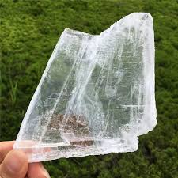

7. Blue Lace Agate – The Tranquillity Stone
Colour: Soft blue with white bands
Chakra: Throat
Healing Properties: Relieves throat tension, neck pain, and emotional strain.
How to Use: Wear as a pendant or hold during meditation.
Affirmation: “I speak and live my truth with ease and serenity.”

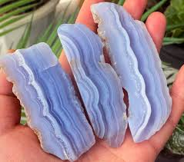

8. Smoky Quartz – The Pain Absorber
Colour: Brown to smoky grey
Chakra: Root
Healing Properties: Absorbs pain, detoxifies the body, and eases chronic fatigue.
How to Use: Place on areas of discomfort or carry in your pocket daily.
Affirmation: “I release pain and anchor myself in calm, healing energy.”

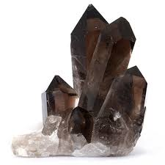

9. Chrysocolla – The Gentle Goddess Stone
Colour: Blue-green
Chakra: Heart & Throat
Healing Properties: Eases menstrual cramps, muscle aches, and emotional heartache.
How to Use: Place on abdomen or heart area during rest.
Affirmation: “I am surrounded by comfort, compassion, and peace.”
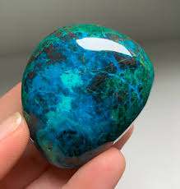

10. Amber – The Ancient Healer
Colour: Golden honey
Chakra: Solar Plexus
Healing Properties: Soothes arthritis, joint pain, and stress-related tension.
How to Use: Wear as jewellery for long-term relief.
Affirmation: “Golden light fills my body with comfort and warmth.”

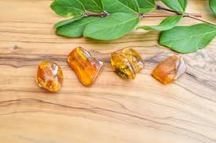

Chapter 5: Crystal Pairings for Specific Ailments

Condition | Recommended Crystals | Notes
Headaches & Migraines | Amethyst + Selenite | Place on temples or forehead
Joint Pain | Malachite + Amber | Massage gently with oil (avoid raw malachite)
Back Pain | Hematite + Smoky Quartz | Place behind lower back during rest
Emotional Pain | Lepidolite + Chrysocolla | Hold during meditation or journaling
Nerve Pain | Black Tourmaline + Selenite | Sweep energy field with selenite wand
Menstrual Cramps | Chrysocolla + Moonstone | Place over womb area for comfort

Chapter 6: How to Use Crystals for Pain Relief
Meditation: Hold a stone in your hand while focusing on the area of pain. Visualize healing light dissolving discomfort.
Crystal Layouts: Place crystals directly on energy centres (chakras) while lying down.
Elixirs: For certain safe stones, create crystal-charged water (use indirect method for non-water-safe stones).
Massage Tools: Use polished wands or spheres to gently roll over sore areas.
Daily Wear: Bracelets and pendants maintain consistent energy contact.

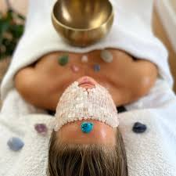

Chapter 7: Daily Rituals for Healing & Comfort
Morning Ritual:
Hold Selenite and Amethyst.
Say: “Today I move through life with ease and comfort.”
Take 3 deep breaths while visualizing white light enveloping your body.
Evening Ritual:
Place Lepidolite or Chrysocolla under your pillow.
Say: “My body restores itself as I rest in calm and peace.”
Weekly Ritual:
Cleanse your crystals with moonlight or sound.
Journal about any changes in your physical or emotional sensations.

Chapter 8: Cleansing and Charging Your Crystals
Moonlight: Place under full moon for emotional cleansing.
Selenite: Lay crystals on a selenite charging plate.
Sound: Use singing bowls or gentle chimes to purify vibrations.
Visualization: Imagine white light enveloping the stone.

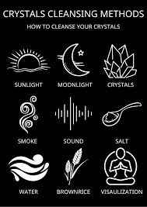

Chapter 9: Affirmations for Pain-Free Living
“My body is in perfect alignment with health and harmony.”
“I release discomfort and invite healing energy into every cell.”
“I am strong, peaceful, and free of pain.”
“Healing energy flows easily through my body and spirit.”
“Each breath I take fills me with renewed vitality.”

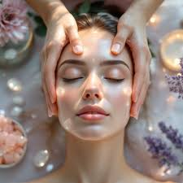

Chapter 10: Final Thoughts – Reclaiming Your Energy Through Healing Stones
Pain can be both a teacher and a messenger.
Crystals remind us that within every ache lies the potential for transformation.
When you align with the gentle vibrations of these sacred stones, you awaken your body’s natural ability to heal itself.
Let your crystals be companions in your journey toward a pain-free, peaceful, and empowered life.
“Healing is not just the absence of pain, but the presence of peace.”

