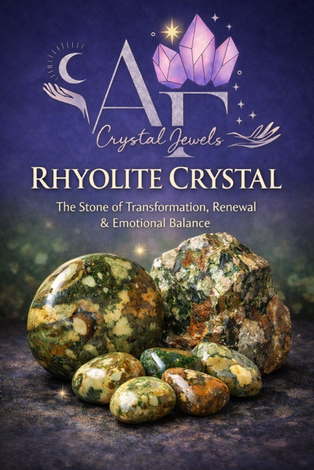
RHYOLITE CRYSTAL
The Stone of Transformation, Renewal & Emotional Balance

Copyright & Disclaimer
© AF Crystal Jewels. All rights reserved.
No part of this publication may be reproduced or distributed without written permission.
This book is for spiritual and educational purposes only and does not replace professional medical or psychological advice.

Table of Contents
Introduction to Rhyolite
What Is Rhyolite?
History & Cultural Significance
Geological Formation & Origins
Physical Appearance & Varieties
Metaphysical Properties
Emotional & Mental Healing Benefits
Spiritual & Energetic Benefits
Chakra Associations
Zodiac & Astrological Connections
Elemental Energy & Vibrational Frequency
Rhyolite in Manifestation Work
Rhyolite for Shadow Work & Inner Healing
Meditation Practices with Rhyolite
Crystal Pairings & Synergies
Using Rhyolite in Daily Life
Feng Shui & Space Clearing
Jewellery & Wearable Energy
Care, Cleansing & Charging
How to Identify Authentic Rhyolite
Ethical Sourcing & Buying Tips
Frequently Asked Questions
Affirmations for Rhyolite
Final Reflections

1. Introduction to Rhyolite
Rhyolite is a powerful stone of personal transformation, emotional integration, and self-acceptance. Often overlooked compared to more popular crystals, rhyolite carries a deeply grounding yet expansive frequency that supports inner growth while gently releasing emotional stagnation.
Known for its intricate patterns and earthy tones, rhyolite encourages you to embrace change with confidence and reconnect with your authentic self.
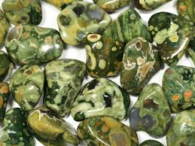

2. What Is Rhyolite?
Rhyolite is a volcanic igneous rock formed from rapidly cooled lava rich in silica. Though technically a rock rather than a single mineral, its energetic composition makes it a respected and widely used crystal in metaphysical practices.
It is sometimes sold under trade names such as Rainforest Rhyolite or Rainforest Jasper (though it is not a true jasper).

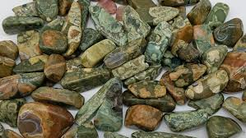

3. History & Cultural Significance
Ancient cultures revered volcanic stones for their connection to creation, destruction, and rebirth. Rhyolite, formed from explosive volcanic activity, symbolises the alchemical power of transformation—breaking down the old to give rise to the new.
Indigenous traditions associated patterned stones with earth wisdom, ancestral memory, and cyclical renewal.

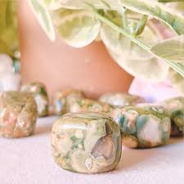

4. Geological Formation & Origins
Rhyolite forms when lava cools rapidly near the Earth’s surface, trapping gases and minerals that create its distinctive swirling patterns.
Major sources include:
- Australia
- United States
- Mexico
- India
- Madagascar
Each region produces slightly different colourations and energetic nuances.

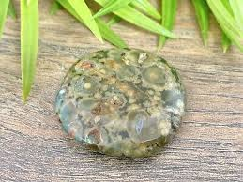

5. Physical Appearance & Varieties
Rhyolite is known for its mottled, orbicular, or flow-banded patterns.
Common colours include:
- Green
- Brown
- Cream
- Yellow
- Grey
- Rust red
Rainforest Rhyolite often features moss-like inclusions that amplify its grounding and nature-connected energy.

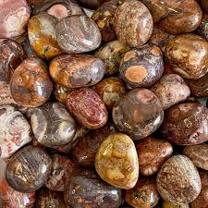

6. Metaphysical Properties
Rhyolite works on both grounded and higher emotional levels, making it ideal for long-term inner work.
Core energetic themes:
- Transformation
- Emotional balance
- Self-worth
- Resilience
- Integration of past experiences

It helps you move forward without denying or suppressing your history.

7. Emotional & Mental Healing Benefits
Rhyolite is especially supportive during periods of emotional upheaval or self-reflection.
It assists with:
- Releasing emotional trauma
- Healing suppressed grief
- Reducing anxiety rooted in past events
- Strengthening emotional resilience
- Encouraging self-compassion

This is a stone that reminds you that growth does not require force—only honesty and patience.

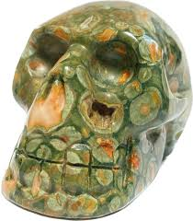

8. Spiritual & Energetic Benefits
Spiritually, rhyolite encourages:
- Soul integration
- Acceptance of life lessons
- Alignment with life purpose
- Grounded spiritual awakening
It supports those who are evolving spiritually but wish to remain deeply connected to everyday reality.

9. Chakra Associations
Rhyolite primarily works with:

• Heart Chakra – emotional healing, compassion
• Solar Plexus Chakra – confidence, personal power
• Root Chakra – grounding, stability
Its multi-chakra nature makes it excellent for holistic energy balancing.

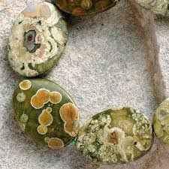

10. Zodiac & Astrological Connections
Rhyolite resonates strongly with:

• Taurus – grounding and emotional security
• Virgo – integration and self-improvement
• Sagittarius – growth through life experience
It is especially helpful during major astrological transitions or personal life changes.

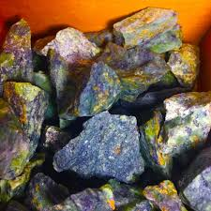

11. Elemental Energy & Vibration

• Element: Earth
• Secondary Influence: Fire (from volcanic origin)
• Vibration: Slow, steady, deeply stabilising
This unique Earth-Fire blend supports grounded transformation rather than chaotic change.

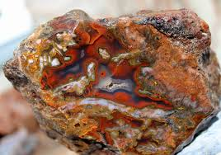

12. Rhyolite in Manifestation Work
Rhyolite is ideal for manifestation rooted in realistic, aligned growth.
Best used for manifesting:

• Emotional stability
• Career direction
• Personal growth goals
• Long-term success
• Self-belief

Unlike fast-acting manifestation stones, rhyolite builds results sustainably.

13. Rhyolite for Shadow Work
This crystal is highly effective for shadow work because it provides emotional safety while exploring deeper layers of the psyche.
It helps you:

• Acknowledge past wounds
• Integrate rejected aspects of self
• Release shame and guilt
• Transform pain into wisdom

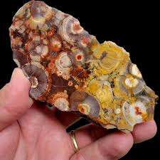

14. Meditation Practices with Rhyolite
Simple grounding meditation:

1. Hold rhyolite over your heart or solar plexus
2. Breathe slowly and deeply
3. Visualise roots connecting you to the Earth
4. Allow memories or emotions to surface gently
5. Affirm acceptance and release

15. Crystal Pairings & Synergies
Powerful combinations:
- Rhyolite + Rose Quartz → emotional healing
- Rhyolite + Citrine → confidence & growth
- Rhyolite + Smoky Quartz → grounding & release
- Rhyolite + Green Aventurine → renewal & abundance

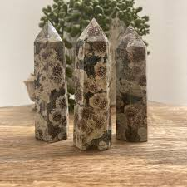

16. Using Rhyolite in Daily Life

Carry in your pocket for emotional steadiness
Place on your desk for calm productivity
Sleep nearby for gentle subconscious healing
Use during journaling or reflection practices

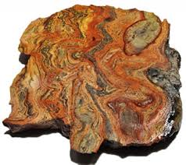

17. Feng Shui & Space Clearing
Place rhyolite in:
- Living rooms for emotional harmony
- Healing spaces for grounding energy
- Entryways for stabilising external influences

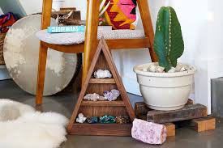

18. Jewellery & Wearable Energy
Worn as jewellery, rhyolite offers:
Continuous emotional grounding
Heart-centred energy throughout the day
Subtle confidence support
Bracelets and pendants are particularly effective.

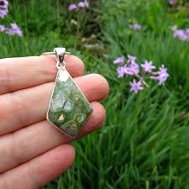

19. Care, Cleansing & Charging
Cleansing methods:
- Smoke (sage, palo santo)
- Sound (singing bowls)
- Moonlight

Avoid prolonged water immersion.

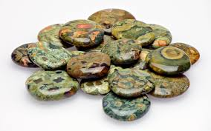

20. How to Identify Authentic Rhyolite
Authentic rhyolite features:
Natural, irregular patterns
Earthy colour palettes
Matte or softly polished surfaces
Uniform colours or plastic-like shine may indicate imitation.

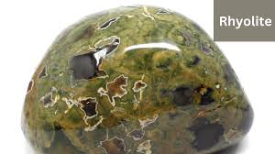

21. Ethical Sourcing & Buying Tips

Choose sellers who:
Provide origin transparency
Avoid dyed or mislabelled stones
Support ethical mining practices

22. Frequently Asked Questions

Is rhyolite safe for beginners?
Yes. Its gentle grounding energy makes it suitable for all levels.

Can rhyolite be used daily?
Absolutely. It supports long-term emotional balance.

23. Affirmations for Rhyolite
I embrace change with strength and grace.
My past experiences empower my present growth.
I am grounded, balanced, and emotionally whole.
Transformation flows through me naturally.

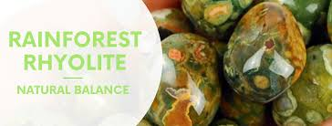

24. Final Reflections
Rhyolite is a reminder that transformation does not require struggle. Through patience, grounding, and self-acceptance, this stone gently guides you toward wholeness.
It is not a crystal of quick fixes—but of lasting evolution.

