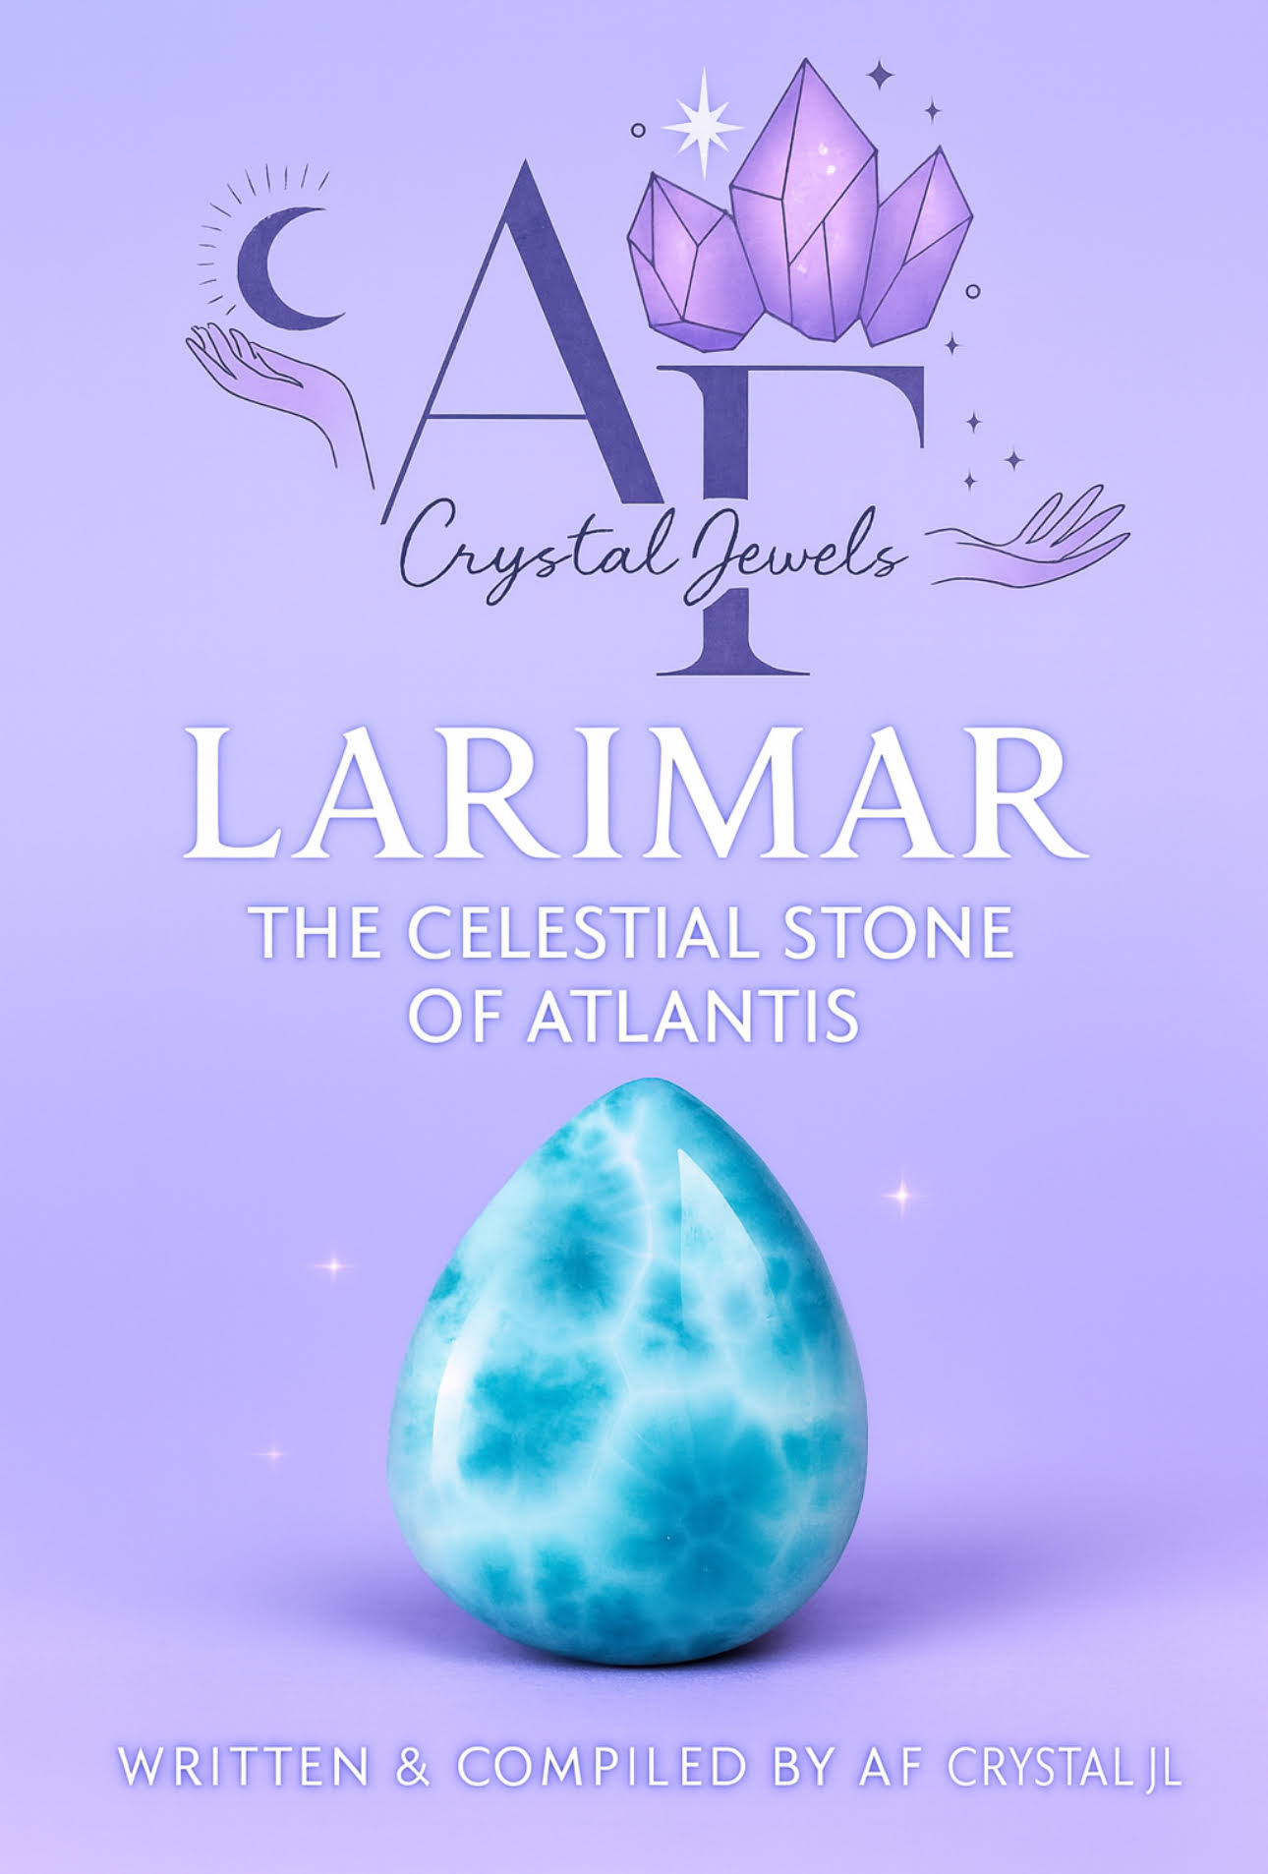
LARIMAR: THE CELESTIAL STONE OF ATLANTIS
A Complete Guide to Meaning, Healing, Rituals & Spiritual Power

Table of Contents
Introduction: The Ocean Stone of Heaven
Chapter 1 – The Birth of Larimar
Chapter 2 – Geological Formation & Rarity
Chapter 3 – The Lore of Atlantis & Larimar
Chapter 4 – Energetic Properties & Spiritual Meaning
Chapter 5 – Larimar & the Chakras
Chapter 6 – Emotional Healing with Larimar
Chapter 7 – Physical & Metaphysical Healing Traditions
Chapter 8 – Larimar for Intuition, Spiritual Growth & Psychic Abilities
Chapter 9 – Manifestation & Feminine Healing Energy
Chapter 10 – Using Larimar in Rituals & Meditation
Chapter 11 – Cleansing, Charging & Caring for Larimar
Chapter 12 – Pairing Larimar with Other Crystals (Synergy Stones)
Chapter 13 – Larimar in Jewellery & Daily Life
Chapter 14 – Selecting Authentic Larimar
Chapter 15 – Affirmations for Larimar
Chapter 16 – Guided Meditation with Larimar
Conclusion – The Return of the Divine Blue Flame

Introduction: The Ocean Stone of Heaven
Larimar is one of the world’s most enchanting crystals—a blue gem that holds the essence of tranquil waters, heavenly light, and the gentle power of the Divine Feminine. Found only in a single location in the Dominican Republic, its swirling blues resemble the Caribbean Sea, while its energy radiates peace, clarity, and spiritual elevation.
Many call it the Stone of Atlantis, believing it to be a relic of ancient wisdom returning to aid humanity in awakening, healing, and emotional liberation.
This eBook serves as a complete guide to Larimar’s meaning, healing properties, rituals, chakra connections, and spiritual uses.
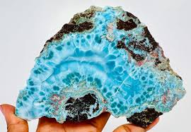

Chapter 1 – The Birth of Larimar
Larimar is a rare blue variety of the mineral pectolite, discovered in 1916 but not officially mined until 1974. The name combines:
“Lari” – from Larissa, the daughter of the man who rediscovered it
“Mar” – the Spanish word for “sea”
Its beautiful blue and white patterns form naturally through volcanic processes, where minerals crystallise in cavities deep within lava flows.
Because Larimar forms through unique geological conditions, it is found in only one place on Earth—making it a gemstone of true rarity.
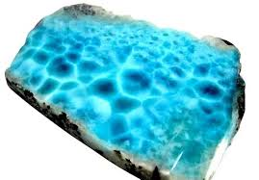

Chapter 2 – Geological Formation & Rarity
Larimar is created when hot gases rising from volcanic activity push mineral-rich fluids into cracks within basaltic lava. Over time, these fluids cool and crystallise into pectolite.
Only a tiny percentage of pectolite gains the blue colouration caused by copper substitution within the crystal structure.
This limited formation process means:
Larimar exists exclusively in the Dominican Republic.
High-quality deep-blue Larimar is becoming increasingly rare.
It is considered one of the most collectible modern gemstones.
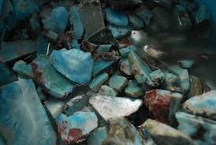

Chapter 3 – The Lore of Atlantis & Larimar
Larimar is often called:
The Atlantis Stone
The Dolphin Stone
The Blue Ray Stone
According to metaphysical traditions and Edgar Cayce’s predictions, a rare blue stone with healing and communication powers would rise from the Caribbean—believed by many to be Larimar.
Larimar is said to carry:
Ancient wisdom from Atlantis
Healing codes of the Blue Ray
Energy of dolphins and oceanic consciousness
Frequencies of peace, harmony, and spiritual evolution
Its frequency feels both ancient and new—like a returning memory from a world long lost.

Chapter 4 – Energetic Properties & Spiritual Meaning
Larimar is predominantly associated with:
Calmness & tranquillity
Peaceful expression
Healing of emotional wounds
Feminine balance
Spiritual clarity
Inner truth
Its energy is gentle yet powerful, like a wave that washes over the heart and mind, dissolving stress and returning one to natural harmony.

Primary Spiritual Properties
Activates higher wisdom
Encourages authentic communication
Softens harsh emotions
Supports emotional detoxification
Strengthens intuitive abilities
Connects you with oceanic and angelic realms
Larimar is especially valued for its calming and soothing effects—making it a natural companion for those seeking emotional peace or spiritual awakening.

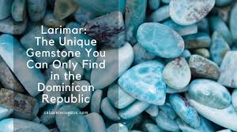

Chapter 5 – Larimar & the Chakras
Throat Chakra (Primary)
Larimar opens and clears the throat chakra, allowing truth to flow without fear or tension.
Heart Chakra (Secondary)
It encourages emotional openness, compassion, and connection.
Third Eye & Crown Chakras (Tertiary)
The stone’s higher frequencies support inner vision, intuition, and spiritual connection.
Soul Star Chakra (Higher Realm)
Advanced practitioners use Larimar to access guidance, angelic messages, and higher consciousness.
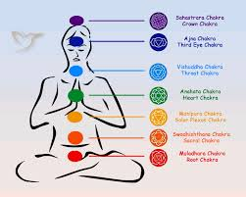

Chapter 6 – Emotional Healing with Larimar
Larimar is considered one of the best stones for emotional healing because it helps dissolve emotional blocks without triggering overwhelm.
What It Helps Release
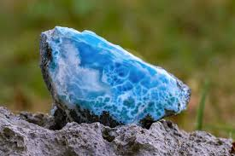
Suppressed emotions
Past trauma
Anger or frustration
Emotional numbness
Overthinking
Guilt & shame
Fear of speaking your truth

What It Helps Cultivate
Peace of mind
Emotional resilience
Authentic expression
Compassion
Self-acceptance
Confidence
Boundaries rooted in love
Larimar is especially useful for empaths, sensitives, and those healing from emotionally heavy relationships.
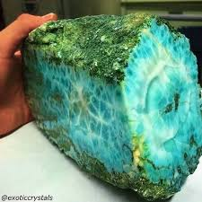

Chapter 7 – Physical & Metaphysical Healing Traditions
Metaphysical healers believe Larimar supports:
Cooling inflammation in the energy body
Reducing energetic tension
Calming the nervous system
Supporting healthy thyroid energy (energetically, not medically)
Encouraging breath and relaxation
Harmonising the body’s energetic flow
It’s often used in sessions for stress relief and soothing the energy field.

Chapter 8 – Larimar for Intuition, Spiritual Growth & Psychic Abilities
Larimar enhances:
Clairaudience
Clairvoyance
Spiritual communication
Channelling
Emotional intuition
Dreamwork
Many say Larimar connects to dolphin consciousness, a gentle yet advanced frequency that helps with telepathic communication and higher dimensional awareness.

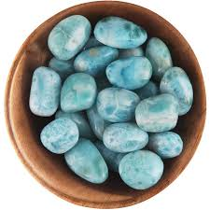

Chapter 9 – Manifestation & Feminine Healing Energy
Larimar carries strong Divine Feminine energies:
Receptivity, Nurturing, Flow, Creativity, Soft strength
It supports manifestation by helping you:
Align with desires emotionally
Remove inner resistance
Communicate intentions clearly
Remain open to receiving
Larimar is also considered a stone of goddess energy, associated with Yemaya, Aphrodite, Kuan Yin, and Mary Magdalena.

Chapter 10 – Using Larimar in Rituals & Meditation
Simple Larimar Meditation
Hold Larimar to your throat or heart.
Breathe deeply and slowly.
Visualise ocean-blue energy filling your body.
Release tension with each exhale.
Emotional Release Ritual
Place Larimar over the heart.
Journal emotions as they rise.
Finish by holding the stone to your chest and repeating a healing affirmation.

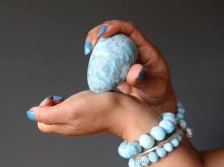

Communication Ritual
Hold the stone at the throat.
Speak intentions aloud.
Ask the stone to support clarity, honesty, and calm expression.
Ocean Connection Ceremony
Use Larimar while listening to ocean waves to deepen connection with water energy.

Chapter 11 – Cleansing, Charging & Caring for Larimar
Cleansing Methods
Moonlight
Sound cleansing
Smoke cleansing
Selenite or clear quartz
Breathwork (intention-based)

Avoid
Sunlight
Harsh water
Saltwater
Chemicals
Larimar can fade under long-term sun exposure.

Charging Methods
Moonlight
Ocean water (symbolic bowl of water; stone shouldn’t be submerged long)
Intention & breath
Crystal grids
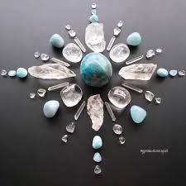

Chapter 12 – Pairing Larimar with Other Crystals (Synergy Stones)
For Emotional Healing
Rose Quartz
Rhodochrosite
Pink Opal
For Intuition
Amethyst
Labradorite
Lapis Lazuli
For Feminine Energy
Moonstone
Selenite
Aquamarine
For Communication
Blue Lace Agate
Angelite
Amazonite
These combinations amplify Larimar’s soothing, spiritual effects.

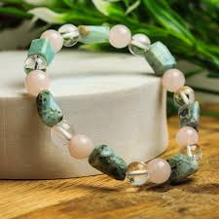

Chapter 13 – Larimar in Jewellery & Daily Life
Wearing Larimar helps:
Keep calm throughout the day
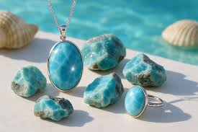
Encourage clear communication
Support emotional balance
Maintain spiritual connection

Jewellery forms:
Pendants (ideal for throat & heart)
Rings
Bracelets
Earrings

Larimar is soft, so it should be stored carefully and kept away from high heat.

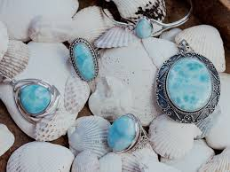

Chapter 14 – Selecting Authentic Larimar
Genuine Larimar has:
Blue to greenish-blue tones
White marbling
Natural patterns like ocean waves
Soft to deep saturation
Slight translucency in some areas
Beware of plastic or dyed stones labelled “Larimar.” Always buy from trusted sources.

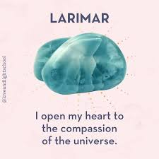
Chapter 15 – Affirmations for Larimar
“I speak my truth with peace and clarity.”
“I am calm, grounded, and emotionally free.”
“I trust my intuition and inner wisdom.”
“I allow healing to flow effortlessly into my life.”
“I am open to receiving love and support.”
“My spirit is aligned with the peaceful rhythm of the universe.”

Chapter 16 – Guided Meditation with Larimar
1. Begin with breath
Inhale deeply, exhale slowly.
Hold Larimar to your heart or throat.
2. Visualise the ocean
See gentle waves washing over your energy, cleansing tension.
3. Connect with the stone
Imagine light-blue energy radiating from Larimar into your aura.
4. Release
Let go of emotions, heavy thoughts, or fears.

5. Receive guidance
Ask your higher self or guides for clarity.
Sit in stillness, listening.
6. Close with gratitude
Thank the stone for its support.
Feel calm, centred, open.

Conclusion – The Return of the Divine Blue Flame
Larimar is a stone of peace, healing, and divine connection.
It teaches us to flow like water, to speak with honesty and compassion, and to follow the inner wisdom of the heart.
By working with Larimar, you learn to stand in your truth—not with force, but with grace.
This is the essence of Larimar:
gentle strength, sacred clarity, and the awakening of the soul.
