**The Power of Blue Crystals: Healing, Communication & Inner Peace**

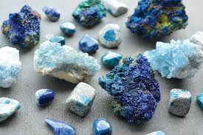

By AF Crystal Jewels

Roxy Slabber

**Table of Contents**

1. Introduction to Blue Crystals
2. Symbolism & Energetic Meaning of the Colour Blue
3. How Blue Crystals Work
4. Blue Crystal Healing Benefits
5. Top 12 Blue Crystals & Their Uses  
   * Blue Lace Agate
   * Lapis Lazuli
   * Aquamarine
   * Blue Kyanite
   * Sodalite
   * Celestite
   * Azurite
   * Blue Apatite
   * Angelite
   * Dumortierite
   * Blue Chalcedony
   * Blue Calcite
6. How to Use Blue Crystals
7. Blue Crystals and the Throat Chakra
8. Blue Crystal Rituals & Affirmations
9. Caring for Your Blue Crystals
10. Final Thoughts

**1. Introduction to Blue Crystals**

Blue crystals are deeply soothing stones known for their ability to calm the mind, encourage honest expression, and foster inner peace. From ancient civilizations to modern energy healers, these tranquil stones have long been used for spiritual communication, emotional balance, and protection.

Whether you’re struggling with communication blocks, looking for mental clarity, or seeking to deepen your intuition, blue crystals offer a gentle yet powerful path to healing.

**2. Symbolism & Energetic Meaning of the Colour Blue**

The colour blue resonates with:

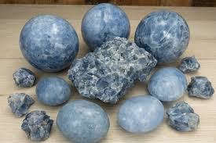

* Calmness and serenity
* Truth and clarity
* Communication and self-expression
* Intuition and spiritual insight
* Loyalty and trust

Energetically, blue aligns with the throat chakra and, in deeper indigo shades, the third eye chakra, supporting truthful speech, clarity of thought, and inner vision.

**3. How Blue Crystals Work**

Crystals emit vibrational frequencies that can interact with your body’s energy field. Blue stones specifically:

* Clear stagnant or blocked energy in the throat and third eye chakras
* Promote clear and heartfelt communication
* Encourage peace, wisdom, and reflection
* Reduce mental chatter and calm anxiety

They are ideal for anyone practicing meditation, public speaking, healing work, or spiritual development.

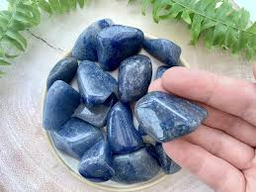

**4. Blue Crystal Healing Benefits**

Emotional Healing

* Calms emotional storms
* Reduces anger and anxiety
* Encourages patience and understanding

Mental Clarity

* Enhances focus and concentration
* Supports logical and intuitive thinking

Spiritual Connection

* Opens channels of divine communication
* Strengthens intuition and dreamwork

Physical Healing

* Supports thyroid and throat health
* 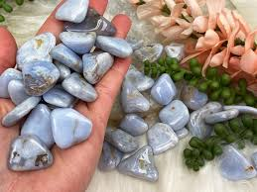Aids respiratory and sinus issues

**5. Top 12 Blue Crystals & Their Uses**

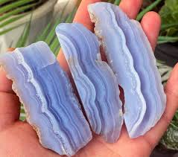

**1. Blue Lace Agate**

A gentle, nurturing stone that soothes anxiety and promotes peaceful communication.

Keywords: Calm, clarity, compassion

Affirmation: “I speak my truth with grace and ease.”

**2. Lapis Lazuli**

A royal stone of truth, wisdom, and deep inner knowing. Used by ancient Egyptians for spiritual insight.

Keywords: Truth, inner power, vision

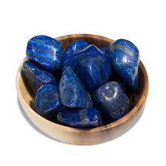Affirmation: “I access divine wisdom and express myself clearly.”

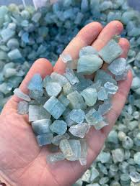**3. Aquamarine**

A crystal of courage, flow, and emotional healing, like the ocean’s soothing embrace.

Keywords: Trust, courage, peace

Affirmation: “I release fear and embrace the calm within me.”

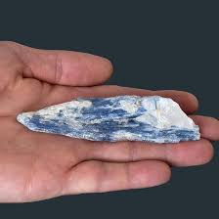

**4. Blue Kyanite**

An energy alignment tool that never needs cleansing. Clears blockages and supports truthful expression.

Keywords: Alignment, honesty, intuition

Affirmation: “My voice aligns with my truth.”

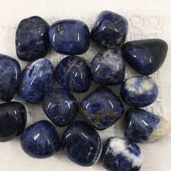

**5. Sodalite**

A stone of rational thought and emotional balance, perfect for mental clarity and self-acceptance.

Keywords: Logic, expression, intuition

Affirmation: “I express myself freely and with confidence.”

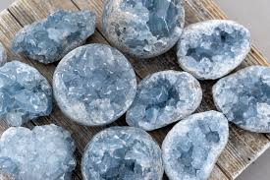**6. Celestite**

A heavenly stone that connects you to angelic realms and spiritual guidance.

Keywords: Divine connection, serenity, clarity

Affirmation: “I am supported by divine light and love.”

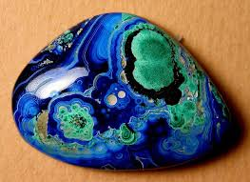

**7. Azurite**

A deep indigo crystal that opens the third eye and awakens psychic insight.

Keywords: Intuition, inner vision, focus

Affirmation: “I trust the wisdom that flows from within.”

**8. Blue Apatite**

A manifestation stone that sharpens focus, clears confusion, and motivates inspired action.

Keywords: Motivation, communication, clarity

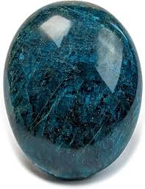Affirmation: “I communicate my vision with confidence and clarity.”

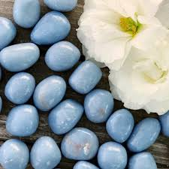**9. Angelite**

A soft, pale blue crystal that fosters peace, forgiveness, and angelic connection.

Keywords: Compassion, unity, calm

Affirmation: “I am surrounded by peace and divine support.”

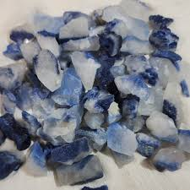

**10. Dumortierite**

A highly intellectual stone that helps with focus, discipline, and patience.

Keywords: Mental clarity, confidence, patience

Affirmation: “I trust the timing of my life and speak with purpose.”

**11. Blue Chalcedony**

Soothing and gentle, this crystal eases overthinking and supports empathy in conversations.

Keywords: Tranquillity, openness, expression

Affirmation: “I speak with kindness and listen with love.”

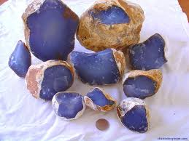

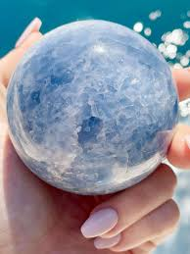**12. Blue Calcite**

An emotional cleanser that soothes the nerves and heightens intuition during dreamwork.

Keywords: Emotional balance, intuition, healing

Affirmation: “I am safe, supported, and deeply at peace.”

**6. How to Use Blue Crystals**

* Wear as Jewellery: Necklaces or pendants near the throat enhance expression
* Carry in Your Pocket: For calm energy during the day
* Meditate With Them: Place on the throat or third eye chakra
* Use in Water Rituals: (only with water-safe stones) for emotional cleansing
* Create Crystal Grids: To amplify intentions around truth, peace, or protection

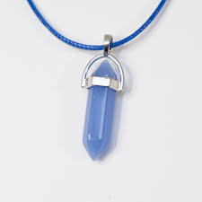

**7. Blue Crystals and the Throat Chakra**

The Throat Chakra (Vishuddha) governs:

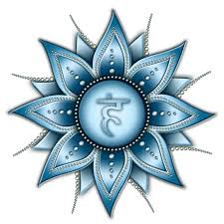

* Speaking your truth
* Active listening
* Confidence in communication
* Artistic expression

When blocked, you may experience sore throats, fear of public speaking, or inability to express your needs. Blue crystals help balance and open this chakra, allowing authentic communication to flow.

**8. Blue Crystal Rituals & Affirmations**

**Daily Ritual for Clear Communication**

1. Hold a blue crystal (e.g., Lapis Lazuli or Blue Lace Agate)
2. Breathe deeply and visualize a blue light glowing at your throat
3. Speak the affirmation:  
   “I communicate with clarity, honesty, and kindness.”
4. Wear or carry the crystal throughout your day

**Full Moon Peace Bath**

* Use Aquamarine, Blue Calcite, or Celestite (non-water-soluble)
* Light candles and play soft music
* Set your intention for release and renewal
* Soak while visualizing stress melting away into the water

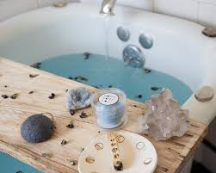

**9. Caring for Your Blue Crystals**

* Cleanse regularly (smoke, moonlight, sound)
* Avoid water with porous or soft stones (e.g., Angelite, Celestite)
* Store away from direct sunlight to prevent fading
* Charge under the full moon or with gentle affirmations

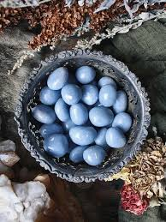

**10. Final Thoughts**

Blue crystals are powerful allies in your journey toward self-expression, calm, and higher truth. Their peaceful vibrations help you speak your truth, trust your inner voice, and live from a place of serenity and spiritual connection.

Whether you’re new to crystals or deepening your practice, may these stones guide you into clarity, peace, and authentic communication.

