Iolite: The Vision Stone of Inner Journey and Spiritual Insight

Title: Iolite: The Vision Stone of Inner Journey and Spiritual Insight

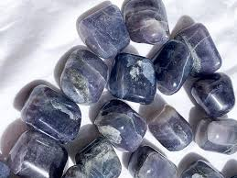

Table of Contents:

1. Introduction to Iolite

2. Geological Background

3. The History of Iolite

4. Metaphysical Properties

5. Healing Benefits of Iolite

6. Iolite and Chakras

7. Using Iolite in Daily Life

8. Iolite Meditation and Spiritual Practices

9. Pairing Iolite with Other Crystals

10. Caring for Iolite

11. Choosing Your Iolite Crystal

12. Affirmations and Intentions

13. Mythology and Symbolism

14. Iolite in Modern Healing and Jewellery

15. Conclusion

Chapter 1: Introduction to Iolite

Iolite, also known as the “Viking’s Compass,” is a captivating gemstone of deep indigo and violet hues. Its name is derived from the Greek word “ios,” meaning violet, perfectly describing its striking colour. Revered as a stone of vision, Iolite has long been associated with spiritual awakening, intuition, and inner exploration. Known for its remarkable ability to help one align with their higher self, Iolite has become a popular crystal for meditation, guidance, and healing practices.

This crystal’s mystical charm is not only in its appearance but in the calming, empowering energy it emits. By working with Iolite, spiritual seekers can tap into hidden truths, gain clarity, and embark on transformative inner journeys.

Chapter 2: Geological Background

Iolite is a magnesium aluminium silicate, scientifically classified as Cordierite. This mineral is known for its pleochroism—an optical phenomenon in which the stone displays different colours when viewed from various angles. Typically, Iolite shifts between shades of violet-blue, light grey, and even honey-yellow depending on the angle of light.

Iolite is primarily sourced from deposits in Sri Lanka, India, Madagascar, Brazil, Canada, and parts of the United States. The most sought-after Iolite stones feature a vivid blue-violet hue and exceptional clarity, making them highly desirable in both jewellery and crystal healing.

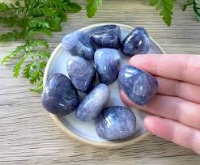

Chapter 3: The History of Iolite

Throughout history, Iolite has been revered for its navigational and mystical properties. Legend states that Viking sailors used thin slices of Iolite as a polarizing filter to locate the sun on cloudy days, allowing them to navigate the seas with remarkable precision. This earned Iolite its nickname, “The Viking’s Compass.”

In ancient cultures, Iolite was believed to enhance shamanic vision and spiritual journeys. It was often used in ritual practices to connect with spiritual guides and explore hidden realms of consciousness. Over time, it became a symbol of clarity, trust, and inner wisdom.

Chapter 4: Metaphysical Properties

Iolite is celebrated for its ability to stimulate the Third Eye Chakra, which is responsible for intuition, inner sight, and psychic abilities. The crystal acts as a spiritual compass, guiding its user toward their soul’s path and higher wisdom.

Metaphysically, Iolite is known for:

- Enhancing spiritual growth and inner vision

- Strengthening intuition and psychic awareness

- Aiding in meditation and astral travel

- Promoting calmness and emotional balance

The energy of Iolite is deeply cleansing, helping to release old patterns and fears while opening the mind to new possibilities.

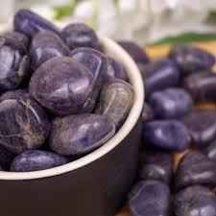

Chapter 5: Healing Benefits of Iolite

Iolite offers a variety of healing benefits for the mind, body, and spirit:

\*\*Emotional Healing:\*\* Iolite helps dissolve anxiety, fear, and self-doubt, encouraging self-confidence and emotional stability. It is particularly helpful for individuals seeking to overcome co-dependency or unhealthy emotional patterns.

\*\*Physical Healing:\*\* In holistic healing, Iolite is said to support detoxification of the liver and aid in regulating metabolism. It is also associated with improving sleep quality, reducing headaches, and alleviating eye strain.

\*\*Mental Clarity:\*\* Iolite’s calming energy improves focus, decision-making, and mental clarity, making it a valuable tool for students, professionals, and spiritual practitioners alike.

Chapter 6: Iolite and Chakras

Iolite’s primary resonance is with the Third Eye Chakra, located between the eyebrows. This chakra governs intuition, insight, and spiritual perception. By working with Iolite, one can strengthen their inner vision and trust their intuitive guidance.

Additionally, Iolite’s connection with the Crown Chakra facilitates spiritual awakening and alignment with higher consciousness. Meditation with Iolite can open both chakras, creating a powerful channel for divine wisdom and self-awareness.

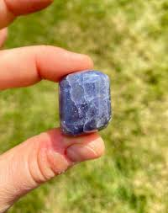

Chapter 7: Using Iolite in Daily Life

Iolite is a versatile crystal that can be incorporated into everyday routines:

- \*\*Jewellery:\*\* Wearing Iolite as a pendant, ring, or bracelet allows you to carry its calming and intuitive energy with you throughout the day.

- \*\*Meditation:\*\* Holding Iolite during meditation enhances spiritual connection and deepens relaxation.

- \*\*Home Decor:\*\* Placing Iolite in your workspace or meditation area encourages harmony, mental clarity, and inspiration.

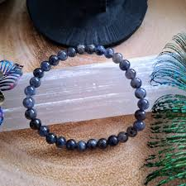

Chapter 8: Iolite Meditation and Spiritual Practices

Meditating with Iolite can be transformative. To begin, find a quiet space and hold the stone near your Third Eye Chakra. Focus on your breath and visualize a deep indigo light surrounding you. Allow Iolite’s energy to open your mind to guidance, spiritual visions, and a profound sense of inner peace.

You can also use Iolite in manifestation rituals by programming it with your intentions. Its energy supports spiritual alignment, helping you manifest goals that align with your higher self.

Chapter 9: Pairing Iolite with Other Crystals

Pairing Iolite with other crystals amplifies its effects:

- \*\*Amethyst:\*\* Enhances spiritual connection and psychic insight.

- \*\*Clear Quartz:\*\* Boosts clarity and amplifies Iolite’s healing energy.

- \*\*Labradorite:\*\* Offers protection while strengthening intuition.

- \*\*Selenite:\*\* Facilitates divine connection and spiritual cleansing.

---

Chapter 10: Caring for Iolite

To maintain Iolite’s energy and beauty, follow these care tips:

- Clean with lukewarm water and a soft cloth.

- Avoid harsh chemicals and prolonged exposure to sunlight, which may fade its colour.

- Recharge Iolite under moonlight or place it on a selenite plate for cleansing.

Chapter 11: Choosing Your Iolite Crystal

When selecting Iolite, consider its colour, clarity, and energy resonance. High-quality Iolite exhibits deep, vibrant violet-blue hues. Choose a stone that feels energetically aligned with you—trust your intuition.

Iolite is available in tumbled stones, raw crystals, faceted gems, and jewellery. Whether you choose a polished or natural piece, Iolite’s energy remains equally powerful.

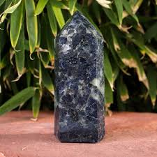

Chapter 12: Affirmations and Intentions

Here are some affirmations to use with Iolite:

- “I trust my intuition and inner guidance.”

- “I am aligned with my higher self and spiritual purpose.”

- “I release fear and step into clarity and confidence.”

Programming your Iolite with these affirmations enhances its healing properties and helps you align with your spiritual journey.

Chapter 13: Mythology and Symbolism

Iolite’s association with navigation symbolizes inner direction and spiritual exploration. In ancient folklore, it was considered a guiding stone, helping seekers find their true path. Astrologically, Iolite is often associated with the zodiac signs Taurus, Libra, and Sagittarius, as it promotes balance, creativity, and insight.

Chapter 14: Iolite in Modern Healing and jewellery

Iolite’s beauty and metaphysical properties have made it popular in both holistic healing and the jewellery industry. Spiritual practitioners use Iolite in crystal grids, meditation practices, and chakra healing. Its deep indigo colour makes it a favourite for elegant jewellery designs, appealing to both gemstone enthusiasts and spiritual seekers.

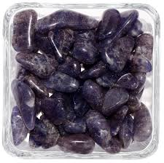

Chapter 15: Conclusion

Iolite is more than just a gemstone—it is a spiritual guide, a healer, and a source of empowerment. Whether you wear it as jewellery, meditate with it, or simply admire its beauty, Iolite invites you to explore the depths of your soul, trust your intuition, and embrace your spiritual path. This visionary stone serves as a beacon of inner light, helping you navigate life with clarity, confidence, and wisdom.

