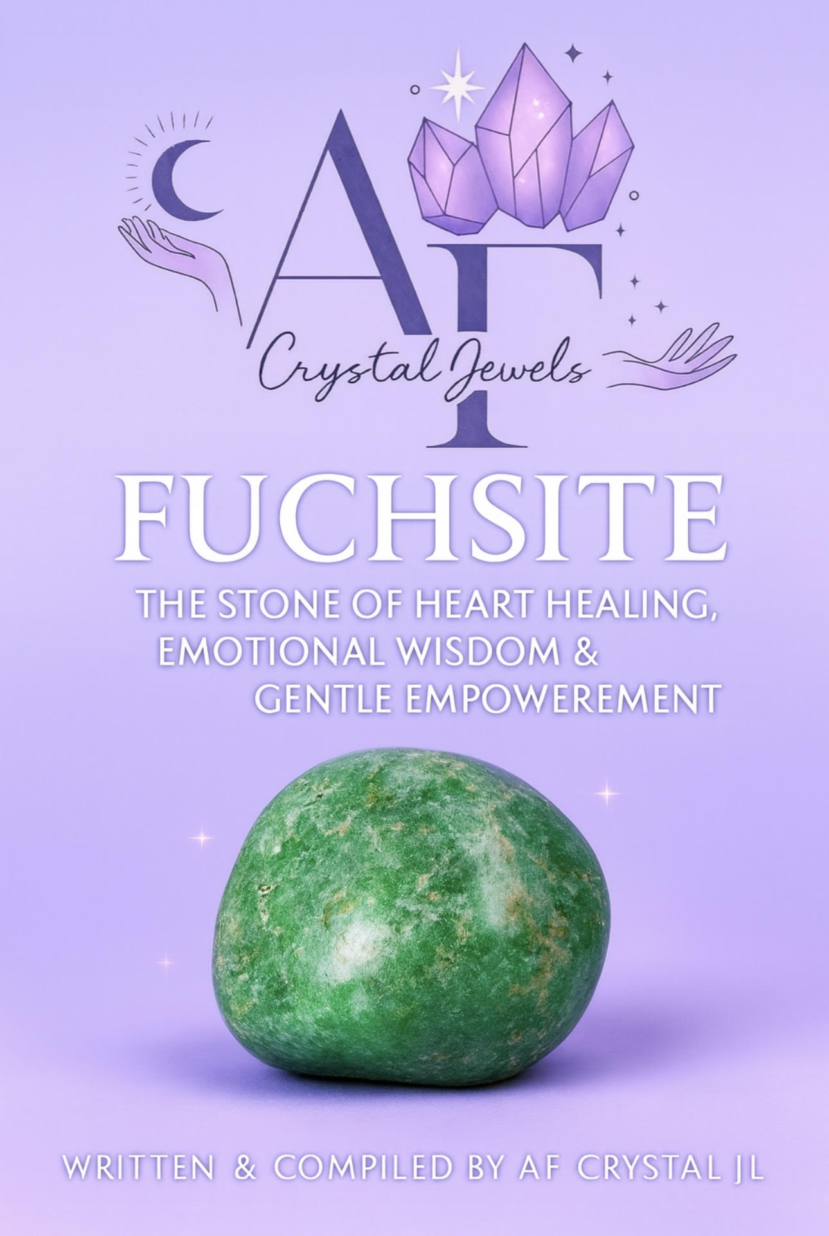
Fuchsite Crystal
The Stone of Heart Healing, Emotional Wisdom & Gentle Empowerment

Introduction
Fuchsite is a crystal of soft strength, emotional intelligence, and heart-centered healing. Known for its shimmering green surface and nurturing energy, this stone teaches an essential spiritual truth: healing does not require force. True transformation unfolds through compassion, awareness, and self-respect.
Often associated with emotional recovery, empathy, and personal boundaries, Fuchsite supports those who give deeply to others—healers, caregivers, empaths, and sensitive souls—by restoring balance between service and self-care.
This eBook explores Fuchsite’s origins, metaphysical properties, emotional and spiritual benefits, chakra connections, practical uses, rituals, affirmations, and crystal pairings—offering a comprehensive guide for beginners and advanced crystal practitioners alike.

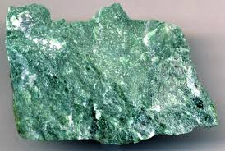

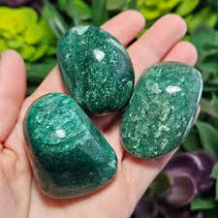

Chapter 1: What Is Fuchsite?
Fuchsite is a variety of muscovite mica rich in chromium, which gives it its distinctive vibrant to pale green colour. Its surface often sparkles due to its layered, reflective structure, symbolizing insight, awareness, and illumination.
Unlike grounding stones, Fuchsite works subtly yet powerfully, supporting emotional processing and energetic restoration without overwhelm.

Key Characteristics:
Colour: Light green to deep emerald green
Texture: Shimmery, flaky, layered
Element: Earth & Water
Energy Type: Gentle, nurturing, restorative
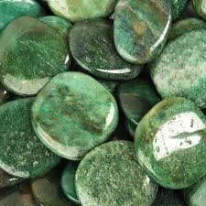

Chapter 2: The History & Origins of Fuchsite
Fuchsite is found in regions rich in metamorphic rock, including:
Brazil
India
Russia
Zimbabwe
Austria
Historically, green stones have symbolized renewal, growth, and healing, and Fuchsite has long been used by shamans and healers to enhance intuition and emotional clarity.
Its reflective quality was believed to mirror inner truth, making it a stone of wisdom and conscious awareness.
Chapter 3: Metaphysical Properties of Fuchsite
Fuchsite resonates strongly with the heart field, supporting emotional intelligence, self-understanding, and energetic balance.

Core Energetic Properties
Encourages emotional healing without suppression
Supports healthy boundaries
Enhances empathy without emotional depletion
Aids recovery from emotional exhaustion
Strengthens intuition and self-trust
Fuchsite teaches the art of receiving, reminding us that rest, pleasure, and compassion are not weaknesses—but necessities.
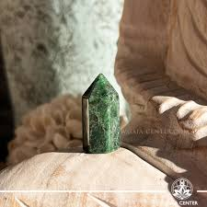

Chapter 4: Emotional Healing Benefits
Fuchsite is especially powerful for individuals who:
Absorb others’ emotions
Over-give or people-please
Struggle with emotional burnout
Carry unresolved emotional wounds

Emotional Support Includes:
Releasing guilt and emotional responsibility
Processing grief gently
Healing relationship trauma
Rebuilding emotional resilience
Cultivating self-worth
This crystal works like a soft emotional balm, allowing feelings to surface safely without becoming overwhelming.

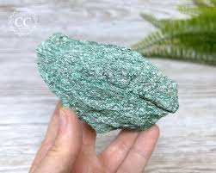

Chapter 5: Spiritual Benefits & Higher Awareness
Spiritually, Fuchsite enhances conscious choice and awareness. It encourages observation without judgment and promotes alignment between the heart and higher wisdom.

Spiritual Effects
Strengthens intuition
Encourages heart-led decisions
Supports spiritual recovery after burnout
Enhances meditative awareness
Assists in past emotional life lessons integration
Fuchsite is ideal for spiritual practitioners who feel drained or disconnected from their purpose.

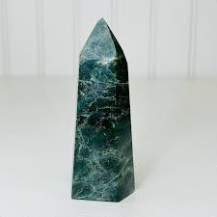

Chapter 6: Chakra & Energy System Connection

Heart Chakra (Primary)
Fuchsite opens and stabilizes the heart chakra, allowing love to flow without self-sacrifice.
Third Eye Chakra (Secondary)
It enhances insight, emotional perception, and intuitive awareness—especially around relationships and personal truth.

Aura Healing
Fuchsite is believed to repair energetic tears caused by emotional trauma or prolonged stress.

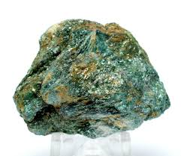

Chapter 7: Physical Energy Associations
While not a substitute for medical care, Fuchsite is traditionally associated with energetic support for:
Nervous system balance
Stress recovery
Cellular rejuvenation
Emotional fatigue
Overall vitality restoration
Its energy is restorative rather than stimulating, making it ideal for rest, recovery, and gentle healing rituals.

Chapter 8: How to Use Fuchsite in Daily Life

Meditation
Hold Fuchsite over the heart to release emotional tension and cultivate calm awareness.
Wearable Use
Wearing Fuchsite jewellery helps maintain emotional boundaries throughout the day.

Sleep Support
Place near the bed to ease emotional processing during sleep.
Workplace Energy
Keep on your desk to prevent emotional exhaustion and overextension.

Chapter 9: Fuchsite Healing Ritual
Heart Restoration Ritual
You will need:
Fuchsite crystal
Green or pink candle
Quiet space
Steps:
Light the candle and sit comfortably.
Place Fuchsite over your heart.
Breathe deeply for 3 minutes.
Visualize green light restoring your energy.
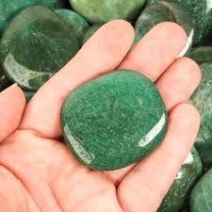
Speak the affirmation below.
Sit in silence for 5 minutes.

Chapter 10: Affirmations for Fuchsite

“I give from a place of balance, not depletion.”
“My heart is open, protected, and wise.”
“I honour my emotional needs without guilt.”
“Healing flows gently and naturally within me.”
“I receive love as freely as I give it.”

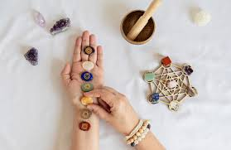

Chapter 11: Crystal Pairings with Fuchsite

Rose Quartz
Enhances emotional healing and self-love.
Malachite
Supports deep emotional transformation.
Green Aventurine
Encourages renewal and heart-led growth.
Lepidolite
Balances emotions and reduces anxiety.
Clear Quartz
Amplifies Fuchsite’s gentle healing energy.

Chapter 12: Caring for & Cleansing Fuchsite
Due to its flaky structure, Fuchsite should be handled gently.
Recommended Cleansing Methods:
Smoke cleansing
Sound healing
Moonlight
Visualization
Avoid water cleansing, as it may damage the stone.

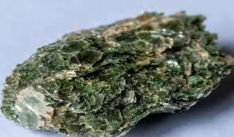

Chapter 13: Who Should Work with Fuchsite?

Fuchsite is ideal for:
Empaths
Healers & caregivers
Therapists & spiritual practitioners
Individuals recovering from emotional burnout
Anyone learning healthy emotional boundaries

Chapter 14: Fuchsite as a Teacher

Fuchsite teaches that strength can be gentle, healing can be slow, and love must include the self. It reminds us that emotional wisdom is not found in endurance—but in awareness, compassion, and balance.

Conclusion
Fuchsite is a crystal of quiet empowerment. It does not push or force transformation; instead, it invites healing through understanding and self-respect.
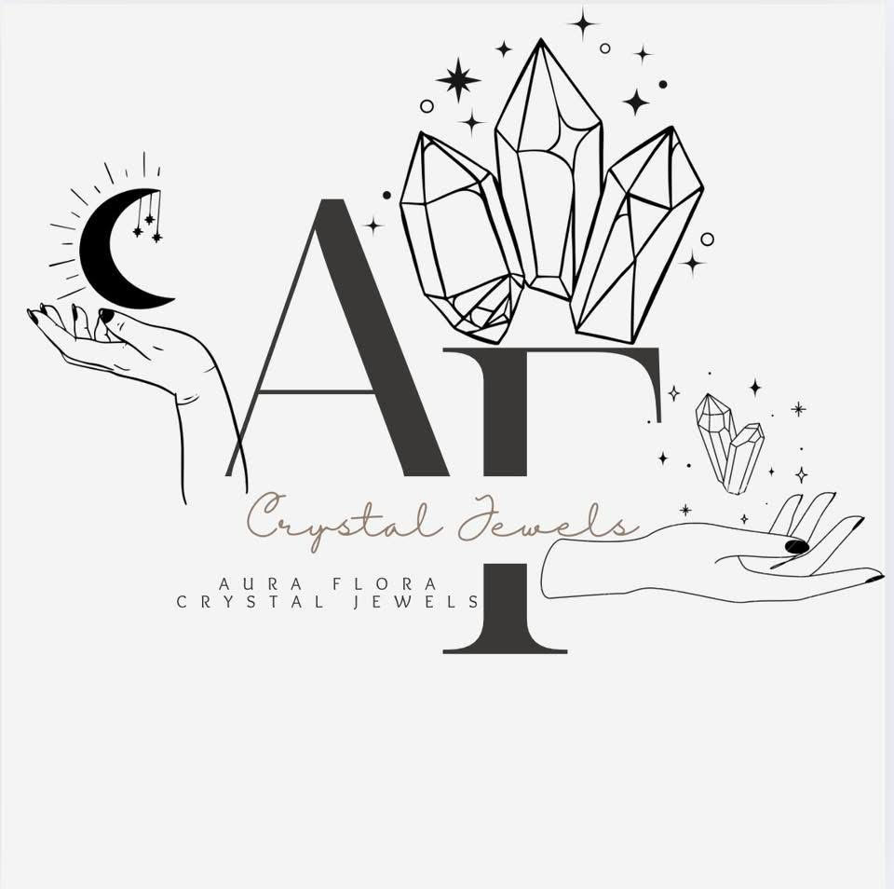
By working with Fuchsite, you learn to listen to your emotions, honor your limits, and restore harmony within your heart—allowing you to give, love, and live from a place of wholeness rather than sacrifice.

