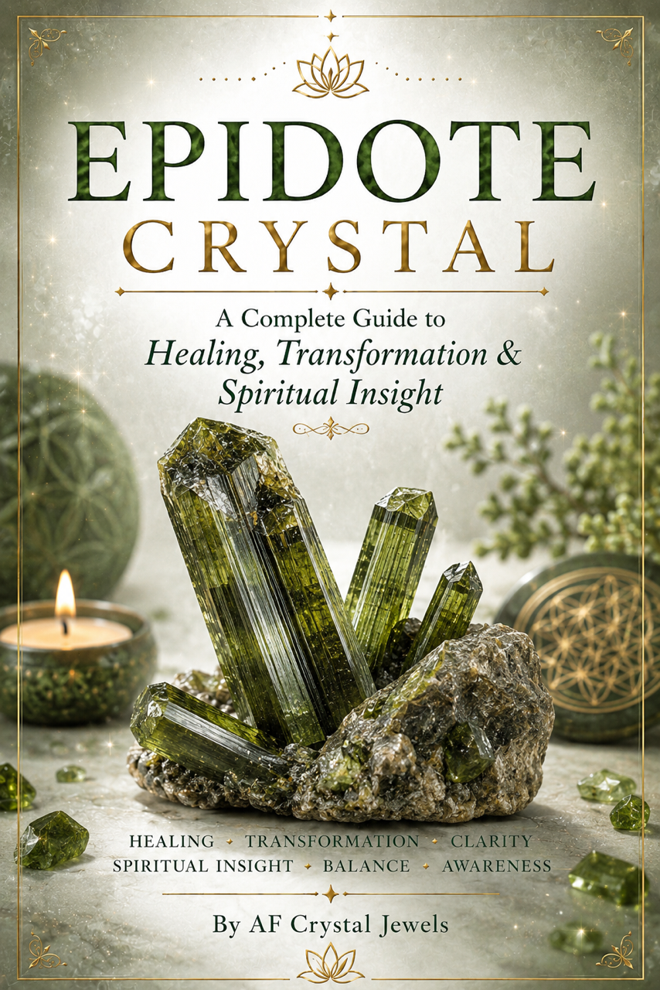
Epidote Crystal
Healing, Transformation & Spiritual Growth

Table of Contents
1. Introduction to Epidote
2. History and Lore
3. Geological Formation and Properties
4. Colours, Variations and Inclusions
5. Spiritual Meaning of Epidote
6. Emotional Healing Benefits
7. Physical Healing Associations
8. Epidote and the Chakras
9. Meditation and Energy Work
10. Manifestation with Epidote
11. Using Epidote in Daily Life
12. Jewellery and Fashion Uses
13. Cleansing and Charging Epidote
14. Crystal Pairings
15. Epidote Rituals and Affirmations
16. Epidote for Protection and Growth
17. Collecting and Caring for Epidote
18. Final Thoughts

Introduction to Epidote
Epidote is a powerful crystal known for transformation, growth, emotional healing and energetic amplification.
This green mineral has captivated crystal healers and collectors for centuries because of its ability to intensify energy and reveal hidden emotional patterns.
Epidote encourages personal evolution by helping individuals release negativity, embrace self-awareness and move forward with purpose.
The crystal often forms in deep green shades with black or golden inclusions, although lighter olive tones are also common.
Its energy is often described as grounding yet expansive, making it ideal for spiritual work and emotional renewal.
Many practitioners believe Epidote amplifies both positive and negative energies, which makes intention and emotional clarity especially important while working with it.
In the modern crystal community, Epidote is widely used for shadow work, manifestation, energetic clearing and chakra alignment.
Its transformative vibration makes it a favourite for people seeking profound inner change.
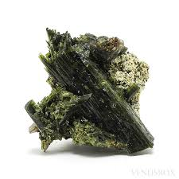

History and Lore
The name Epidote originates from the Greek word “epidosis,” meaning increase or addition.
Historically, Epidote has been associated with growth, expansion and strengthening energy.
Ancient cultures valued green stones for fertility, prosperity and protection, and Epidote was often linked to spiritual wisdom and nature spirits.
In metaphysical traditions, Epidote became recognised as a stone that reveals truth.
Healers believed it could expose emotional wounds that needed attention while simultaneously offering support and courage during healing.
Some traditions considered it a karmic stone that amplified the results of one's thoughts and actions.
Collectors also value Epidote because of its fascinating crystal structures and associations with minerals such as quartz, prehnite and feldspar.
Geological Formation and Properties
Epidote is a calcium aluminium iron silicate mineral commonly found in metamorphic rocks.
It forms in environments involving heat, pressure and hydrothermal activity.
The crystal belongs to the monoclinic crystal system and often develops elongated prismatic formations.
Major deposits are found in Austria, Mexico, Norway, Pakistan, South Africa and the United States.
Epidote has a hardness of approximately 6 to 7 on the Mohs scale, making it durable enough for jewellery and decorative use.
Its colour ranges from olive green to dark forest green due to iron content.
Many specimens display a vitreous shine and complex crystal formations that attract collectors worldwide.
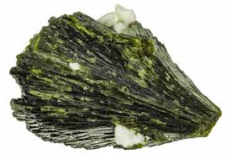

Colours, Variations and Inclusions
Epidote is most commonly recognised for its rich green appearance, though shades vary dramatically. Some pieces appear yellow-green while others are nearly black-green.
Transparent specimens are highly prized by collectors.
Common combinations include:
• Epidote with Quartz
• Unakite (Epidote mixed with Pink Feldspar)
• Epidote with Prehnite
• Epidote with Garnet
These combinations blend Epidote’s transformative energy with the unique qualities of accompanying minerals,

Spiritual Meaning of Epidote
Spiritually, Epidote symbolises transformation, growth, self-discovery and energetic amplification.
It encourages individuals to examine limiting beliefs and emotional habits that no longer serve them.
Epidote is often used during periods of transition because it supports courage and emotional honesty.
It can bring hidden fears or unresolved emotions to the surface, making it a valuable crystal for shadow work and spiritual awakening.
Many energy workers believe Epidote magnifies intention, which means thoughts, emotions and desires may become more energetically active while working with the crystal.

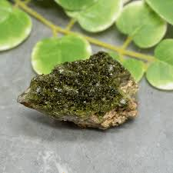

Emotional Healing Benefits
Epidote is deeply connected to emotional healing and release.
It supports emotional growth by helping individuals identify toxic patterns, limiting beliefs and suppressed emotions.
Benefits commonly associated with Epidote include:
• Releasing negativity
• Increasing optimism
• Encouraging self-responsibility
• Strengthening emotional resilience
• Supporting recovery from emotional exhaustion
Because Epidote amplifies energy, many practitioners recommend pairing it with grounding stones when processing intense emotions.
Physical Healing Associations
In crystal healing traditions, Epidote is associated with vitality, recovery and energetic balance.
Some believe it supports the immune system, nervous system and overall physical regeneration.
It is often used to symbolically support:
• Recovery after exhaustion
• Physical vitality
• Energetic cleansing
• Stress reduction
• Emotional tension release
Crystal healing is a spiritual practice and should never replace professional medical advice or treatment.

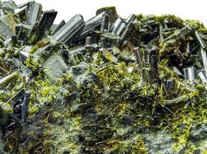

Epidote and the Chakras
Epidote primarily resonates with the Heart Chakra because of its green colouring and emotional healing properties. It encourages compassion, emotional honesty and forgiveness.
Some practitioners also connect Epidote to the Solar Plexus Chakra because it strengthens confidence and personal empowerment.
When used with meditation or chakra balancing practices, Epidote may help restore energetic harmony and emotional clarity.

Meditation and Energy Work
Meditating with Epidote can create a powerful experience of self-reflection and energetic transformation. Many people hold the crystal during meditation to uncover hidden emotions and gain insight into personal challenges.
Suggested meditation practice:
1. Sit in a quiet space.
2. Hold Epidote near the heart or in the hands.
3. Focus on releasing stagnant energy.
4. Visualise green light surrounding the body.
5. Repeat affirmations connected to healing and growth.
Epidote is also popular in Reiki sessions, energy grids and spiritual cleansing rituals.

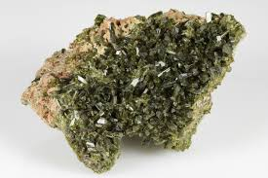

Manifestation with Epidote
Epidote is considered a manifestation amplifier.
Because it magnifies energetic patterns, many practitioners use it carefully and intentionally during manifestation rituals.
To work with Epidote for manifestation:
• Set clear intentions.
• Focus on positive emotional states.
• Pair it with abundance stones such as Citrine or Pyrite.
• Write goals and meditate with the crystal daily.
The crystal encourages accountability by helping individuals align actions with intentions.
Using Epidote in Daily Life
Epidote can be incorporated into daily routines for emotional support and spiritual awareness.
Some people carry small tumbled stones in pockets or place Epidote near workspaces for motivation and clarity.
Other uses include:
• Crystal grids
• Home energy cleansing
• Meditation altars
• Journaling practices
• Morning affirmations
Its grounding yet transformative energy makes it useful during periods of change and personal development.
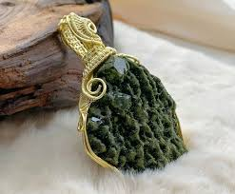

Jewellery and Fashion Uses
Epidote is frequently crafted into pendants, bracelets and statement jewellery.
Its earthy green colour pairs beautifully with silver, copper and natural designs.
Wearing Epidote jewellery allows individuals to remain connected to its energy throughout the day.
Many people choose pendants positioned near the heart chakra for emotional support and energetic alignment.
Cleansing and Charging Epidote
Regular cleansing is recommended because Epidote absorbs and amplifies energy.
Popular cleansing methods include:
• Moonlight charging
• Sound cleansing
• Smoke cleansing
• Selenite charging plates
• Visualisation techniques
Avoid prolonged exposure to harsh chemicals or extreme temperatures to preserve the crystal’s appearance.
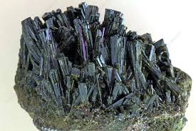

Crystal Pairings
Epidote combines well with many crystals depending on the intention.
Recommended pairings:
• Rose Quartz for emotional healing
• Black Tourmaline for grounding
• Citrine for manifestation
• Amethyst for spiritual awareness
• Clear Quartz for amplification
These combinations can be used in meditation, jewellery or crystal grids.
Epidote Rituals and Affirmations
Rituals help strengthen the connection between intention and crystal energy.
Sample affirmation:
“I release old patterns and welcome positive transformation into my life.”
Simple ritual:
1. Light a candle.
2. Hold Epidote in your hands.
3. Focus on releasing stagnant emotions.
4. Speak affirmations aloud.
5. Visualise healing energy flowing through the body.

Epidote for Protection and Growth
Although Epidote is primarily known for transformation, many people also use it for energetic protection.
By exposing negative emotional patterns, it helps individuals become more aware of unhealthy environments and relationships.
Its growth-oriented energy supports:
• Personal empowerment
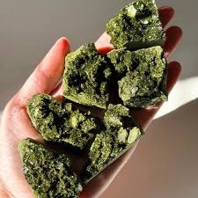
• Spiritual evolution
• Emotional awareness
• Positive decision-making
• Confidence during change

Collecting and Caring for Epidote
Collectors value Epidote for both metaphysical and geological reasons.
When purchasing Epidote, look for rich colour, stable formations and authentic sourcing.
Store Epidote separately from softer crystals to avoid scratches.
Clean gently with a soft cloth and avoid harsh cleaning products.

Final Thoughts
Epidote is a remarkable crystal of transformation, emotional healing and energetic growth.
Its ability to amplify intentions and reveal hidden emotional patterns makes it one of the most powerful stones for personal evolution.
Whether used in meditation, manifestation rituals, jewellery or spiritual healing practices, Epidote encourages courage, honesty and renewal.
By working with this crystal intentionally and consistently, individuals may deepen self-awareness and strengthen their connection to personal transformation.
May Epidote inspire growth, clarity and positive change on every stage of your spiritual journey.

