Mexican Lace Agate: The Stone of Joy, Balance & Protection

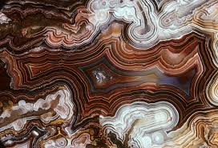

By AF Crystal Jewels – Roxy Slabber

Table of Contents

1. Introduction to Mexican Lace Agate
2. Origins and Geological Formation
3. Physical Characteristics
4. Metaphysical Properties
5. Emotional and Spiritual Benefits
6. Healing Uses in Daily Life
7. Chakra and Energy Alignment
8. Affirmations with Mexican Lace Agate
9. Cleansing, Charging & Caring for Your Stone
10. Crystal Pairings and Synergies
11. Rituals and Practices
12. How to Use in Jewellery and Decor
13. Selecting and Sourcing Quality Stones
14. Conclusion: Embracing the Joyful Energy of Mexican Lace Agate

Chapter 1: Introduction to Mexican Lace Agate

Mexican Lace Agate, often referred to as Crazy Lace Agate, is a vibrant, swirling banded chalcedony from Chihuahua, Mexico. Known as the Stone of Laughter, this crystal radiates warmth, optimism, and emotional support. With its intricate patterns and colourful layers—reds, creams, golds, and browns—it serves as both a protective talisman and a mood lifter.

It is widely used in holistic healing, spiritual rituals, and energy work, especially by those seeking mental clarity, stability, and lightness of being.

Chapter 2: Origins and Geological Formation

Mexican Lace Agate is found primarily in the northern Mexican desert region of Chihuahua. It forms within volcanic rocks, where silica-rich fluids fill cavities and crystallize over time, layering minerals into concentric bands.

These beautiful formations can take millions of years to develop. The stone is a type of chalcedony—part of the quartz family—formed through rhythmic crystallization and mineral deposition, giving it the lace-like, colourful appearance it’s famous for.

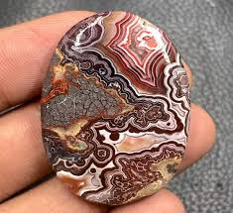

Chapter 3: Physical Characteristics

Colour: Cream, white, beige, gold, red, brown, orange

Texture: Smooth, polished or raw with a waxy lustre

Hardness: 6.5–7 on the Mohs scale

Pattern: Banded, often circular or lace-like; each piece is unique

Composition: Silicon dioxide (SiO₂) with traces of iron and other minerals

No two Mexican Lace Agates look the same, making each piece truly one-of-a-kind.

Chapter 4: Metaphysical Properties

Vibration: Joyful, stabilizing, uplifting

Element: Earth

Zodiac Association: Gemini

Planet: Mercury

Numerical Vibration: 7

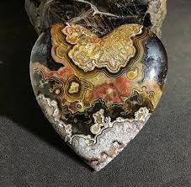

Mexican Lace Agate is widely known for:

Amplifying happiness and optimism

Balancing emotional highs and lows

Providing mental clarity during decision-making

Encouraging self-confidence and inner strength

Offering energetic protection from negativity

Chapter 5: Emotional and Spiritual Benefits

This stone acts like emotional sunshine—it doesn’t remove your problems but helps you face them with a lighter heart and a clearer mind.

Key Emotional Benefits:

Lifts depression and emotional fatigue

Eases anxiety and overwhelm

Promotes laughter and a positive mindset

Encourages personal growth without judgment

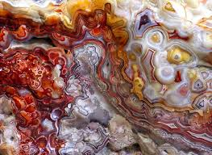

Spiritually:

Enhances energy flow through the auric field

Strengthens connection with Earth energies

Inspires playful, childlike wonder in spiritual practice

Chapter 6: Healing Uses in Daily Life

Mexican Lace Agate is ideal for:

Wearing during stressful meetings or public speaking

Holding during meditation to calm the mind

Placing on the solar plexus to clear stagnant emotional energy

Keeping near your workspace for creativity and focus

Using in children’s bedrooms to create a joyful, calm atmosphere

It’s particularly helpful for emotional healing from past trauma, fear, or burnout. Use it as a companion stone during transitions, healing journeys, or energetic realignments.

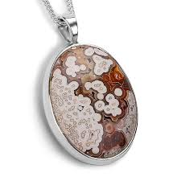

Chapter 7: Chakra and Energy Alignment

Primary Chakra: Solar Plexus

This is the centre of self-esteem, personal power, and emotional energy. Mexican Lace Agate supports courage, clarity, and emotional balance here.

Secondary Chakras: Third Eye & Root

Third Eye: Enhances insight, logic, and mental clarity

Root: Grounds energy and creates stability during change

Its multi-coloured bands allow it to gently balance multiple chakras, making it a harmonizing all-purpose stone for energetic healing.

Chapter 8: Affirmations with Mexican Lace Agate

Use the following affirmations while holding or meditating with your crystal:

“I welcome joy, laughter, and light into my life.”

“I am centred, grounded, and emotionally secure.”

“My mind is clear, and my heart is light.”

“I release fear and open myself to fun and creativity.”

“I embrace life’s changes with confidence and clarity.”

Repeat affirmations aloud or silently during meditation or morning rituals to align with the crystal’s energy.

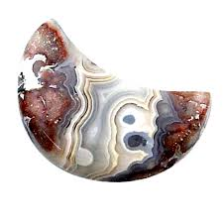

Chapter 9: Cleansing, Charging & Caring for Your Stone

To keep your Mexican Lace Agate energetically clear and vibrant

Cleansing Methods:

Smoke cleansing with sage or palo santo

Moonlight (especially full moon)

Sound baths with crystal bowls

Running under lukewarm water (dry thoroughly)

Charging Suggestions:

Place in sunlight for no more than 30 minutes (avoid fading)

Bury in soil overnight for grounding energy

Place on a selenite charging plate

Cleanse regularly if used daily, particularly after intense emotional work.

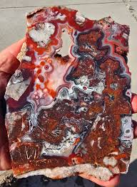

Chapter 10: Crystal Pairings and Synergies

Mexican Lace Agate works well with other uplifting, balancing, or grounding crystals:

|  |  |
| --- | --- |
| Crystal | Synergy Purpose |
|  |  |
| Citrine | Amplifies joy and abundance |
| Carnelian | Boosts creativity and vitality |
| Lepidolite | Adds emotional calm during transitions |
| Smoky Quartz | Deepens grounding and protection |
| Howlite | Balances overactive thoughts and nerves |

Use in grids, jewellery, or rituals depending on your needs

Chapter 11: Rituals and Practices

Morning Joy Ritual

Hold your stone in both hands upon waking

Close your eyes and breathe deeply

Say: “Today, I choose laughter, clarity, and peace.”

Visualize warm golden light radiating from your solar plexus

Emotional Reset Meditation:

Lie down with the stone on your belly

Breathe slowly and imagine your emotional energy flowing out through the stone

End with a gratitude affirmation and a smile

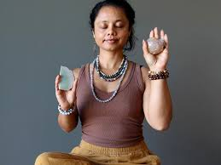

Chapter 12: How to Use in Jewellery and Decor

Wearing Mexican Lace Agate as jewellery—especially as a pendant near the solar plexus—is highly effective for continuous emotional balance.

Other uses:

Place a polished stone on your desk for productivity

Add it to your altar as a joy-enhancing tool

Use in a crystal bowl in your living space for positive vibes

Tumble-stone necklaces for light-hearted, playful energy

Its aesthetic appeal also makes it a favourite in home décor and artisan crafts.

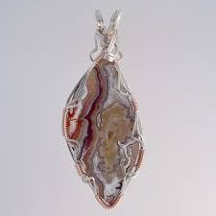

Chapter 13: Selecting and Sourcing Quality Stones

When selecting your Mexican Lace Agate

Look for rich patterns and vibrant colour contrasts

Choose pieces that visually “speak” to you—intuition matters

Opt for stones sourced ethically from Mexico

Avoid overly dyed or artificially enhanced specimens

Certified crystal retailers or trusted holistic suppliers are ideal sources.

Chapter 14: Conclusion: Embracing the Joyful Energy of Mexican Lace Agate

Mexican Lace Agate isn’t just a stone—it’s an invitation to laugh more, live lighter, and find joy even in uncertain times. With its mesmerizing patterns and balancing energy, it empowers you to face life’s chaos with grace, humour, and grounded optimism.

Whether you wear it daily, meditate with it, or simply admire its natural beauty, let this crystal be a reminder: Life is meant to be lived with joy.

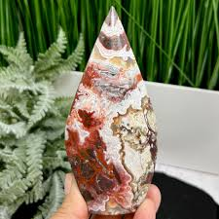

Thank you for exploring the magic of Mexican Lace Agate with AF Crystal Jewels.

May your path be joyful, your heart light, and your spirit radiant.

