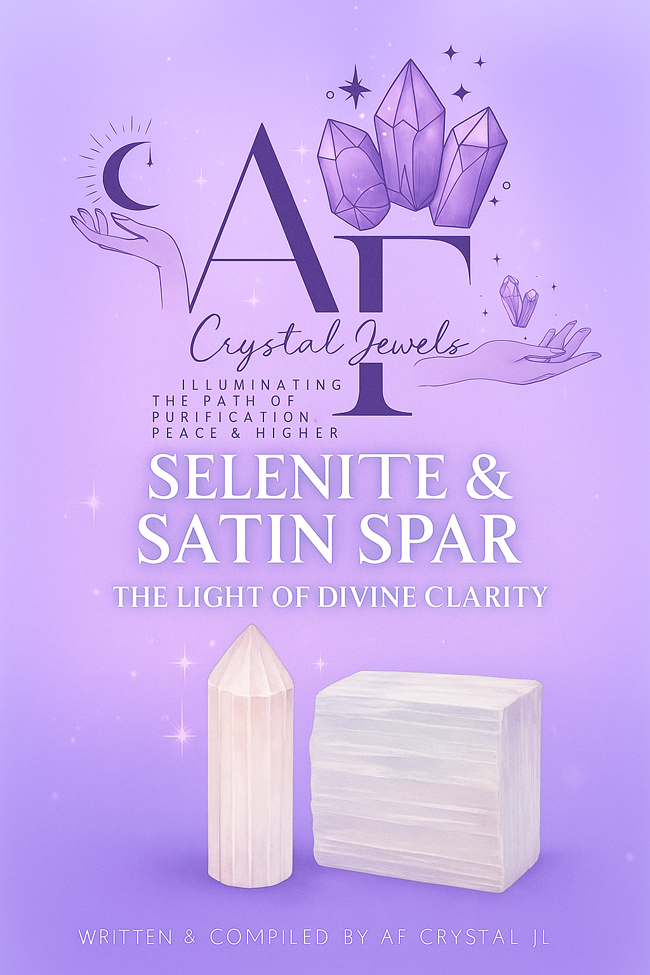
Table of Contents

- Introduction
- The True Nature of Selenite & Satin Spar
- History & Origin of the Stone of Light
- Physical Characteristics & Mineral Composition
- Energetic Properties & Spiritual Symbolism
- Selenite vs. Satin Spar — Understanding the Difference
- Healing Benefits for Mind, Body & Spirit
- Chakra Alignment & Energy Flow
- Using Selenite & Satin Spar in Daily Practice
- Rituals for Cleansing & Divine Connection
- Meditation with Selenite: The Path of Light
- Affirmations for Purification & Clarity
- Crystal Combinations for Enhanced Energy
- How to Care for Your Selenite & Satin Spar
- Home & Space Cleansing with Selenite
- Selenite in Grids & Energy Work
- Myths, Legends & Angelic Associations
- Modern Uses & Practical Applications
- Crystal Charging & Programming
- Final Reflections: Becoming the Light

Chapter 1: Introduction

Selenite and Satin Spar are among the most radiant and spiritually charged crystals known to humankind. Revered since ancient times as stones of divine light, these luminous minerals embody clarity, peace, and higher consciousness. Their energy is so pure and high-frequency that they are often used to cleanse and recharge other crystals, spiritual tools, and spaces.

This guide explores the mysteries, healing benefits, and sacred uses of both Selenite and Satin Spar — two varieties of the same mineral family, yet with distinct appearances and textures. Through this eBook, you’ll learn how to connect with their angelic vibration, integrate them into daily rituals, and invite their purifying light into every area of your life.

Chapter 2: The True Nature of Selenite & Satin Spar

Selenite and Satin Spar both belong to the Gypsum family, a soft sulfate mineral composed of calcium sulfate dihydrate (CaSO₄·2H₂O). The name “Selenite” comes from the Greek word selēnē, meaning “moon,” reflecting its luminous glow that resembles moonlight.
Both varieties share the same chemical composition, but their structures differ:
Selenite forms in transparent, flat crystal plates with a glass-like sheen.
Satin Spar forms in fibrous, silky masses with a pearly lustre.
In the crystal world, the name “Selenite” is often used as an umbrella term for all gypsum crystals, though true Selenite and Satin Spar have slightly different appearances and energies.

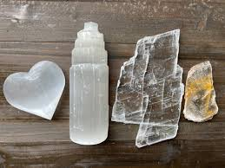

Chapter 3: History & Origin of the Stone of Light
Since ancient times, Selenite has been revered as a sacred crystal connected to the moon and the divine feminine.
Ancient Greece: The Greeks crafted temple windows from thin sheets of Selenite to let in “heavenly light.”
Egypt: Selenite was used in ceremonial objects dedicated to the Moon Goddess and placed in tombs for safe passage to the afterlife.
Medieval Europe: Selenite was believed to protect from evil spirits and bring purity to one’s home.
Satin Spar, with its fibrous structure and ethereal glow, became a symbol of inner reflection, angelic protection, and higher awareness.

Chapter 4: Physical Characteristics & Mineral Composition
Mineral Class: Sulfate (Gypsum family)
Chemical Formula: CaSO₄·2H₂O
Hardness: 2 on the Mohs scale (very soft)
Luster: Silky to pearly (Satin Spar), vitreous (Selenite)
Transparency: Transparent to translucent
Color: White, colorless, sometimes with peach or golden tones
Structure: Monoclinic
Because of its softness, Selenite can be scratched easily — handle it gently and avoid water exposure.

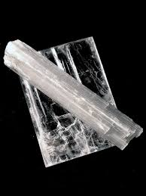

Chapter 5: Energetic Properties & Spiritual Symbolism
Selenite and Satin Spar vibrate at an exceptionally high frequency. Their light energy resonates with angelic realms, divine wisdom, and spiritual purification.

Spiritual Symbolism:
Light and illumination
Clarity and truth
Connection to higher consciousness
Emotional cleansing
Protection and divine peace

These crystals act as conduits for higher guidance, helping dissolve energy blockages and restore balance in the aura.

Feature | Selenite | Satin Spar
Appearance | Clear, flat, transparent sheets | Fibrous, silky, opaque
Lustre | Glassy | Pearly, satin-like
Energy Feel | Deep, calm, serene | Soothing, uplifting, radiant
Uses | Meditation, channelling, clarity | Cleansing, home energy clearing, aura purification

In practice, both varieties carry similar energy frequencies and can be used interchangeably. Satin Spar is more commonly found in towers, wands, and spheres, while Selenite appears in sheet or slab form.

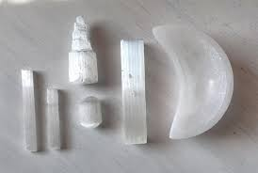

Chapter 7: Healing Benefits for Mind, Body & Spirit

Spiritual Healing
Connects you with your higher self and spirit guides
Opens the crown and soul star chakras
Enhances intuition and divine communication

Emotional Healing
Clears emotional heaviness and anxiety
Brings calm and serenity
Promotes mental clarity and balanced emotions

Physical Healing (Metaphysical)
Aids energetic detoxification
Supports restful sleep
Balances electromagnetic energy fields

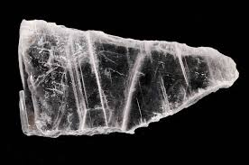

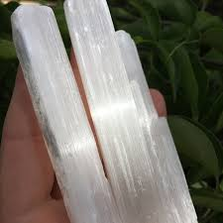

Chapter 8: Chakra Alignment & Energy Flow

Selenite and Satin Spar resonate primarily with the Crown Chakra (Sahasrara) and the Soul Star Chakra, located above the head.
They also help align all chakras by:
Clearing stagnant energy
Restoring balance across the energetic body
Creating a bridge between the physical and spiritual realms

Affirmation for Chakra Alignment:
“I am a vessel of divine light. My energy flows freely through all levels of my being.”
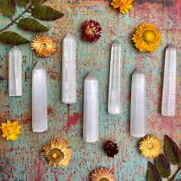

Chapter 9: Using Selenite & Satin Spar in Daily Practice
Meditate with a Selenite wand on your crown chakra to open higher awareness.
Keep a Selenite tower in your living room or sacred space to cleanse energy daily.
Use a Satin Spar stick to “comb” your aura after emotional stress.
Place Selenite under your pillow for restful sleep and dream clarity.

Chapter 10: Rituals for Cleansing & Divine Connection

The Moonlight Purification Ritual
Hold your Selenite in your hands and visualize a beam of white light washing over it.
Speak aloud:
“Under the moon’s glow, may this light cleanse and bless my soul.”
Place it near a window overnight to recharge with lunar energy.

Daily Energy Cleanse
Wave your Satin Spar wand through your energy field each morning while affirming:
“I release all that no longer serves me. I am cleansed, aligned, and radiant.”
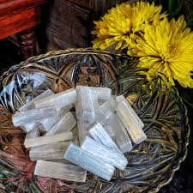

Chapter 11: Meditation with Selenite — The Path of Light

Sit comfortably with Selenite in both hands.
Focus on your breath and visualize white light entering through your crown.
Allow that light to expand through your entire body, dissolving all tension.
Sit in stillness for 10–15 minutes.
Outcome: Deep peace, mental clarity, and heightened spiritual awareness.

Chapter 12: Affirmations for Purification & Clarity
“I am light. I am pure. I am one with divine energy.”
“My mind is clear, my heart is open, and my spirit is at peace.”
“I release the past and align with the energy of truth.”
“I am surrounded by protective, luminous energy.”

Chapter 13: Crystal Combinations for Enhanced Energy

Purpose | Combine With | Benefit
Cleansing | Black Tourmaline | Clears negativity while stabilizing energy
Intuition | Amethyst | Enhances psychic vision and spiritual clarity
Manifestation | Citrine | Channels clear intention into creation
Love & Compassion | Rose Quartz | Promotes self-love and divine connection

Chapter 14: How to Care for Your Selenite & Satin Spar
Avoid water. Both dissolve when exposed to moisture.
Cleanse energetically with sound (singing bowl, bell), smoke (sage, palo santo), or moonlight.
Store carefully away from harder stones that may scratch them.

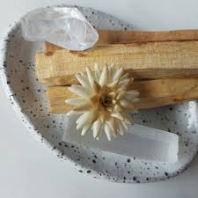

Chapter 15: Home & Space Cleansing with Selenite

Place a Selenite tower in each room corner or along windowsills to create a grid of light.
You can also run a Selenite wand along walls and doorways to purify stagnant energy.

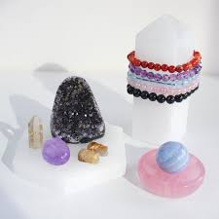

Chapter 16: Selenite in Grids & Energy Work

Selenite acts as an amplifier and purifier in crystal grids. It enhances the vibration of all other stones it’s paired with.
Use Selenite rods as grid borders or centre points for spiritual protection and divine alignment.

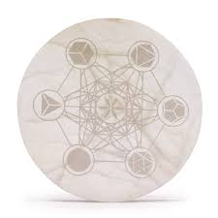

Chapter 17: Myths, Legends & Angelic Associations

Selenite is often linked to Archangel Gabriel, the messenger of divine truth and clarity.
It’s also associated with the Moon Goddess Selene, who governs intuition, emotions, and the cycles of renewal.
Legend says Selenite was formed from the light of the full moon, solidified by the tears of celestial beings who wept for the world’s lost purity.

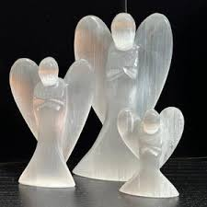

Chapter 18: Modern Uses & Practical Applications

Used in Reiki and energy healing sessions
Decorative lamps and towers that radiate gentle light
Aura cleansing tools for practitioners and therapists
Meditation aids for higher channelling and peace
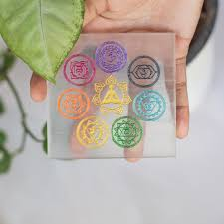

Chapter 19: Crystal Charging & Programming
To charge Selenite:
Place it under the full moon.
Surround it with other crystals to amplify mutual energy.

To program Selenite:
Hold it to your heart and speak your intention clearly:
“I infuse this crystal with the frequency of peace and divine light.”

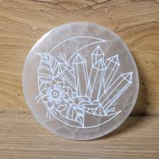

Chapter 20: Final Reflections — Becoming the Light

Selenite and Satin Spar are not just crystals; they are gateways to higher realms. Their presence reminds us of our own purity, clarity, and connection to divine wisdom.
When you invite these luminous stones into your practice, you are not only cleansing your environment — you are also awakening the inner light that resides within.
“You are the light. You are the peace. You are the reflection of divine clarity.”

