**Seraphinite: The Angel Stone of Healing & Divine Connection**

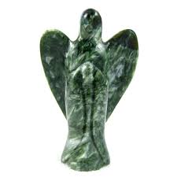

By AF Crystal Jewels

**Table of Contents**

1. **Introduction**
2. **The Origin & Properties of Seraphinite**
3. **Spiritual Meaning and Symbolism**
4. **Healing Properties of Seraphinite**
5. **Physical Healing**
6. **Emotional & Mental Healing**
7. **Spiritual Healing**
8. **Chakras & Energy Systems**
9. **How to Use Seraphinite**
10. **Meditation**
11. **Rituals & Daily Practices**
12. **Wearing Seraphinite Jewelry**
13. **Crystal Grids & Altar Spaces**
14. **Pairing Seraphinite with Other Crystals**
15. **Cleansing and Charging Seraphinite**
16. **Myths & Legends Surrounding Seraphinite**
17. **Final Thoughts**

Introduction

Seraphinite is often referred to as the “Angel Stone,” named after the Seraphim, the highest order of angels. Its lush green colour, feather-like silvery patterns, and high vibrational energy make it one of the most powerful stones for spiritual connection, healing, and inner peace.

This exquisite stone is more than a visual marvel—it is a gentle and deeply transformative crystal that aligns you with higher realms of divine light and guidance.

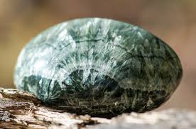

The Origin & Properties of Seraphinite

Scientific Name: Clinochlore

Colour: Deep forest green with silvery-white feathery inclusions

Hardness: 2–2.5 on the Mohs scale

Origin: Found mainly in the Lake Baikal region of Siberia, Russia

Composition: Magnesium, aluminium, iron silicate

The feather-like patterns in Seraphinite evoke images of angel wings, making it visually captivating and rich with symbolism.

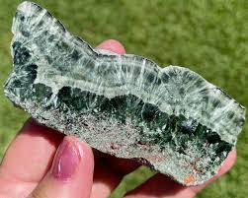

Spiritual Meaning and Symbolism

Seraphinite is known for its profound connection to the angelic realm and is believed to:

Open up communication with one’s guardian angels.

Facilitate deep spiritual enlightenment.

Inspire compassion, unconditional love, and self-healing.

Help one recognize their divine purpose.

Healing Properties of Seraphinite

Physical Healing

Seraphinite is thought to support cellular regeneration, bolster the heart and lungs, and encourage detoxification. Some healers use it as a rejuvenating crystal for the physical body.

Emotional & Mental Healing

Seraphinite aids in releasing emotional blockages, bringing clarity, reducing anxiety, and nurturing a deep sense of inner peace. It reminds you that you are never alone, encouraging self-acceptance and forgiveness.

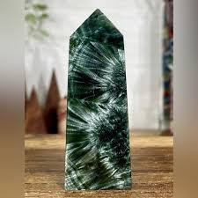

Spiritual Healing

Its high vibration makes it perfect for those seeking enlightenment and a direct connection with divine light. Meditating with Seraphinite can lead to heightened intuition, visionary experiences, and the gentle clearing of energetic debris.

Chakras & Energy Systems

Seraphinite powerfully resonates with the Heart Chakra, gently opening it for compassion and empathy. It also aligns with the Crown Chakra for spiritual growth and the Third Eye Chakra for intuitive guidance.

Its harmonizing energy brings balance across all chakras and supports a strong light-body activation.

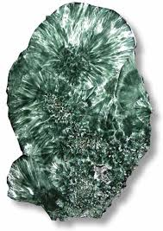

How to Use Seraphinite

Meditation

Hold Seraphinite in your hands or place it on your heart center during meditation. Visualize its green light filling your body, soothing your soul, and uplifting your consciousness.

Rituals & Daily Practices

Place Seraphinite near your bed for restful sleep and angelic guidance.

Wear it as a pendant to keep its protective, gentle energy close.

Include it in a gratitude ritual, holding the stone as you give thanks to the universe.

Crystal Grids & Altar Spaces

Create a grid with Seraphinite at the center to channel higher energies into your sacred space. Surround it with stones like Selenite, Clear Quartz, or Amethyst to amplify its divine frequency.

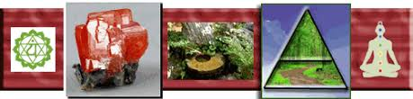

Pairing Seraphinite with Other Crystals

With Selenite: Deepens spiritual connection and purification.

With Rose Quartz: Enhances self-love and emotional healing.

With Moldavite: Strengthens transformative spiritual growth.

With Lepidolite: Encourages deep relaxation and emotional balance.

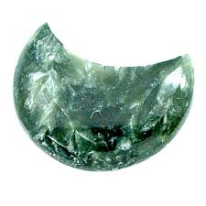

Cleansing and Charging Seraphinite

Cleanse using moonlight, sound bowls, or a gentle smudge.

Recharge by placing it on a Selenite plate or near a Quartz cluster overnight.

Avoid submerging it in water due to its softness.

Myths & Legends Surrounding Seraphinite

Ancient Siberian shamans believed Seraphinite was a gift from the angels, a fragment of their heavenly light left for humans to uplift their spirit and facilitate sacred journeys.

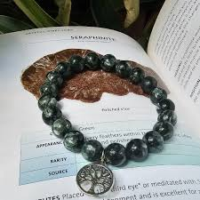

Final Thoughts

Whether you use Seraphinite as a personal talisman, a meditation ally, or as part of your healing practice, this gentle green stone reminds you that angels walk beside you. Its feather-light energy soothes, heals, and illuminates your path toward wholeness.

Let Seraphinite be your bridge to the divine and a constant reminder that you are loved, guided, and protected.

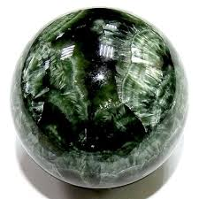

Thank you for reading this eBook.

💜 May Seraphinite fill your life with light, compassion, and deep spiritual insight.

— AF Crystal Jewels

