**Bumblebee Jasper: The Crystal of Radiant Empowerment**

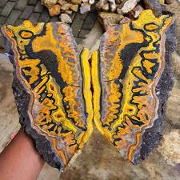

By AF Crystal Jewels

Roxy Slabber

**Table of Contents**

1. Introduction
2. What Is Bumblebee Jasper?
3. Origins and Formation
4. Physical Appearance and Composition
5. Metaphysical Properties
6. Chakra Connections
7. Healing Benefits
8. Spiritual and Emotional Uses
9. How to Use Bumblebee Jasper
10. Rituals and Affirmations
11. Cleansing and Charging
12. Safety and Handling Precautions
13. Combining with Other Crystals
14. Crystal Grids and Manifestation Work
15. How to Spot Authentic Bumblebee Jasper
16. Myths and Symbolism
17. Daily Practices with Bumblebee Jasper
18. Journal Prompts for Personal Growth
19. Summary and Final Reflections

**1. Introduction**

Welcome to Bumblebee Jasper: The Crystal of Radiant Empowerment. This guide is designed to help you unlock the transformative energy of one of the most visually stunning and energetically vibrant stones in the crystal kingdom. Whether you’re a beginner or an advanced practitioner, this eBook offers practical insights and spiritual wisdom to deepen your connection to this crystal ally.

**2. What Is Bumblebee Jasper?**

Despite its name, Bumblebee Jasper is not a true jasper. It is a vibrant, fibrous calcite rich in sulphur and volcanic material. Its bright yellow, orange, and black bands mimic the colours of a bumblebee, symbolizing joy, focus, and spiritual flight.

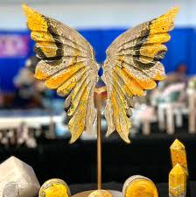

**3. Origins and Formation**

Bumblebee Jasper is found primarily in Mount Papandayan, West Java, Indonesia, a region of intense volcanic activity. The stone is formed from a combination of volcanic matter, anhydrite, hematite, sulphur, and arsenic-rich minerals, contributing to its unique composition and vibrant appearance.

**4. Physical Appearance and Composition**

* Colour: Vivid bands of yellow, orange, black, and grey
* Mineral Class: Carbonate (mostly calcite)
* Hardness: 4 to 5 on the Mohs scale
* Key Elements: Sulphur (yellow), Manganese Oxide (black), Arsenic compounds

The banded formation reflects dynamic energy flow, often used to activate personal power and ambition.

**5. Metaphysical Properties**

Bumblebee Jasper is a stone of empowerment, vitality, and manifestation. Its bold energy encourages personal growth, confidence, and a fearless pursuit of goals.

**Key Properties:**

* Boosts willpower and personal power
* Enhances self-esteem
* Activates the solar plexus chakra
* Encourages taking risks and stepping outside your comfort zone
* Stimulates creativity and joyful expression

**6. Chakra Connections**

Bumblebee Jasper strongly connects to:

* Solar Plexus Chakra (Manipura) – center of personal power, self-worth, and motivation
* Sacral Chakra (Svadhisthana) – creativity, passion, and emotional balance

It ignites your inner fire, helping you align your actions with your higher purpose.

**7. Healing Benefits**

**Physical:**

* Supports the digestive system
* Assists in circulatory regulation
* Boosts energy levels and reduces fatigue

**Emotional:**

* Dispels self-limiting beliefs
* Alleviates emotional stagnation
* Provides an optimistic outlook

**Spiritual:**

* Promotes alignment with life purpose
* Enhances intuition
* Encourages soul-level transformation

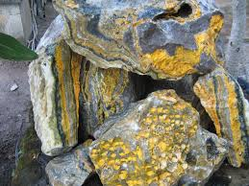

**8. Spiritual and Emotional Uses**

Bumblebee Jasper is ideal for shadow work, vision-boarding, and spiritual manifestation. It clears energetic blocks and motivates action, especially in emotionally heavy or self-doubting states.

Use this crystal when:

* You’re facing a major decision
* You need courage to speak your truth
* You’re starting a new creative venture

**9. How to Use Bumblebee Jasper**

* Meditation: Hold the stone on your solar plexus and visualize a golden light radiating from your core
* Affirmation Work: Repeat empowering mantras while holding the stone
* Crystal Grids: Use as the central stone in a manifestation grid
* Jewellery: Wear as a pendant to boost energy and confidence throughout the day
* Work Desk Companion: Keep it nearby during work to maintain motivation

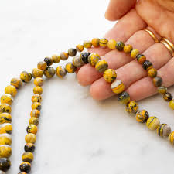

**10. Rituals and Affirmations**

**Morning Empowerment Ritual:**

1. Hold Bumblebee Jasper in both hands.
2. Close your eyes and take 3 deep breaths.
3. Repeat:  
   “I radiate confidence. I trust my path. I take bold, joyful action.”

**Manifestation Affirmations:**

* “I trust my inner compass and follow my highest truth.”
* “I am fearless in pursuit of my purpose.”
* “Each day, I rise with confidence and joy.”

**11. Cleansing and Charging**

Due to its mineral composition (especially sulfur and arsenic), avoid water-based cleansing.

**Safe Cleansing Methods:**

* Smoke cleansing (e.g., sage, Palo Santo)
* Sound cleansing (singing bowl)
* Moonlight (preferably during the waxing or full moon)
* Selenite plates for passive cleansing

Avoid: Salt, water, and harsh chemicals.

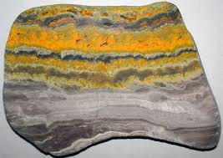

**12. Safety and Handling Precautions**

Bumblebee Jasper contains toxic elements (sulphur and arsenic). Although safe when polished and sealed:

* Do not submerge in water
* Avoid inhaling dust from raw pieces
* Wash hands after handling raw or unsealed specimens
* Keep away from children and pets

**13. Combining with Other Crystals**

**Powerful Pairings:**

* Carnelian – for amplified creativity
* Citrine – for abundance and manifestation
* Tiger’s Eye – for courage and grounded confidence
* Clear Quartz – for energy amplification

These combinations magnify personal power and focus during manifestation rituals.

**14. Crystal Grids and Manifestation Work**

Bumblebee Jasper Manifestation Grid:

* Centre: Bumblebee Jasper (purpose)
* Surrounding stones: Citrine, Pyrite, Clear Quartz
* Intent: Clarity, courage, and abundance
* Shape: Triangle or Sunburst pattern

**15. How to Spot Authentic Bumblebee Jasper**

**Genuine Characteristics:**

* Bright, natural patterns with no dye residue
* Variations in banding and natural imperfections
* Cool to touch with a slight weightiness

Warning: Imitation stones may be made from dyed resin or painted calcite. Purchase only from trusted sources.

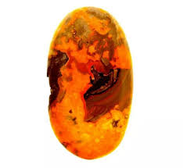

**16. Myths and Symbolism**

* Symbol of Transformation – like the bumblebee, it symbolizes doing the impossible
* Elemental Fusion – fire (volcanic) and air (bee symbolism) unite to inspire fearless movement
* Solar Magic – connected to the sun’s radiant life-force and manifestation energy

**17. Daily Practices with Bumblebee Jasper**

* Set intentions every morning with the crystal in hand
* Keep on your desk to stay motivated
* Use during journaling to uncover blocks and take aligned action
* Place on sacral or solar plexus during meditations for chakra activation

**18. Journal Prompts for Personal Growth**

1. Where in my life do I need to be more courageous?
2. What dream am I ready to pursue, even if it scares me?
3. What does personal power mean to me?
4. What am I manifesting in the next 30 days?

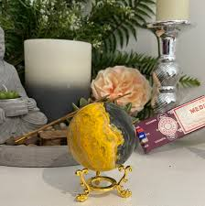

**19. Summary and Final Reflections**

Bumblebee Jasper is a catalyst for transformation. It doesn’t whisper; it roars. It asks you to rise boldly into your power, to embrace your mission, and to live with radiant joy and clarity. Use this guide as your compass, and let this crystal be your spark.

