**Purplerite: The Stone of Divine Insight & Inner Power**

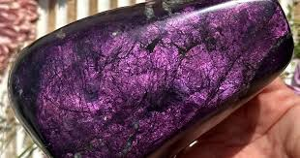

By AF Crystal Jewels

Roxy Slabber

**Table of Contents**

1. Introduction
2. What is Purplerite?
3. The Origins & Composition of Purplerite
4. Metaphysical Properties
5. Chakra Alignment
6. Healing Benefits
7. Everyday Uses
8. Rituals & Practices
9. Crystal Pairings
10. Affirmations for Purplerite
11. How to Cleanse & Charge Purplerite
12. Final Reflections

**1. Introduction**

In the vast and mystical world of crystals, there are those that stand out not just for their appearance but for their energetic depth. Purplerite is one such stone—a rare and mesmerizing crystal known for its deep violet hues and potent spiritual properties. This guide will introduce you to the full power of Purplerite, whether you’re seeking clarity, energetic protection, or an enhanced connection to your higher self.

**2. What is Purplerite?**

Purplerite is a rare, violet-toned crystal prized for its mysterious beauty and strong energetic frequency. With deep, marbled shades of purple and streaks of silver or black, it is often associated with intuition, psychic vision, and divine empowerment. Though not widely known, it is rapidly gaining attention among energy healers, spiritual seekers, and crystal collectors.

**3. The Origins & Composition of Purplerite**

Though geological data is still emerging, Purplerite is believed to be a form of silicate mineral with high levels of manganese and iron, contributing to its unique coloration and energy signature. It has been reportedly found in select regions of South America and Eastern Europe.

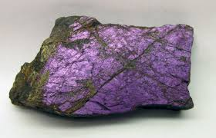

Physical Characteristics:

* Colour: Deep violet to indigo with black or silver veining
* Hardness: 6.5–7 on the Mohs scale
* Lustre: Silky to vitreous

**4. Metaphysical Properties**

Purplerite is often referred to as “The Stone of Divine Insight” due to its remarkable influence on spiritual clarity and inner knowing.

**Energetic Properties:**

* Heightens intuition and psychic sensitivity
* Encourages emotional mastery and resilience
* Amplifies spiritual downloads during meditation
* Shields the aura from psychic interference

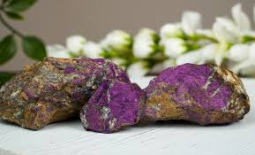

**5. Chakra Alignment**

Primary Chakra: Third Eye (Ajna)

Secondary Chakra: Crown (Sahasrara)

Purplerite activates the Third Eye and Crown chakras, facilitating deeper spiritual connection, lucid dreaming, astral travel, and inner vision. It’s ideal for energy workers, mystics, and those on the path of awakening.

**6. Healing Benefits**

**Emotional:**

* Eases mental overwhelm and emotional confusion
* Assists in letting go of fear and mistrust
* Encourages emotional sovereignty and confidence

**Mental:**

* Supports focused thought and intuitive clarity
* Enhances creative problem-solving
* Calms overactive thinking

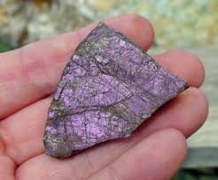

**Physical:**

While not a substitute for medical treatment, Purplerite is said to:

* Support hormonal balance
* Relieve tension headaches caused by emotional stress
* Improve sleep quality when placed near the bed

**7. Everyday Uses**

* Meditation Companion: Hold Purplerite during meditation to deepen your spiritual connection and activate inner vision.
* Desk Ally: Place on your workspace to stay mentally sharp and energetically protected.
* Pocket Stone: Carry daily to reduce stress and stay aligned with your intuition.
* Under Pillow: Use for dream recall and to reduce anxiety during sleep.

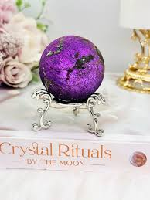

**8. Rituals & Practices**

**Third Eye Awakening Ritual**

1. Sit quietly and place Purplerite on your forehead.
2. Breathe deeply and visualize violet light radiating from your third eye.
3. Repeat the affirmation: “I see clearly with divine wisdom.”

**Dream Recall Ritual**

1. Place the crystal under your pillow or on your nightstand.
2. Keep a journal nearby.
3. Upon waking, write down your dreams and reflect on any symbolism.

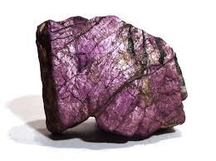

**9. Crystal Pairings**

To amplify Purplerite’s power, pair it with:

* Labradorite: For enhanced psychic protection and intuition
* Amethyst: To boost spiritual clarity and emotional healing
* Clear Quartz: To magnify Purplerite’s vibrational output
* Lepidolite: For emotional balance and calming anxious thoughts

**10. Affirmations for Purplerite**

Use these affirmations during meditation or journaling:

* “I trust my inner vision and divine intuition.”
* “I am aligned with the wisdom of the universe.”
* “My energy is protected, and my mind is clear.”
* “I release fear and step into my spiritual power.”

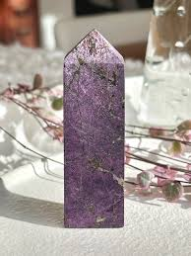

**11. How to Cleanse & Charge Purplerite**

Cleansing:

* Smoke cleansing (sage, palo santo)
* Sound (singing bowls or tuning forks)
* Moonlight (avoid prolonged sunlight exposure)

Charging:

* Place on a Selenite plate
* Use intention and visualization
* Bury in earth for 24 hours for grounding recharge

**12. Final Reflections**

Purplerite is more than a beautiful gemstone—it is a spiritual tool for transformation. With consistent use and sacred intention, this crystal can guide you to deeper insight, resilience, and alignment with your highest path.

Whether you are navigating emotional uncertainty, seeking divine guidance, or simply want to elevate your spiritual practice, Purplerite offers both strength and serenity in its rich violet glow.

