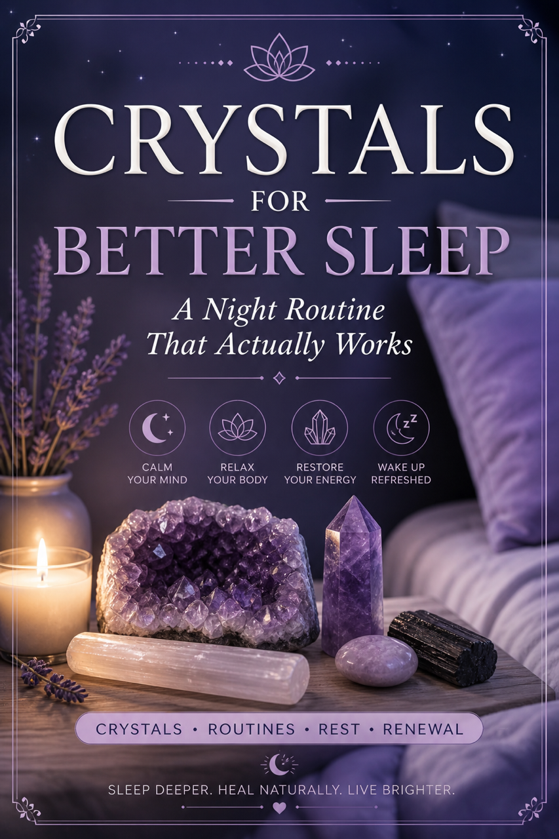
Crystals for Better Sleep
A Night Routine That Actually Works

1. Introduction (Expanded)
Sleep is not simply a physical process, it is a neurological, emotional, and energetic reset cycle.
When you struggle to sleep, the issue is rarely just “tiredness.” It is usually a combination of:

- Nervous system dysregulation
- Mental overstimulation
- Emotional residue from the day
- Energetic imbalance

Crystals act as anchors, tools that help your body transition from an alert, active state into a calm, receptive one.
This guide is designed to give you a repeatable system that works with your body—not against it.



2. Why You’re Not Sleeping Properly (Deeper Insight)
Most sleep issues fall into three core patterns:
1. The Overactive Mind
Constant thinking, replaying conversations, planning tomorrow
Linked to an overactive crown chakra
2. The Stressed Body
Tight chest, shallow breathing, restlessness
Nervous system stuck in “fight or flight”

3. The Unsettled Energy Field
Feeling uneasy, heavy, or emotionally drained
Often caused by absorbing external energy throughout the day

Key Insight
Sleep improves when you:
- Calm the mind
- Relax the body
- Stabilise your energy
Your routine must address all three.



3. How Crystals Support Sleep (Advanced Explanation)
Crystals don’t “make you sleep.”
They influence the conditions required for sleep.

They work through:

1. Nervous System Regulation
Certain crystals promote a parasympathetic response (rest state).

2. Emotional Release
They help dissolve stored tension from the day.

3. Environmental Energy
They shift the “feel” of your space into something calm and safe.
Important Principle
Crystals are most effective when combined with:
- Breathwork
- Intention
- Consistency
Without these, results will be minimal.
4. The Best Crystals for Deep Sleep (Expanded)

Amethyst – The Mind Calmer

Best for:
- Overthinking
- Insomnia caused by mental activity
Use: Under pillow or held during breathing

Lepidolite – The Emotional Stabiliser
Best for:
- Anxiety
- Emotional overwhelm
Use: Hold against chest before sleep

Selenite – The Energy Cleanser
Best for:
- Clearing lingering energy from the day
Use: Sweep around body or place near bed

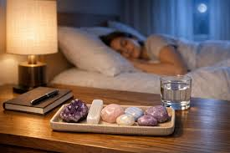
Black Tourmaline – The Grounding Shield
Best for:
- Feeling unsafe or restless
Use: Bedside or room corners

Rose Quartz – The Nervous System Soother
Best for:
- Emotional tension, heartbreak, stress
Use: Hold during affirmations

5. Your Night Routine That Actually Works (Optimised System)
This routine is structured to progressively slow your system down.

Phase 1: Transition (30–60 mins before bed)
Goal: Shift from stimulation → relaxation
- Turn off screens
- Lower lights
- Avoid heavy conversations
Why it matters:
Your brain needs a clear signal that the day is ending.

Phase 2: Energy Reset (2–3 mins)
- Use selenite
- Slowly move it around your body
Visualise:
Energy clearing from your head → down to your feet

Phase 3: Nervous System Downshift (5–7 mins)
Hold amethyst or lepidolite
- Breathe:
- Inhale → 4 seconds
- Exhale → 6–8 seconds
Why this works:
Longer exhales activate the parasympathetic nervous system

Phase 4: Mental Release (2 mins)
Instead of suppressing thoughts:
Acknowledge them
Then say:
“Not now. Tomorrow.”
This prevents mental resistance.

Phase 5: Intention Programming (1 min)
Say:
“I release all tension. My body knows how to rest. I allow deep, uninterrupted sleep.”
This trains your subconscious.
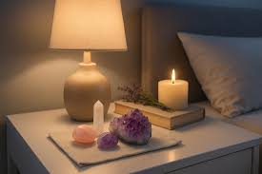
Phase 6: Sleep Setup
- Amethyst → under pillow
- Lepidolite → bedside
- Black tourmaline → near bed
- Selenite → headboard

6. 5-Minute Emergency Calm Ritual (Upgraded)
Use this when anxiety spikes at night.
Step-by-step:
- Sit upright
- Hold lepidolite
- Place one hand on chest, one on stomach
- Breathe slowly
Add this layer:
On inhale → “I receive calm”
On exhale → “I release tension”
This engages both mind and body simultaneously

7. Crystal Placement for Maximum Effect
Placement is strategic, not random.
Sleep Zone Layout
- Head area → calming crystals (amethyst, selenite)
- Body area → soothing crystals (rose quartz, lepidolite)
- Room perimeter → grounding (black tourmaline)


Pro Tip
Too many crystals can create energetic noise.
Use 3–5 maximum.
8. Weekly Reset Routine (Enhanced)
Once per week:

Step 1: Physical Reset
- Change bedding
- Declutter surfaces

Step 2: Energetic Reset
Cleanse crystals (moonlight or selenite plate)

Step 3: Intention Reset
Ask: “What energy do I want in this space this week?”

9. Common Mistakes (Expanded)
Treating crystals as a quick fix
Skipping breathwork (this is critical)
Using stimulating crystals at night
Inconsistent routine
Reality Check
Results come from:
Consistency + environment + routine
Not crystals alone.

10. Sleep Affirmations (Advanced Use)
Use them during the transition phase, not just in bed.

For Overthinking
“My mind is slowing down. I don’t need to solve anything right now.”

For Anxiety
“I am safe. My body can relax.”

For Light Sleepers
“I remain deeply asleep throughout the night.”

11. Final Thoughts (Stronger Close)
Better sleep is not achieved by forcing rest.
It is created by:
- Calming the nervous system
- Clearing emotional residue
- Establishing a repeatable signal for sleep
- This system works because it aligns mind, body, and energy.



