**Hackmanite: The Shifting Stone of Light and Shadow**

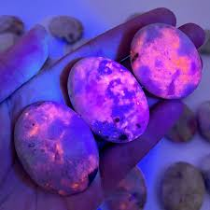

Unlocking the Secrets of the Tenebrescent Gem

By AF Crystal Jewels – Roxy Slabber

**Contents**

1. Introduction to Hackmanite
2. Mineralogical Properties
3. The Magic of Tenebrescence
4. History and Origins
5. Where Hackmanite is Found
6. Metaphysical Properties
7. Healing Uses of Hackmanite
8. Chakras and Hackmanite
9. Using Hackmanite in Daily Life
10. How to Care for Hackmanite
11. Hackmanite Combinations
12. Rituals and Affirmations
13. Ethical Sourcing & Buying Guide
14. Final Thoughts

**1. Introduction to Hackmanite**

Hackmanite is a rare and mystical gemstone admired for its unusual ability to change colour under UV light—a phenomenon known as tenebrescence. More than a geological marvel, Hackmanite is embraced by healers, mystics, and collectors alike for its metaphysical properties, believed to promote clarity, transformation, and psychic awakening.

**2. Mineralogical Properties**

* Chemical Formula: Na₈(Al₆Si₆O₂₄)Cl₂
* Crystal System: Isometric
* Hardness: 5.5–6 on Mohs scale
* Colour: Light pink, violet, grey, or white that can deepen in colour when exposed to UV light
* Lustre: Vitreous
* Unique Trait: Tenebrescence (reversible colour change)

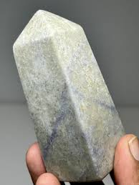

**3. The Magic of Tenebrescence**

Tenebrescence is the rare ability of some minerals to change colour when exposed to ultraviolet light and revert to their original colour in the dark or under sunlight. Hackmanite can shift from pale to deep purple or pink depending on light exposure. This reversible transformation mirrors the concept of spiritual and emotional transitions—darkness becoming light and vice versa.

**4. History and Origins**

Discovered in Greenland in 1896 and named after Finnish geologist Viktor Hackman, Hackmanite was long considered a scientific curiosity. In recent years, however, spiritual communities have embraced it as a stone of psychic awakening and self-discovery.

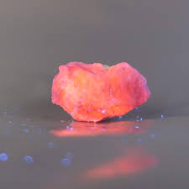

**5. Where Hackmanite is Found**

Major deposits of Hackmanite are located in:

* Greenland
* Afghanistan
* Myanmar (Burma)
* Canada
* Russia
* Tanzania

Each region produces stones with slightly different hues and tenebrescent qualities.

**6. Metaphysical Properties**

Hackmanite is thought to:

* Stimulate the third eye and crown chakras
* Encourage truth, introspection, and self-awareness
* Enhance psychic gifts and clairvoyance
* Assist in emotional release and spiritual insight
* Act as a shield against negativity during transformation

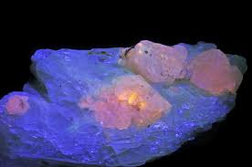

**7. Healing Uses of Hackmanite**

Emotional Healing: Hackmanite helps release emotional blockages, particularly those rooted in fear or trauma. It supports those experiencing sudden changes or inner conflict.

Mental Clarity: Aids in decision-making, improves intuition, and offers a sense of balance between logic and feeling.

Spiritual Growth: Assists with spiritual awakening, dream recall, and alignment with higher consciousness.

**8. Chakras and Hackmanite**

|  |  |
| --- | --- |
| **Chakra** | **Effect** |
| Third Eye | Enhances intuition and spiritual vision |
| Crown | Connects to higher realms and divine wisdom |
| Throat (lesser influence) | Aids in honest expression and spiritual truths |

**9. Using Hackmanite in Daily Life**

* Meditation: Hold it in your hand or place it on your forehead to enhance spiritual meditation.
* Dream Work: Sleep with it under your pillow to enhance dream recall and lucid dreaming.
* Energy Grids: Use in grids for transformation, insight, and lightwork.
* Jewellery: Wearing Hackmanite helps maintain emotional balance and energetic protection throughout the day

**10. How to Care for Hackmanite**

* Cleaning: Cleanse with dry cloth or moonlight—avoid water and salt due to its fragility.
* Recharging: Place in moonlight or under UV light to enhance its colour and energy.
* Storage: Keep away from direct sunlight, which can reverse its tenebrescent effect too quickly.

**11. Hackmanite Combinations**

With Amethyst: Enhances spiritual awareness and purification.

With Moonstone: Deepens intuition and emotional balance.

With Clear Quartz: Amplifies Hackmanite’s psychic and protective qualities.

With Labradorite: Increases mysticism and transformation.

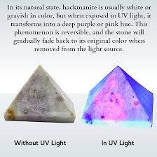

**12. Rituals and Affirmations**

Hackmanite Illumination Ritual

* Sit in a darkened room with Hackmanite in hand.
* Expose the stone briefly to UV light, watching it glow.
* As you meditate, visualize old beliefs dissolving and clarity forming.
* Speak aloud:  
  “From shadow into light, I transform with grace. I see, I know, I grow.”

Daily Affirmation

“I embrace the light within me and trust the wisdom it reveals.”

**13. Ethical Sourcing & Buying Guide**

Due to its rarity, Hackmanite is often sold in synthetic forms or mislabelled. Look for:

* Reputable sellers offering origin details (Afghanistan, Burma, etc.)
* Stones with verified tenebrescence (ask for a UV light test video)
* Avoid overly saturated or suspiciously cheap stones

**14. Final Thoughts**

Hackmanite is more than just a beautiful and rare stone. It serves as a metaphor for the journey of transformation—where shadows become lessons and darkness reveals inner light. Whether you’re a collector, a healer, or simply curious, Hackmanite invites you to see beyond the surface and embrace the unseen beauty within.

