**Crystals & Shapes: Unlocking the Energy of Sacred Geometry in Stone**

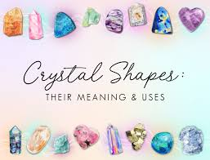

By AF Crystal Jewels

Roxy Slabber

Introduction

Crystals have been treasured for thousands of years not only for their beauty but also for their ability to channel energy. While most people focus on colour or mineral type, an often-overlooked factor is shape.

The shape of a crystal — whether naturally formed deep within the earth or polished by skilled hands — has a profound influence on how it transmits, stores, and directs energy. A sphere radiates harmony in every direction. A point sends energy to a focused target. A pyramid concentrates universal life force like a beam of light.

In this guide, you will discover how crystal shapes affect their healing properties, how to choose the right form for your intentions, and how to combine shapes for powerful results. Whether you are a collector, healer, or spiritual seeker, understanding the language of crystal geometry will elevate your practice to the next level.

Chapter 1 – The Power of Shape in Crystal Healing

Every crystal carries a unique vibrational signature based on its atomic structure and chemical composition. Yet the outer form also plays a key role. Shape acts like an energetic antenna, shaping the way energy moves through and around the stone.

Key points:

Shape directs energy. Points focus, spheres radiate, cubes ground.

Shape amplifies intention. Combining the right crystal type with the right shape multiplies results.

Natural vs. polished. Natural forms carry raw earth energy; polished forms channel energy more smoothly and intentionally.

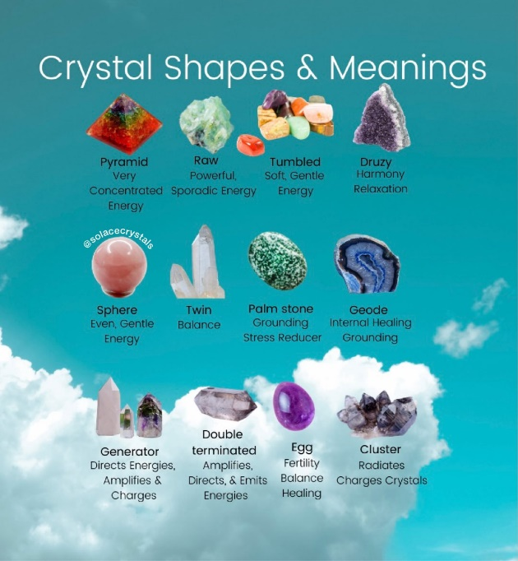

Example: A naturally terminated quartz point may carry a powerful but raw beam of energy, while a polished quartz sphere will offer a gentler, more harmonized flow.

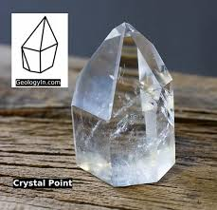

Chapter 2 – Crystal Points & Wands

Single-Terminated Points

Energy Direction: Draws energy in at the base, projects it through the tip.

Uses: Directing healing energy, focusing intentions, activating crystal grids.

Best Crystals: Clear Quartz (amplification), Amethyst (spiritual focus), Citrine (manifestation).

Affirmation: “I direct my energy toward my highest good.”

Ritual: Hold the point with the base toward your body to draw in energy, or with the tip toward an object/person to send energy.

Double-Terminated Points

Energy Direction: Sends and receives energy from both ends simultaneously.

Uses: Balancing two points of energy (e.g., chakra balancing), connecting people or intentions, energy flow in both directions.

Best Crystals: Herkimer Diamond (clarity), Smoky Quartz (grounding), Fluorite (mental balance).

Crystal Wands

Energy Direction: Channels and directs energy along its length.

Uses: Reiki, acupressure, aura cleansing, reflexology.

Best Crystals: Selenite (cleansing), Black Obsidian (cord cutting), Rose Quartz (emotional healing).

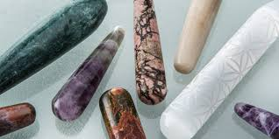

Chapter 3 – Spheres

Energy Direction: Radiates energy evenly in all directions, creating a balanced energy field.

Uses: Meditation, emotional healing, creating a harmonious environment.

Best Crystals:

Rose Quartz Sphere – Emits unconditional love

Labradorite Sphere – Boosts intuition and psychic ability

Clear Quartz Sphere – Amplifies energy and intention

Affirmation: “I radiate peace and harmony in all directions.”

Ritual: Meditate while gazing into a sphere to quiet the mind and deepen spiritual connection.

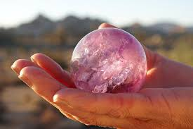

Chapter 4 – Pyramids

Energy Direction: Draws universal energy in through the base, focuses it through the apex.

Uses: Amplifying manifestation, creating energy vortexes, altar work.

Best Crystals:

Citrine Pyramid – Attracts abundance

Obsidian Pyramid – Shields against negativity

Green Aventurine Pyramid – Encourages growth and opportunity

Affirmation: “My intentions are clear and amplified by universal energy.”

Ritual: Place a pyramid over a written intention to charge and manifest it.

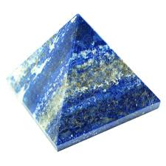

Chapter 5 – Cubes

Energy Direction: Grounds and stabilizes energy, connecting to the Earth’s core.

Uses: Root chakra work, protection grids, stability in life changes.

Best Crystals:

Black Tourmaline Cube – Energy shielding

Fluorite Cube – Mental organization

Pyrite Cube – Financial stability

Affirmation: “I am stable, grounded, and secure.”

Ritual: Place four cubes at the corners of a room to create a grounded protective field.

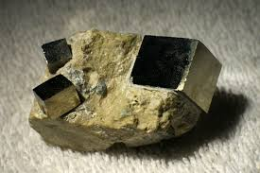

Chapter 6 – Hearts

Energy Direction: Channels gentle, loving energy that resonates with the heart chakra.

Uses: Emotional healing, relationship harmony, self-love practices.

Best Crystals:

Rose Quartz Heart – Love and compassion

Rhodonite Heart – Emotional balance

Chrysoprase Heart – Forgiveness

Affirmation: “My heart is open to give and receive love.”

Ritual: Sleep with a heart-shaped crystal under your pillow to invite loving dreams.

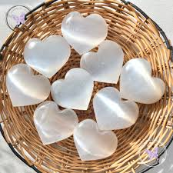

Chapter 7 – Palm Stones & Tumbles

Energy Direction: Smooth, gentle, and easy to carry energy flow.

Uses: Stress relief, meditation, pocket talismans.

Best Crystals:

Amethyst Palm Stone – Calming the mind

Moonstone Tumble – Emotional balance

Carnelian Tumble – Motivation and vitality

Affirmation: “I carry my energy tool with me wherever I go.”

Ritual: Hold during deep breathing to release tension.

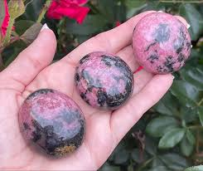

Chapter 8 – Clusters & Geodes

Energy Direction: Multiple points radiate energy simultaneously, creating a vibrant field.

Uses: Charging other crystals, cleansing spaces, group meditation.

Best Crystals:

Amethyst Cluster – Spiritual growth

Celestite Geode – Angelic connection

Apophyllite Cluster – Higher guidance

Affirmation: “I am surrounded by pure, uplifting energy.”

Ritual: Place in the centre of your home to keep energy light and clear.

Chapter 9 – Sacred Geometry Carvings

Merkaba – Activates light body, aids spiritual travel.

Platonic Solids – Balance the elements in body and environment.

Flower of Life – Symbol of creation, unity, and connection.

Metatron’s Cube – Sacred protection and divine blueprint alignment.

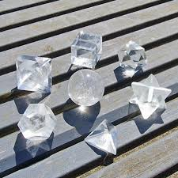

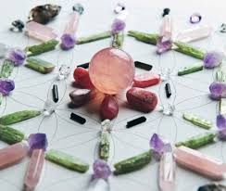Chapter 10 – Choosing & Combining Shapes

Match shape to intention:

Healing → Point

Harmony → Sphere

Manifestation → Pyramid

Protection → Cube

Love → Heart

Combine shapes in crystal grids for amplified effect.

Trust intuition — the right shape will often “call” to you.

Appendix – Quick Shape Reference

|  |  |  |  |
| --- | --- | --- | --- |
| Shape | Energy Flow | Main Uses | Best Crystals |
| Point | Focused beam | Healing, manifestation | Quartz, Amethyst |
| Double-Terminated | Dual flow | Energy balance | Herkimer, Fluorite |
| Wand | Directional | Reiki, massage | Selenite, Rose Quartz |
| Sphere | Radiates evenly | Harmony, meditation | Rose Quartz, Clear Quartz |
| Pyramid | Amplifies | Manifestation | Citrine, Obsidian |
| Cube | Grounds | Stability, protection | Black Tourmaline, Pyrite |
| Heart | Gentle love | Emotional healing | Rose Quartz, Rhodonite |
| Cluster | Multi-point | Cleansing, charging | Amethyst, Celestite |

Conclusion

Shapes are not just aesthetic — they are energetic tools that determine how a crystal works with you. By choosing the right combination of crystal type and shape, you create a powerful ally for healing, manifestation, and protection.

When you hold a crystal, you are holding a piece of the Earth’s sacred geometry — a reminder that energy flows in patterns, and that with awareness, you can direct that flow toward your highest good.

