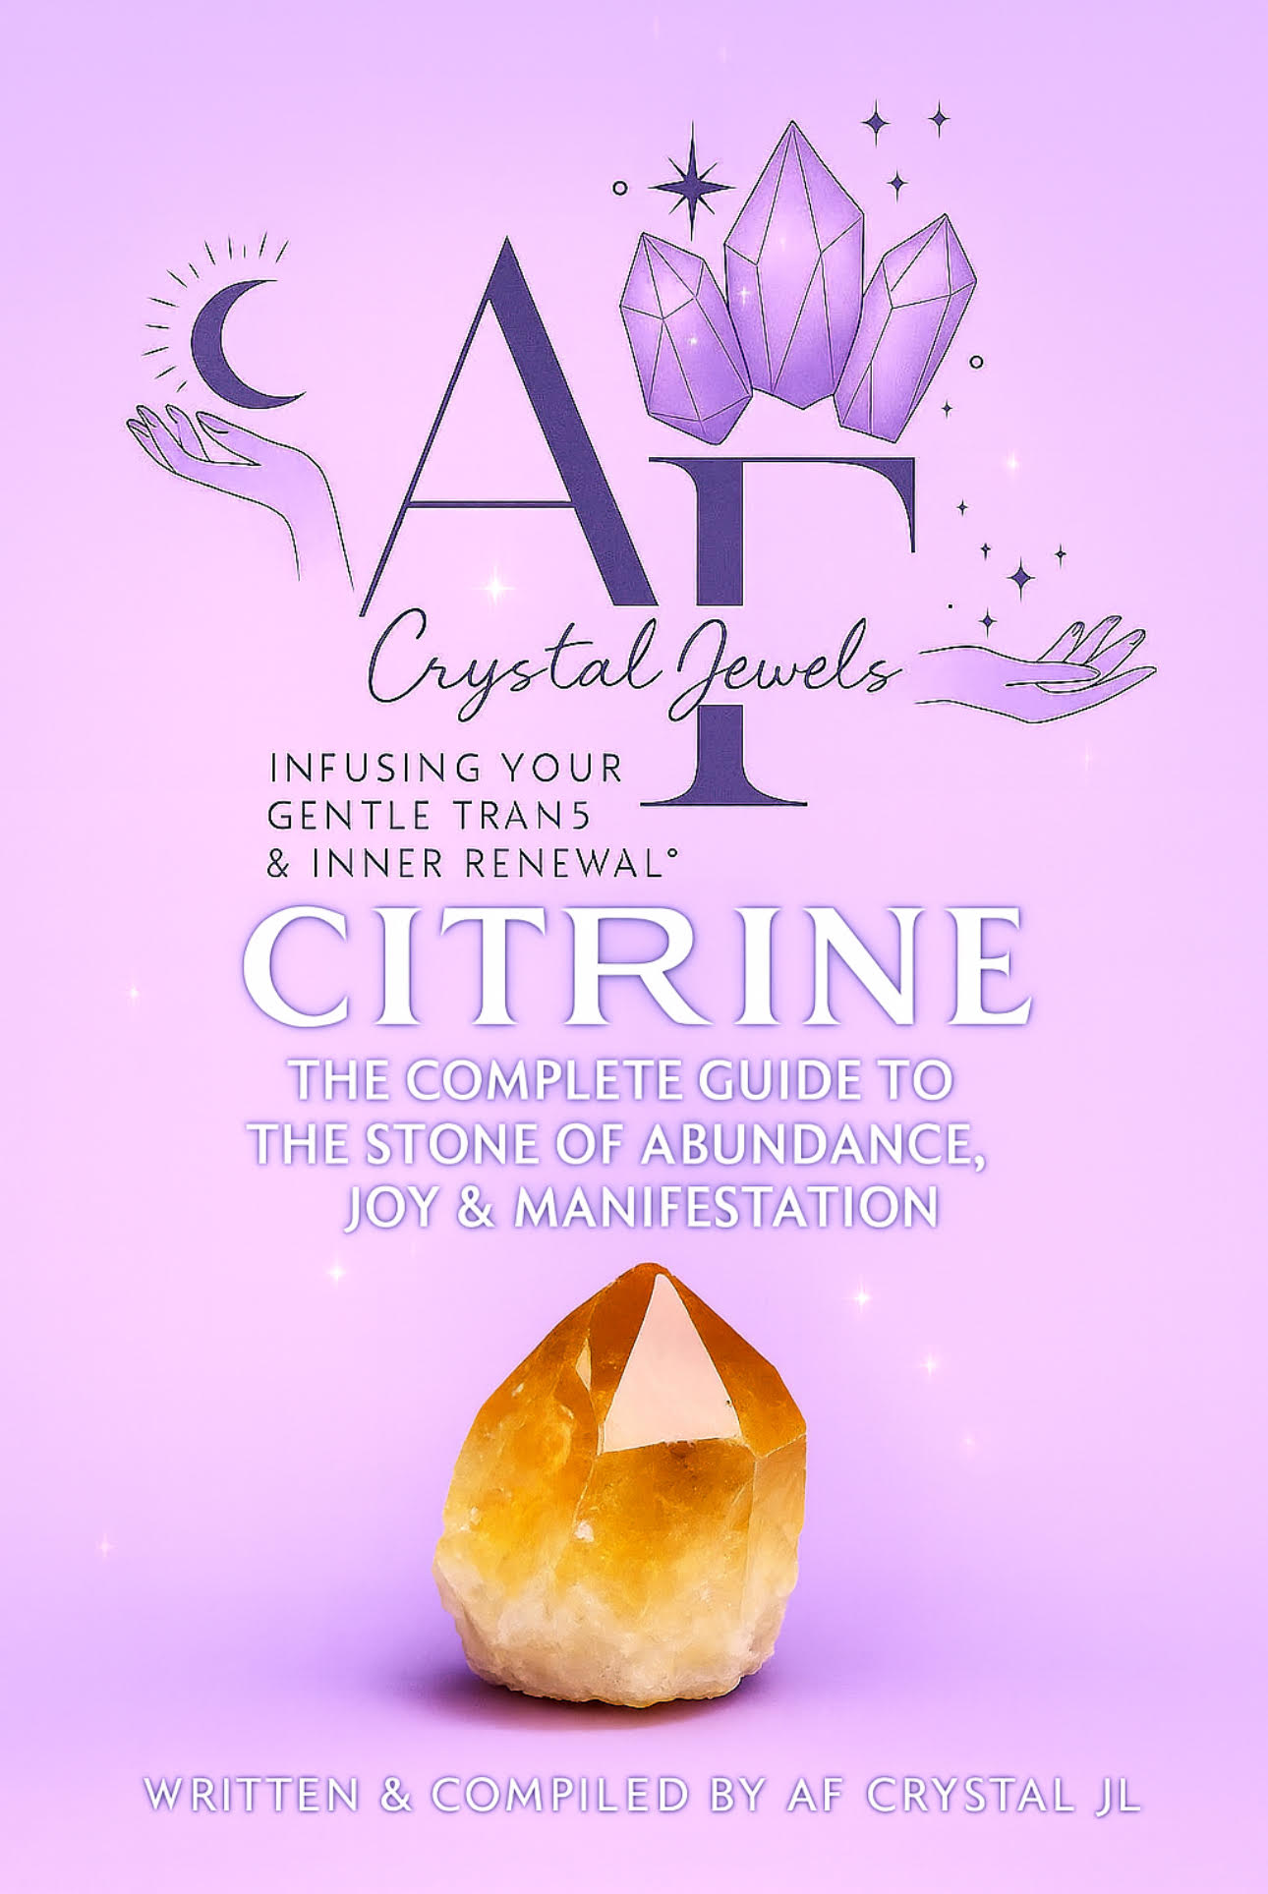

CITRINE: THE COMPLETE GUIDE TO THE STONE OF ABUNDANCE, JOY & MANIFESTATION

Table of Contents
- Introduction
- What Is Citrine?
- Geological Formation & Varieties
- Citrine Through History
- Metaphysical Properties of Citrine
- Emotional, Mental & Spiritual Benefits
- Citrine & The Chakras
- How to Use Citrine for Manifestation
- Citrine for Wealth & Abundance
- Citrine in the Home & Workplace
- Citrine & Meditation Practices
- Crystal Pairings: Best Stones to Use with Citrine
- Cleansing, Charging & Caring for Citrine
- How to Spot Natural vs. Heat-Treated Citrine
- Citrine Grids for Abundance, Joy & Creativity
- Daily Rituals & Affirmations
- Citrine Jewellery & How to Wear It
- Citrine for Entrepreneurs, Healers & Creatives
- FAQ: Everything You Need to Know About Citrine
- Conclusion

1. Introduction
Citrine is one of the most beloved crystals in the world of metaphysical healing. Known for its radiant golden hue and vibrant energy, it has been treasured for centuries as a stone of abundance, joy, confidence and manifestation. This complete guide reveals everything about Citrine—from its geology to its spiritual uses—so you can confidently work with this powerful crystal in your daily life and healing practice.

2. What Is Citrine?
Citrine is a yellow-to-golden variety of quartz, coloured by traces of iron within its structure. Its energy is warm, uplifting, and invigorating, making it ideal for personal power, manifestation and abundance work.

Key Properties
Mineral family: Quartz
Colour: Pale yellow to deep gold
Hardness: 7 on the Mohs scale
Chemical composition: SiO₂ (Silicon Dioxide)
Energy type: Amplifying, cleansing, energising
Citrine is often referred to as the “Merchant’s Stone” or “Stone of Success” due to its long-standing association with prosperity and wealth.

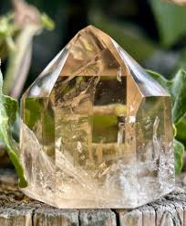

3. Geological Formation & Varieties
Citrine forms naturally when quartz undergoes heating deep in the Earth, causing iron impurities to oxidize and create warm yellow shades.

Types of Citrine
Natural Citrine – Very rare; typically pale, smoky, or champagne-toned.
Heat-Treated Citrine – Made by heating amethyst or smoky quartz to create bright golden to orange tones.
Kundalini Citrine (Zambian) – Deep smoky-gold, high-frequency natural Citrine.
Lemon Citrine – Very light yellow and clear; highly uplifting energy.
Each variety carries the same fundamental vibration of abundance, though natural Citrine is often perceived as more subtle and grounding.

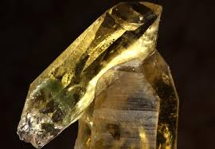

4. Citrine Through History
Citrine has been used since ancient times as:
A talisman for merchants and traders
A protection stone worn during travel
A symbol of vitality and the sun
A stone of courage for soldiers and leaders
In Ancient Rome it was prized for its connection to the sun god, symbolizing clarity and strength.

5. Metaphysical Properties of Citrine
Citrine’s metaphysical properties make it one of the most versatile crystals for both beginners and experienced practitioners.

Primary Energetic Attributes
Promotes wealth, prosperity and manifestation
Enhances creativity and mental clarity
Boosts confidence and personal power
Clears stagnant or negative energy
Aligns you with joy, optimism and vibrant wellbeing
Strengthens intuition around money and decision-making
It is one of the few crystals believed to never hold or absorb negative energy—instead, it transmutes it.
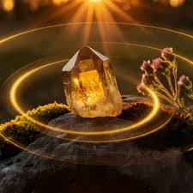

6. Emotional, Mental & Spiritual Benefits
Emotional Benefits
Lifts mood and emotional heaviness
Dissolves fear, self-doubt and low self-worth
Encourages playfulness and positivity
Supports emotional resilience

Mental Benefits
Improves focus, decision-making and organization
Boosts productivity and motivation
Enhances creativity and problem-solving
Helps break patterns of scarcity thinking

Spiritual Benefits
Aligns you with abundance frequencies
Strengthens manifestation power
Connects you to Solar energy
Cleanses your aura of density and energetic blocks

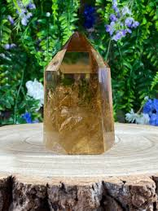

7. Citrine & The Chakras
Citrine resonates primarily with:
Solar Plexus Chakra (Manipura)
Personal power
Confidence
Self-worth
Decision-making
Leadership
Sacral Chakra (Swadhisthana)
Creativity
Passion
Sensuality
Flow and inspiration
Balancing these two chakras enhances manifestation, financial success and emotional vitality.

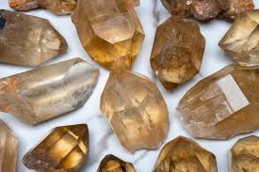

8. How to Use Citrine for Manifestation
Citrine is one of the strongest manifestation crystals due to its solar energy.
Techniques
Write goals while holding Citrine to amplify intention.
Place Citrine on your Solar Plexus during visualization.
Keep Citrine in your wallet or cash drawer.
Use Citrine in a manifestation grid.
Combine Citrine with affirmations and breathwork.

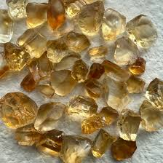

9. Citrine for Wealth & Abundance
Citrine is renowned as a money magnet.
How to Use Citrine for Wealth
Place a piece in your money corner (far left corner of your home from the front door—Feng Shui).
Keep a small stone in your purse or wallet.
Place a Citrine tower on your business desk.
Use Citrine in business rituals, such as new product launches or financial planning sessions.
Affirmation
“I attract wealth, success and aligned opportunities with ease.”

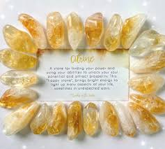

10. Citrine in the Home & Workplace
At Home
Brightens mood and fills rooms with positive energy
Ideal for the living room, kitchen or creative space
Protects the home from negativity
At Work
Supports motivation, confidence and creativity
Enhances abundance energy for business owners
Great for desks, studios and offices

11. Citrine Meditation Practices
Quick Citrine Meditation
Hold Citrine in your left hand or place it on your Solar Plexus.
Breathe deeply, visualizing golden light filling your body.
Repeat a chosen affirmation.

Advanced Meditation
Use Citrine with sound healing or sunlit meditation for amplified effects.

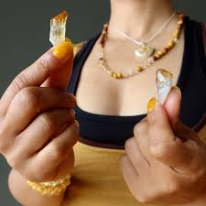

12. Crystal Pairings: Best Stones to Use with Citrine
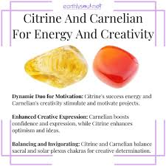
For Money & Success
Pyrite
Green Aventurine
Jade

For Creativity & Inspiration
Carnelian
Orange Calcite
Sunstone

For Confidence & Power
Tiger’s Eye
Garnet
Red Jasper
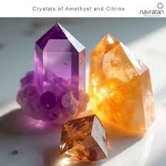

13. Cleansing, Charging & Caring for Citrine
Citrine is self-cleansing, but you may still choose to energetically refresh it.
Safe Methods
Sunlight charging
Sound cleansing
Smoke cleansing
Intention

Avoid
Water with natural Citrine (can be fine but not recommended for clusters)
Long-term heat exposure for heat-treated Citrine

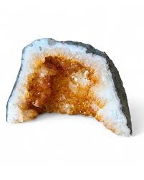
14. How to Spot Natural vs. Heat-Treated Citrine
Natural Citrine
Pale champagne to smoky yellow
Even colour
More rare and expensive

Heat-Treated Citrine
Bright orange or deep golden
White base common
More common and affordable

Both types are energetically effective.

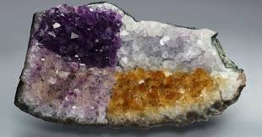

15. Citrine Grids for Abundance, Joy & Creativity
Abundance Grid Layout
Centre stone: Citrine point
Supporting stones: Pyrite, Green Aventurine, Clear Quartz
Intention written beneath the grid
Activate using a quartz point

Creativity Grid
Citrine
Carnelian
Sunstone
Clear Quartz

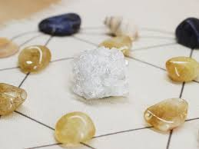

16. Daily Rituals & Affirmations
Morning Ritual
Hold Citrine and state:
“I step into today with confidence and joy.”

Evening Ritual
Place Citrine on your Solar Plexus and breathe out the day’s heaviness.
Affirmations
“I am aligned with abundance and success.”
“My energy radiates confidence and joy.”
“Opportunities come to me effortlessly.”

17. Citrine Jewellery & How to Wear It
Wearing Citrine
As a pendant near the Solar Plexus for empowerment
On the right hand for manifestation
As earrings for confidence and communication
Wearing Citrine daily strengthens its energetic influence.

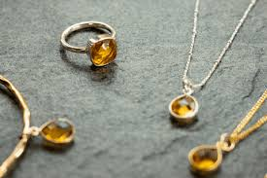

18. Citrine for Entrepreneurs, Healers & Creatives
Entrepreneurs
Boosts strategic clarity, courage and abundance mindset.
Healers
Helps maintain high energy and avoid emotional burnout.
Creatives
Ignites imagination, passion and flow-state creation.

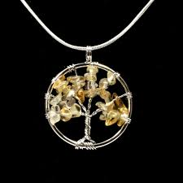

19. Frequently Asked Questions
Is heat-treated Citrine “real”?
Yes—energetically it still carries powerful Citrine qualities.

Can Citrine bring money?
Citrine aligns your energy with abundance, increasing motivation, opportunity and attraction.

How often should I charge it?
Whenever the energy feels dull or heavy.

Can I sleep with Citrine?
Some people find it too energizing; others love its uplifting frequency.

20. Conclusion
Citrine is one of the most powerful crystals for abundance, joy and manifestation. Whether you’re using it for spiritual growth, wealth-building, confidence, creativity, or emotional healing, its bright solar energy brings warmth and transformation into every area of life.

Consistent use deepens its influence—Citrine responds beautifully to intention, gratitude and aligned action.

