**Pyrolusite: The Crystal of Transformation and Clarity**

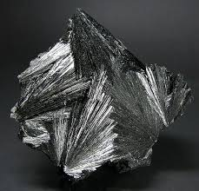

By AF Crystal Jewels

Roxy Slabber

Table of Contents

1. Introduction: Meeting Pyrolusite
2. Geological Background and Discovery
3. Physical Characteristics and Appearance
4. Historical Uses of Pyrolusite
5. Metaphysical Properties of Pyrolusite
6. Healing Benefits: Mind, Body, Spirit
7. Pyrolusite and the Chakras
8. Pyrolusite in Meditation and Energy Practices
9. Rituals and Daily Practices with Pyrolusite
10. Crystal Pairings and Combinations
11. Affirmations and Intentions with Pyrolusite
12. Caring for Your Pyrolusite
13. Legends, Symbolism, and Cultural Lore
14. Modern Uses and Scientific Relevance
15. Closing Reflections: Walking the Path of Transformation

Chapter 1 – Introduction: Meeting Pyrolusite

Pyrolusite, a shimmering black-to-steely grey mineral, has fascinated humans for millennia. Beyond its industrial role as the chief source of manganese, it carries deep symbolic meaning. Known as the stone of transformation and clarity, Pyrolusite dissolves stagnation, strengthens willpower, and protects against toxic influences.

Chapter 2 – Geological Background and Discovery

Pyrolusite is the most common and important ore of manganese, composed of manganese dioxide (MnO₂).

Formation: Occurs in sedimentary deposits, hydrothermal veins, and weathered metamorphic rocks

Major Sources: Brazil, India, South Africa, Ukraine, and the USA

Crystallography: Belongs to the tetragonal crystal system, usually forming fibrous, columnar, or massive structures

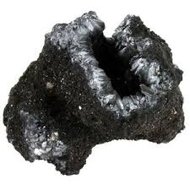

Chapter 3 – Physical Characteristics and Appearance

Colour: Black, dark grey, or bluish-black

Lustre: Metallic to dull, with a distinctive sooty streak

Hardness: 2–2.5 on Mohs scale (soft and fragile)

Other Traits: Easily leaves black marks on skin or paper, often appearing in radiating or dendritic formations

Chapter 4 – Historical Uses of Pyrolusite

Ancient Egypt: Used as a pigment and in glassmaking to remove greenish hues

Greek and Roman Times: Employed in steel production and decorative arts

Alchemy: Believed to transform base materials and was associated with purification processes

Industrial Age: Essential in producing manganese steel, batteries, and chemical catalysts

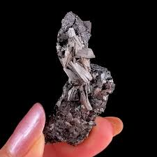

Chapter 5 – Metaphysical Properties of Pyrolusite

Pyrolusite is often regarded as a stone of transformation, purification, and protection.

Purification: Clears toxic energy, dissolves negative influences

Clarity: Sharpens insight, cuts through confusion

Transformation: Helps break destructive cycles, empowering new beginnings

Protection: Acts as a psychic shield against manipulative or draining energies

Chapter 6 – Healing Benefits: Mind, Body, Spirit

Mind: Supports clear thinking, enhances problem-solving skills

Emotions: Helps release self-sabotaging patterns and resentment

Body: Traditionally believed to aid detoxification and energy renewal

Spirit: Encourages alignment with higher truth and spiritual resilience

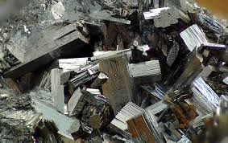

Chapter 7 – Pyrolusite and the Chakras

Root Chakra: Grounds and stabilizes, releasing fear and insecurity

Solar Plexus Chakra: Strengthens willpower and confidence

Third Eye Chakra: Enhances clarity, intuition, and discernment

Chapter 8 – Pyrolusite in Meditation and Energy Practices

During meditation, Pyrolusite helps release intrusive thoughts and lingering negativity. Many practitioners hold it to the solar plexus to amplify personal strength and dissolve fear-based blockages.

Practice Example:

Sit comfortably with Pyrolusite in hand.

Visualize a black veil of negativity dissolving.

See yourself standing strong, renewed, and clear.

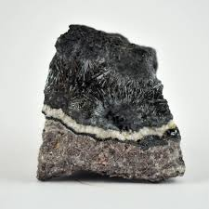

Chapter 9 – Rituals and Daily Practices with Pyrolusite

Morning Shielding Ritual: Carry Pyrolusite in your pocket to ward off toxic energies

Evening Release: Place the crystal near your bed to clear mental clutter before sleep

Cleansing Space: Place Pyrolusite in corners of a room to neutralize heavy or stagnant energy

Chapter 10 – Crystal Pairings and Combinations

With Clear Quartz: Amplifies purification

With Black Tourmaline: Creates strong psychic protection

With Citrine: Transforms stagnant energy into vitality and creativity

With Amethyst: Enhances spiritual clarity and protection

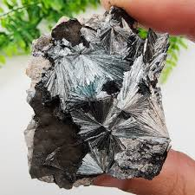

Chapter 11 – Affirmations and Intentions with Pyrolusite

“I release all toxic influences and stand in clarity.”

“I am empowered to transform my life with strength and purpose.”

“I am shielded, grounded, and free from negativity.”

Chapter 12 – Caring for Your Pyrolusite

Caution: Pyrolusite is soft and fragile; handle gently

Cleansing: Smudge with sage or place near selenite (avoid water cleansing)

Charging: Place under moonlight or near clear quartz

Storage: Wrap in cloth to avoid smudging and scratches

Chapter 13 – Legends, Symbolism, and Cultural Lore

In folklore, Pyrolusite was seen as a stone of alchemy and purification. Alchemists believed it contained the power to transmute impurities—both in metals and in the human soul. In esoteric traditions, it symbolized the fire of transformation and the cutting away of illusion.

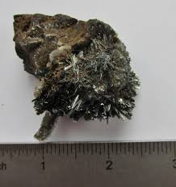

Chapter 14 – Modern Uses and Scientific Relevance

Today, Pyrolusite is essential in industries:

Metallurgy: For strengthening steel and aluminium alloys

Energy: Used in dry cell batteries and as a depolarizer

Glassmaking: To decolorize and purify glass

Its dual role—scientific and spiritual—underscores its unique transformative nature.

Chapter 15 – Closing Reflections: Walking the Path of Transformation

Pyrolusite teaches that transformation requires both release and renewal. It clears away what no longer serves us and strengthens our resolve to walk with clarity and power. By working with this stone, one learns the art of resilience and the wisdom of purification, embodying strength through change.

