**Sacred & Rare: A Collector’s Guide to Crystals of Power**

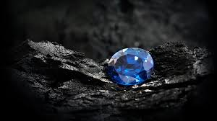

By AF Crystal Jewels

Roxy Slabber

**Introduction:**

Crystals have long been revered for their unique beauty and spiritual significance. Among the countless stones found on Earth, rare crystals hold a special place due to their powerful energies and the deep spiritual transformations they can facilitate. This guide will take you on a journey through 15 of the rarest and most powerful crystals, each with distinct qualities, uses, and healing properties. Whether you’re a seasoned collector or a newcomer to the world of crystals, this book will help you understand how to harness the power of these precious stones in your daily life.

**The Power of Rare Crystals**

Rare crystals are not only stunning to the eye but also highly revered for their potent healing and spiritual properties. Many of these stones are believed to be formed under unique geological conditions, making them a rare occurrence on Earth. Their energy can connect us with higher consciousness, protect us from negative influences, and facilitate deep inner healing. Through the ages, these crystals have been sought after for their ability to amplify intentions, provide clarity, and facilitate personal and spiritual transformation.

**How to Use Crystals**

Each crystal in this guide is imbued with distinct frequencies that resonate with different energy centres of the body. To work with crystals, it’s important to first cleanse them to remove any stagnant or negative energy they may have absorbed. Cleansing can be done using various methods such as smudging with sage, placing the crystal under running water, or leaving it under the moonlight. Once cleansed, you can set intentions by holding the crystal, meditating with it, or placing it on the body in specific locations to balance the chakras. Over time, as you work with these rare crystals, you’ll begin to feel their energy subtly shifting your own.

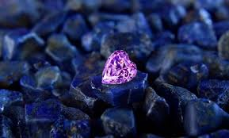

**Chapter 1: Phenakite**

**Overview**:

Phenakite is an extraordinary crystal known for its highly transparent, almost ethereal appearance. It is often sought after by spiritual seekers for its potent ability to amplify energy and enhance spiritual connection.

**Properties**:

Phenakite is a powerful energy amplifier, making it a popular choice for those who wish to deepen their connection with higher realms. It is believed to stimulate the third eye and crown chakras, facilitating clarity and an expanded consciousness. Many people find that working with Phenakite helps them access higher planes of existence, enabling telepathic communication and even astral travel.

**Origins**:

This crystal was first discovered in Russia but has since been found in Brazil, Madagascar, and other regions. Its rarity adds to its allure, with high-quality specimens being highly sought after.

**Uses**:

Phenakite is known to aid in deep meditation and is commonly used in spiritual rituals to heighten awareness. It is also thought to encourage personal growth by helping one overcome emotional and mental blocks, opening the mind to new perspectives.

**Affirmation**:

“I am aligned with higher wisdom, open to divine guidance and clarity.”

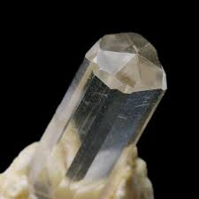

**Chapter 2: Alexandrite**

**Overview**:

Alexandrite is a rare and highly prized gemstone known for its extraordinary ability to change colour depending on the light source, ranging from green in daylight to red or purple under incandescent light. This rare characteristic has earned it the title of “the chameleon gem.”

**Properties**:

This crystal is believed to bring balance to the wearer’s emotional and spiritual life. Alexandrite is often used to align the heart and mind, helping individuals maintain balance between the material and spiritual worlds. It’s also thought to enhance personal power, improving decision-making and self-esteem.

**Origins**:

Discovered in the Ural Mountains of Russia in the 1830s, Alexandrite is now found in Brazil, Sri Lanka, and some parts of Africa. Its rarity and fascinating colour-change properties make it one of the most valuable gemstones on Earth.

**Uses**:

Alexandrite is often used during meditation to help align the heart chakra and encourage emotional stability. It is also known to enhance creativity and support personal transformation by fostering a deep connection to one’s higher self.

**Affirmation**:

“I embrace change, transition, and the flow of abundance into my life.”

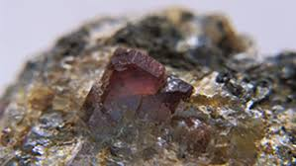

**Chapter 3: Moldavite**

**Overview**:

Moldavite is a unique, extraterrestrial stone, believed to have been formed from a meteorite impact approximately 14.8 million years ago. Its energy is intense and transformative, making it a powerful crystal for spiritual seekers.

**Properties**:

This tektite is known for its high vibrational frequency, making it an ideal crystal for anyone undergoing spiritual awakening or transformation. It activates the heart chakra and helps users transcend to higher states of consciousness. Moldavite’s energy is often described as a catalyst for rapid, profound transformation.

**Origins**:

Moldavite is found primarily in the Czech Republic, though it has also been discovered in smaller quantities in other locations. The stone’s extraterrestrial origin and its strong connection to cosmic energies make it highly sought after by collectors and spiritual practitioners alike.

**Uses**:

Moldavite is often used for deep meditation and to connect with cosmic energies. It is believed to facilitate a higher understanding of the universe, spiritual healing, and energetic protection.

**Affirmation**:

“I am open to divine transformation and the universal flow of energy.”

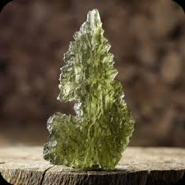

**Chapter 4: Grandidierite**

**Overview**:

Grandidierite is a rare and highly prized green-blue gemstone that has become one of the most sought-after gems among collectors. It is known for its stunning colour and unique energy.

**Properties**:

Grandidierite is thought to enhance mental clarity and emotional stability. Its calming energy helps one navigate through life’s challenges with grace and calmness, promoting self-empowerment and personal growth. It is especially helpful for aligning the heart and mind.

**Origins**:

Found exclusively in Madagascar, Grandidierite is an incredibly rare gemstone. Its discovery was an important event in the world of gemmology, as it quickly became a highly coveted gem due to its intense colour and rarity.

**Uses**:

Grandidierite is used in spiritual practices to enhance clarity of thought, boost self-esteem, and create a sense of emotional balance. It is especially useful in helping individuals release emotional blockages and foster personal growth.

**Affirmation**:

“I trust in my inner wisdom and remain open to healing and growth.”

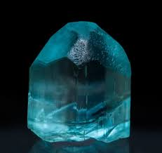

**Chapter 5: Taaffeite**

**Overview**:

Taaffeite is one of the rarest gemstones in the world, often mistaken for spinel due to its similar appearance. This gemstone has a soft, delicate colour range, ranging from pale lavender to deep purple.

**Properties**:

Taaffeite is revered for its calming and healing properties. It is thought to aid in emotional healing and alleviate stress, promoting inner peace and mental clarity. It also enhances spiritual awareness, fostering a deeper connection with the soul.

**Origins**:

Taaffeite was first discovered in Sri Lanka, though it has also been found in Myanmar and Tanzania. Its rarity and high value make it a coveted gemstone for collectors.

**Uses**:

Taaffeite is used to balance the mind and emotions, helping the user release stress and negativity. It is also believed to encourage clarity of thought, making it a valuable tool for meditation and spiritual practices.

**Affirmation**:

“I release past hurts and embrace peace and spiritual wisdom.”

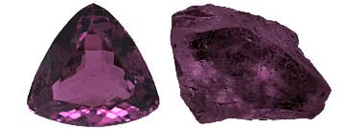

**Chapter 6: Blue Garnet**

**Overview**:

Blue Garnet is a rare and fascinating gemstone known for its ability to change colour based on lighting conditions, shifting from blue to purplish red. This colour-changing property makes it both an intriguing and mystical stone.

**Properties**:

This crystal is known to stimulate the root chakra, grounding its user while simultaneously enhancing emotional healing. Blue Garnet provides balance between the heart and mind, helping to foster emotional stability while promoting strength during times of uncertainty. It is a powerful ally for anyone looking to deepen their emotional intelligence and cultivate self-love.

**Origins**:

Blue Garnet was first discovered in Madagascar, with additional deposits found in Russia. It is incredibly rare, adding to its desirability among collectors and spiritual practitioners alike.

**Uses**:

Blue Garnet is often used to ground emotional energy and restore balance during times of upheaval. It is also helpful in relationships, promoting harmony and understanding between partners. Additionally, it encourages self-compassion and helps release guilt and negative emotions.

**Affirmation**:

“I am grounded in love and stability, embracing change with grace.”

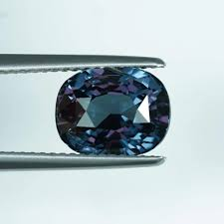

**Chapter 7: Painite**

**Overview**:

Painite was once considered the rarest mineral on Earth, and it remains one of the most difficult-to-find gemstones. Its reddish-brown to brownish-black colour is subtle, but its energy is profound.

**Properties**:

Painite is revered for its ability to stimulate the third eye chakra and open pathways to spiritual enlightenment. It aids in overcoming mental blocks and enhances psychic abilities, making it an excellent stone for meditation and deep spiritual practices. Painite also promotes clarity and insight, helping the user make better decisions.

**Origins**:

First discovered in Myanmar, Painite was once thought to be a type of garnet before being classified as a unique mineral. Due to its rarity, only a handful of specimens are available on the market.

**Uses**:

Painite is used to enhance spiritual awareness and psychic abilities. It can be placed on the third eye during meditation to increase intuition and clarity. It also helps to clear mental fog and provides mental strength during difficult times.

**Affirmation**:

“I trust my intuition and embrace the wisdom of the universe.”

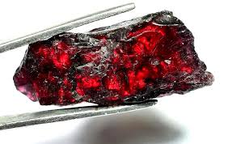

**Chapter 8: Jeremejevite**

**Overview**:

Jeremejevite is a rare gemstone known for its striking blue to pale blue-green hues. This stone is highly valued for its clarity and rarity.

**Properties**:

Jeremejevite is a crystal that enhances communication, especially in spiritually guided work. It stimulates the throat chakra, allowing for clear, honest expression and the release of pent-up emotions. It is also believed to facilitate higher-level communication with the divine, making it a powerful tool for spiritual seekers.

**Origins**:

First discovered in Russia, Jeremejevite is also found in Africa, though it remains extremely rare in both regions. Due to its scarcity and beautiful coloration, it is highly coveted by collectors.

**Uses**:

Jeremejevite is particularly effective in helping individuals open up and speak their truth. It is used to remove blockages in the throat chakra and aids in self-expression. Additionally, it can be used in spiritual communication and dream work to receive guidance.

**Affirmation**:

“I speak my truth with clarity, confidence, and power.”

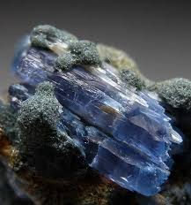

**Chapter 9: Tanzanite**

**Overview**:

Tanzanite is a mesmerizing gemstone that displays a rich, deep blue-violet hue. This stone is often referred to as a “one-generation” gemstone, as it is found only in one place on Earth.

**Properties**:

Tanzanite is believed to be a powerful stone for spiritual transformation. It is known to activate the throat and third eye chakras, facilitating clear communication and a deeper connection with higher realms. Tanzanite encourages intuition, spiritual awakening, and insight into personal truths.

**Origins**:

Found only in the Merelani Hills of Tanzania, Tanzanite is one of the rarest gemstones on Earth. Its vivid colour and rarity have made it an essential stone for collectors and spiritual practitioners.

**Uses**:

Tanzanite is used to stimulate the third eye, promoting psychic development and clarity. It also encourages open communication and self-expression. Many individuals use Tanzanite during meditation to gain insight and understanding into their spiritual path.

**Affirmation**:

“I embrace spiritual growth, clear communication, and intuitive wisdom.”

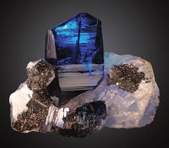

**Chapter 10: Larimar**

**Overview**:

Larimar is a soothing blue gemstone with unique patterns that resemble the sky and ocean. This tranquil crystal has a serene energy that is perfect for relaxation and healing.

**Properties**:

Larimar is a heart and throat chakra stone, helping individuals connect to their emotions and express them with ease. It is known for its calming energy, making it a great ally for stress relief and emotional healing. Larimar also encourages peace and harmony in relationships, allowing individuals to communicate openly and lovingly.

**Origins**:

Found only in the Dominican Republic, Larimar is a rare and highly valued stone. Its blue hues are reminiscent of the Caribbean Sea, adding to its allure.

**Uses**:

Larimar is often used to bring peace and calmness to the mind, body, and spirit. It can be placed on the heart or throat chakra during meditation to release emotional tension and improve communication. It is also known to aid in the healing of emotional trauma.

**Affirmation**:

“I speak with love, kindness, and wisdom, fostering peace in all areas of my life.”

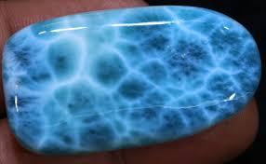

**Conclusion:**

As we have explored throughout this guide, rare crystals hold immense power for healing, spiritual growth, and personal transformation. Each crystal has its unique energy and properties that can be utilized in different ways, whether for physical healing, emotional balance, or spiritual awakening. Working with these stones requires mindfulness and intention, but when used properly, they can enhance your life in profound ways.

**Final Thoughts:**

The journey with rare crystals is one of deep discovery, transformation, and connection. As you work with these powerful stones, remember that each crystal offers a unique experience and a tool for personal growth. Their energies will guide you, support you, and empower you to achieve a greater understanding of yourself and the universe.

**Where to Find Rare Crystals:**

While many of these rare crystals can be found through reputable crystal dealers, it’s important to ensure authenticity when purchasing. Look for dealers who offer certification of authenticity and who can provide information on the sourcing of their crystals. Additionally, some crystals are found only in specific regions, so it’s essential to verify their origin to ensure you’re acquiring a genuine specimen.

