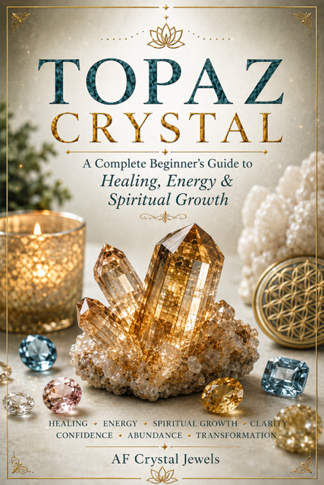
TOPAZ CRYSTAL
A Complete Beginner’s Guide to Healing, Energy & Spiritual Growth
AF Crystal Jewels

Introduction to Topaz
Topaz is one of the world’s most admired gemstones, known for its stunning beauty, powerful symbolism, and versatile energy. Throughout history, Topaz has been associated with wisdom, abundance, confidence, protection, and spiritual enlightenment.
Available in a range of colours including blue, golden, pink, white, green, and the rare Imperial Topaz, this crystal is treasured by collectors, healers, and jewellery enthusiasts alike.
Topaz is often called the “Stone of Manifestation” because it is believed to help focus intentions, attract opportunities, and encourage personal growth. Whether worn as jewellery, used in meditation, or displayed in the home, Topaz offers both beauty and inspiration.

Affirmation:
“I welcome clarity, confidence, and abundance into my life.”

History and Origins of Topaz
The name Topaz is believed to originate from the ancient island of Topazios in the Red Sea. For thousands of years, civilizations around the world valued Topaz for both its beauty and mystical properties.

Ancient Beliefs
Egyptians
Associated Topaz with the sun god Ra.
Believed it carried powerful protective energy.
Greeks
Thought Topaz increased strength and courage.
Used it as a talisman for protection.
Romans
Wore Topaz for safe travel and good fortune.
India
Considered Topaz a sacred gemstone connected to wisdom, prosperity, and long life.
Major Sources Today
- Brazil
- Pakistan
- Nigeria
- Sri Lanka
- Russia
- Mexico
Brazil remains the most famous source of Imperial Topaz.

Types and Colours of Topaz
Topaz naturally occurs in several beautiful colours, each with unique energetic associations.

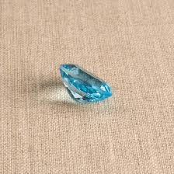
Blue Topaz
Communication
Truth
Self-expression
Throat Chakra

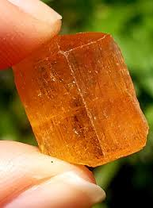
Imperial Topaz
Confidence
Leadership
Prosperity
Solar Plexus Chakra
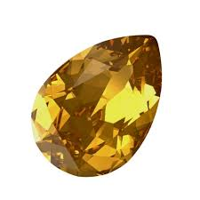
Golden Topaz
Joy
Motivation
Abundance
Solar Plexus Chakra

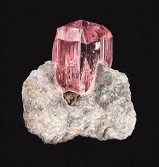
Pink Topaz
Love
Compassion
Emotional healing
Heart Chakra
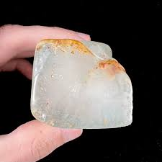
White Topaz
Mental clarity
Spiritual awareness
Crown Chakra
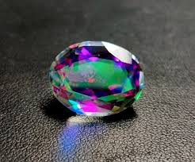
Mystic Topaz
Transformation
Intuition
Spiritual growth

Spiritual and Metaphysical Properties
Topaz is often regarded as a crystal of empowerment and manifestation.
Spiritual Benefits
- Enhances intuition
- Raises spiritual awareness
- Encourages personal growth
- Supports meditation
- Strengthens manifestation practices
- Emotional Benefits
- Helps release fear and self-doubt
- Encourages optimism
- Promotes emotional balance
- Supports self-confidence
- Mental Benefits
- Improves focus
- Encourages clear thinking
- Supports learning and creativity
- Aids decision-making
Topaz encourages individuals to align with their true purpose while maintaining confidence and clarity.
Topaz and the Chakras
Because Topaz occurs in multiple colours, it can work with several chakra centres.

TOPAZ VARIETY | CHAKRA
Pink Topaz | Heart
Golden Topaz | Solar Plexus
Imperial Topaz | Solar Plexus
White Topaz | Crown
Mystic Topaz | Third Eye & Crown
Green Topaz | Heart
Blue Topaz | Throat

Chakra Healing
Blue Topaz encourages honest communication.
Golden and Imperial Topaz strengthen confidence and personal power.
Pink and Green Topaz support emotional healing and compassion.
White and Mystic Topaz enhance spiritual connection and higher consciousness.


Manifestation, Success and Abundance
Topaz has long been associated with prosperity and achievement.
Why Use Topaz for Manifestation?
- Helps focus intentions
- Encourages positive thinking
- Supports confidence in taking action
- Aligns goals with purpose

Simple Manifestation Ritual
- Hold your Topaz crystal.
- Write down a clear intention.
- Visualize your goal as already achieved.
- Repeat an affirmation daily.
- Carry the crystal with you.

Abundance Affirmation
“I am open to prosperity, success, and limitless opportunities.”
Golden and Imperial Topaz are especially popular for abundance work and career success.

Crystal Pairings and Everyday Use
Topaz works beautifully with other crystals.
Recommended Combinations
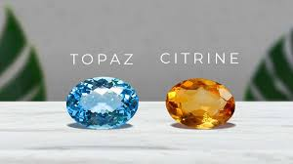
Topaz + Citrine
- Wealth
- Success
- Positive energy

Topaz + Clear Quartz
- Amplified intentions
- Clarity
- Topaz + Amethyst
- Spiritual growth
- Wisdom
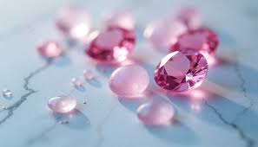
Topaz + Rose Quartz
- Love
- Emotional healing

Topaz + Labradorite
- Intuition
- Transformation

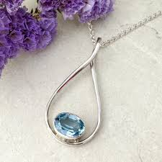
Everyday Uses
- Wear as jewellery
- Carry in a pocket or purse
- Place on your desk
- Use during meditation
- Add to crystal grids

Cleansing, Charging and Care
Proper care helps maintain the beauty and energy of your Topaz.
Cleansing Methods
✓ Moonlight
✓ Sound healing
✓ Selenite charging plates
✓ Crystal clusters
✓ Visualization

- Charging Methods
- Full moon energy
- Meditation and intention
- Selenite
- Clear Quartz clusters

Care Tips
Avoid harsh chemicals
Store separately from softer gemstones
Avoid prolonged direct sunlight, which may fade some colours
Topaz has a hardness of 8 on the Mohs scale, making it suitable for everyday wear.

Final Thoughts & Affirmations
Topaz is a crystal of confidence, wisdom, abundance, and spiritual illumination. Its diverse colours and energetic qualities make it one of the most versatile gemstones available.
Whether you are seeking emotional healing, greater self-expression, enhanced intuition, or support in achieving your goals, Topaz can be a valuable companion on your journey.

Daily Topaz Affirmations
- I speak my truth with confidence.
- I trust my inner wisdom.
- Prosperity flows freely into my life.
- I am aligned with my highest purpose.
- I welcome joy, abundance, and success.
- My confidence grows stronger every day.

Closing Affirmation
“I radiate confidence, clarity, abundance, and light. I trust the journey unfolding before me.”

