**Petalite: The Angel Stone of Peace & Transformation**

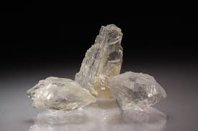

**By AF Crystal Jewels**

**Roxy Slabber**

Introduction to Petalite

Petalite is a rare and ethereal crystal known for its high vibration and calming energy, often called the “Angel Stone.” Its soft colours and gentle appearance hide its profound power to bring emotional balance and spiritual connection. For centuries, Petalite has been revered by healers and spiritual seekers as a protective and uplifting stone that helps open channels to higher realms. Its rarity and soothing vibration make it a favourite among collectors and energy workers seeking serenity and enlightenment.

Petalite Overview

Petalite belongs to the feldspathoid mineral group and comes in shades of pink, white, grey, and sometimes colourless forms. It has a glassy, pearly lustre and is prized for its soft appearance and powerful energy. Due to its rarity and aesthetic appeal, high-quality Petalite crystals are considered highly valuable among collectors. Its unique properties make it a sought-after crystal in both the jewellery and healing industries.

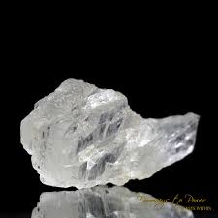

Origins & Sources

Petalite is mined primarily in Brazil, Namibia, and Afghanistan, with notable deposits also found in

Sweden and Australia. It forms in granite pegmatites and is closely associated with lithium-bearing

minerals. Many suppliers today focus on ethically sourcing Petalite to preserve its natural environment.

This commitment to sustainable mining practices enhances the crystal’s appeal for conscious collectors.

Metaphysical Properties

Petalite is known for its strong spiritual resonance, often used to connect with angels and higher guidance. Its calming vibrations soothe emotional distress and create a sense of safety and peace. The stone is a powerful energy cleanser, clearing negativity and providing psychic protection for sensitive individuals. It is closely connected to the crown and heart chakras, enhancing spiritual awareness and deep compassion.

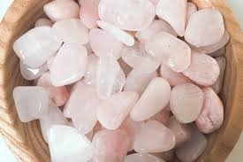

Healing Properties

Petalite supports deep emotional healing, helping release trauma, grief, and stress from the energy body. Its uplifting frequency encourages spiritual awakening, guiding users toward enlightenment and inner peace. This crystal is especially helpful for highly sensitive individuals, empaths, and healers seeking balance and strength. Petalite is also widely used in meditation and dream work to enhance intuition and divine connection.

Petalite in Everyday Life

Petalite can be placed in your home or workspace to maintain a calm, positive environment and dispel negative energy. Its energy enhances intuition and spiritual focus, making it a valuable tool for healers and spiritual practitioners. Wearing Petalite jewellery offers ongoing protection and emotional support throughout the day. This versatile stone adds both beauty and healing energy to any collection.

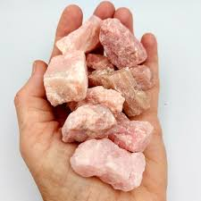

How to Use Petalite

Petalite can be used in meditation by placing it on the crown chakra or holding it in your hand to connect with higher guidance. It is a powerful stone for crystal grids focused on peace, protection, and spiritual growth. Pair Petalite with stones like Selenite, Amethyst, or Rose Quartz for amplified effects.

Elixirs can also be made using the indirect method, as Petalite should not be submerged in water.

Affirmations for Petalite

Using affirmations with Petalite enhances its calming and spiritual energy. Examples include: “I am guided and protected by divine light,” “I release fear and embrace peace,” and “My heart is open to unconditional love and healing.” Repeating these affirmations while holding Petalite creates a powerful energetic shift.

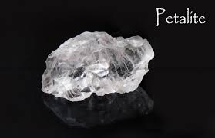

Caring for Your Petalite

Petalite is a relatively durable crystal but should be handled with care due to its rarity. Cleansing can be done with moonlight, sound, or smudging rather than harsh chemicals or sunlight. Store Petalite in a soft pouch or lined box to protect it from scratches or environmental damage. Proper care ensures its energy remains clear and vibrant for years to come.

Scientific Perspective

Petalite has a Mohs hardness of 6–6.5 and is composed of lithium aluminium silicate. Its unique crystal structure gives it a pearly lustre and makes it valuable for industrial lithium extraction. Historically,

Petalite was one of the first minerals discovered to contain lithium, leading to advances in battery and glass manufacturing. Its scientific significance adds to its allure as both a collector’s item and a healing tool.

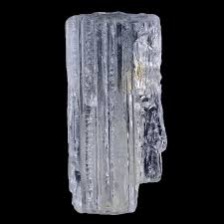

Fun Facts & Legends

Legends say Petalite was used in ancient times as a talisman for protection against negative forces. Its association with angelic realms has made it a stone of spiritual guardianship across cultures. Some of the most famous Petalite crystals have been discovered in Brazil, where they are treasured for their size and clarity. Its rarity and mystical reputation make it a captivating crystal for enthusiasts.

Conclusion

Petalite is a remarkable crystal that offers a unique combination of beauty, rarity, and powerful healing energy. It is a must-have for anyone seeking peace, protection, and spiritual growth in their crystal practice. By working with Petalite, you invite angelic guidance, deep emotional healing, and a higher state of consciousness into your life. Its serene presence makes it an invaluable addition to any crystal collection

