Stilbite: The Crystal of Serenity, Dreams & Divine Connection

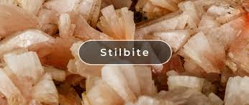

By AF Crystal Jewels

Roxy Slabber

Table of Contents

1. Introduction
2. What Is Stilbite?
3. Geological Formation & Origins
4. Metaphysical Properties
5. Healing Benefits
6. Stilbite and the Chakras
7. How to Use Stilbite
8. Rituals and Daily Practices
9. Stilbite Crystal Combinations
10. Cleansing and Charging Stilbite
11. Stilbite in Meditation & Dreamwork
12. Affirmations for Working with Stilbite
13. Buying and Caring for Stilbite
14. Final Thoughts

1. Introduction

In a fast-paced world filled with distraction and overstimulation, there are few crystals that offer the gentle, soul-soothing calm of Stilbite. Known for its soft energy, radiant light, and deeply spiritual vibration, Stilbite is a cherished crystal for those seeking peace, angelic communication, dream recall, and heart-based guidance.

Whether you’re a beginner in crystal healing or a seasoned practitioner, Stilbite brings a quiet elegance to your spiritual toolkit.

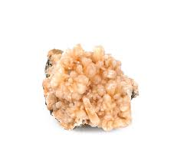

2. What Is Stilbite?

Stilbite is a member of the zeolite family—minerals known for their ability to purify, detoxify, and absorb negative energy. It often appears in soft peach, pink, white, and sometimes golden or orange hues, with a radiant pearlescence and sheaf-like crystalline formation.

Its name is derived from the Greek word stilbein, meaning “to shine,” which perfectly reflects its luminous, high-vibration energy.

3. Geological Formation & Origins

Stilbite forms in cavities of volcanic rock, especially in basalt, and is often found alongside other zeolites like apophyllite and heulandite.

Common sources include:

India (most abundant and high-quality specimens)

Iceland

USA (Oregon, New Jersey)

Scotland

Canada

It crystallizes in delicate blades, fan-shaped clusters, or “wheat-sheaf” formations, adding to its unique appeal in both metaphysical and geological collections.

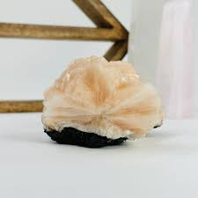

4. Metaphysical Properties

Stilbite is a deeply spiritual stone, often referred to as the Stone of Divine Guidance and Inner Peace. Its energy is soft, feminine, and nurturing.

Key Properties:

Enhances intuition and psychic insight

Opens the heart to universal love

Facilitates angelic and spiritual connection

Assists in dream recall and lucid dreaming

Encourages deep emotional healing and forgiveness

Promotes serenity and gentle clarity in the mind

5. Healing Benefit:

Emotional Healing

Dissolves grief, sorrow, and emotional heaviness

Encourages feelings of trust and surrender

Helps release attachment to past trauma

Soothes anxiety and restlessness

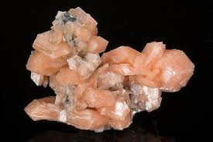

Mental Healing

Clears mental fog and encourages inner stillness

Aids in gentle focus during meditation or creative tasks

Opens the subconscious mind for healing and reflection

Physical Support

While Stilbite is primarily an emotional and spiritual stone, some healers believe it may:

Assist with insomnia and promote restful sleep

Support the brain and nervous system through energetic alignment

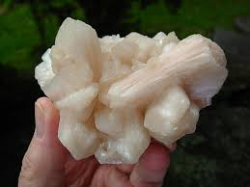

6. Stilbite and the Chakras

Primary Chakra:

🌸 Heart Chakra (Anahata) – Opens the heart to unconditional love and compassion.

Secondary Chakras:

🔮 Third Eye Chakra (Ajna) – Enhances spiritual vision, inner knowing, and dream recall.

💜 Crown Chakra (Sahasrara) – Connects with higher realms, angelic guides, and divine inspiration.

7. How to Use Stilbite

Meditation Aid: Hold during meditation to deepen relaxation and open intuitive insight.

Sleep Companion: Place under your pillow to encourage dream work and restful sleep.

Crystal Grids: Use in heart-healing, spiritual growth, or inner peace grids.

Sacred Spaces: Display in altars or healing spaces to radiate peaceful energy.

Jewellery: Wear as a pendant to carry its calming vibration throughout the day.

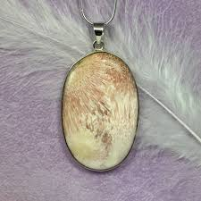

8. Rituals and Daily Practices

Stilbite Morning Centering Ritual

Sit in a quiet place, holding Stilbite over your heart.

Breathe deeply for a few minutes.

Say: “I open my heart to peace, clarity, and divine guidance.”

Visualize soft pink or white light expanding from your heart.

Dream Recall Practice

Place Stilbite under your pillow or on your nightstand.

Set an intention before bed: “I remember and receive the wisdom of my dreams.”

Keep a dream journal nearby for morning recording.

9. Stilbite Crystal Combinations

Stilbite pairs well with high-vibration and emotionally supportive crystals:

|  |  |
| --- | --- |
| Crystal | Synergistic Effect |
|  |  |
| Apophyllite | Boosts spiritual insight and light-body activation |
| Celestite | Enhances angelic communication |
| Amethyst | Deepens meditation and intuitive awareness |
| Rose Quartz | Softens the heart and encourages emotional healing |
| Scolecite | Opens the crown and promotes dreamwork and inner peace |

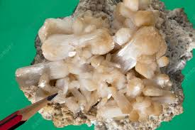

10. Cleansing and Charging Stilbite

Stilbite is delicate and should be handled gently. Avoid water cleansing.

Cleansing methods:

Smudging with sage or palo santo

Sound healing (tuning forks, singing bowls)

Selenite plate or geode

Moonlight (especially full moon) for gentle recharging

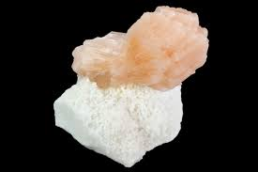

11. Stilbite in Meditation & Dreamwork

Stilbite’s connection to the higher realms makes it a superb tool for:

Guided Meditation: Use to access angelic messages or spirit guide communication.

Past Life Exploration: Helps unlock subconscious memories in safe, gentle ways.

Astral Travel: Assists in safe spiritual journeying when used with intention.

Dream Interpretation: Facilitates symbolic insight and divine messages from dreams.

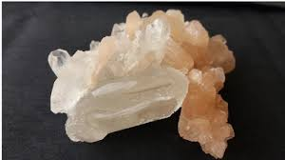

12. Affirmations for Working with Stilbite

Repeat these affirmations while holding or meditating with your crystal:

“I am surrounded by peace, love, and divine light.”

“My dreams bring me healing and clarity.”

“I trust in the guidance of my higher self.”

“I am open to gentle transformation and emotional renewal.”

“The universe supports my heart’s healing.”

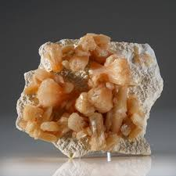

13. Buying and Caring for Stilbite

Buying Tips:

Look for intact formations with lustrous, radiant blades.

Natural colours range from cream and white to soft peach and pink.

Often sold as cluster specimens, spheres, or in matrix with apophyllite.

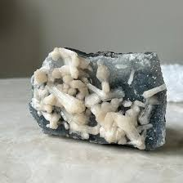

Caring Tips:

Keep away from water and harsh sunlight.

Store gently to avoid crumbling.

Energetically cleanse regularly, especially if used for emotional healing.

14. Final Thoughts

Stilbite is more than a pretty mineral—it is a crystalline gateway to inner calm, higher guidance, and spiritual serenity. Whether used in daily rituals, dreamwork, or meditative practice, this gentle healer will support you in returning to your heart, aligning with your intuition, and moving forward with grace.

