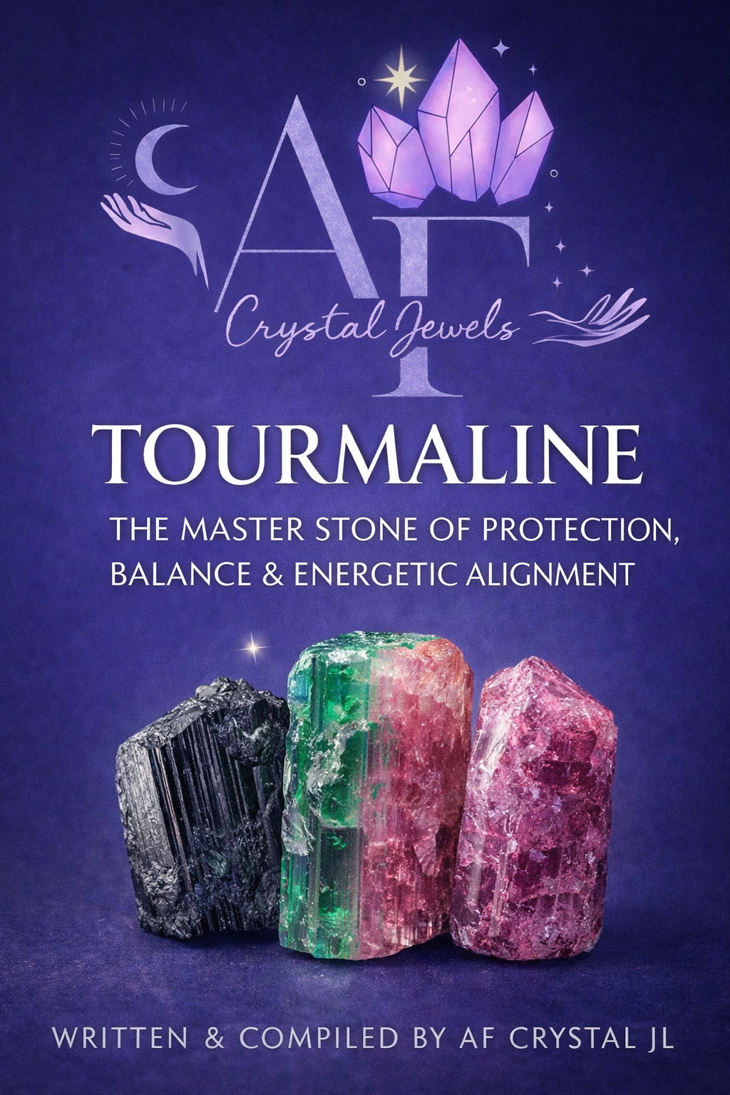
TOURMALINE
The Master Stone of Protection, Balance & Energetic Alignment

Table of Contents
Introduction to Tourmaline
The Origins & Formation of Tourmaline
The Many Varieties of Tourmaline
Physical Characteristics & Identification
Historical & Cultural Significance
The Spiritual Meaning of Tourmaline
General Metaphysical Properties
Emotional & Mental Healing Benefits
Tourmaline & Energy Protection
Chakra Associations of Tourmaline
Black Tourmaline: Grounding & Shielding
Pink Tourmaline: Heart Healing & Compassion
Green Tourmaline: Vitality & Growth
Watermelon Tourmaline: Emotional Balance
Blue Tourmaline (Indicolite): Truth & Higher Communication
Tourmaline for Manifestation & Abundance
Using Tourmaline in Rituals & Daily Practice
Meditation & Energy Work with Tourmaline
Crystal Pairings & Grids
Care, Cleansing & Charging
Who Should Work with Tourmaline
Final Reflections & Affirmations

1. Introduction to Tourmaline
Tourmaline is one of the most versatile and powerful crystals in the mineral kingdom. Known for its wide spectrum of colours and energetic properties, Tourmaline acts as a bridge between the physical and energetic realms, offering protection, balance, healing, and spiritual alignment.
Often referred to as a master crystal, Tourmaline adapts to the needs of the user—grounding when necessary, opening the heart when required, and elevating consciousness when one is ready.

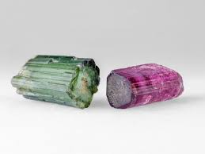
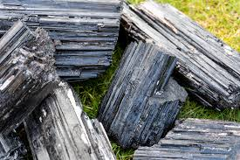

2. The Origins & Formation of Tourmaline
Tourmaline is a complex boron silicate mineral that forms in igneous and metamorphic rocks, particularly in pegmatites. Its chemical complexity allows for a vast range of colours, each reflecting subtle differences in composition and energetic frequency.
Major sources include:
Brazil
Afghanistan
Pakistan
Madagascar
Sri Lanka
Africa
United States
Its formation reflects adaptability, resilience, and energetic diversity.

3. The Many Varieties of Tourmaline
Tourmaline exists in more colour variations than almost any other gemstone, including:

Black (Schorl)
Pink (Rubellite)
Green (Verdelite)
Blue (Indicolite)
Watermelon (Pink & Green)
Yellow
Brown
Colorless (Achroite)
Each variety carries unique energetic qualities while maintaining Tourmaline’s core protective essence.

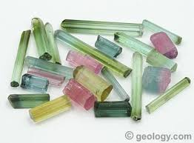

4. Physical Characteristics & Identification
Hardness: 7–7.5 (Mohs)
Crystal System: Trigonal
Lustre: Vitreous
Transparency: Transparent to opaque
Tourmaline often forms in elongated, striated crystals and can display natural colour zoning.

5. Historical & Cultural Significance
Historically, Tourmaline has been revered for its mystical properties:
Ancient shamans used it for protection and grounding
It was believed to attract inspiration and insight
Used in talismans to ward off negative forces
In ancient cultures, Tourmaline was seen as a stone of connection between Earth and Spirit.
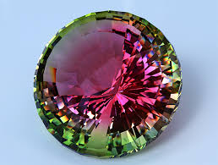

6. The Spiritual Meaning of Tourmaline
Spiritually, Tourmaline represents:
Energetic sovereignty
Balance between light and shadow
Emotional integration
Protection during spiritual growth
It helps maintain clarity and stability while navigating higher consciousness.

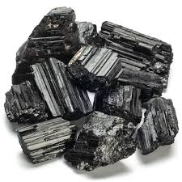

7. General Metaphysical Properties
Tourmaline is known to:
Transmute negative energy
Strengthen the auric field
Promote emotional balance
Enhance grounding and clarity
Support energetic boundaries
It is particularly effective for sensitive individuals and empaths.

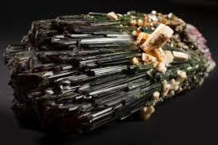

8. Emotional & Mental Healing Benefits
Emotionally, Tourmaline supports:
Releasing fear and anxiety
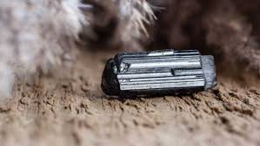
Healing emotional wounds
Encouraging self-compassion
Stabilizing mood swings

Mentally, it enhances:
Focus and clarity
Calm decision-making
Emotional resilience

9. Tourmaline & Energy Protection
Tourmaline is one of the strongest stones for energetic protection:
Shields against negative influences
Grounds excess energy
Absorbs and neutralizes harmful vibrations
Protects during spiritual work
Black Tourmaline is especially effective for daily energetic defence.

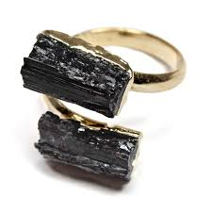

10. Chakra Associations of Tourmaline
Tourmaline aligns with multiple chakras depending on colour:
Root Chakra: Black, Brown
Heart Chakra: Pink, Green
Throat Chakra: Blue
Crown Chakra: Clear
This makes Tourmaline ideal for full-spectrum chakra balancing.

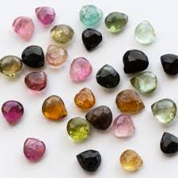

11. Black Tourmaline: Grounding & Shielding
Black Tourmaline is the ultimate grounding stone:
Anchors energy into the Earth
Creates a protective energetic barrier
Supports emotional stability
It is ideal for stress relief and energetic cleansing.
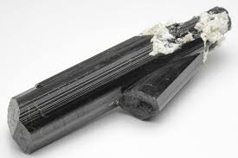

12. Pink Tourmaline: Heart Healing & Compassion
Pink Tourmaline resonates deeply with the heart:
Encourages emotional healing
Promotes self-love
Soothes grief and emotional trauma
It gently opens the heart while maintaining energetic safety.

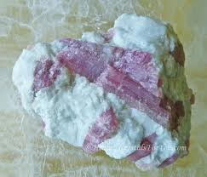

13. Green Tourmaline: Vitality & Growth
Green Tourmaline supports:
Physical vitality
Emotional renewal
Abundance and prosperity
Connection with nature
It aligns growth with heart-centred intentions.

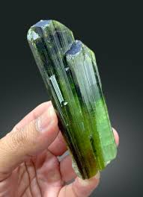

14. Watermelon Tourmaline: Emotional Balance
This rare variety balances:
Heart and emotional body
Inner harmony
Emotional integration
It is especially helpful for healing emotional extremes.

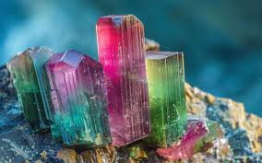

15. Blue Tourmaline (Indicolite): Truth & Higher Communication
Blue Tourmaline enhances:
Honest communication
Spiritual insight
Throat chakra alignment
It supports expressing truth with clarity and compassion.

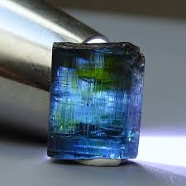

16. Tourmaline for Manifestation & Abundance
Tourmaline supports manifestation by:
Removing energetic blocks
Aligning intention with action
Protecting energy during growth
Green and Watermelon Tourmaline are especially effective for abundance work.

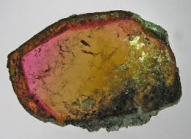

17. Using Tourmaline in Rituals & Daily Practice
Suggested uses:
Wear as jewellery for daily protection
Place near entrances for energetic shielding
Use in grounding rituals
Meditate with during emotional processing
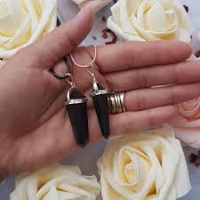

18. Meditation & Energy Work with Tourmaline
Meditation guidance:
Hold or place near the body
Set a clear intention
Visualize energy grounding or balancing
Tourmaline supports steady, focused meditative states.

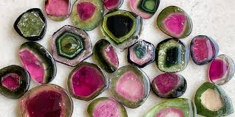

19. Crystal Pairings & Grids
Powerful pairings include:
Clear Quartz – amplification
Amethyst – spiritual clarity
Smoky Quartz – grounding
Rose Quartz – emotional healing

Ideal grid intentions:
Protection
Emotional balance
Grounded manifestation

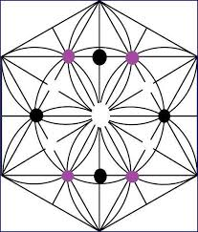
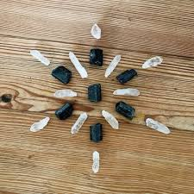

20. Care, Cleansing & Charging
Tourmaline is relatively durable but benefits from regular cleansing:
Smoke cleansing
Sound
Moonlight
Earth grounding
Avoid harsh chemicals and prolonged water exposure.

21. Who Should Work with Tourmaline
Ideal for:
Empaths and healers
Spiritual practitioners
Those under stress
Individuals seeking energetic balance
Tourmaline is suitable for beginners and advanced users alike.

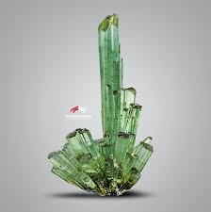

22. Final Reflections & Affirmations
Tourmaline teaches us the power of balance, protection, and integration. It reminds us that true spiritual strength comes from being grounded, present, and energetically sovereign.
Affirmation
“I am protected, balanced, and aligned. My energy is clear, grounded, and empowered.”

Tourmaline is not just a crystal—it is a companion for modern life, offering stability and clarity in an ever-changing world.


