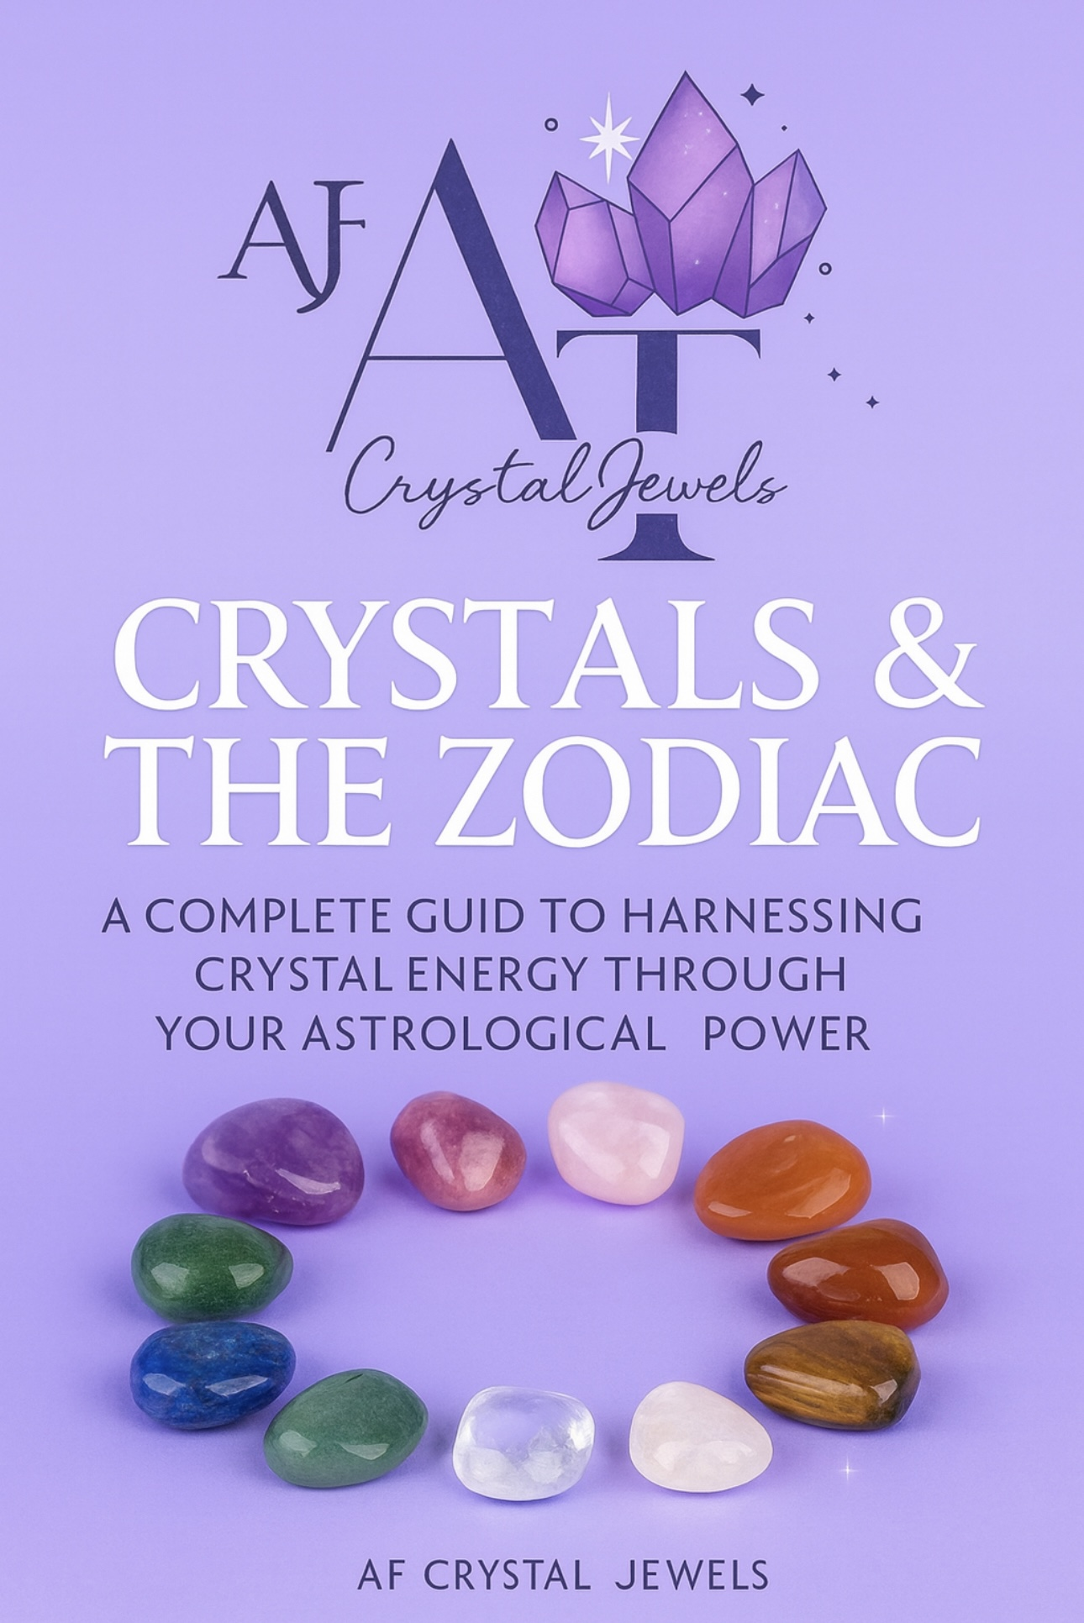
Crystals & The Zodiac
A Complete Guide to Harnessing Crystal Energy Through Your Astrological Power

Introduction
For thousands of years, crystals and the zodiac have been used as sacred tools for guidance, healing, and spiritual alignment. When combined, they create a powerful system that helps you work with your natural strengths, overcome challenges, and activate your highest potential.
Each zodiac sign carries unique elemental energy, planetary influences, emotional patterns, and soul lessons. Crystals amplify, balance, and awaken these energies, allowing you to live more intentionally and aligned with your true nature.
This guide offers a comprehensive breakdown of each zodiac sign, their ruling planets, elemental dynamics, emotional landscapes, and the most powerful crystals to support their journey.

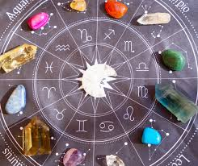

How Crystals & Astrology Work Together
Crystals vibrate at stable energetic frequencies. Astrology reflects changing cosmic energies and personality patterns based on planetary movement and celestial timing
When you use a crystal aligned with your zodiac energy, you experience:
• Emotional balance
• Mental clarity
• Stronger intuition
• Spiritual protection
• Increased manifestation power
• Chakra alignment
Crystals act as energetic allies, supporting your path as revealed through your zodiac blueprint.
Zodiac Elements & Crystal Alignment
Fire Signs (Aries, Leo, Sagittarius)
Energy: Passion, action, drive

Crystals: Carnelian, Red Jasper, Ruby, Sunstone
Earth Signs (Taurus, Virgo, Capricorn)
Energy: Stability, grounding, structure

Crystals: Green Aventurine, Jade, Moss Agate, Tiger’s Eye
Air Signs (Gemini, Libra, Aquarius)
Energy: Communication, intellect, inspiration
Crystals: Blue Lace Agate, Clear Quartz, Fluorite, Celestite

Water Signs (Cancer, Scorpio, Pisces)
Energy: Emotion, intuition, depth
Crystals: Moonstone, Amethyst, Aquamarine, Lepidolite

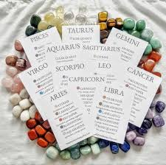

Aries (March 21 – April 19)
The Warrior of the Zodiac
Element: Fire
Ruling Planet: Mars
Core Traits: Bold, pioneering, fearless, independent
Challenges: Impulsiveness, impatience, burnout
Best Crystals for Aries:
Carnelian – Ignites confidence, courage, and action
Red Jasper – Grounds fiery energy and stabilizes emotions
Bloodstone – Strengthens endurance and resilience
Clear Quartz – Amplifies Aries intention and manifesting power

How to Use:
Hold Carnelian during goal setting. Wear Red Jasper when under pressure. Meditate with Clear Quartz to align ambition with wisdom.

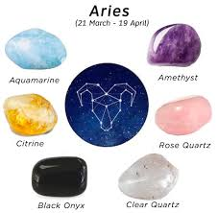

Taurus (April 20 – May 20)
The Earth Guardian
Element: Earth
Ruling Planet: Venus
Core Traits: Loyal, sensual, grounded, reliable
Challenges: Stubbornness, resistance to change, emotional attachment

Best Crystals for Taurus:
Rose Quartz – Opens the heart to love and softness
Green Aventurine – Abundance, luck, and opportunity
Emerald – Heart alignment and loyalty
Malachite – Emotional transformation and growth

How to Use:
Place Rose Quartz near your bed. Carry Green Aventurine when manifesting prosperity.

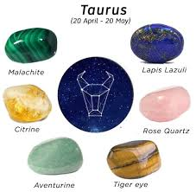

Gemini (May 21 – June 20)
The Cosmic Messenger
Element: Air
Ruling Planet: Mercury
Core Traits: Curious, witty, expressive, adaptable
Challenges: Anxiety, indecision, mental overload

Best Crystals for Gemini:
Blue Lace Agate – Calms racing thoughts and improves communication
Citrine – Confidence and mental clarity
Fluorite – Focus and organization
Tiger’s Eye – Mental stability and grounding

How to Use:
Meditate with Fluorite before planning. Keep Blue Lace Agate on your throat chakra.

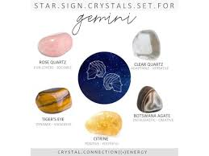

Cancer (June 21 – July 22)
The Sacred Moon Child
Element: Water
Ruling Planet: Moon
Core Traits: Nurturing, intuitive, emotionally deep
Challenges: Over sensitivity, mood swings, emotional withdrawal

Best Crystals for Cancer:
Moonstone – Emotional balance and divine feminine energy
Selenite – Spiritual cleansing and peace
Rhodochrosite – Self-love and inner child healing
Pearl – Emotional purity and softness

How to Use:
Sleep with Moonstone under your pillow. Cleanse energy with Selenite wands.

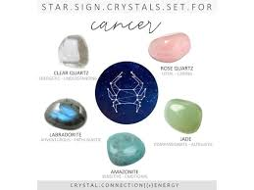

Leo (July 23 – August 22)
The Solar King/Queen
Element: Fire
Ruling Planet: Sun
Core Traits: Charismatic, creative, confident
Challenges: Ego struggles, need for validation, burnout

Best Crystals for Leo:
Sunstone – Joy, radiance, and leadership energy
Pyrite – Confidence and abundance
Citrine – Solar plexus activation
Ruby – Passion and vitality

How to Use:
Wear Sunstone jewellery for confidence. Use Pyrite in wealth rituals.

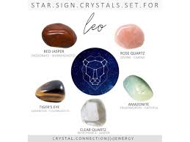

Virgo (August 23 – September 22)
The Divine Healer
Element: Earth
Ruling Planet: Mercury
Core Traits: Analytical, practical, service-oriented
Challenges: Perfectionism, anxiety, overthinking

Best Crystals for Virgo:
Amazonite – Nervous system balance and truth expression
Peridot – Emotional purification and joy
Moss Agate – Grounding and natural harmony
Smoky Quartz – Stress release and emotional detox

How to Use:
Meditate with Amazonite for clarity. Carry Smoky Quartz for anxiety relief.

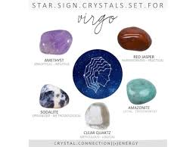

Libra (September 23 – October 22)
The Harmonizer
Element: Air
Ruling Planet: Venus
Core Traits: Balanced, diplomatic, romantic
Challenges: People-pleasing, indecision, emotional dependency

Best Crystals for Libra:
Lapis Lazuli – Inner truth and wisdom
Rose Quartz – Harmony in relationships
Opal – Emotional healing and intuition
Clear Quartz – Alignment and energetic cleansing

How to Use:
Journal with Lapis Lazuli beside you. Sleep near Rose Quartz for heart healing.

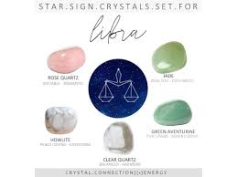

Scorpio (October 23 – November 21)
The Alchemist
Element: Water
Ruling Planet: Pluto
Core Traits: Intense, intuitive, transformative
Challenges: Emotional extremes, control issues, secrecy

Best Crystals for Scorpio:
Obsidian – Shadow work and protection
Garnet – Sexual vitality and grounding
Labradorite – Psychic awakening
Malachite – Deep emotional transformation

How to Use:
Meditate with Obsidian for protection. Use Garnet to activate root and sacral chakras.

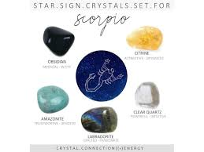

Sagittarius (November 22 – December 21)

The Sacred Explorer
Element: Fire
Ruling Planet: Jupiter
Core Traits: Optimistic, adventurous, philosophical
Challenges: Restlessness, poor focus, overpromising

Best Crystals for Sagittarius:
Sodalite – Truth and higher wisdom
Turquoise – Travel protection
Amethyst – Spiritual awakening
Citrine – Manifestation and success

How to Use:
Carry Turquoise when traveling. Meditate with Amethyst for higher guidance.

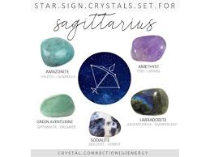

Capricorn (December 22 – January 19)
The Master Builder
Element: Earth
Ruling Planet: Saturn
Core Traits: Disciplined, ambitious, strategic
Challenges: Workaholism, emotional suppression, rigidity

Best Crystals for Capricorn:
Onyx – Strength and endurance
Garnet – Life force and motivation
Hematite – Grounding and focus
Smoky Quartz – Emotional release

How to Use:
Keep Onyx in your workspace. Meditate with Hematite before decisions.

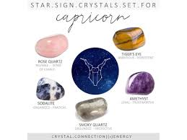

Aquarius (January 20 – February 18)

The Visionary
Element: Air
Ruling Planet: Uranus
Core Traits: Innovative, humanitarian, original
Challenges: Emotional detachment, unpredictability

Best Crystals for Aquarius:
Amethyst – Spiritual clarity
Lepidolite – Nervous system regulation
Fluorite – Mental organization
Aquamarine – Calm communication

How to Use:
Sleep near Amethyst. Use Lepidolite during stress.

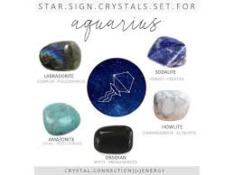

Pisces (February 19 – March 20)

The Mystic
Element: Water
Ruling Planet: Neptune
Core Traits: Dreamy, intuitive, compassionate
Challenges: Escapism, weak boundaries, emotional overwhelm

Best Crystals for Pisces:
Aquamarine – Emotional clarity
Amethyst – Spiritual protection
Chrysocolla – Gentle communication
Celestite – Angelic connection

How to Use:
Meditate with Celestite. Bathe with Aquamarine nearby.

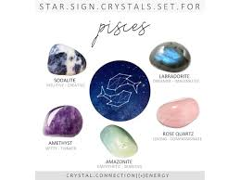

Crystal Rituals by Zodiac
New Moon Ritual:
Hold your zodiac crystal, set intentions, breathe deeply, visualize your future.

Full Moon Ritual:
Place crystals under moonlight to recharge.

Daily Alignment Practice:
Carry your main stone, repeat affirmations, drink water with presence.

How to Cleanse & Charge Zodiac Crystals
• Moonlight cleansing
• Selenite charging
• Sound cleansing (singing bowls, bells)
• Smoke cleansing (incense, palo santo, sage)

Final Blessing
You are a cosmic being made of stardust and divine intention. Through crystals and zodiac wisdom, you awaken your power, align with your soul, and walk your path with clarity, courage, and grace.
Your energy is sacred.
Your light is eternal.
Your journey is divine.
