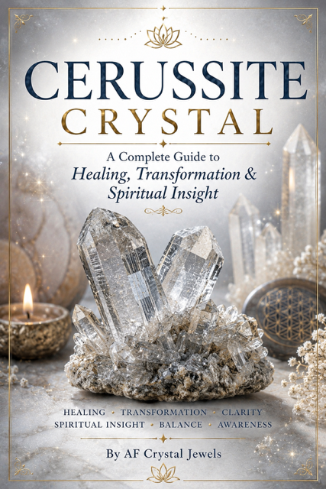
Cerussite Crystal
A Complete Guide to Healing, Transformation & Spiritual Insight
By AF Crystal Jewels

Table of Contents
- Introduction to Cerussite
- The History and Discovery of Cerussite
- Geological Formation and Sources
- Physical and Mineralogical Properties
- Cerussite Crystal Meanings
- Spiritual and Metaphysical Properties
- Emotional Healing Benefits
- Mental and Energetic Effects
- Cerussite and the Chakras
- Cerussite and Astrology
- Cerussite in Meditation Practices
- Manifestation and Intuitive Development
- Cerussite in Energy Healing
- Crystal Pairings with Cerussite
- Cerussite Rituals and Ceremonies
- Cerussite Crystal Grids
- Cerussite for Protection and Grounding
- Cerussite in Daily Life
- Cerussite Jewellery and Decorative Use
- Caring for Cerussite
- Scientific Facts About Cerussite
- Frequently Asked Questions
- Cerussite Affirmations
- Journal Prompts for Inner Transformation
- Final Reflections

Chapter 1: Introduction to Cerussite

Cerussite is one of the most fascinating and energetically powerful crystals in the mineral kingdom. Known for its striking crystal formations, brilliant lustre, and spiritually transformative energy, Cerussite is treasured by crystal collectors, healers, and advanced spiritual practitioners.
This crystal carries a unique combination of grounding and higher consciousness. Unlike many spiritual stones that pull energy upward without stability, Cerussite creates balance between earthly awareness and spiritual expansion. It teaches transformation through patience, wisdom, and energetic clarity.

Cerussite is often associated with:
Deep emotional healing
Spiritual awakening
Grounded transformation
Intuitive development
Karmic understanding
Energetic alignment
Its energy can feel both calming and powerful. Many practitioners describe Cerussite as a crystal that slows emotional chaos while simultaneously opening pathways to higher insight.
Because Cerussite contains lead carbonate, it should always be handled responsibly. Despite this, its metaphysical significance continues to make it one of the most respected transformational crystals.

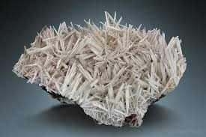

Chapter 2: The History and Discovery of Cerussite
Cerussite has a long scientific and mineralogical history. The mineral was first formally identified in the 18th century and became highly valued due to its remarkable brilliance and crystal formations.
The name “Cerussite” originates from the Latin word cerussa, meaning “white lead.” Historically, lead compounds were widely used in ancient societies for pigments, cosmetics, and industrial applications.
Cerussite naturally forms as a secondary mineral through the oxidation of galena, a lead sulfide mineral. Over long periods of time, environmental exposure transforms galena into Cerussite crystals.
Collectors throughout history prized Cerussite because of:
- Its brilliant sparkle
- Delicate twinned crystal structures
- Rare formation habits
- Exceptional optical qualities
Today, Cerussite is more appreciated as a collector’s mineral and metaphysical crystal than as an industrial resource.

Chapter 3: Geological Formation and Sources
Cerussite forms in oxidized zones of lead ore deposits. When galena is exposed to oxygenated water and environmental weathering, chemical reactions gradually create lead carbonate crystals.
Major Cerussite deposits have been found in:
- Namibia
- Morocco
- Australia
- United States
- Mexico
- Germany
- Italy
- Congo
Namibian Cerussite specimens are especially famous for their exceptional clarity and complex crystal structures.
Cerussite crystals often form as:
- Twinned crystals
- Needle-like formations
- Reticulated clusters
- Transparent prisms
Its geological formation symbolizes transformation through pressure, time, and environmental change — a theme reflected strongly in its spiritual meaning.

Chapter 4: Physical and Mineralogical Properties
Cerussite possesses remarkable physical beauty and optical brilliance.
Key Mineral Data
PROPERTY | DESCRIPTION
Chemical Formula | PbCO3
Mineral Family | Carbonate
Crystal System | Orthorhombic
Hardness | 3.5 Mohs
Lustre | Adamantine
Transparency | Transparent to translucent
Colours | White, clear, grey, smoky brown

Cerussite has one of the highest refractive indexes among minerals, which creates its diamond-like brilliance.
However, it is fragile and sensitive to pressure. Because of its softness and lead content, Cerussite should be handled carefully and stored safely.

Chapter 5: Cerussite Crystal Meanings
Cerussite symbolizes transformation, grounding, spiritual maturity, and energetic purification.
Its energy encourages individuals to:
- Release outdated patterns
- Stabilize emotions
- Expand spiritual awareness
- Strengthen energetic boundaries
- Develop deeper self-awareness
Unlike fast-moving manifestation stones, Cerussite promotes gradual and lasting transformation.
Its message is simple:
True spiritual growth requires grounding, patience, and inner clarity.
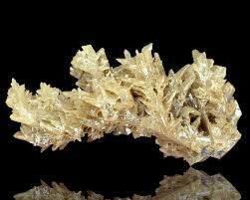

Chapter 6: Spiritual and Metaphysical Properties
Cerussite is often regarded as a high-frequency transformational crystal.
Practitioners believe it assists with:
- Spiritual awakening
- Soul evolution
- Karmic healing
- Consciousness expansion
- Energetic cleansing
- Past-life understanding
Many healers describe Cerussite as a bridge between earthly life and higher wisdom. It allows spiritual insight while maintaining practical stability.
The crystal may also support shadow work by helping individuals face suppressed emotions with calm awareness.

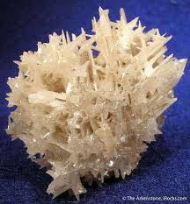

Chapter 7: Emotional Healing Benefits
Emotionally, Cerussite is deeply stabilising.
It may help with:
- Anxiety
- Emotional overwhelm
- Fear of change
- Grief processing
- Emotional exhaustion
- Inner confusion
Cerussite encourages emotional discipline without emotional suppression. It teaches calm observation rather than reactive behaviour.
During periods of intense personal transformation, Cerussite can act as an energetic anchor.

Chapter 8: Mental and Energetic Effects
Cerussite is associated with mental clarity and energetic organisation.
Its energy may:
- Slow racing thoughts
- Improve focus
- Encourage disciplined thinking
- Support decision-making
- Enhance self-awareness
- Reduce energetic chaos
Energetically, Cerussite helps clear stagnant emotional residue while strengthening grounding.

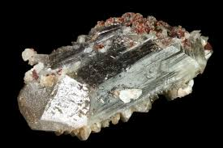

Chapter 9: Cerussite and the Chakras
Cerussite resonates strongly with three primary chakras.
- Root Chakra
Provides grounding, security, and emotional steadiness.
- Third Eye Chakra
Enhances intuition, perception, and spiritual insight.
- Crown Chakra
Supports higher consciousness and spiritual connection.
Cerussite creates an unusual balance between grounding and expansion, allowing safe spiritual development.

Chapter 10: Cerussite and Astrology
Cerussite aligns particularly well with:
- Capricorn
Supports discipline, structure, and resilience.
- Scorpio
Encourages transformation and emotional depth.
- Aquarius
Enhances spiritual awareness and innovative thinking.
These zodiac signs often resonate strongly with Cerussite’s transformational energy.

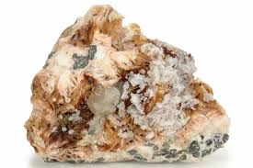

Chapter 11: Cerussite in Meditation Practices
Cerussite can deepen meditation by increasing stillness and awareness.
Ways to use Cerussite in meditation:
- Hold the crystal during breathwork
- Place near the Root Chakra
- Use during shadow work
- Combine with guided visualisation
- Meditate during moon rituals
Cerussite is especially effective during periods of spiritual transition or emotional healing.

Chapter 12: Manifestation and Intuitive Development
Cerussite supports grounded manifestation.
Rather than encouraging impulsive action, it promotes:
- Strategic thinking
- Long-term planning
- Energetic alignment
- Inner clarity
- Intuitive trust
It is ideal for those seeking sustainable personal growth.

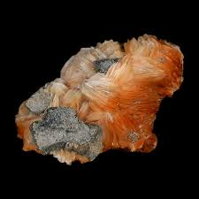

Chapter 13: Cerussite in Energy Healing
Energy healers often use Cerussite for energetic purification and emotional balancing.
Common placements include:
- Feet for grounding
- Third Eye for intuition
- Aura cleansing layouts
- Chakra balancing sessions
Cerussite may help release stagnant emotional energy during Reiki or healing sessions.

Chapter 14: Crystal Pairings with Cerussite
Cerussite combines beautifully with several crystals.
Recommended Pairings
- Smoky Quartz
Enhances grounding and emotional stability.
- Amethyst
Supports intuition and spiritual calm.
- Labradorite
Strengthens transformation and psychic awareness.
- Black Tourmaline
Provides energetic protection.
- Clear Quartz
Amplifies Cerussite’s energy.
- Selenite
Encourages energetic cleansing.

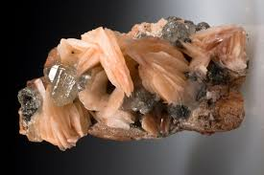

Chapter 15: Cerussite Rituals and Ceremonies
Transformation Ritual
- You will need:
- Cerussite
- White candle
- Journal
- Smoky Quartz
Steps:
Light the candle.
Hold Cerussite while breathing deeply.
Reflect on patterns you wish to release.
Write intentions in your journal.
Sit quietly for 10 minutes.
This ritual supports emotional release and clarity.

Chapter 16: Cerussite Crystal Grids
Cerussite can strengthen grids focused on:
- Grounding
- Spiritual clarity
- Emotional healing
- Personal transformation
- Simple Grid Layout
Centre Stone:
- Cerussite
- Supporting Stones:
- Smoky Quartz
- Clear Quartz
- Black Tourmaline
Activate the grid with focused intention and meditation.
Chapter 17: Cerussite for Protection and Grounding
Although Cerussite is spiritually expansive, it also offers grounding energy.
It may help:
- Stabilize emotions
- Reduce energetic overwhelm
- Strengthen boundaries
- Improve spiritual discernment
- Encourage emotional balance
Its grounding qualities make it useful for empaths and sensitive individuals.

Chapter 18: Cerussite in Daily Life
Cerussite can be incorporated into daily spiritual routines.
Ideas include:
- Meditation spaces
- Journaling sessions
- Healing altars
- Personal reflection practices
- Energy healing rooms
Its presence encourages mindfulness and calm awareness.

Chapter 19: Cerussite Jewellery and Decorative Use
Because Cerussite is fragile, it is less commonly used in jewellery than harder gemstones.
However, collectors value it highly for:
- Mineral displays
- Spiritual altars
- Collector specimens
- Decorative crystal arrangements
- Its brilliant sparkle creates a visually striking appearance.

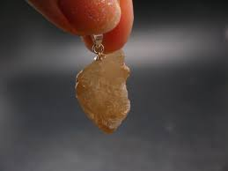

Chapter 20: Caring for Cerussite
Cerussite requires careful handling.
Important Safety Guidelines
- Avoid water cleansing
- Never create crystal elixirs
- Wash hands after handling
- Keep away from children and pets
- Store separately from harder stones

Energetic Cleansing Methods
Safe cleansing options include:
- Moonlight
- Sound cleansing
- Incense smoke
- Selenite charging

Chapter 21: Scientific Facts About Cerussite
Interesting scientific facts include:
- Cerussite has exceptional optical brilliance.
- It often forms intricate twinned crystals.
- It is one of the most visually dazzling carbonate minerals.
- Large flawless crystals are rare and valuable.
- Mineralogists admire Cerussite for both scientific significance and aesthetic beauty.

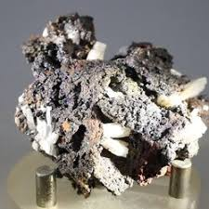

Chapter 22: Frequently Asked Questions
Is Cerussite rare?
High-quality crystal specimens are considered relatively rare and collectible.

Is Cerussite safe?
Yes, when handled responsibly. Avoid ingestion and wash hands after handling.

Can Cerussite go in water?
No. Water exposure is not recommended.

What is Cerussite best used for?
Transformation, grounding, intuition, and emotional healing.

Chapter 23: Cerussite Affirmations
I remain grounded during transformation.
I trust my spiritual evolution.
My intuition guides me clearly and wisely.
I release fear and welcome growth.
I am balanced, calm, and aligned.

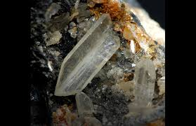

Chapter 24: Journal Prompts for Inner Transformation
What emotional patterns am I ready to release?
How can I remain grounded during change?
What does spiritual growth truly mean to me?
Where do I need stronger boundaries?
What fears are preventing my transformation?

Chapter 25: Final Reflections
Cerussite is a crystal of grounded transformation, spiritual wisdom, and emotional clarity. Its energy encourages balanced growth rather than rapid or chaotic change.
This remarkable crystal reminds us that true evolution requires patience, awareness, and stability. Whether used in meditation, energy work, or personal reflection, Cerussite offers a powerful pathway toward deeper understanding and conscious transformation.
For collectors, healers, and spiritual practitioners, Cerussite remains one of the mineral kingdom’s most fascinating and spiritually meaningful stones.

