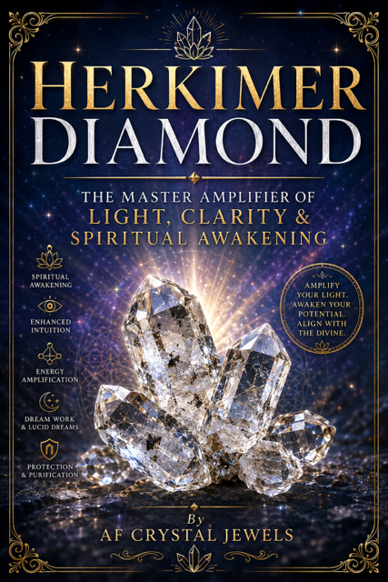
Herkimer Diamond: The Master Amplifier of Light, Clarity & Spiritual Awakening
By AF Crystal Jewels
Disclaimer
This eBook is intended for spiritual, educational, and inspirational purposes only. Crystal haling is a complementary spiritual practice and is not intended to replace professional medical, psychological, or financial advice.

Table of Contents

- Introduction to Herkimer Diamond
- What Is a Herkimer Diamond?
- History & Discovery
- Geological Formation
- Physical Properties & Identification
- Locations Around the World
- The Spiritual Energy of Herkimer Diamond
- Metaphysical Properties
- Chakra Healing
- Herkimer Diamond & the Third Eye
- Emotional Healing Benefits
- Mental Clarity & Consciousness Expansion
- Herkimer Diamond for Manifestation
- Meditation with Herkimer Diamond
- Dream Work & Lucid Dreaming
- Protection & Energy Purification
- Herkimer Diamond in Reiki & Energy Healing
- Crystal Grids Using Herkimer Diamond
- Zodiac & Astrological Associations
- Elemental Energy & Numerology
- Combining Herkimer Diamond with Other Crystals
- Herkimer Diamond Rituals
- Sacred Affirmations
- Using Herkimer Diamond in Daily Life
- Jewelry & Wearing Herkimer Diamond
- Cleansing & Charging Methods
- Caring for Your Crystal
- Herkimer Diamond Myths & Legends
- Frequently Asked Questions
- Final Thoughts

Chapter 1: Introduction to Herkimer Diamond

Among the world’s most spiritually powerful crystals, Herkimer Diamond stands as a beacon of amplified light, divine clarity, and energetic awakening. Despite its name, it is not a true diamond. Instead, Herkimer Diamond is an exceptionally clear, naturally double-terminated quartz crystal found primarily in Herkimer County, New York.
What makes this crystal extraordinary is its purity, brilliance, and naturally faceted structure. Unlike most quartz crystals that require cutting and polishing, Herkimer Diamonds emerge from the earth already sparkling with remarkable geometric perfection.
For centuries, healers, mystics, and spiritual practitioners have considered Herkimer Diamond one of the highest vibration stones available for spiritual transformation, psychic activation, and energetic cleansing.

This crystal is often referred to as:
- The Stone of Attunement
- The Dream Crystal
- The Master Amplifier
- The Soul Awakening Crystal

Its energy is sharp, bright, and highly transformative. Many people describe its vibration as electric, celestial, or deeply awakening.
Herkimer Diamond acts like a bridge between worlds — linking the physical body with higher consciousness, spiritual insight, and divine guidance.

Chapter 2: What Is a Herkimer Diamond?
A Herkimer Diamond is a rare variety of double-terminated quartz crystal discovered primarily in the dolostone deposits of Herkimer County, New York.
Unlike traditional quartz points that form with one termination, Herkimer Diamonds naturally develop with points at both ends.
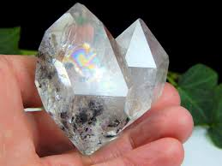
These crystals are famous for:
- Exceptional clarity
- High vibrational frequency
- Natural geometric symmetry
- Brilliant sparkle
- Powerful amplification abilities

True Herkimer Diamonds often contain unique inclusions such as:
- Water bubbles
- Carbon deposits
- Rainbow fractures
- Black anthraxolite inclusions
- Tiny moving air bubbles
These inclusions are considered spiritually significant and energetically unique.
Many collectors and healers treasure Herkimer Diamonds because no two crystals are exactly alike.

Chapter 3: History & Discovery
The Mohawk people discovered Herkimer Diamonds long before European settlers arrived in North America. These crystals were considered sacred stones connected to visions, dreams, and spirit communication.
Archaeologists have uncovered Herkimer Diamonds in ancient trade routes and burial sites dating back hundreds of years.
In the late 1700s, miners and settlers began excavating the crystals commercially in Herkimer County.
Today, crystal enthusiasts travel from around the world to mine Herkimer Diamonds themselves in New York.
Many spiritual practitioners believe that personally mined Herkimer Diamonds carry especially strong energetic bonds with their owner.

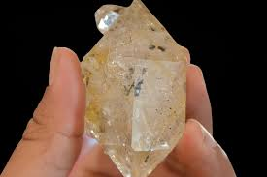

Chapter 4: Geological Formation
Herkimer Diamonds formed approximately 500 million years ago inside cavities within dolostone rock.
The crystals grew slowly under intense pressure and mineral-rich conditions, allowing them to develop extraordinary clarity and natural faceting.
Their double-terminated structure forms when the crystal grows freely without attaching to surrounding rock surfaces.
This rare formation contributes to their unique energetic flow.
Spiritually, double termination symbolizes:
- Balance
- Duality
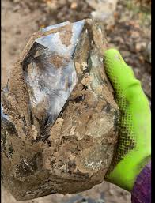
- Energy circulation
- Spiritual connection between realms

Chapter 5: Physical Properties & Identification
Mineral Family: Quartz
Chemical Composition: Silicon Dioxide (SiO₂)
Hardness :7.5 on the Mohs scale
Crystal System: Hexagonal
Common Colours
- Clear
- Smoky
- Slightly golden
- Rainbow-filled

Distinctive Features
- Double terminations
- Natural faceting
- High transparency
- Brilliant sparkle
Authentic Herkimer Diamonds are never perfectly flawless. Tiny inclusions often confirm authenticity.

Chapter 6: Locations Around the World
Although authentic Herkimer Diamonds come from New York, similar double-terminated quartz crystals can be found in:
- Afghanistan
- Pakistan
- China
- Ukraine
- Norway
However, true Herkimer Diamonds specifically originate from Herkimer County, New York.
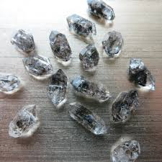

Chapter 7: The Spiritual Energy of Herkimer Diamond
Herkimer Diamond possesses one of the highest vibrations among quartz crystals.
Its energy is:
- Intensely purifying
- Expansive
- Illuminating
- Protective
- Spiritually awakening
This crystal rapidly clears stagnant energy and elevates consciousness.

Many users report experiences such as:
- Heightened intuition
- Increased synchronicities
- Stronger dream recall
- Enhanced meditation
- Sudden spiritual insights
Herkimer Diamond often accelerates spiritual growth rapidly.
Because of this, sensitive individuals may need time to adjust to its frequency.

Chapter 8: Metaphysical Properties
Herkimer Diamond is known for amplifying intentions and spiritual energy.
Primary Metaphysical Benefits
- Energy Amplification
- Enhances the energy of intentions, affirmations, and other crystals.
- Psychic Activation
- Stimulates clairvoyance, intuition, and spiritual awareness.
- Emotional Clearing
- Releases energetic blockages and emotional heaviness.
- Spiritual Alignment
- Connects the physical self with higher consciousness.
- Deep Purification
- Cleanses the aura and removes stagnant vibrations.

Chapter 9: Chakra Healing
Herkimer Diamond aligns with all chakras but strongly resonates with:

- Crown Chakra
Promotes spiritual connection and enlightenment.

- Third Eye Chakra
Enhances intuition, visions, and inner wisdom.

- Soul Star Chakra
Facilitates connection to divine consciousness.

When placed on the chakras during healing work, Herkimer Diamond may intensify energetic flow throughout the body.

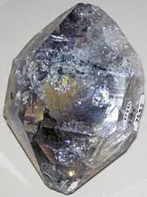
Chapter 10: Herkimer Diamond & the Third Eye
The Third Eye Chakra governs:
- Intuition
- Psychic perception
- Inner knowing
- Spiritual insight
- Herkimer Diamond powerfully stimulates this chakra.

Many practitioners use the crystal during meditation by placing it on the forehead to activate visionary states and deeper awareness.
Some people experience vivid imagery, spiritual downloads, or enhanced intuition during these practices.

Chapter 11: Emotional Healing Benefits
Herkimer Diamond assists in emotional healing by illuminating hidden emotions and energetic patterns.
It can help with:
- Emotional overwhelm
- Anxiety
- Mental fog
- Fear-based thinking
- Emotional suppression
The crystal encourages emotional honesty and energetic release.
Because its vibration is intense, emotional healing may occur quickly and deeply.

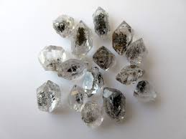

Chapter 12: Mental Clarity & Consciousness Expansion
One of Herkimer Diamond’s greatest gifts is mental clarity.
It sharpens perception and helps dissolve confusion.
Students, healers, spiritual teachers, and creatives often use Herkimer Diamond to:
- Improve focus
- Enhance inspiration
- Increase spiritual understanding
- Access higher perspectives
Many users feel mentally energized after working with this crystal.

Chapter 13: Herkimer Diamond for Manifestation
Herkimer Diamond acts as a powerful manifestation amplifier.
It strengthens:
- Intentions
- Visualization practices
- Affirmations
- Energy work
- Simple Manifestation Practice

Hold your Herkimer Diamond.
- Close your eyes.
- Visualize your desired outcome clearly.
- Speak your intention aloud.
- Imagine the crystal radiating your intention into the universe.
Because Herkimer Diamond magnifies energy, clarity of intention is extremely important.
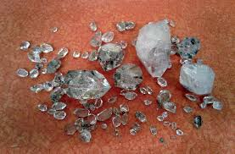

Chapter 14: Meditation with Herkimer Diamond
Meditating with Herkimer Diamond may deepen spiritual awareness significantly.

Meditation Method
- Sit comfortably in a quiet space.
- Hold the crystal or place it on the Third Eye.
- Focus on your breath.
- Allow thoughts to pass naturally.
- Observe sensations, visions, or intuitive impressions.

Benefits may include:
- Deep peace
- Enhanced intuition
- Energetic cleansing
- Spiritual downloads

Chapter 15: Dream Work & Lucid Dreaming
Herkimer Diamond is widely known as a dream crystal.
It may support:
- Dream recall
- Lucid dreaming
- Prophetic dreams
- Astral travel
- Sleep-time healing
Place the crystal beneath your pillow or beside your bed before sleep.
Keep a dream journal nearby to record impressions immediately upon waking.

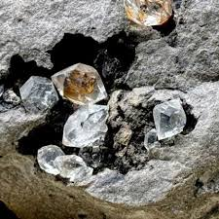

Chapter 16: Protection & Energy Purification
Although Herkimer Diamond is associated with light energy, it also serves as a powerful energetic purifier.

It can help:
- Clear heavy energy
- Strengthen the aura
- Remove energetic attachments
- Raise environmental vibrations
Many healers place Herkimer Diamonds near doorways, altars, or sacred spaces.

Chapter 17: Herkimer Diamond in Reiki & Energy Healing
Reiki practitioners often use Herkimer Diamond to amplify healing sessions.
Benefits include:
- Intensified energy flow
- Faster energetic clearing
- Chakra alignment
- Enhanced spiritual communication
- Double-terminated crystals are especially useful for directing energy flow between practitioner and recipient.

Chapter 18: Crystal Grids Using Herkimer Diamond

Herkimer Diamond serves beautifully as a centre stone in crystal grids.
- Popular Grid Intentions
- Spiritual awakening
- Manifestation
- Protection
- Dream enhancement
- Abundance

Recommended Pairings
- Amethyst
- Clear Quartz
- Moldavite
- Selenite
- Labradorite

Chapter 19: Zodiac & Astrological Associations
Herkimer Diamond resonates strongly with:

- Sagittarius
Supports expansion, wisdom, and spiritual growth.

- Aquarius
Enhances innovation and higher consciousness.

- Pisces
Strengthens intuition and dream work.

However, all zodiac signs can benefit from its energy.

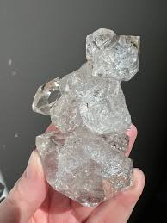

Chapter 20: Elemental Energy & Numerology

Element : Storm
Its storm element reflects transformation, illumination, and energetic movement.
Numerology: Vibration Number: 11
Master Number 11 represents:
- Spiritual awakening
- Intuition
- Divine inspiration
- Enlightenment

Chapter 21: Combining Herkimer Diamond with Other Crystals

- Herkimer Diamond + Moldavite
Rapid spiritual transformation.

- Herkimer Diamond + Amethyst
Enhanced intuition and peaceful meditation.

- Herkimer Diamond + Rose Quartz
Heart healing and emotional clarity.

- Herkimer Diamond + Black Tourmaline
Protection and energetic grounding.

- Herkimer Diamond + Citrine
Manifestation and abundance amplification.

Chapter 22: Herkimer Diamond Rituals

Full Moon Charging Ritual
You Will Need
- Herkimer Diamond
- Candle
- Journal
- Ritual Steps

- Cleanse the crystal.
- Place it under moonlight.
- Speak your intentions aloud.
- Meditate with the crystal.
- Journal any insights received.

Chapter 23: Sacred Affirmations

Use these affirmations while holding your Herkimer Diamond.
“I am aligned with divine clarity.”
“My intuition guides me with wisdom.”
“I release all energetic blockages.”
“I radiate light, truth, and peace.”
“I am spiritually protected and supported.”
“My manifestations flow effortlessly.”

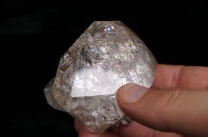

Chapter 24: Using Herkimer Diamond in Daily Life

- You can work with Herkimer Diamond by:
- Wearing it as jewellery
- Carrying it in your pocket
- Meditating daily
- Placing it on your altar
- Using it in crystal grids
- Sleeping near it
- Daily interaction strengthens your energetic connection with the crystal.

Chapter 25: Jewellery & Wearing Herkimer Diamond
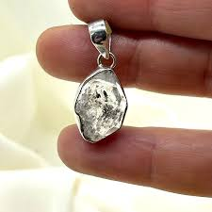
Herkimer Diamond jewellery allows constant energetic interaction.
Popular forms include:
- Pendants
- Rings
- Bracelets
- Earrings
Wearing the crystal near the Crown or Heart Chakra may enhance spiritual awareness throughout the day.

Chapter 26: Cleansing & Charging Methods
Because Herkimer Diamond absorbs and amplifies energy, regular cleansing is important.
Cleansing Methods
- Moonlight
- Sound healing
- Incense smoke
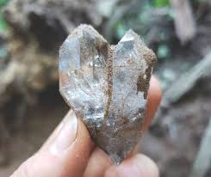
- Selenite charging
- Running water
- Charging Methods
- Full moonlight
- Meditation
- Crystal clusters
- Sacred intention

Chapter 27: Caring for Your Crystal

Although durable, Herkimer Diamond should still be handled carefully.
Care Tips
- Store separately to avoid scratches
- Clean gently with soft cloths
- Avoid harsh chemicals
- Keep energetically cleansed
- Respectful care strengthens your relationship with the crystal.

Chapter 28: Herkimer Diamond Myths & Legends
Many spiritual traditions associate Herkimer Diamond with:
- Angelic communication
- Ancient wisdom
- Interdimensional travel
- Divine guidance
Some believe the crystal acts as a “light bridge” connecting earthly consciousness with higher realms.

Chapter 29: Frequently Asked Questions
Is Herkimer Diamond a real diamond?
No. It is a double-terminated quartz crystal.

Can beginners use Herkimer Diamond?
Yes, although sensitive individuals may need gradual exposure to its strong energy.

Can Herkimer Diamond go in water?
Brief exposure is generally safe, but prolonged soaking is not recommended.

Is Herkimer Diamond rare?
High-quality specimens with excellent clarity are considered relatively rare.
Chapter 30: Final Thoughts
Herkimer Diamond is far more than a beautiful crystal.
It is a powerful spiritual ally capable of illuminating the mind, purifying the spirit, and accelerating personal transformation.
Its brilliance reminds us that clarity already exists within us — waiting to be awakened.
Whether used for meditation, manifestation, healing, or spiritual exploration, Herkimer Diamond carries a frequency of light that encourages growth, truth, and higher consciousness.
When approached with respect and intention, this remarkable crystal can become a lifelong companion on your spiritual journey.

