**Crystal Healing & the Chakras: Aligning Energy from Root to Soul Star**

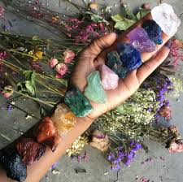

By AF Crystal Jewels

Roxy Slabber

**Table of Content**

1. Introduction to Chakras & Crystal Healing
2. Understanding the Chakra System: Main & Extended Chakras
3. How Crystals Interact with the Energy Body
4. Preparing for Chakra Healing
5. The 12-Chakra System Overview
6. Root Chakra (Muladhara)
7. Sacral Chakra (Svadhisthana)
8. Solar Plexus Chakra (Manipura)
9. Heart Chakra (Anahata)
10. Throat Chakra (Vishuddha)
11. Third Eye Chakra (Ajna)
12. Crown Chakra (Sahasrara)
13. Earth Star Chakra
14. Soul Star Chakra
15. Stellar Gateway Chakra
16. Crystals for Chakra Activation & Balance
17. Chakra Healing Techniques with Crystals
18. Chakra Meditation & Affirmations
19. Creating Chakra Crystal Grids
20. Integrating Chakra Healing into Daily Life
21. Advanced Chakra Healing Practices
22. Common Blockages & How to Clear Them
23. Conclusion: Awakening the Full Spectrum of Your Energy

**Chapter 1: Introduction to Chakras & Crystal Healing**

Chakras are energy centres within the human subtle body that influence physical, emotional, and spiritual well-being. Crystal healing is the use of specific stones to align, balance, and activate these chakras. When crystals resonate with a chakra’s frequency, they help to clear stagnation, restore balance, and enhance energy flow.

**Chapter 2: Understanding the Chakra System: Main & Extended Chakras**

The traditional system includes 7 main chakras aligned along the spine. However, there are extended chakras located above and below the body that connect us to Earth energy and cosmic consciousness. This eBook focuses on the 12-chakra system, providing a more holistic path to multidimensional healing.

**Chapter 3: How Crystals Interact with the Energy Body**

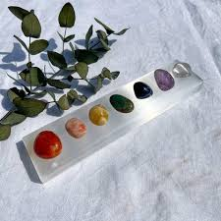Crystals emit stable vibrational frequencies. Each chakra resonates with specific frequencies, and crystals amplify or harmonize those energies. This alignment supports healing on physical, emotional, and spiritual levels.

**Chapter 4: Preparing for Chakra Healing**

1. Cleanse your crystals (using moonlight, water, smoke, or sound).
2. Create a calm space (light candles, play soft music).
3. Set an intention (e.g., “I balance my heart chakra for love and compassion.”).
4. Use breathwork to centre yourself before beginning.

**Chapter 5: The 12-Chakra System Overview**

|  |  |  |  |
| --- | --- | --- | --- |
| **Chakra** | **Location** | **Purpose** | **Crystal Example** |
| Earth Star | 12–18” below feet | Grounding to Earth grid | Black Tourmaline, Jet |
| Root | Base of spine | Survival, stability | Red Jasper, Smoky Quartz |
| Sacral | Below navel | Creativity, sexuality | Carnelian, Orange Calcite |
| Solar Plexus | Above navel | Confidence, power | Citrine, Yellow Jasper |
| Heart | Center of chest | Love, compassion | Rose Quartz, Green Aventurine |
| Throat | Throat area | Communication, truth | Lapis Lazuli, Aquamarine |
| Third Eye | Between eyebrows | Intuition, insight | Amethyst, Labradorite |
| Crown | Top of head | Divine connection | Clear Quartz, Selenite |
| Soul Star | 6–12” above head | Access to higher self | Scolecite, Apophyllite |
| Stellar Gateway | 12–18” above head | Cosmic consciousness | Moldavite, Phenakite |
| Higher Heart | Between Heart & Throat | Soul truth, unconditional love | Pink Kunzite, Rhodochrosite |
| Solar Star | Above Solar Plexus | Purpose, soul direction | Golden Healer Quartz, Sunstone |

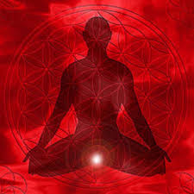**Chapter 6: Root Chakra (Muladhara)**

* Colour: Red
* Crystals: Red Jasper, Smoky Quartz, Black Tourmaline
* Affirmation: “I am grounded. I am safe. I belong.”
* Signs of Imbalance: Anxiety, fear, financial instability
* Healing Tips: Meditate with Red Jasper on the tailbone area; walk barefoot on the earth

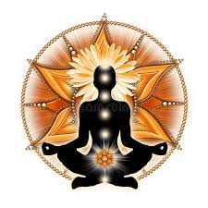

**Chapter 7: Sacral Chakra (Svadhisthana)**

* Colour: Orange
* Crystals: Carnelian, Orange Calcite, Sunstone
* Affirmation: “I honour my emotions and express my creativity freely.”
* Signs of Imbalance: Guilt, creative blocks, intimacy issues
* Healing Tips: Place Carnelian over lower abdomen and visualize orange light

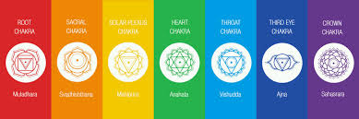

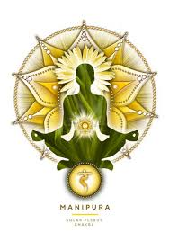**Chapter 8: Solar Plexus Chakra (Manipura)**

* Colour: Yellow
* Crystals: Citrine, Tiger’s Eye, Yellow Jasper
* Affirmation: “I am confident in my power.”
* Signs of Imbalance: Low self-esteem, control issues, digestive problems
* Healing Tips: Wear Citrine jewellery daily; do core-strengthening yoga

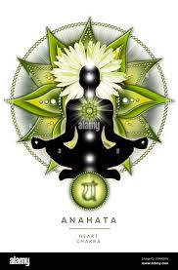**Chapter 9: Heart Chakra (Anahata)**

* Colour: Green or Pink
* Crystals: Rose Quartz, Green Aventurine, Rhodonite
* Affirmation: “I give and receive love with ease.”
* Signs of Imbalance: Loneliness, resentment, heartache
* Healing Tips: Place Rose Quartz on chest and repeat affirmations

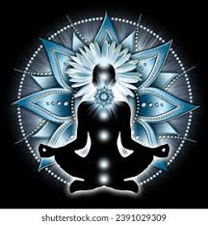**Chapter 10: Throat Chakra (Vishuddha)**

* Colour: Blue
* Crystals: Lapis Lazuli, Aquamarine, Blue Lace Agate
* Affirmation: “My voice is clear, confident, and true.”
* Signs of Imbalance: Fear of speaking, sore throat, dishonesty
* Healing Tips: Chant “HAM,” journal freely, wear Aquamarine.

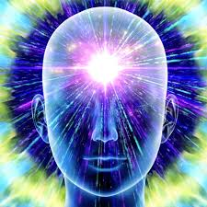**Chapter 11: Third Eye Chakra (Ajna)**

* Colour: Indigo
* Crystals: Amethyst, Fluorite, Labradorite
* Affirmation: “I trust my inner wisdom.”
* Signs of Imbalance: Headaches, lack of focus, confusion
* Healing Tips: Meditate with Amethyst on forehead; reduce screen time

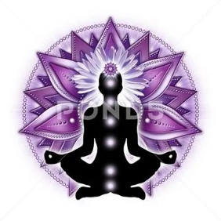

**Chapter 12: Crown Chakra (Sahasrara)**

* Colour: Violet or White
* Crystals: Clear Quartz, Selenite, Lepidolite
* Affirmation: “I am connected to divine light.”
* Signs of Imbalance: Disconnection, cynicism, spiritual confusion
* Healing Tips: Silent meditation, use Clear Quartz in headstand pose

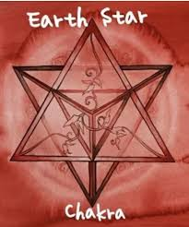

**Chapter 13: Earth Star Chakra**

* Location: Beneath the feet
* Crystals: Black Tourmaline, Hematite, Jet
* Function: Connects to Earth’s crystalline grid, deep grounding
* Practice: Lie down with a Black Tourmaline below your feet to feel rooted

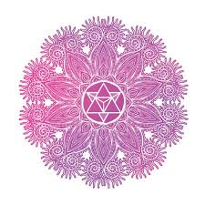**Chapter 14: Soul Star Chakra**

* Location: Above the crown
* Crystals: Danburite, Apophyllite, Scolecite
* Function: Connection to soul purpose, akashic records
* Practice: Meditate under moonlight with Apophyllite above the head

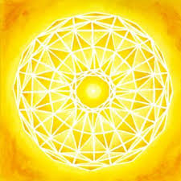**Chapter 15: Stellar Gateway Chakra**

* Location: Highest energetic point
* Crystals: Moldavite, Phenakite, Herkimer Diamond
* Function: Gateway to divine realms, multidimensional awareness
* Practice: Create a triangle grid using high-frequency stones during cosmic alignments

**Chapter 16: Crystals for Chakra Activation & Balance**

Each chakra resonates with specific stones based on colour, vibration, and elemental association. Below is a curated selection of common and rare crystals that work harmoniously with each chakra. Use these intuitively or based on your energetic needs.

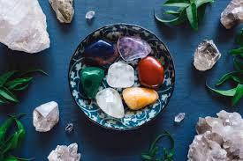

**Root Chakra (Muladhara)**

Purpose: Grounding, safety, survival

* Black Tourmaline – Protection from negativity
* Red Jasper – Stability and courage
* Hematite – Magnetic grounding
* Smoky Quartz – Transmutation of fear
* Jet (rare) – Ancestral healing, energetic shielding

**Sacral Chakra (Svadhisthana)**

Purpose: Creativity, sensuality, emotional flow

* Carnelian – Passion and vitality
* Orange Calcite – Emotional healing
* Sunstone – Joy and abundance
* Peach Moonstone – Feminine energy
* Spessartine Garnet (rare) – Creative manifestation

**Solar Plexus Chakra (Manipura)**

Purpose: Confidence, personal power

* Citrine – Empowerment and success
* Yellow Jasper – Mental clarity
* Tiger’s Eye – Focus and willpower
* Golden Calcite – Self-worth
* Heliodor (rare) – Leadership and energetic radiance

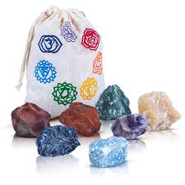

**Heart Chakra (Anahata)**

Purpose: Love, compassion, emotional balance

* Rose Quartz – Unconditional love
* Green Aventurine – Healing and growth
* Rhodonite – Emotional forgiveness
* Pink Tourmaline (rare) – Healing grief
* Dioptase (rare) – Heart chakra awakening

**Throat Chakra (Vishuddha)**

Purpose: Communication, self-expression

* Aquamarine – Clear communication
* Blue Lace Agate – Calming expression
* Lapis Lazuli – Authenticity and wisdom
* Chrysocolla – Sacred truth
* Larimar (rare) – Divine feminine expression

**Third Eye Chakra (Ajna)**

Purpose: Intuition, insight, spiritual sight

* Amethyst – Spiritual awareness
* Labradorite – Psychic protection
* Fluorite – Focus and perception
* Azurite (rare) – Deep intuition and inner vision
* Indigo Gabbro (rare) – Multidimensional connection

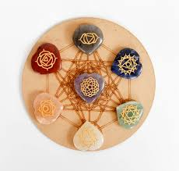

**Crown Chakra (Sahasrara)**

Purpose: Divine consciousness, enlightenment

* Clear Quartz – Amplification and clarity
* Selenite – Angelic connection
* Lepidolite – Calming crown energy
* Nirvana Quartz (rare) – Spiritual awakening
* Auralite-23 (rare) – Universal wisdom integration

**Soul Star Chakra**

* Danburite – Soul-level healing
* Apophyllite – Accessing spiritual guides
* Scolecite – Inner peace and soul travel

**Stellar Gateway Chakra**

* Moldavite – Accelerated transformation
* Phenakite – High-frequency activation
* Herkimer Diamond – Lightbody expansion

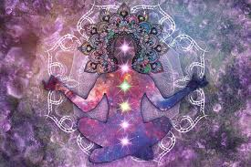

**Chapter 17: Chakra Healing Techniques with Crystals**

**1. Chakra Crystal Layouts (Full-Body Spread)**

* Lay flat and place aligned stones on each chakra.
* Start at the Root and move upward, staying 5–10 minutes per stone.
* Visualize light flowing through each chakra.

**2. Pendulum Scans for Detecting Imbalances**

* Hold a pendulum over each chakra.
* A clockwise spin indicates openness, erratic or no movement signals blockage.
* Use crystal healing on stagnant chakras, then re-scan.

**3. Breathwork with Crystal Touch Points**

* Inhale deeply while holding a crystal over a chakra.
* Exhale and release emotional stagnation.
* For example, hold Lepidolite on the crown while practicing breath awareness to relieve mental overwhelm.

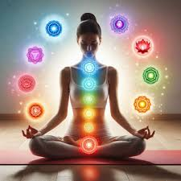

**Chapter 18: Chakra Meditation & Affirmations**

Each chakra benefits from focused meditation supported by breath, visualization, and affirmations. Use a crystal aligned with the chakra during each practice.

**Guided Chakra Meditation Structure**

1. Sit comfortably, spine aligned.
2. Start at the Root and visualize its colour expanding.
3. Place a crystal on the chakra or hold in hand.
4. Repeat affirmations with mindful breath.

**Affirmations for Each Chakra**

* Root: “I am safe. I am grounded. I trust life.”
* Sacral: “I embrace pleasure and creativity.”
* Solar Plexus: “I am confident and in control of my life.”
* Heart: “With every breath, I open myself to love. My heart is a sanctuary of peace.”
* Throat: “I speak my truth with clarity and courage.”
* Third Eye: “I trust my intuition and inner wisdom.”
* Crown: “I am connected to the divine and guided by higher wisdom.”

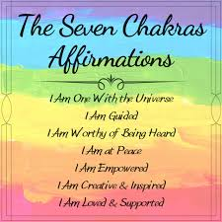

**Chapter 19: Creating Chakra Crystal Grids**

**1. Choosing Geometric Patterns**

* Flower of Life: For full-spectrum alignment
* Spiral: For clearing blockages
* Triangle: For manifestation or protection

**2. Crystal Placement Guidelines**

* Centre stone = intention (e.g., Clear Quartz for clarity)
* Place chakra-specific stones outward from the centre in harmony with your chosen grid
* Activate with a wand or finger by tracing the energy path

**3. Grid Intentions**

* Clear Blockages: Use grounding and releasing stones (e.g., Smoky Quartz, Black Tourmaline)
* Protect Auric Field: Combine Selenite, Amethyst, and Obsidian
* Amplify Spiritual Insight: Use Apophyllite, Azurite, and Moldavite

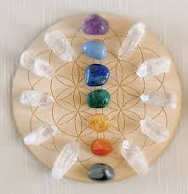

**Chapter 20: Integrating Chakra Healing into Daily Life**

**Morning Rituals by Chakra**

* Monday (Root): Walk barefoot outdoors
* Tuesday (Sacral): Creative journaling with Carnelian
* Wednesday (Solar Plexus): Power yoga with Citrine
* Thursday (Heart): Loving-kindness meditation with Rose Quartz
* Friday (Throat): Speak affirmations aloud with Blue Lace Agate
* Saturday (Third Eye): Dream journaling with Amethyst
* Sunday (Crown): Silent meditation with Selenite

**Aromatherapy Pairings**

* Root: Vetiver, Patchouli
* Heart: Rose, Geranium
* Third Eye: Frankincense, Clary Sage

**Weekly Chakra Focus**

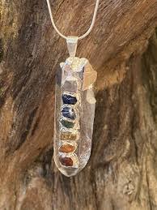Choose one chakra each week. Carry or wear the corresponding crystal and align your rituals to that energy centre.

**Chapter 21: Advanced Chakra Healing Practices**

**1. Past-Life and Karmic Healing**

* Use Lemurian Quartz or Labradorite to access karmic wounds.
* Focus on the Soul Star chakra to release karmic imprints.

**2. Anchoring Light Codes with Crystals**

* Crystals like Azeztulite, Scolecite, and Phenakite can hold vibrational light codes during meditation or celestial alignments.

**3. Sacred Geometry Integration**

* Create energy temples or crystal mandalas using Metatron’s Cube, Sri Yantra, or Seed of Life.

**4. Activating Dormant Chakras**

* Focus on minor chakras (e.g., thymus/higher heart) with high-vibration crystals like Kunzite or Danburite.
* Use breath and mantra activation during full/new moons.

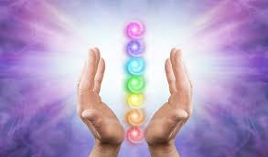

**Chapter 22: Common Blockages & How to Clear Them**

**1. Repressed Trauma**

Symptoms: Emotional numbness, closed heart

Crystals: Rhodonite, Pink Tourmaline, Black Obsidian

Ritual: Journaling + crystal grid around Heart with release mantra

**2. Chronic Fatigue**

Symptoms: Low energy, foggy mind, disconnection

Crystals: Citrine, Clear Quartz, Auralite-23

Ritual: Morning energy cleanse with Selenite + affirmations

**3. Energetic Overexpansion**

Symptoms: Feeling scattered, anxiety, psychic overwhelm

Crystals: Smoky Quartz, Hematite, Indigo Gabbro

Ritual: Grounding bath with crystal-infused salts; visualize energy drawing back into centre

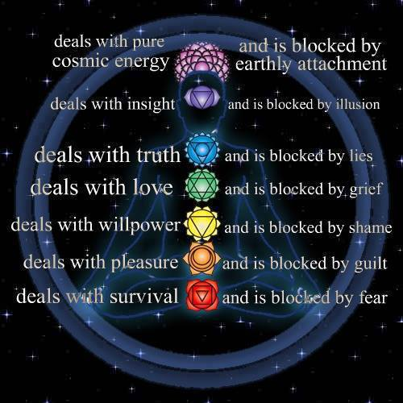

**Chapter 23: Conclusion: Awakening the Full Spectrum of Your Energy**

Crystal and chakra healing is a pathway to deep personal alignment. As you clear and activate each chakra, your vibration rises, your intuition sharpens, and your connection to source energy strengthens.

This journey is not linear—it’s a spiral of growth and remembrance. With sacred intention, crystals become allies in embodying your soul’s fullest potential. Let your energy system become a radiant channel of grounded light and divine truth.

**Final Words: A Journey of Light and Alignment**

As you close these pages, remember that the power of crystal and chakra healing lies not in complexity, but in conscious connection. Each stone, each breath, and each moment of presence is a step toward deeper alignment with your authentic self.

May this guide serve as a sacred companion on your journey—a reminder that healing is a daily practice, and your energy is your most precious resource. Trust in your intuition, honour your rhythms, and let your light shine unapologetically.

You are not only healing—you are awakening.

With energy, grace, and crystal clarity,

Roxy Slabber , AF Crystal Jewels