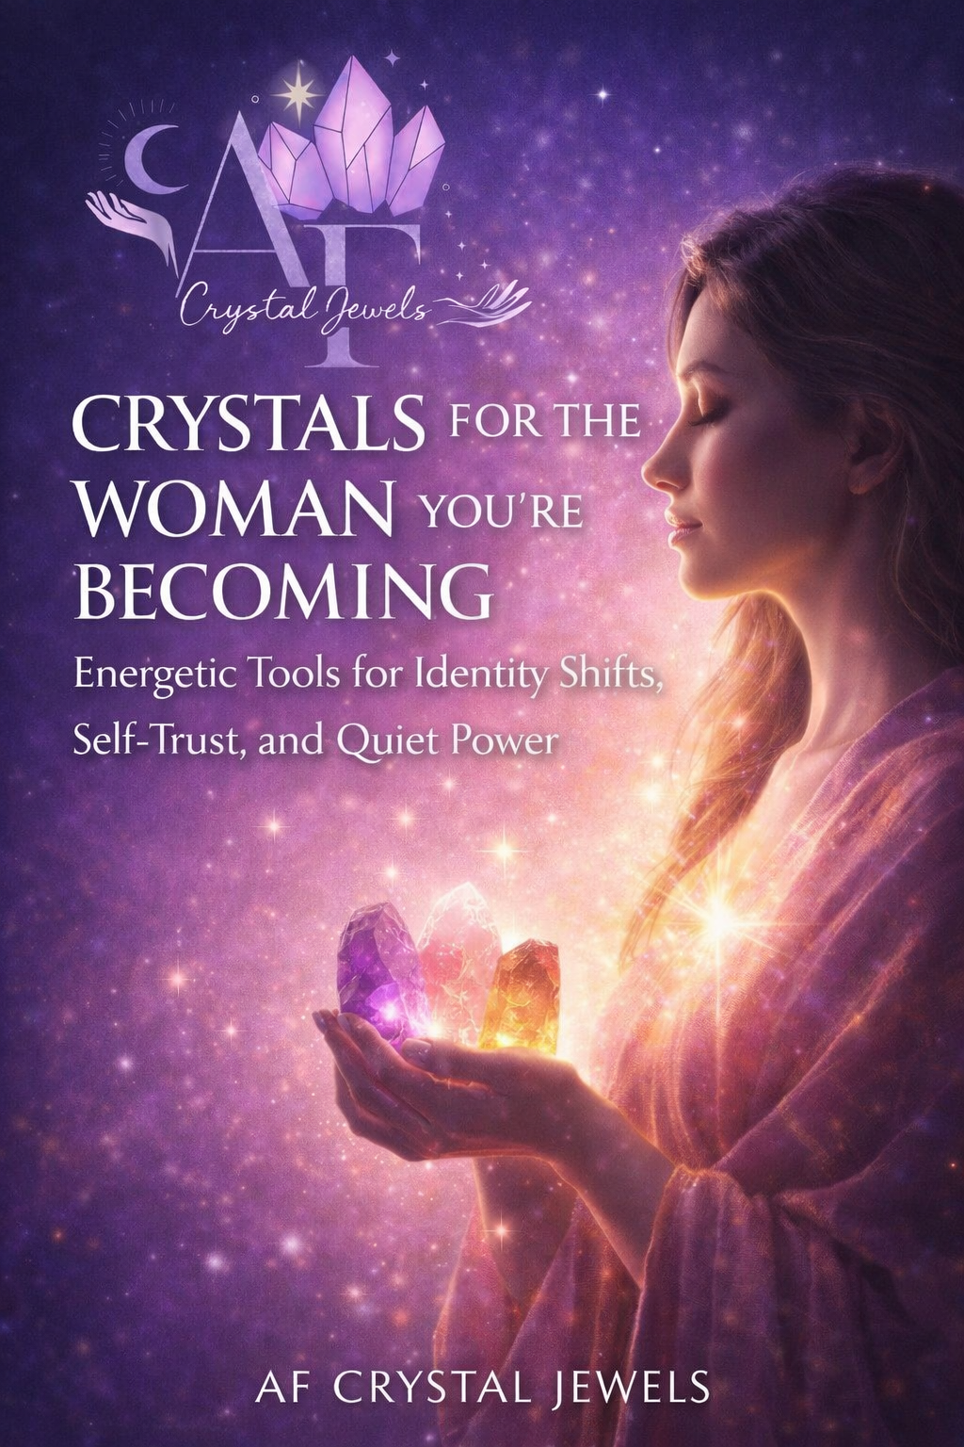
Crystals for the Woman You’re Becoming
Energetic Tools for Identity Shifts, Self-Trust, and Quiet Power

Copyright
© 2026
All rights reserved. No part of this book may be reproduced or distributed without written permission from the publisher.
This book is intended for spiritual and educational purposes only and does not replace professional medical, psychological, or legal advice.

Dedication
For the woman who knows she has outgrown her old life but hasn’t fully stepped into the new one yet.
This is for the becoming.

Table of Contents

An Invitation to Become
Why Identity Shifts Feel So Uncomfortable
Crystals as Anchors for Transformation
From Surviving to Self-Led
From People-Pleasing to Boundaries
From Hustle to Alignment
From Self-Doubt to Inner Authority
From Emotional Overwhelm to Regulation
From Scarcity to Receiving
From Waiting to Deciding
From Fragmented to Whole
Daily Practices for the Woman You’re Becoming
Rituals for Identity Anchoring
When the Old Version Tries to Return
Integration: Living as Her
A Closing Blessing

Chapter 1: An Invitation to Become
There comes a moment in every woman’s life when healing is no longer enough.
You’ve done the work.
You’ve reflected, processed, released, and learned.
And yet—something feels unfinished.
Not broken.
Not wounded.
Just… incomplete.

This book is not about fixing yourself.
It is about becoming the woman your healing prepared you for.

Crystals are not here to save you.
They are here to stabilize the version of you that is emerging.

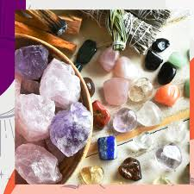

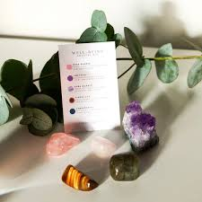

Chapter 2: Why Identity Shifts Feel So Uncomfortable

Growth is not always loud or dramatic.
Sometimes it is quiet, disorienting, and deeply internal.
Identity shifts feel uncomfortable because:
Your nervous system prefers familiarity
Your environment may still relate to the old you
Your habits lag behind your awareness

You may feel:
Restless
Detached
Emotional without clear reason
Pulled forward and backward at the same time
This is not regression.
This is reorganization.

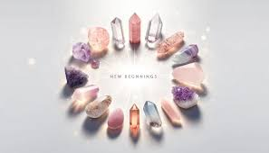



Chapter 3: Crystals as Anchors for Transformation

Crystals hold stable frequencies.
When your inner world is changing, stability matters.
Crystals help by:
Grounding new identity traits
Regulating emotional transitions
Acting as physical reminders of who you are becoming
Think of crystals as anchors, not accelerators.



Chapter 4: From Surviving to Self-Led
Survival mode is reactive.
Self-leadership is intentional.
Signs You’re Leaving Survival:
You pause before responding
You choose rest without guilt
You no longer explain yourself excessively

Crystals for This Shift:
Smoky Quartz – grounding and nervous system safety
Hematite – embodiment and stability
Black Tourmaline – emotional protection

Affirmation:
“I am safe to lead my life with clarity and calm.”

Chapter 5: From People-Pleasing to Boundaries

People-pleasing is often mistaken for kindness.
In truth, it is self-abandonment dressed as harmony.
Boundaries are not walls.
They are instructions for how to love you properly.

Crystals for Boundary Work:
Labradorite – energetic sovereignty
Tiger’s Eye – confident decision-making
Obsidian – truth and self-honesty

Reflection:
Where have I been negotiating my needs to keep the peace?

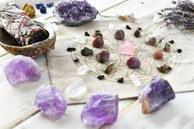

Chapter 6: From Hustle to Alignment

Hustle says: prove your worth.
Alignment says: embody it.
Alignment does not mean doing less—it means doing what matters.
Crystals for This Shift:
Citrine – confident expansion
Green Aventurine – ease and opportunity
Fluorite – clarity and focus

Affirmation:
“I allow success to meet me in alignment, not exhaustion.”
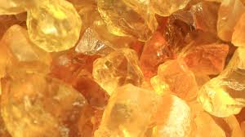

Chapter 7: From Self-Doubt to Inner Authority
Self-doubt fades when self-trust becomes embodied.
Inner authority sounds quiet but feels solid.
Crystals for Inner Authority:
Amethyst – intuitive clarity
Sodalite – truth and inner logic
Lapis Lazuli – self-expression with confidence
Practice: Before asking for advice, place your hand on your crystal and ask yourself first.

Chapter 8: From Emotional Overwhelm to Regulation
Strength is not emotional numbness.
It is the ability to feel without being consumed.
Crystals for Emotional Regulation:
Rose Quartz – self-compassion
Lepidolite – nervous system support
Moonstone – emotional cycles and balance
Reminder: You do not need to heal faster. You need to feel safer.

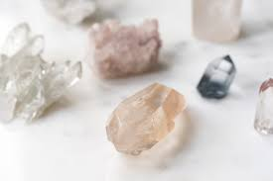

Chapter 9: From Scarcity to Receiving
Receiving requires trust, not effort.
Scarcity often shows up as:
Over giving
Difficulty resting
Guilt around ease
Crystals for Receiving:
Pyrite – confidence in worth
Citrine – abundance consciousness
Amazonite – trust and flow
Affirmation:
“I allow myself to receive without justification.”

Chapter 10: From Waiting to Deciding
Waiting keeps you small.
Deciding activates momentum.
You do not need more clarity.
You need self-permission.
Crystals for Decisiveness:
Carnelian – courage and action
Clear Quartz – amplified intention
Red Jasper – grounded confidence

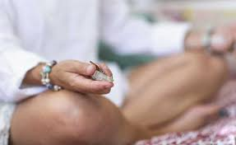

Chapter 11: From Fragmented too Whole

You are not many broken pieces.
You are one woman integrating multiple versions of herself.
Crystals for Integration:
Rhodonite – emotional harmony
Kunzite – heart-centred strength
Selenite – energetic coherence
Practice: Thank the past versions of yourself. They carried you here.

Chapter 12: Daily Practices for the Woman You’re Becoming
Morning: hold one crystal and set a tone
Midday: pause and breathe with intention
Evening: reflect without judgment
Consistency matters more than intensity.
Chapter 13: Rituals for Identity Anchoring
Identity Anchoring Ritual:
Choose a crystal that represents who you are becoming
Sit quietly and visualize your future self
Say aloud:
“I allow myself to live as this woman now.”
Carry or wear the crystal consistently for 21 days

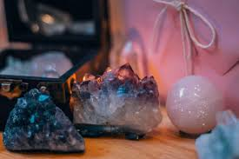

Chapter 14: When the Old Version Tries to Return
Regression is not failure.
It is a signal for compassion.
When the old version appears:
Pause
Ground

Choose again
You are not starting over.
You are reinforcing.

Chapter 15: Integration – Living as Her
Becoming is not an event.
It is a practice.
You will know you are living as her when:
You trust yourself
You respond instead of reacting
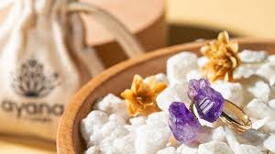
You no longer seek permission

Chapter 16: A Closing Blessing
May you stop shrinking for rooms you’ve outgrown.
May you trust the woman emerging within you.
May your crystals remind you, not of who you were, but of who you already are becoming.

