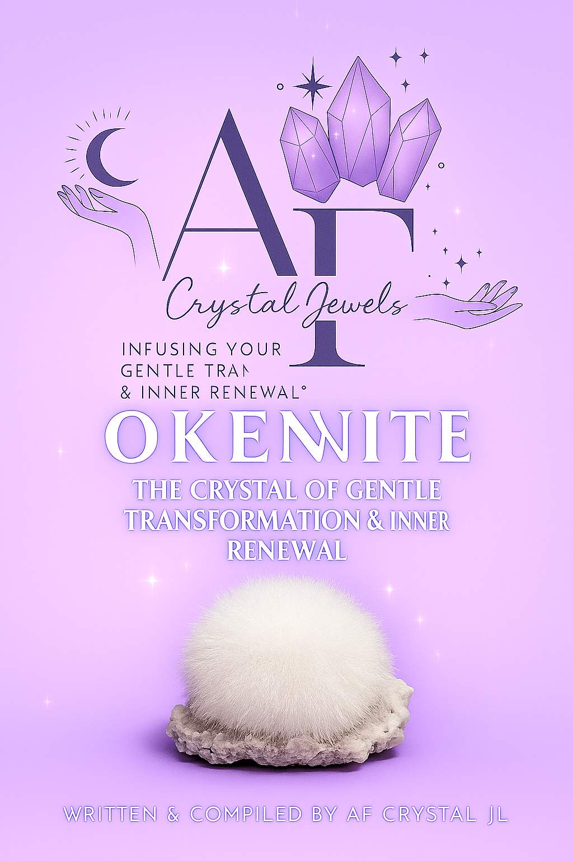
Okenite: The Crystal of Gentle Transformation & Inner Renewal
A Comprehensive Guide to the Healing, Spiritual, and Metaphysical Power of Okenite

Chapter 1: Introduction — The Gentle Power of Okenite

Soft, delicate, and ethereal, Okenite appears like a wisp of white silk spun by celestial hands. Its cotton-like fibres evoke purity and tenderness, a reflection of the nurturing energy it embodies. Known as the Stone of Gentle Transformation, Okenite encourages forgiveness, emotional release, and spiritual renewal.
Its vibration is subtle yet profound working not through force, but through compassion. Okenite teaches that healing need not be dramatic; it can unfold quietly through acceptance, love, and patience. For those navigating emotional pain, this stone offers comfort and serenity, guiding one to release guilt and self-criticism.
Symbolically, Okenite represents new beginnings, inner cleansing, and divine softness. Its pure white colour resonates with the energy of higher consciousness, connecting the human heart to universal love. In essence, Okenite is a reminder that transformation can occur without struggle—through surrender, trust, and the grace of gentle energy.

Chapter 2: The Origin & Formation of Okenite
Okenite is a hydrous calcium silicate mineral, typically found within volcanic rock cavities known as geodes. It forms in spherical clusters of delicate, fibrous crystals that resemble snowballs or cotton tufts. Despite its soft appearance, Okenite is brittle and must be handled with care, as its silky fibres can easily break.
Geologically, Okenite is associated with zeolite minerals, often appearing alongside Apophyllite, Gyrolite, and Stilbite. These combinations enhance its energetic properties, amplifying purification and emotional balance.
Major deposits of Okenite are found in Poona (Pune), India, which remains the world’s most well-known source. Smaller occurrences have been reported in Iceland, Chile, and New Zealand. Each location produces slightly different variations in lustre and texture, yet all share the same soft, angelic energy that defines this mineral.
Its natural formation within ancient volcanic environments mirrors its spiritual symbolism—just as Okenite emerges from the heart of fire and stone, it teaches the soul to find purity and peace amid life’s most transformative experiences.

Chapter 3: The History & Lore of Okenite
While Okenite was officially described by scientists in the 19th century, its mystical energy predates modern discovery. Ancient healers and seers viewed fibrous white stones as gifts of the heavens, believing them to carry the light of angels.
In metaphysical lore, Okenite is said to be a stone of karmic release, assisting the soul in clearing emotional residues from past experiences or even past lives. It gently brings unresolved issues to the surface, allowing healing without emotional overwhelm.
Collectors and crystal healers often describe Okenite as a “teacher of forgiveness.” It helps the heart let go of self-blame and opens one to divine understanding. In modern crystal healing, it is revered as a rare stone of transformation that teaches compassion—toward oneself and others.
Its appearance, soft as cloud or cotton, symbolizes the purity of unconditional love, reminding us that strength lies in softness and vulnerability is a sacred power.

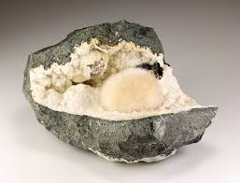

Chapter 4: The Spiritual Significance of Okenite
Spiritually, Okenite is one of the purest vibrations among the mineral kingdom. Its frequency aligns closely with angelic realms, facilitating communication with higher guidance, spirit guides, and one’s higher self.
It supports the soul’s journey of ascension and integration, particularly for those healing emotional wounds or karmic imbalances. Okenite’s gentle energy wraps around the aura like a cocoon of divine light, cleansing residual pain and restoring balance.
Energetically, this crystal embodies forgiveness, purity, and rebirth. It encourages self-compassion and emotional truth, helping one face inner shadows without judgment. Through this process, Okenite promotes spiritual maturity—an awakening through softness rather than struggle.
Many practitioners describe meditating with Okenite as entering a field of white light—calming, protective, and deeply nurturing. It’s a stone for spiritual growth through surrender, aligning the heart with divine love and higher consciousness.

Chapter 5: Okenite and the Chakras
Okenite’s radiant white energy primarily resonates with the Crown Chakra (Sahasrara), located at the top of the head. This chakra governs spiritual connection, divine wisdom, and enlightenment. When activated by Okenite, the Crown Chakra opens gracefully, allowing divine light to flow into one’s consciousness.
It also harmonizes with the Heart Chakra (Anahata), gently clearing grief, guilt, and emotional heaviness. Through this alignment, Okenite creates a bridge between the heart and the higher self—uniting love and wisdom.
For chakra healing, place Okenite:
On the Crown Chakra during meditation to deepen spiritual connection.
Over the Heart Chakra to release emotional pain and invite forgiveness.
Between the Heart and Solar Plexus to dissolve self-judgment and invite compassion.
Its energy is ideal for balancing the upper chakras, particularly during times of transformation or emotional recovery.

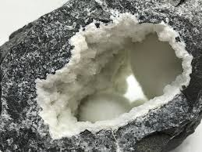

Chapter 6: Healing Properties — Mind, Body & Spirit
Emotional Healing:
Okenite assists in releasing guilt, resentment, and emotional burdens. It helps individuals forgive themselves and others, easing the weight of the past. Its presence encourages gentle emotional expression, allowing the heart to open without fear.
Mental Healing:
By calming overactive thoughts, Okenite nurtures clarity and acceptance. It dispels negative self-talk and supports new patterns of loving awareness. It’s particularly beneficial during transitions, grief, or self-discovery.

Physical Healing (Complementary Use):
Energetically, Okenite is believed to support the body’s detoxification process and promote balance in the nervous system. It may assist those recovering from exhaustion or chronic tension. (Note: Crystal healing complements but does not replace professional medical care.)
Spiritual Healing:
Okenite clears karmic debris and aids in spiritual ascension. It strengthens the aura, enhances meditation, and promotes deep states of peace. Its energy guides one to understand that all healing begins within.
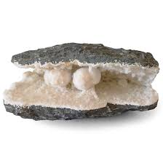

Chapter 7: Using Okenite in Daily Practice
Because of its delicate structure, Okenite should not be worn as jewellery or placed in water. Instead, it is best used in gentle spiritual settings—altars, meditation spaces, or healing rooms.
Daily Practices:
Morning Meditation: Hold Okenite near your heart to begin the day with calm and compassion.
Forgiveness Ritual: Write a letter to release past emotions while keeping Okenite nearby. Burn the letter safely afterward as a symbolic act of letting go.
Emotional Cleansing: Place the crystal beside your bed or workspace to absorb emotional heaviness and restore serenity.
Cleansing Methods:
Cleanse Okenite energetically by placing it near Selenite, using sound (gentle bell or tuning fork), or visualizing pure white light surrounding it. Avoid water or salt due to its fragility.

Chapter 8: Okenite Crystal Pairings & Synergies
Okenite harmonizes beautifully with other high-vibration and compassionate stones:
Selenite: Amplifies spiritual purity and light connection.
Apophyllite: Enhances angelic communication and emotional cleansing.
Stilbite: Deepens intuition and soul-level healing.
Rose Quartz: Strengthens self-love and heart healing.
Celestite: Invites divine serenity and inner peace.
These pairings can be arranged in crystal grids or healing layouts to create an atmosphere of renewal and spiritual harmony.
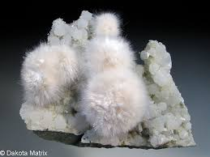

Chapter 9: Affirmations & Intentions with Okenite
Affirmations magnify Okenite’s energy, anchoring transformation into conscious awareness. Repeat daily while holding or meditating with the crystal:
“I release all guilt and forgive myself with love.”
“I am open to gentle transformation and divine healing.”
“My heart is pure, my spirit renewed.”
“I embrace change with compassion and grace.”
“Peace flows through me effortlessly.”
By speaking these intentions, Okenite’s vibration merges with your emotional field, helping align thought and energy with higher truth.

Chapter 10: Manifestation & Energy Work
Okenite supports manifestation through surrender—teaching that one need not force outcomes, but align with the flow of divine timing.
In energy work, place Okenite at the Crown Chakra to channel healing light, or in the centre of a forgiveness grid surrounded by Rose Quartz and Selenite. Its energy gently dissolves resistance, allowing new experiences to enter your life with ease.
For those practicing Reiki or crystal healing, Okenite enhances the practitioner’s compassion and sensitivity, helping them hold space for others without absorbing their emotions.

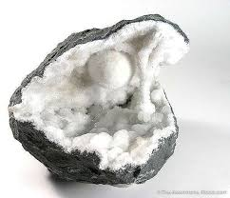

Chapter 11: Caring for Okenite
Due to its fibrous texture, Okenite is extremely delicate. Never wash or submerge it in water. Handle it minimally, as the fibres can break easily.
Store it in a soft-lined box or display it in a glass case to preserve its beauty. Clean energetically using gentle methods—Selenite slabs, incense smoke, or sound cleansing.
By caring for Okenite with respect, you mirror the very lesson it teaches gentleness is a form of strength.

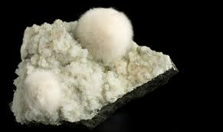

Chapter 12: Conclusion — The Path of Gentle Awakening
Okenite is more than a crystal—it is a teacher of compassion, forgiveness, and renewal. Its presence reminds us that transformation need not be turbulent; it can unfold softly, in harmony with the soul’s rhythm.
Through its luminous vibration, Okenite reveals that healing occurs when we accept ourselves fully past, present, and future. It guides the heart toward wholeness, encouraging peace where once there was pain.
When embraced with reverence, Okenite becomes a sacred companion on the path of gentle awakening—illuminating the journey home to self-love and divine grace.
